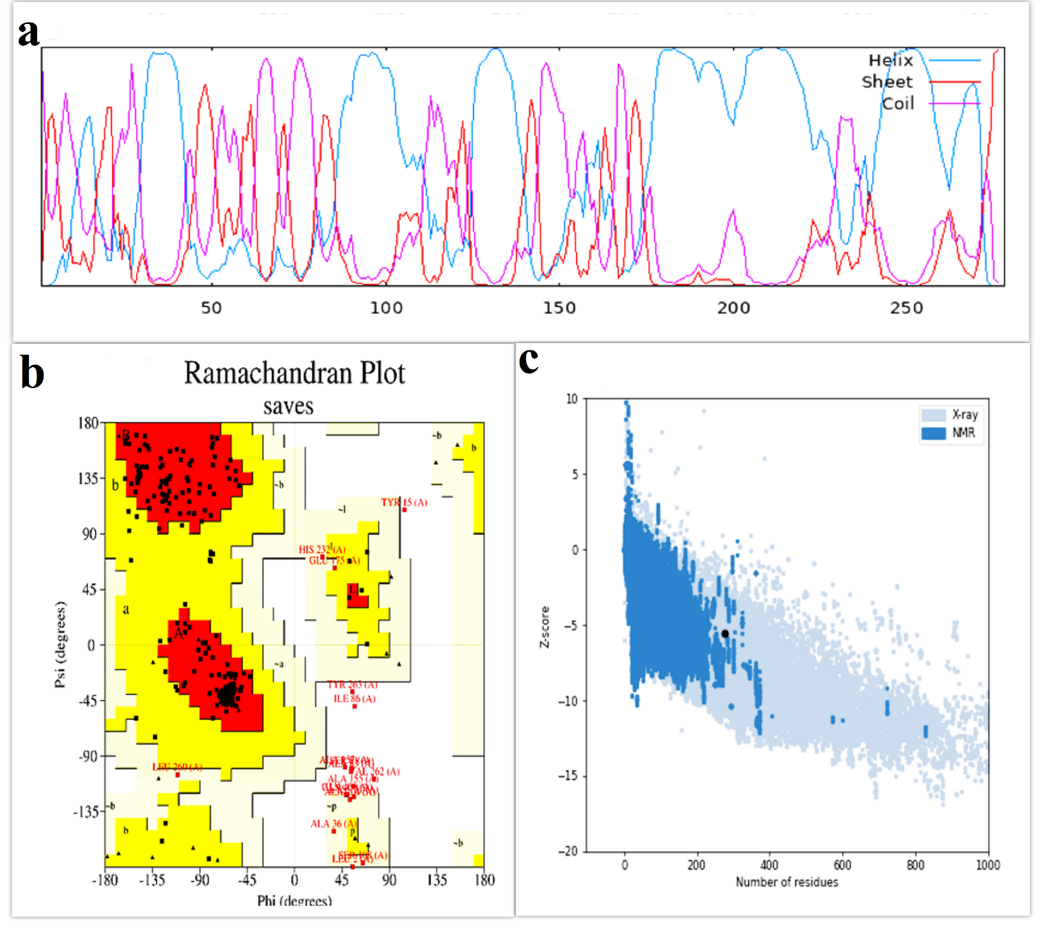
Supplementary Figure 1: Prediction and analysis of the secondary and tertiary structures of the non-adjuvant vaccine candidate: (a) Secondary structure of the non-adjuvanted vaccine candidate, (b) Validation of the tertiary structure of the non-adjuvanted vaccine by Ramachandran plot, (c) Validation of the tertiary structure of the non-adjuvanted vaccine by ProSA-web server.

