ONLINE SUPPLEMENT: FIGURES AND TABLES

Alternative splicing and global transcriptome changes associated with LPS stimulation in human peripheral blood mononuclear cells

This PDF file includes:
Supplemental Table 1. Demographic and clinical characteristics of the woman donor PBMC samples
Supplemental Table 2. Parameters used for Trimmomatic, STAR, and FeatureCounts.
Supplemental Table 3. Sex specific genes for TLRs
Supplemental Table 4. Summary of alternative splicing events
Supplemental Table 5. PSI Concordance
Supplemental Table 6. Junction support of alternatively spliced and differentially expressed genes
Supplemental Table 7. Enrichment of biological pathways for alternatively spliced genes
Supplemental Table 8. Summary of splice-aware protein-protein network enrichment tests for TLR

Supplemental Figure 1. PCA plots of individual and combined duplicate samples
Supplemental Figure 2. Boxplots of expression for common differentially expressed inflammatory genes
Supplemental Figure 3. Enrichment of the top 10 GO terms for differentially expressed genes
Supplemental Figure 4. Summary of alternatively spliced (AS) genes with affected protein features
Supplemental Figure 5. Graph summary of pathway-level statistics for mRNA surveillance and SNARE pathways

Supplemental Data Tables (in separate documents):
Supplemental File 2. Global differential gene expression results.
Supplemental File 3. Enrichment of GO categories for global differentially expressed genes results.
Supplemental File 4. Pathway impact analysis of global differential gene expression results.
Supplemental File 5. Differential alternative splicing results.
Supplemental File 6. Pathway enrichment of differential alternative splicing results.
Supplemental File 7. Network enrichment of alternative splicing results.
Supplemental File 8. Differential Expression and Differential Alternative Splicing of TLR-related Genes Hypothesized to be Associated with Sex-Specific Differences in Immune Response
Supplemental File 9. Prioritized Alternative Splicing Events

Supplemental Table 1. Demographic and clinical characteristics and RNA quality metrics between LPS and PBS-treated PBMCs of the women donor PBMC samples.
Study ID | Age | Ethnicity | Smoker | Weight | Height | Blood Type | Viability | CMV status | 260/280  LPS  (R1,R2) | 260/230  LPS  (R1,R2) | 260/280  PBS  (R1,R2) | 260/230  PBS  (R1,R2)
0035 | 48 | Asian | No | 58 | 166 | O+ | 99.0 | Negative | 2.0, 2.1 | 2.1, 2.1 | 2.0, 2.1 | 2.2, 2.1
0036 | 54 | Caucasian | No | 86 | 180 | A+ | 99.3 | Negative | 2.1, 2.1 | 2.0, 2.1 | 2.1, 2.1 | 2.2, 2.1
0037 | 50 | Black | No | 100 | 155 | O+ | 98.0 | Unknown | 2.1, 2.0 | 2.0, 2.1 | 2.0, 2.1 | 2.1, 2.0
Abbreviations: CMV, Cytomegalovirus; LPS, lipopolysaccharide; PBS, phosphate-buffered saline; R1, replicate 1; R2, replicate 2.
All samples had RIN values >8.0.

Supplemental Table 2. Parameters used for Trimmomatic, STAR, and FeatureCounts.
Software Tool | Parameters
Trimmomatic | ILLUMINACLIP:adapter.fa:2:30:10:2:True  LEADING:17 TRAILING:13  SLIDINGWINDOW:4:15 MINLEN:75  HEADCROP:10
STAR | --sjdbGTFfile gencode.v46.primary_assembly.annotation.gtf  --readFilesManifest manifest.txt  --alignEndsProtrude 25 ConcordantPair  --readFilesCommand gunzip -c  --outSAMtype BAM Unsorted SortedByCoordinate  --outFilterMultimapNmax 20  --outFilterMismatchNmax 10  --outSAMunmapped Within KeepPairs  --outSAMattrRGline ID:${base} SM:${base}  --quantMode TranscriptomeSAM  --twopassMode Basic
FeatureCounts | -s 2 -p --countReadPairs  -a gencode.v46.primary_assembly.annotation.gtf

Supplemental Table 3. Summary of genes previously hypothesized* to be associated with sex differences in acute inflammatory responses and Toll-like receptors (TLRs) and the X chromosomes.
Gene Symbol | Gene Name | Chr | Entrez gene ID | Ensembl gene ID | DE | DAS  (SE, RI, MXE, A3SS, A5SS)
BTK | Bruton tyrosine kinase | Xq22.1 | 695 | ENSG00000010671 | No
CD14 | CD14 molecule | 5q31.3 | 929 | ENSG00000170458 | No
IFNA1 | Interferon alpha 1 | 9p21.3 | 3439 | ENSG00000197919 | ND | ND
IFNB1 | Interferon beta 1 | 9p21.3 | 3456 | ENSG00000171855 | ND | ND
IFNG | Interferon gamma | 12q15 | 3458 | ENSG00000111537 | Yes | RI
IKBKB | Inhibitor of nuclear factor kappa B kinase subunit beta | 8p11.21 | 3551 | ENSG00000104365 | No
IKBKG | Inhibitor of nuclear factor kappa B kinase regulatory subunit gamma | Xq28 | 8517 | ENSG00000269335 | No
IL12A | Interleukin 12A | 3q25.33 | 3592 | ENSG00000168811 | No
IL1A | Interleukin 1 alpha | 2q14.1 | 3552 | ENSG00000115008 | Yes
IL1B | Interleukin 1 beta | 2q14.1 | 3553 | ENSG00000125538 | Yes | RI, A5SS
IRAK1 | Interleukin 1 receptor associated kinase 1 | Xq28 | 3654 | ENSG00000184216 | No
IRAK2 | Interleukin 1 receptor associated kinase 2 | 3p25.3 | 3656 | ENSG00000134070 | Yes
IRF1 | Interferon regulatory factor 1 | 5q31.1 | 3659 | ENSG00000125347 | No
MAPK8 | Mitogen-activated protein kinase 8 | 10q11.22 | 5599 | ENSG00000107643 | No
MYD88 | MYD88 innate immune signal transduction adaptor | 3p22.2 | 4615 | ENSG00000172936 | No | A5SS
NFKB1 | Nuclear factor kappa B subunit 1 | 4q24 | 4790 | ENSG00000109320 | No
TLR1 | Toll like receptor 1 | 4p14 | 7096 | ENSG00000174125 | No
TLR2 | Toll like receptor 2 | 4q31.3 | 7097 | ENSG00000137462 | No
TLR3 | Toll like receptor 3 | 4q35.1 | 7098 | ENSG00000164342 | No
TLR4 | Toll like receptor 4 | 9q33.1 | 7099 | ENSG00000136869 | No | SE
TLR6 | Toll like receptor 6 | 4p14 | 10333 | ENSG00000174130 | No
TLR7 | Toll like receptor 7 | Xp22.2 | 51284 | ENSG00000196664 | Yes
TLR8 | Toll like receptor 8 | Xp22.2 | 51311 | ENSG00000101916 | No
TLR9 | Toll like receptor 9 | 3p21.2 | 54106 | ENSG00000239732 | ND | ND
TNF | Tumor necrosis factor | 6p21.33 | 7124 | ENSG00000232810 | No
*Source: Popotas A, Casimir GJ, Corazza F, Lefevre N. Sex-related immunity: could Toll-like receptors be the answer in acute inflammatory response? Front Immunol. 2024;15:1379754. Epub 20240521. doi: 10.3389/fimmu.2024.1379754. PubMed PMID: 38835761; PMCID: PMC11148260. Abbreviations: A3SS, alternative 3’ splice sites; A5SS, alternative 5’ splice sites; AS, alternatively spliced; MXE, mutually exclusive exons; ND, no expression detected; RI, retained introns; SE, spliced exon.

Supplemental Table 4. Summary of alternative splicing events.
Event Type | Total Events JC |  | Total Events JCEC |  | Sig Events JC |  | Sig Events JC Sample Higher Inclusion | Sig Events JC Sample 2 Higher Inclusion |  | Sig Events JCEC |  | Sig Events JCEC Sample Higher Inclusion |  | Sig Events JCEC Sample 2 Higher Inclusion
SE | 158,340 |  | 160,586 |  | 5,183 |  | 2,467 | 2,716 |  | 5,400 |  | 2,498 |  | 2,902
MXE | 49,456 |  | 50,108 |  | 1,700 |  | 851 | 849 |  | 1,684 |  | 804 |  | 880
RI | 22,862 |  | 22,917 |  | 1,203 |  | 434 | 769 |  | 1,294 |  | 476 |  | 818
A3SS | 67,759 |  | 67,861 |  | 1,209 |  | 588 | 621 |  | 1,205 |  | 595 |  | 610
A5SS | 39,622 |  | 39,722 |  | 737 |  | 372 | 365 |  | 786 |  | 397 |  | 389
Abbreviations: A3SS, alternative 3’ splice sites; A5SS, alternative 5’ splice sites; AS, alternatively spliced; MXE, mutually exclusive exons; RI, retained introns; SE, spliced exon; Sig, significant; JC, junction counts; JCEC, junction counts and exon counts.

Supplemental Table 5. PSI Concordance. Reproducibility of percent-spliced-in (PSI) values across biological replicates for significant differentially alternatively spliced events, overall and by event type. For each treatment group (LPS, PBS), agreement among the three replicate PSI measurements is summarized across events by mean pairwise Spearman and Pearson correlation, the median within-event standard deviation of PSI, and the intraclass correlation coefficient (ICC; two-way, agreement, single rater) with 95% confidence interval. n, number of significant events.
Event type | Treatment | n | Mean pairwise  Spearman ρ | Mean pairwise  Pearson r | Median within-event  PSI SD | ICC | ICC 95% CI
SE | LPS | 1316 | 0.797 | 0.910 | 0.055 | 0.909 | 0.901–0.917
SE | PBS | 1316 | 0.842 | 0.944 | 0.032 | 0.944 | 0.939–0.949
MXE | LPS | 347 | 0.879 | 0.937 | 0.052 | 0.937 | 0.925–0.947
MXE | PBS | 347 | 0.895 | 0.946 | 0.042 | 0.946 | 0.936–0.955
RI | LPS | 388 | 0.813 | 0.903 | 0.056 | 0.902 | 0.884–0.917
RI | PBS | 388 | 0.870 | 0.940 | 0.038 | 0.940 | 0.929–0.949
A5SS | LPS | 167 | 0.854 | 0.929 | 0.049 | 0.929 | 0.909–0.945
A5SS | PBS | 167 | 0.850 | 0.935 | 0.053 | 0.933 | 0.915–0.949
A3SS | LPS | 279 | 0.755 | 0.881 | 0.052 | 0.881 | 0.857–0.902
A3SS | PBS | 279 | 0.780 | 0.935 | 0.035 | 0.934 | 0.920–0.946
All | LPS | 2497 | 0.826 | 0.916 | 0.054 | 0.915 | 0.910–0.921
All | PBS | 2497 | 0.866 | 0.945 | 0.035 | 0.945 | 0.941–0.948
Abbreviations: PSI, percent-spliced-in; ICC, intraclass correlation coefficient; n, number of significant events; SE, skipped exon; MXE, mutually exclusive exons; RI, retained intron; A5SS/A3SS, alternative 5′/3′ splice site.

Supplemental Table 6. Expression level and splice-junction support for the 70 genes shared between the differential expression and differential alternative splicing analyses.
Gene | Ensembl ID | log₂FC | logCPM | Lower-expression  condition | Mean junction reads  (lower-expression  condition)
PTGS1 | ENSG00000095303 | 1.91 | 3.67 | LPS | 10.0
ADA2 | ENSG00000093072 | 2.18 | 8.21 | LPS | 10.0
— | ENSG00000259354 | -2.20 | 3.01 | PBS | 10.0
SLC46A1 | ENSG00000076351 | 1.76 | 3.16 | LPS | 10.3
OSBPL5 | ENSG00000021762 | 1.29 | 3.78 | LPS | 11.0
FLVCR2 | ENSG00000119686 | 2.53 | 4.74 | LPS | 12.0
MAP3K8 | ENSG00000107968 | -1.32 | 5.73 | PBS | 12.0
PTGS2 | ENSG00000073756 | -5.47 | 8.72 | PBS | 12.3
ADGRG3 | ENSG00000182885 | -2.24 | 2.64 | PBS | 12.3
CXCL2 | ENSG00000081041 | -3.42 | 6.75 | PBS | 12.7
STAB1 | ENSG00000010327 | 5.30 | 4.99 | LPS | 13.0
CSF1R | ENSG00000182578 | 4.26 | 7.36 | LPS | 13.0
— | ENSG00000293154 | -3.01 | 2.42 | PBS | 13.7
SORBS3 | ENSG00000120896 | 1.50 | 4.83 | LPS | 13.7
CCL20 | ENSG00000115009 | -2.59 | 1.53 | PBS | 14.3
MMP14 | ENSG00000157227 | -3.02 | 8.18 | PBS | 14.3
ELL2 | ENSG00000118985 | -1.61 | 6.69 | PBS | 17.3
ECM1 | ENSG00000143369 | 1.70 | 1.20 | LPS | 18.0
ITGAX | ENSG00000140678 | 1.99 | 7.75 | LPS | 18.3
CD302 | ENSG00000241399 | 1.76 | 5.24 | LPS | 19.7
TYROBP | ENSG00000011600 | 2.61 | 7.33 | LPS | 21.0
TNFRSF18 | ENSG00000186891 | -1.54 | 1.73 | PBS | 21.7
TNIP1 | ENSG00000145901 | -1.22 | 7.25 | PBS | 21.7
SERPING1 | ENSG00000149131 | 3.09 | 8.00 | LPS | 22.0
ACP5 | ENSG00000102575 | 2.71 | 6.68 | LPS | 23.0
CAMK1 | ENSG00000134072 | 4.46 | 3.16 | LPS | 23.7
SULF2 | ENSG00000196562 | 3.89 | 4.05 | LPS | 23.7
TLR10 | ENSG00000174123 | -1.07 | 5.95 | PBS | 23.7
ITGAM | ENSG00000169896 | 2.90 | 5.08 | LPS | 24.0
MT1X | ENSG00000187193 | -3.22 | 5.96 | PBS | 26.0
LST1 | ENSG00000204482 | 4.17 | 2.76 | LPS | 28.0
MILR1 | ENSG00000271605 | 2.44 | 2.89 | LPS | 28.7
SLC8A1 | ENSG00000183023 | 3.89 | 6.41 | LPS | 29.3
PLEKHG3 | ENSG00000126822 | 1.89 | 4.20 | LPS | 29.7
SLAMF1 | ENSG00000117090 | -1.40 | 6.62 | PBS | 29.7
TREM1 | ENSG00000124731 | -3.47 | 4.63 | PBS | 30.3
SYTL3 | ENSG00000164674 | -1.34 | 4.54 | PBS | 33.0
TRIP10 | ENSG00000125733 | -1.43 | 3.72 | PBS | 33.3
CYBB | ENSG00000165168 | 3.94 | 10.04 | LPS | 34.0
TNIP3 | ENSG00000050730 | -3.93 | 6.39 | PBS | 40.3
CLEC17A | ENSG00000187912 | -1.29 | 4.81 | PBS | 40.7
AIF1 | ENSG00000204472 | 4.03 | 4.30 | LPS | 46.3
ADCY7 | ENSG00000121281 | 1.24 | 7.39 | LPS | 47.3
IL2RA | ENSG00000134460 | -3.13 | 7.11 | PBS | 56.3
NAMPT | ENSG00000105835 | -2.44 | 9.84 | PBS | 63.0
IFNG | ENSG00000111537 | -6.04 | 7.95 | PBS | 64.7
SLC37A2 | ENSG00000134955 | 3.24 | 4.82 | LPS | 65.3
ATP6V0A1 | ENSG00000033627 | 1.93 | 5.74 | LPS | 66.3
SLCO4A1 | ENSG00000101187 | -3.54 | 5.34 | PBS | 69.3
BMF | ENSG00000104081 | -1.00 | 6.21 | PBS | 75.0
FURIN | ENSG00000140564 | -2.26 | 7.79 | PBS | 77.0
LIMK2 | ENSG00000182541 | -1.72 | 5.71 | PBS | 81.0
ADAMTSL4 | ENSG00000143382 | 4.58 | 4.46 | LPS | 89.3
RASGRP4 | ENSG00000171777 | 3.07 | 2.55 | LPS | 107.7
IL18BP | ENSG00000137496 | 1.81 | 6.82 | LPS | 135.3
PECAM1 | ENSG00000261371 | 1.61 | 7.32 | LPS | 145.3
IL1B | ENSG00000125538 | -5.99 | 10.68 | PBS | 146.3
CXCL1 | ENSG00000163739 | -5.43 | 9.22 | PBS | 191.3
GAS7 | ENSG00000007237 | 2.08 | 6.04 | LPS | 194.7
AQP9 | ENSG00000103569 | -2.49 | 7.18 | PBS | 206.0
ZC3H12A | ENSG00000163874 | -1.76 | 6.40 | PBS | 208.3
ARHGAP31 | ENSG00000031081 | 1.61 | 6.32 | LPS | 213.7
CXCL3 | ENSG00000163734 | -3.51 | 5.91 | PBS | 234.3
CTSC | ENSG00000109861 | 2.38 | 8.49 | LPS | 242.3
SGK1 | ENSG00000118515 | 1.64 | 7.60 | LPS | 313.0
FCGR2B | ENSG00000072694 | 2.14 | 5.32 | LPS | 322.3
DDIT4 | ENSG00000168209 | -2.82 | 5.58 | PBS | 387.3
CIITA | ENSG00000179583 | 1.52 | 7.71 | LPS | 452.3
LYZ | ENSG00000090382 | 5.29 | 11.46 | LPS | 610.0
CXCL8 | ENSG00000169429 | -4.86 | 12.35 | PBS | 2676.3
Genes are ordered by increasing junction support. For each gene, the direction of the expression change defines the lower-expression condition (log₂FC > 0, lower in LPS; log₂FC < 0, lower in PBS). Mean junction reads is the per-group average of inclusion plus skipping junction reads across the three replicates for that gene’s significant splicing event(s), taken in the lower-expression condition (minimum across events where a gene has more than one). All values are at least the pre-specified threshold of 10. log₂FC, log₂ fold change; logCPM, log₂ counts per million (overall expression). Dashes denote genes without an assigned symbol (Ensembl ID shown).

Supplemental Table 7. Enrichment of biological pathways for alternatively spliced genes across event types between LPS and PBS-treated PBMCs from three women donors.

Event Type | Database | AS Genes  Tested (n) | Pathways Tested  (n) | Pathways Enriched  (n)
SE | WikiPathway | 940 | 446 | 58
 | Elsevier |  | 1,190 | 132
 | BioPlanet |  | 1,071 | 139
MXE | WikiPathway | 240 | 214 | 4
 | Elsevier |  | 513 | 14
 | BioPlanet |  | 503 | 20
RI | WikiPathway | 356 | 376 | 134
 | Elsevier |  | 1,035 | 489
 | BioPlanet |  | 808 | 237
A3SS | WikiPathway | 223 | 248 | 1
 | Elsevier |  | 580 | 4
 | BioPlanet |  | 543 | 5
A5SS | WikiPathway | 146 | 199 | 22
 | Elsevier |  | 552 | 97
 | BioPlanet |  | 402 | 35
Abbreviations: A3SS, alternative 3’ splice sites; A5SS, alternative 5’ splice sites; AS, alternatively spliced; MXE, mutually exclusive exons; RI, retained introns; SE, spliced exon.

Supplemental Table 8. Summary of splice-aware protein-protein network enrichment tests for Toll Like Receptor, TLR4, and MyD88 related pathways from the Reactome (R-HSA) and WikiPathways (WP) databases associate with differentially alternatively spliced genes of human PBMCs treated with LPS or PBS predicted to impact protein-protein network interactions.
Pathway ID | Pathway name | AS genes (SE events only)  (number of interactions affecting the pathway) | FDR | NEASE score
WP1449 | Regulation of toll-like receptor signaling pathway | BRD4 (1), RASSF1 (3), RBM4 (1), GRK3 (3), PTPN22 (3), RPS3 (2), NFKBIE (9), IL1R1 (4), TESK2 (1), MAP2K2 (17), ANKRD28 (8), ACVR1B (8), PSMA5 (2), TLR4 (16), GABPB1 (2), YES1 (1), TXK (7), PIK3C2A (4), TRIM5 (1) | 4.04x10⁻⁶ | 23.74
WP75 | Toll-like Receptor Signaling Pathway | BRD4 (1), RASSF1 (3), RBM4 (1), GRK3 (3), PTPN22 (1), RPS3 (2), NFKBIE (7), IL1R1 (3), TESK2 (1), MAP2K2 (15), ANKRD28 (5), ACVR1B (6), TLR4 (12), GABPB1 (2), YES1 (1), TXK (4), PIK3C2A (4) | 1.39x10⁻⁴ | 17.69
WP3877 | Simplified Depiction of MYD88 Distinct Input-Output Pathway | RPS3 (1), RNF185 (1), NFKBIE (3), IL1R1 (1), MAP2K2 (1), ANKRD28 (1), TLR4 (7), UBE2B (2) | 1.08x10⁻³ | 9.38
WP3858 | Toll-like receptor signaling related to MyD88 | RPS3 (1), NFKBIE (7), IL1R1 (1), MAP2K2 (2), ANKRD28 (4), ACVR1B (1), TLR4 (9), GABPB1 (2) | 4.81x10⁻³ | 7.63

Supplemental Table 9. Canonical M1 and M2 macrophage polarization marker genes with differential expression or differential alternative splicing between LPS-stimulated and PBS-treated PBMCs from healthy women donors.
Gene | Polarization | logFC | DE FDR | Expression  higher in | AS event(s) | ΔPSI | AS FDR | Inclusion  higher in
CD86 | M1 | +1.17 | 4.8e-02 | PBS | NS | — | — | —
CXCL10 | M1 | +4.46 | 3.8e-03 | PBS | NS | — | — | —
CXCL11 | M1 | +4.33 | 2.1e-02 | PBS | NS | — | — | —
CYBB | M1 | +3.94 | 6.8e-11 | PBS | SE (×3), A3SS | −0.13 to −0.06 | <1e-16 | PBS
IL1B | M1 | −5.99 | 4.1e-07 | LPS | A5SS, RI | −0.18 to −0.14 | <1e-16 | PBS
IL6 | M1 | −4.53 | 1.8e-08 | LPS | NS | — | — | —
PTGS2 | M1 | −5.47 | 8.5e-11 | LPS | RI (×3) | −0.45 to −0.14 | 4.1e-06 | PBS
SOCS3 | M1 | −1.50 | 2.0e-02 | LPS | NS | — | — | —
STAT1 | M1 | NS | — | — | SE | −0.52 | 3.3e-03 | PBS
TLR4 | M1 | NS | — | — | SE | +0.07 | 1.6e-03 | LPS
CD163 | M2 | NS | — | — | A3SS | +0.14 | 1.9e-03 | LPS
CHI3L1 | M2 | +2.15 | 4.2e-02 | PBS | NS | — | — | —
CLEC7A | M2 | +4.46 | 3.5e-05 | PBS | NS | — | — | —
IL10 | M2 | −4.78 | 1.2e-10 | LPS | NS | — | — | —
MMP9 | M2 | NS | — | — | A3SS, RI | +0.08 | 2.2e-07 | LPS
MRC1 | M2 | +9.25 | 2.6e-43 | PBS | NS | — | — | —
STAB1 | M2 | +5.30 | 1.1e-12 | PBS | MXE | −0.07 | 8.1e-03 | PBS

Genes are grouped by their reported role in the M1 or M2 macrophage polarization program. Only genes with a significant result in at least one analysis are shown.
Differential expression (DE) was assessed with edgeR (FDR < 0.05). The logFC corresponds to the PBS versus LPS coefficient, so a positive logFC indicates higher expression in PBS-treated cells and a negative logFC indicates higher expression in LPS-treated cells. Expression higher in gives the condition with the higher normalized expression. NS, not significant at FDR < 0.05.
Differential alternative splicing (AS) was assessed with rMATS-turbo (FDR < 0.01 and |ΔPSI| ≥ 0.05). ΔPSI is the inclusion level in LPS-treated cells minus PBS-treated cells, so a positive value indicates higher exon inclusion in LPS-treated cells. Counts in parentheses give the number of significant events of that type, the ΔPSI column reports the range across those events, and AS FDR is the smallest FDR among them. NS, no event met the thresholds.
M1 markers screened: CD80, CD86, NOS2, TNF, IL1B, IL6, IL12A, IL12B, IL23A, CXCL9, CXCL10, CXCL11, CCL5, CCR7, SOCS3, MARCO, FCGR1A, IRF5, STAT1, CYBB, TLR4, PTGS2, TNFAIP3.
M2 markers screened: MRC1, CD163, ARG1, IL10, TGM2, CCL17, CCL18, CCL22, CCL24, MSR1, STAB1, CLEC7A, CD200R1, MAF, IRF4, PPARG, FN1, TGFB1, VEGFA, CHI3L1, MMP9, F13A1, SELENOP, DHCR7.
Markers screened but not listed showed no significant DE or AS. DHCR7 showed no significant DE (logFC −0.74, FDR 0.34) or AS. CYBB is retained for completeness and is discussed in the main text.

A | Individual Samples
All Genes
1000 Most Variable Genes
B | Combined Duplicates
All Genes
1000 Most Variable Genes

Supplemental Figure 1. Plots of the first four dimensions of a principal components analysis (PCA) of gene expression levels for peripheral blood mononuclear cells (PBMCs) from three donors treated with either lipopolysaccharide (LPS) or Phosphate-buffered saline (PBS) for (A) all individual samples and (B) combined duplicates using all genes or the 1000 most variable genes.

IL-6 | IL-8 | IL-10 | IL-12
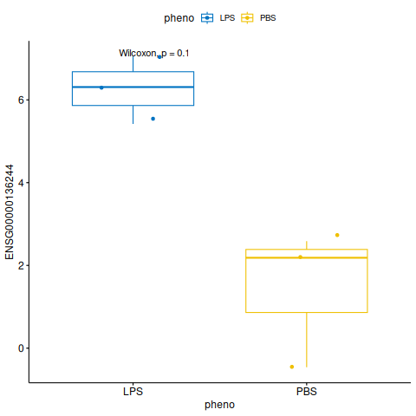 | 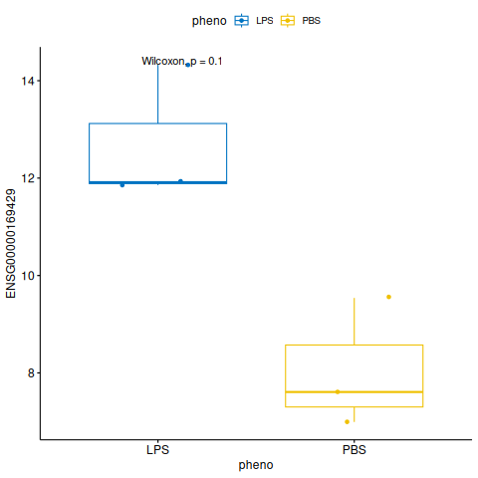 | 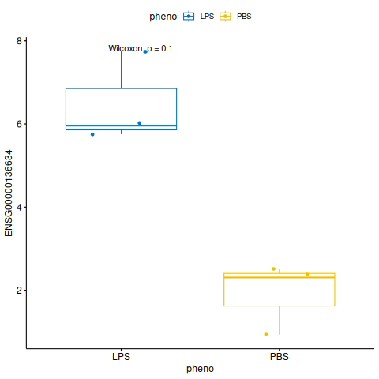 | 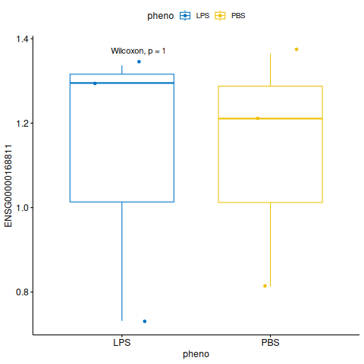
IL-23 | INFG | TNFA
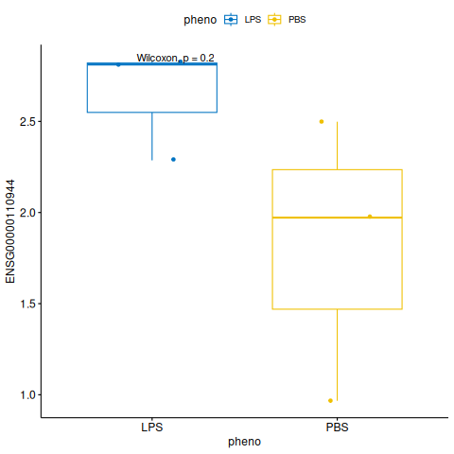 | 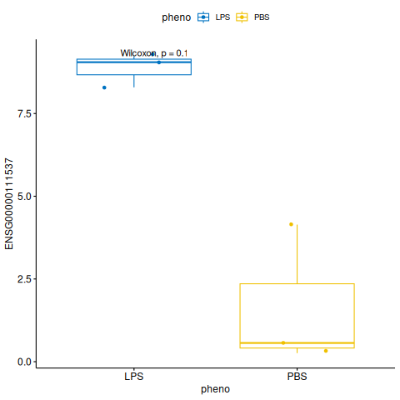 | 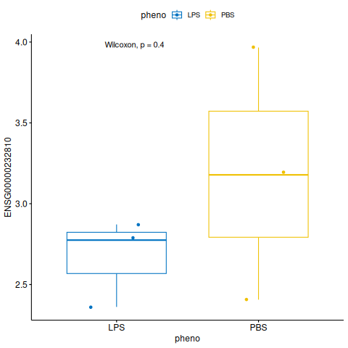

Supplemental Figure 2. Boxplots of expression for LPS and PBS-treated human PBMCs for pro- and anti-inflammatory genes commonly associated with immune response and LPS treatment.

Supplemental Figure 3. Enrichment of the top 10 GO terms for genes differentially expressed between LPS and PBS.

Supplemental Figure 4. Summary of alternatively spliced (AS) genes with affected protein features associated with LPS or PBS treatment of human PBMCs. (A) Gene affecting protein features. (B) Summary of affected features.

Supplemental Figure 5. Graph summary of pathway-level statistics. The perturbation propagation in the (A) mRNA surveillance (hsa03015) and (B) the SNARE interactions in vesicular transport (hsa04130) pathways. The square nodes denote genes with gene expression change, and the circle nodes denote all other nodes. The color of each node represents the perturbation (red = positive, blue = negative), and the shade represents the strength of the perturbation. Note that the square nodes with no parents have no accumulation.

