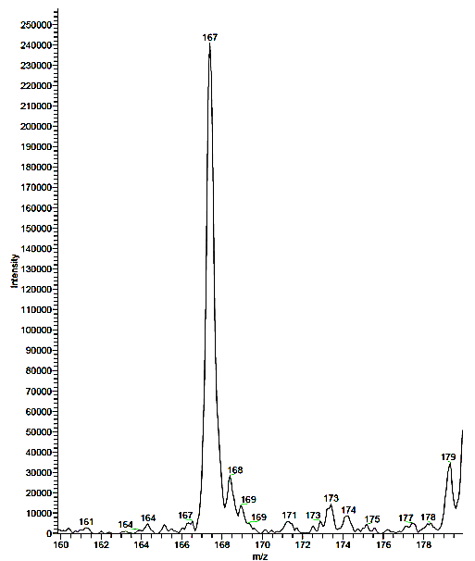

Additional File 6: LC-ESI-MS (negative ion mode) specta for enzyme-catalyzed indole-isonitrile biosynthesis product. Observed peak is at 167 amu. Expected peak is 167 amu for the anion shown in figure.

