Supplementary material
2
3 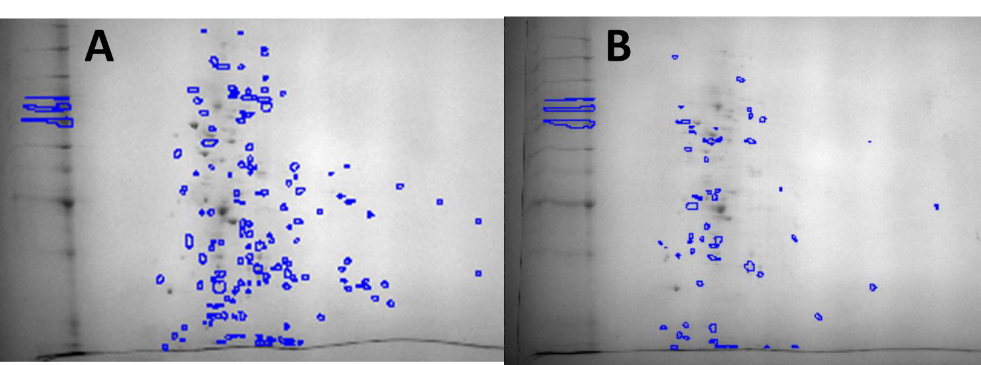
4
5
6 Supplementary Figure 1. 2D-PAGE gel of unique spots presents in protein exudates from A)

7 Vibrio fischeri ETJB1H planktonic cells and B) Vibrio fischeri ETJB1H biofilm cells. Circles

8 indicate the spots that are unique for each protein extraction. Spot detection revealed 271 spots

9 for the planktonic cells and 199 spots for biofilm cells. Using planktonic cells as the reference

10 profile, there were a total of 21 spots upregulated and 52 downregulated for the biofilm cells.

11
12
13
14

