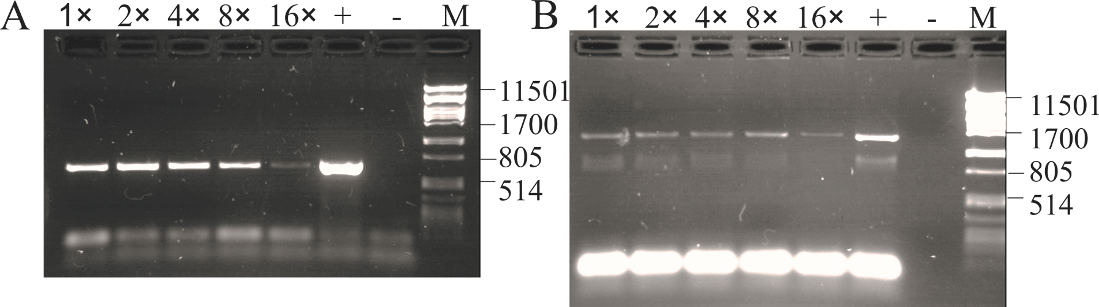

Additional File 5. Amplification of PCR products from (A) psaBA-IGS or (B) 16S rDNA gene locus from DNA extracted from one single Planktothrix filament and diluted 1-, 2-, 4-, 8-, and 16-fold using the Phire Hot Start Polymerase PCR buffer. M, PstI lambda DNA size marker. Positive control was amplified from P. agardhii NIVA-CYA126/8 (AJ441056).

