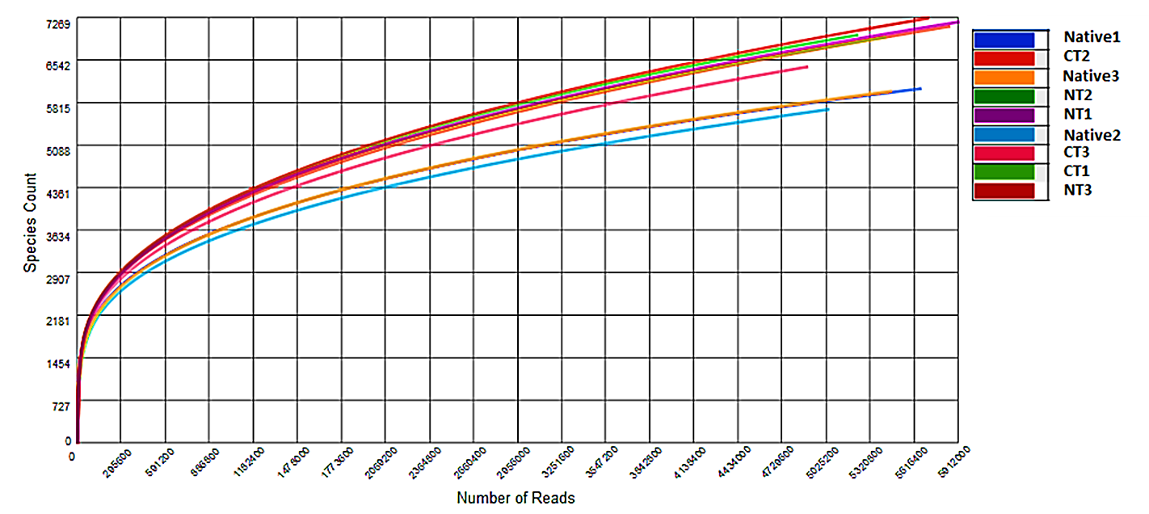
S1 Fig. Rarefaction curves generated with the MG-RAST software against M5NR database using normalized values between 0 and 1 for no-tillage (NT), conventional tillage (CT) and undisturbed Cerrado (Native) soil metagenomes.

S2 Fig. Sequence abundance orders of Betaproteobacteria compared to M5NR database using normalized values between 0 and 1 for no-tillage (NT), conventional tillage (CT) and undisturbed Cerrado (Native) soil metagenomes.

S3 Fig. Sequence abundance of phyla of Archaea Domain compared to M5NR database, and using normalized values between 0 and 1 for no-tillage (NT), conventional tillage (CT) and undisturbed Cerrado (Native) soil metagenomes.

S4 Fig. Sequence abundance of the phyla of Eukaryota Domain compared to M5NR database and using normalized values between 0 and 1 for no-tillage (NT), conventional tillage (CT) and undisturbed Cerrado (Native) soil metagenomes.

S5 Fig. Sequence abundance in the Viruses domain compared to M5NR database using normalized values between 0 and 1 for no-tillage (NT), conventional tillage (CT) and undisturbed (Native) soil metagenomes.

