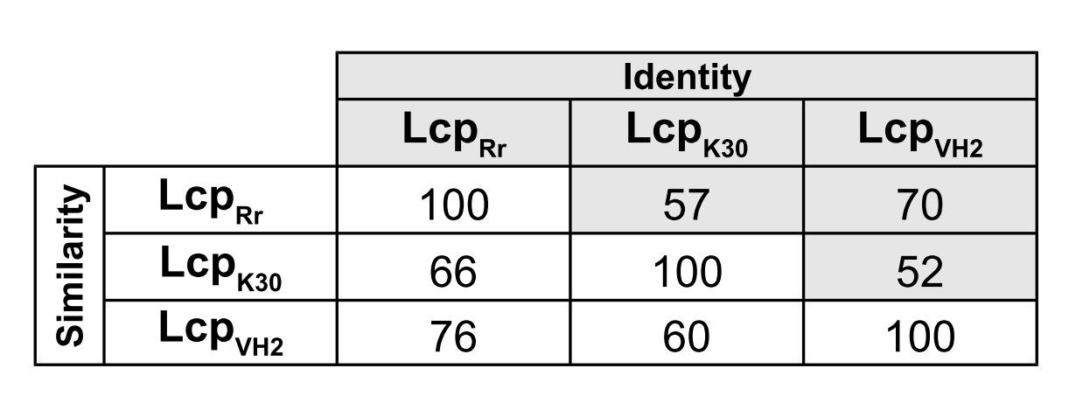
Additional file 1a: Identity and similarity of biochemically characterized Lcp proteins

Lcp_{Rr} -RPWRWSPAGSIPGTGSGADPRQVWDNEADPLVASLLERGDVPRVNELLRTWKKNSQPLP
Lcp_{K30} RPLWTWSPSASVAGTGVGVDPEYVWDEEADPVLAAVIDRGEVPAVNALLKQWTRNDQALP
Lcp_{VH2} ---------NSIPGVGTGADPRTIFDDEADQVIARVIDSGKVVEVNNLLNQWRTNSQPLP
*: *.* *.**. ::*:*** ::* ::: *.* ** **. * *.* **

Lcp_{Rr} EGLPNDLRDFMEHARQLPTWADPAKLETAVRFNEKRGLYLGVLYGFVSGMMSTVIPKEAL
Lcp_{K30} GGLPGDLREFMEHARRMPSWADKAALDRGAQFSKTKGIYVGALYGLGSGLMSTAIPRESR
Lcp_{VH2} AGLPPELRDFIEHARQLPSWTDRGKLAAAVRFNQRRGTYLGVLYGFASGMMSTVIPKEAR
*** :**:*:****::*:*:* . * ..:*.: :* *:*.***: **:***.**:*:

Lcp_{Rr} AVYYSKGGANMKGRISKTAKLGYDIGSRNAYLGDGEMIVTSVKTRLVHAAVRHLLPQSSH
Lcp_{K30} AVYYSKGGADMKDRIAKTARLGYDIGDLDAYLPHGSMIVTAVKTRMVHAAVRHLLPQSPA
Lcp_{VH2} AVYYSKGGWDLKDRISKTAKLGYDIGALNAYQPDGEMVVTCVKTRMAHAGVRHLLPKSAH
******** ::* **:***:****** :** .*.*:**.****:.**.******:*

Lcp_{Rr} WSNMA-PEDVPISQHDMMVTWHSLPTSVMRTLKEWKVPIPAAEADGFLHSWQVSAHMLGI
Lcp_{K30} WSQTSGGQKIPISQADIMVTWHSLATFVMRKMKQWGVRVNTADAEAYLHVWQVSAHMLGV
Lcp_{VH2} WVRSA-PEEKPISQADIMVTWHSLPTTVMRNLEKWKVPLPADESEGFLHSWQVTAAMLGV
* . : :. **** *:******* * ***.:::* * : : :::.:** ***:* ***:

Lcp_{Rr} EDQYIPATWDDAESQAQEALDPILAPTPEGVKLADMLLDLGKGLDFTLLTRPILGALTRF
Lcp_{K30} SDEYIPATWDAANAQSKQVLDPILAHTPEGEALTEVLLGIVAELDAG-LTRPLIGAFSRY
Lcp_{VH2} QDQYIPNSWATADSQAKQVLDPILAWTPEGQKLADMLLDLGMDLDLTLLSRPILGALTRF
.*:*** :* *::*:::.****** **** *:::** : ** *:**::**::*:

Lcp_{Rr} ALGDEIADWLNIPREPVWGTLLDVAWGPFIAVREGLLPLPLAPDAYWTFDELLRQFVLLY
Lcp_{K30} TLGGEVGDMIGLAKQPVLERLIATAWPLLVAFREGLIPLPAVPAVLWTLEEALRKFVLLF
Lcp_{VH2} MLGDKIADWLHIPREPVWTPLLETAWGPYVAVREGLLNAGLPRETYWLFDEFLRQFVLFY
** ::.* : : ::** *: .** :*.****: . * ::* **:***::

Lcp_{Rr} MSELR-PISIEIPEYNNPNYP
Lcp_{K30} LSEGR-RIAIDIPDVNRPS--
Lcp_{VH2} MAELRMPISIQIPYFNNPNYN
::* * *:*:** *.*.

Additional file 1b: Amino acid sequence alignment of biochemically characterized Lcp proteins (without signal peptide sequences). Asterics, colons and dots indicate identical or similar residues, respectively

