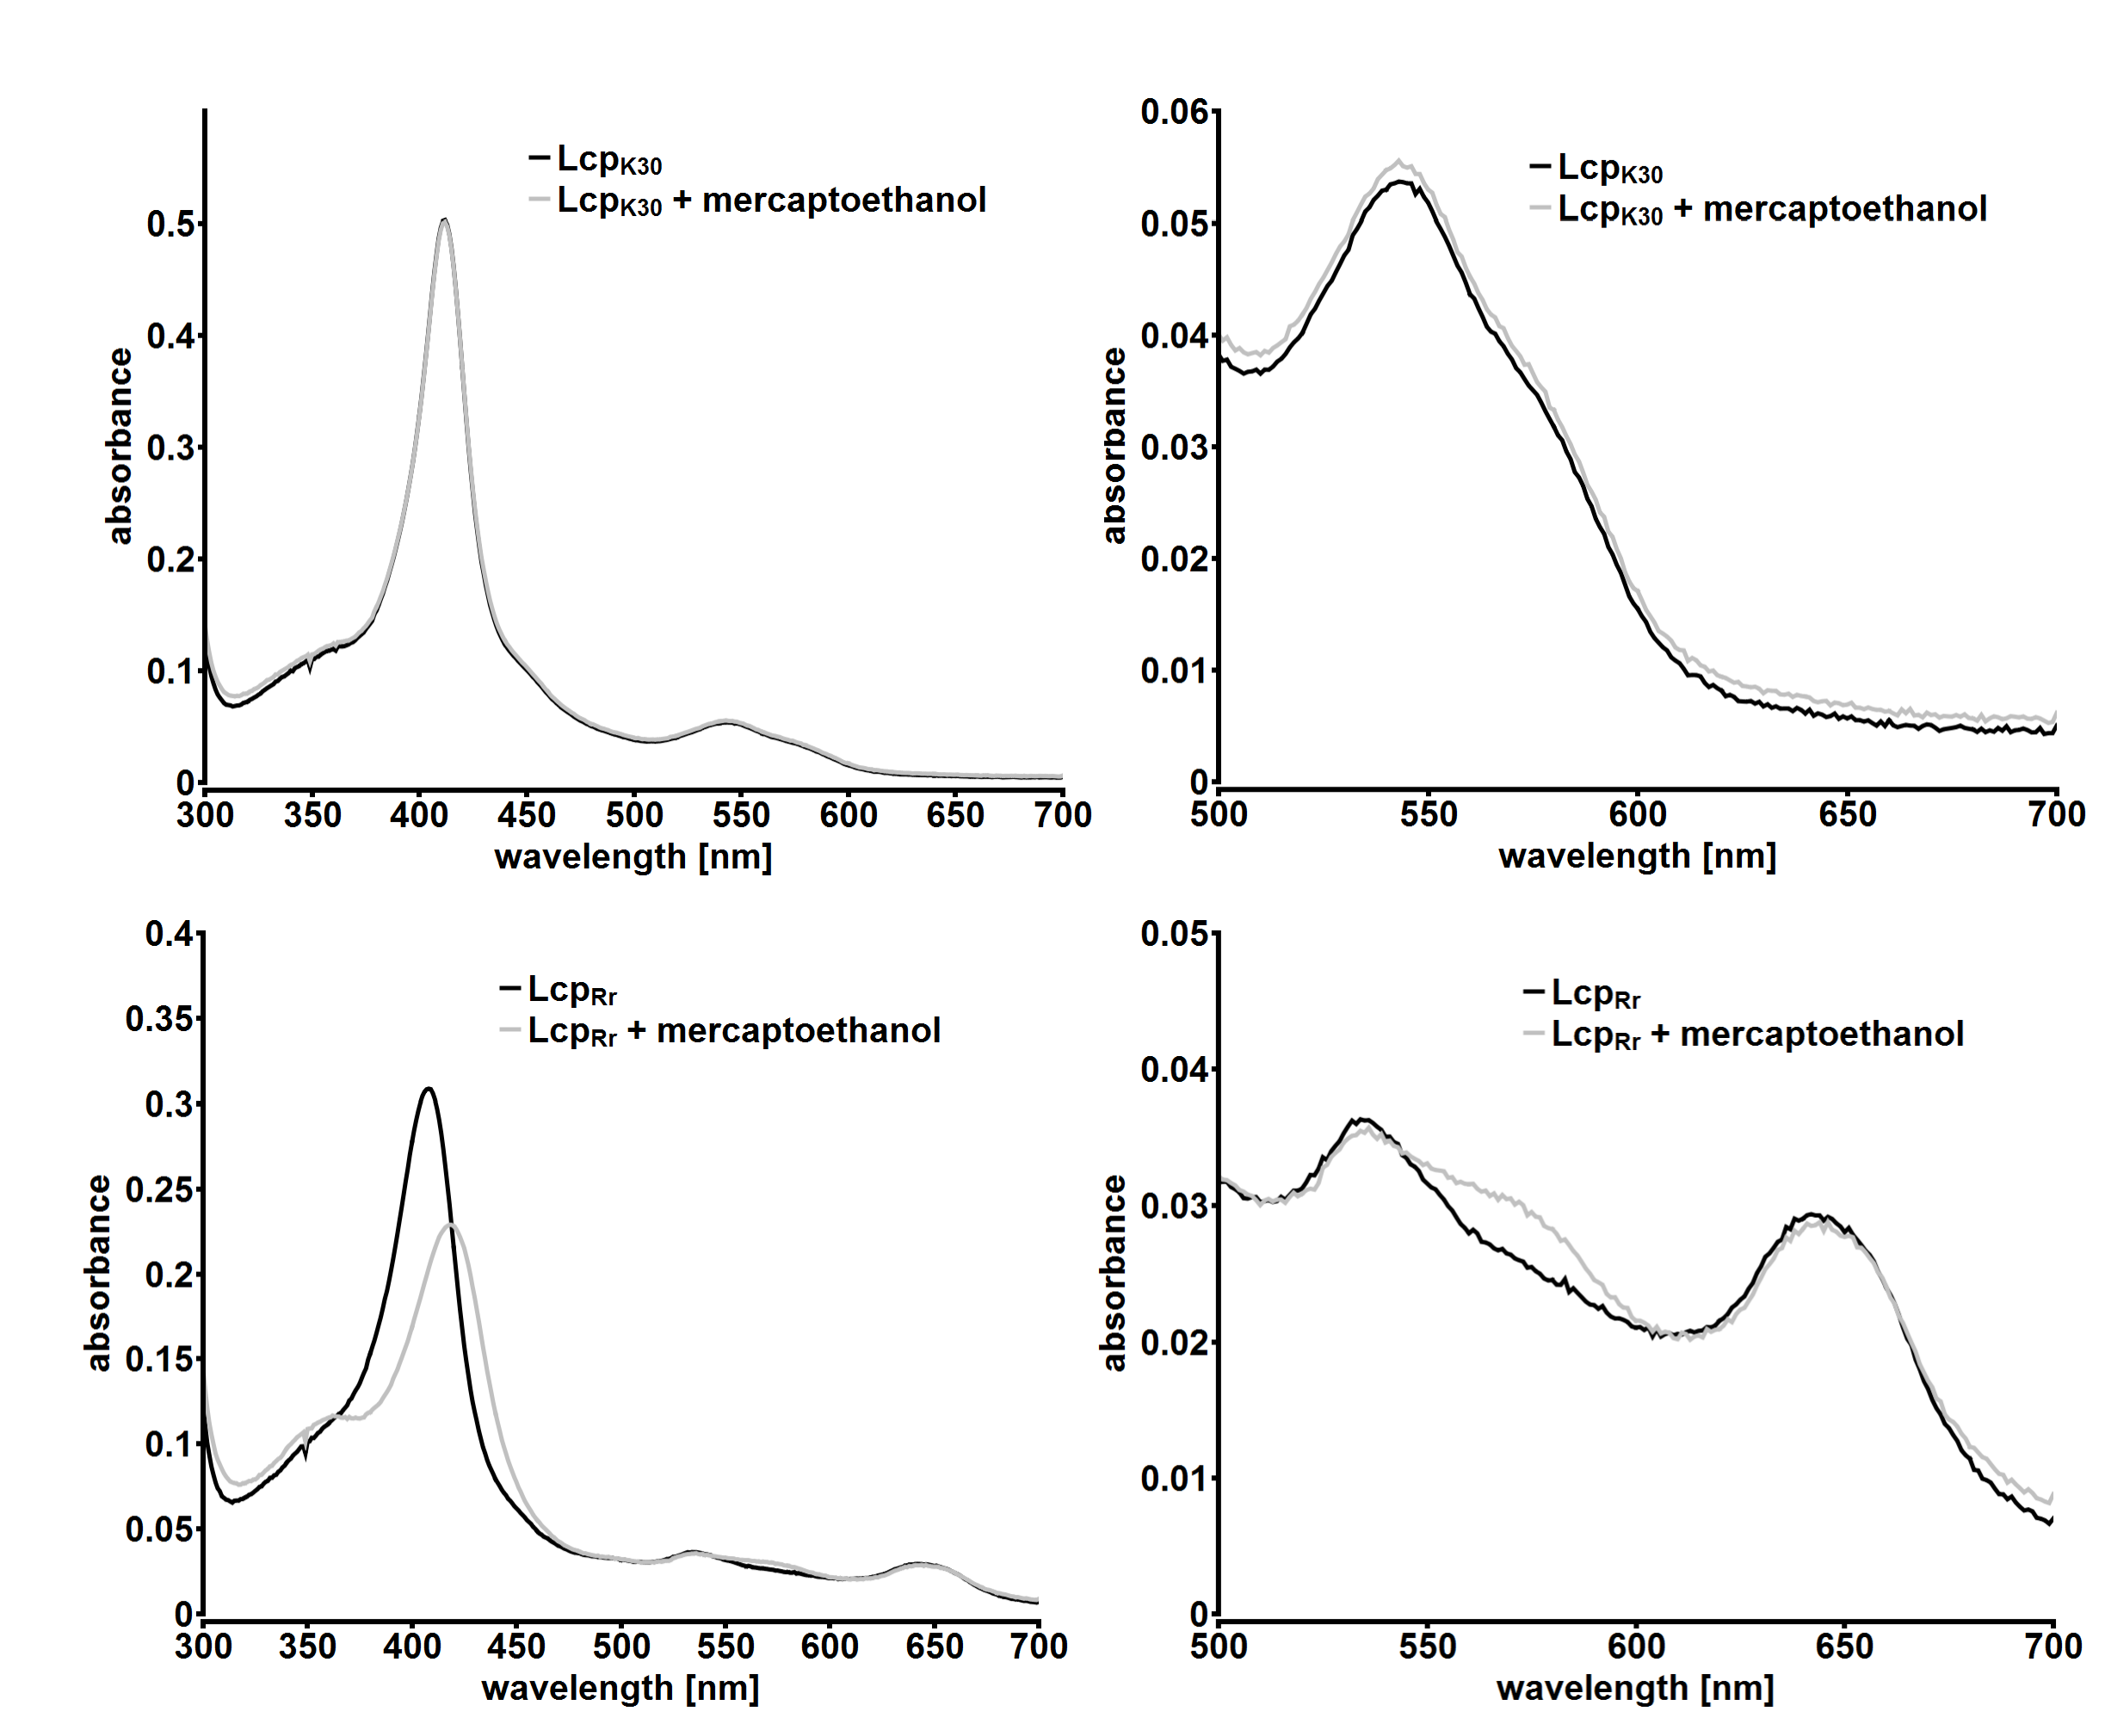

Additional file 4: UVvis spectra of Lcp_{K30} and Lcp_{Rr} in the presence of mercaptoethanol. Note, a change of the spectrum in the presence of mercaptoethanol only in case of Lcp_{Rr} but not in case of Lcp_{K30.}

