Rarefaction curves of different solid waste on the municipal dumpsite
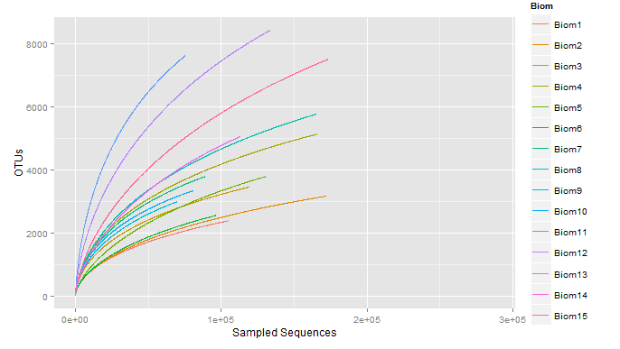  (a) | 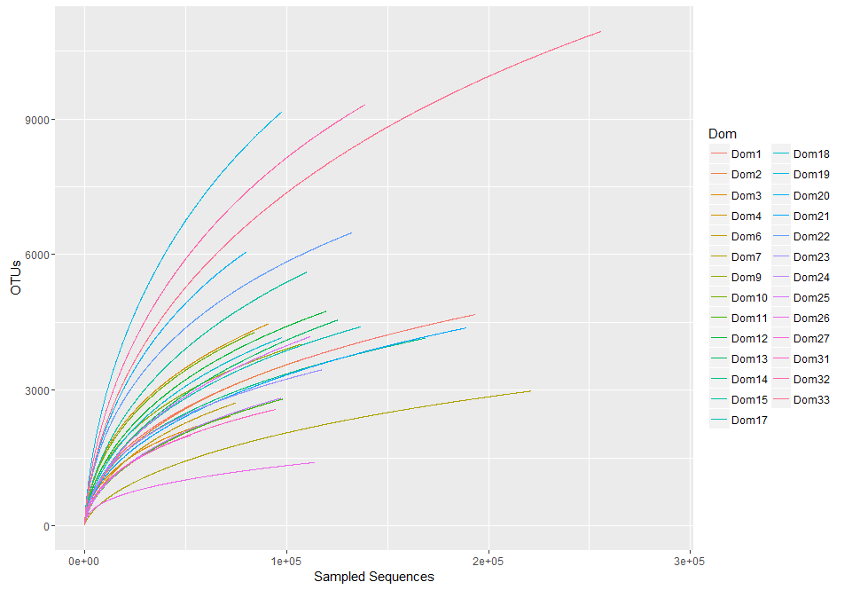  (b)
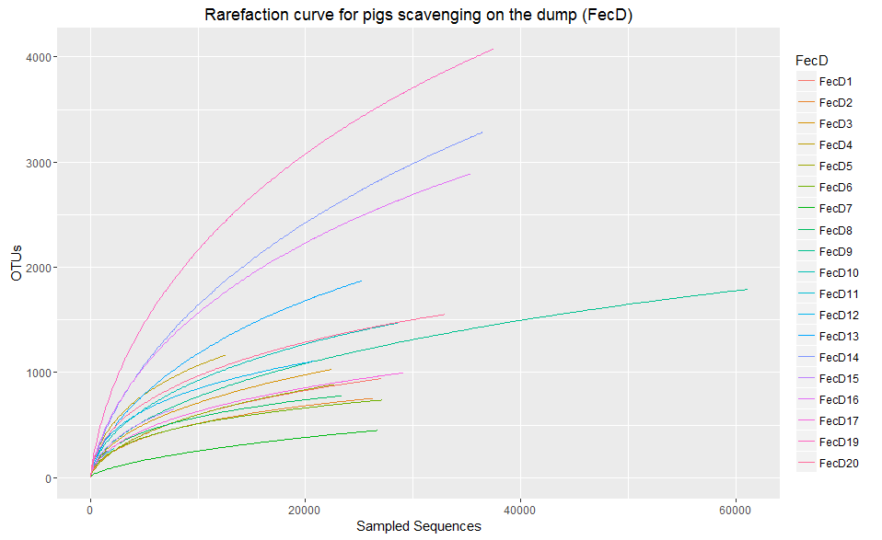  (c) | 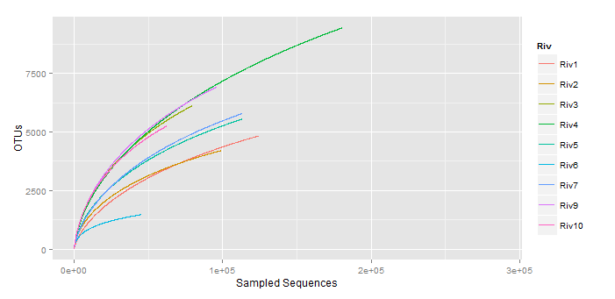  (d)
Figure S1: Rarefaction analysis of the different solid waste. Estimation of OTUs was done at 97% sequence similarity cut-off. (a) Represent solid biomedical waste, (b) domestic waste (c) faecal material of pigs scavenging on dumpsite and (d) river sludge near the municipal dumpsite. No subsampling was done to any type of solid waste.

