Heatmap showing abundance and distribution of predominant bacteria phyla from different solid waste
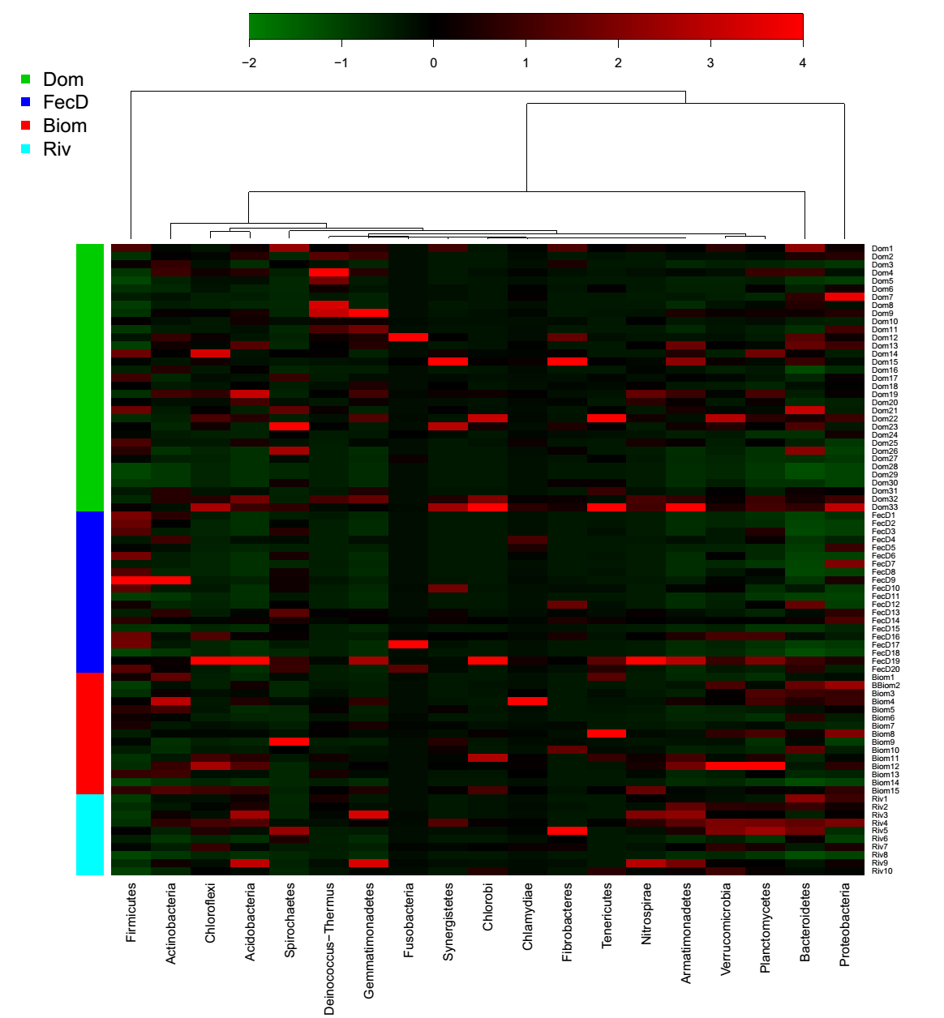
Figure S1: Heatmap showing abundance and distribution of predominant bacteria phyla from different types of solid waste. Taxa were assigned at 97% 16S rRNA sequence similarity. The abundance of each phylum is indicated by a different colour as shown in key.

