OTU based dendrogram demonstrating the similarity and differences of bacteria communities’ structure and membership from different solid wastes.
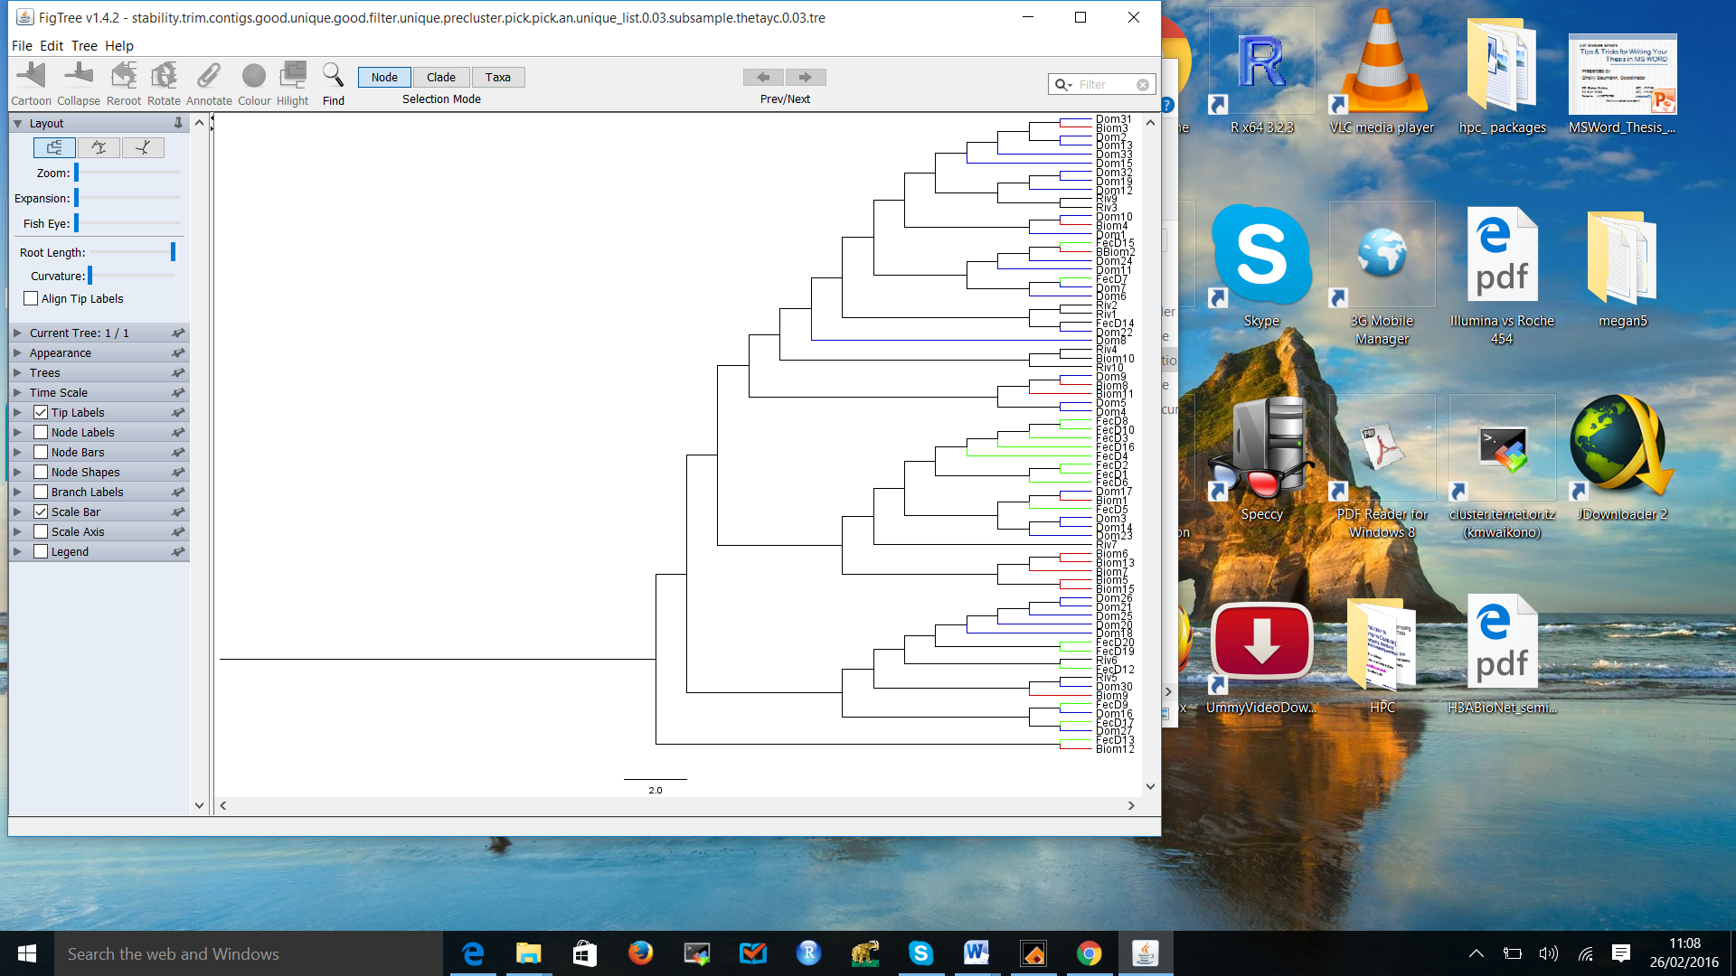
Figure S1 (a): OTU based dendrogram demonstrating the similarity and differences of the bacterial community structure from different types of solid waste. The dendrogram is based on Yue & Clayton indices.
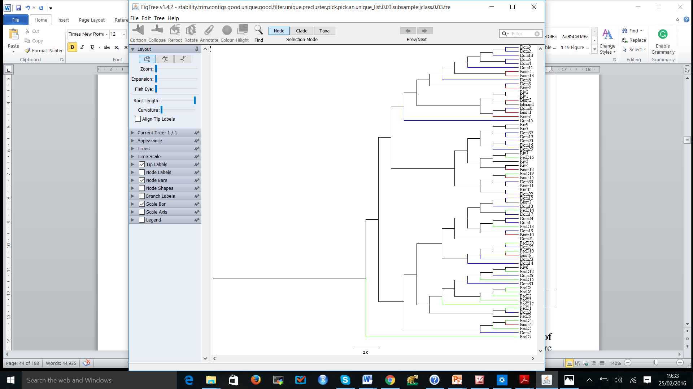 Figure S1 (b): OTU based dendrogram demonstrating the similarity and differences of the bacterial community membership from different solid wastes. The dendrogram is based on traditional Jaccard index

