Additional File 1
Legionella effector AnkX interacts with host nuclear protein PLEKHN1

Xiaobo Yu^{1†}, Rebecca R. Noll^{2†}, Barbara P. Romero Dueñas, Samual C. Allgood², Kristi Barker³, Jeffrey L. Caplan^{2,5}, Matthias P. Machner⁴, Joshua LaBaer³,
Ji Qiu³*, M. Ramona Neunuebel²*

¹ State Key Laboratory of Proteomics, Beijing Proteome Research Center, National Center for Protein Sciences-Beijing (PHOENIX Center), Beijing Institute of Radiation Medicine, Beijing, 102206, China
² Department of Biological Sciences, University of Delaware, Newark, Delaware, USA, 19716
³Virginia G. Piper Center for Personalized Diagnostics, Biodesign Institute, Arizona State University, Tempe, Arizona, USA, 85287
⁴ Eunice Kennedy Shriver National Institute of Child Health and Human Development, National Institutes of Health, Bethesda, Maryland, USA, 20892
⁵ Delaware Biotechnology Institute, Newark, Delaware, USA, 19711

Running title: Novel human targets of the L. pneumophila effector AnkX

†X.Y. and R.R.N. contributed equally to this work.

To whom correspondence should be addressed:

*Dr. Ji Qiu
Arizona State University
Tempe, AZ, 85287
Tel: +1 480 9652805
E-mail: ji.qiu@asu.edu

*Dr. M. Ramona Neunuebel
Department of Biological Sciences
University of Delaware
105 The Green, Newark, DE 19716
Tel: +1 302 8313450
E-mail: neunr@udel.edu

Table S1. Microbial strains and plasmids used in this study
Strain or plasmid | Relevant features | Source or reference
E. coli strains
GC5 | F− ϕ80lacZΔM15 Δ(lacZYA-argF)U169 recA1 endA1 hsdR17(rK− mK+) phoA supE44 thi-1 gyrA96 relA1λ−tonA | Genesee
KRX | [F´, traD36, ΔompP, proA⁺B⁺, lacIq, Δ(lacZ)M15] ΔompT, endA1, recA1, gyrA96 (Nal^{r}), thi-1, hsdR17 (r_{k}–, m_{k}⁺), e14– (McrA–), relA1, supE44, Δ(lac-proAB), Δ(rhaBAD)::T7 RNA polymerase | Promega
BL21(DE3) | F⁻ompT hsdS_{B}(r_{B}⁻ m_{B}⁻) gal dcm(DE3) | ThermoFisher Scientific
Plasmids
pcDNA6.2N/EmGFP-DEST | Encodes GFP; Cam^{r}, Amp^{r} | Life Technologies
362 pCS-Cherry-DEST | Encodes mCherry; Cam^{r}, Amp^{r} | Addgene
pDON221-cPLEKHN1 | Encoding PLEKHN1; Kan^{r} | http://dnasu.org
pcDNA6.2N/EmGFP-DEST-cPLEKHN1 | Encoding GFP-PLEKHN1 (human); Amp^{r} | This study
pFN22K HaloTag® CMVd1 Flexi® | Encodes HaloTag; Kan^{r} | Promega
pFN22K HaloTag CMVd1 Flexi-ankX | Encodes HaloTag-AnkX; Kan^{r} | [1]
362 pCS-Cherry-DEST-ankX₁₋₁₄₀ | Encoding mCherry-tagged AnkX fragment (aa 1-140); Amp^{r} | [1]
362 pCS-Cherry-DEST-ankX₄₉₁₋₈₀₉ | Encoding mCherry-tagged AnkX fragment (aa 491-809); Amp^{r} | [1]
362 pCS-Cherry-DEST-ankX₈₁₀₋₉₄₉ | Encoding mCherry-tagged AnkX fragment (aa 810-949); Amp^{r} | [1]
pFN22K HaloTag CMVd1 Flexi-ankX_{H229A} | Encodes HaloTag-AnkX_{H229A}; Kan^{r} | This study
pJFT7_cHalo | Mammalian cell-free expression vector for C-terminal HaloTag fusion; Amp^{r} | [2]
pFN22K HaloTag CMVd1 Flexi-cPLEKHN1 | Encodes HaloTag-PLEKHN1; Kan^{r} | This study
Abbreviations: Kan^{r}, kanamycin resistance; Amp^{r}, ampicillin resistance; Cam^{r}, chloramphenicol resistance.
Table S2. List of oligonucleotides used for this study.
Name | Sequence 5’ to 3’ direction
Fw-SgfI-PLEKHN1 | CTAAGCGATCGCCATGGGGAACAGCCACTGTG
Rv-PmeI-PLEKHN1 | GCCGGTTTAAACTCAGATCCACTGCACAAGCC
Fw-AnkX H229A | CATATTCGAATGTACGAAGTATTAGCCCCTTTTCGA
Rv-AnkX H229A | TCGAAAAGGGGCTAATACTTCGTACATTCGAATATG

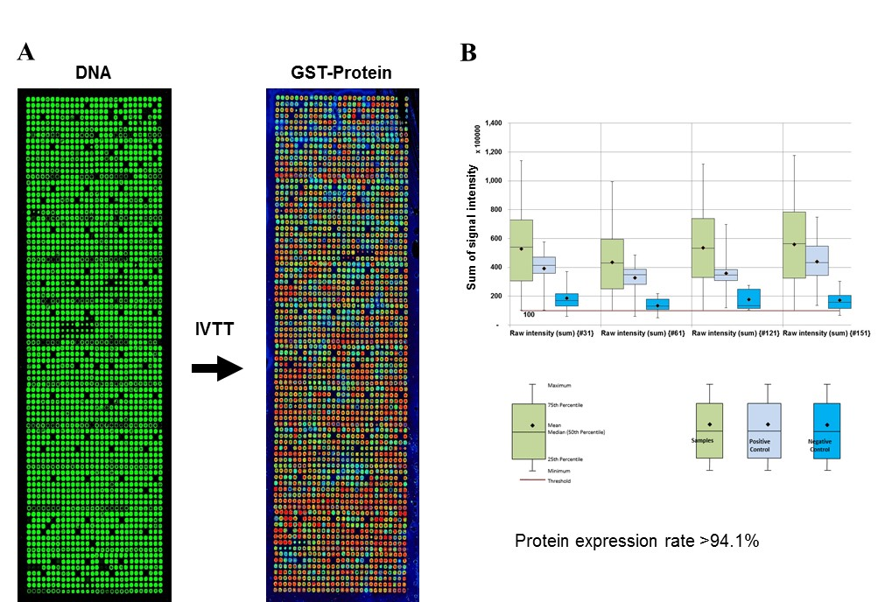
Figure 3. Quality of NAPPA arrays in protein production. (A) Representative images of DNA PicoGreen and GST staining before and after in vitro DNA transcription and translation. (B) Distribution of fluorescent signal intensity of proteins on NAPPA microarrays. The expression rate of proteins that were displayed on NAPPA was calculated by using the signals of nonspots (buffer) plus two standard deviations.

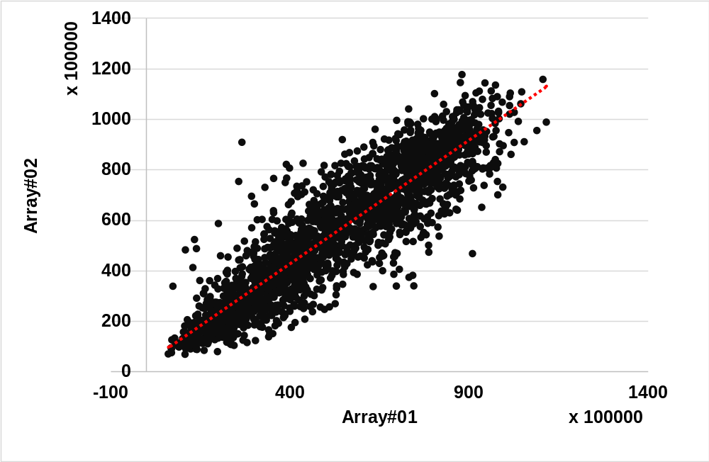
Additional file 1. Correlation of NAPPA protein microarrays. The array contains 2,206 human genes. The GST-proteins displayed on NAPPA were detected by mouse anti-GST antibody followed by HRP labeled goat anti-GST secondary antibody.

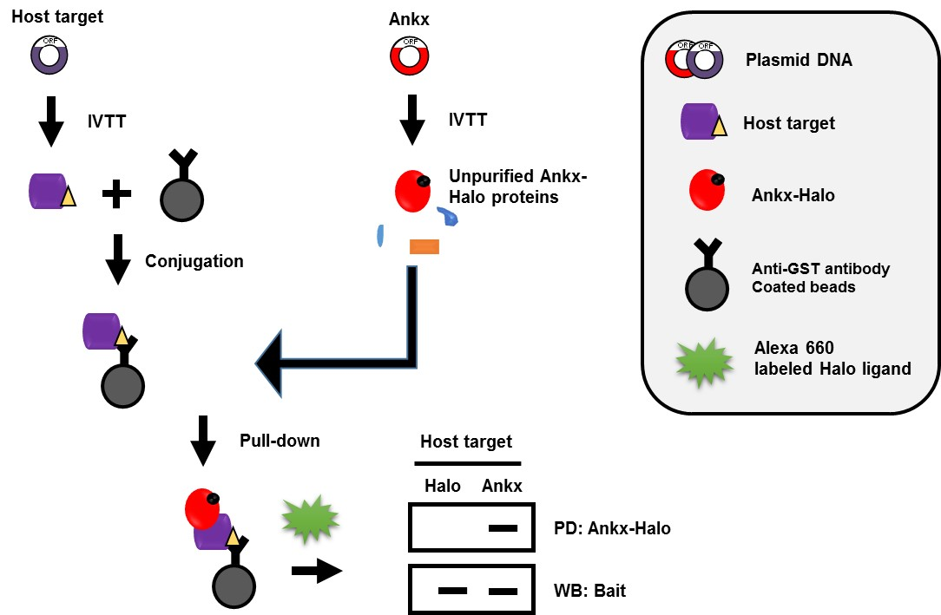
Additional file 1. Workflow of bead-based pull-down assay used in the validation of protein-protein interactions.

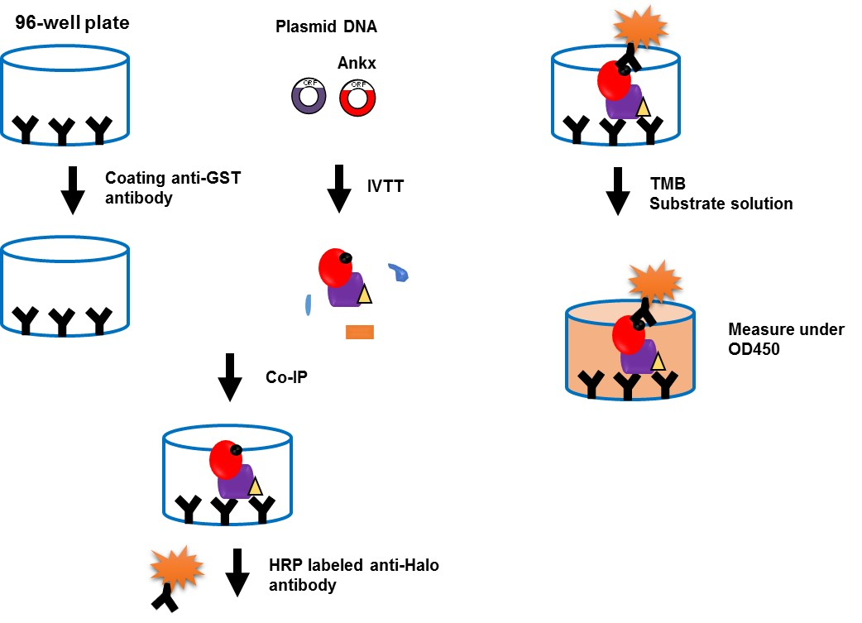
Additional file 1. Workflow of wNAPPA approach used for the validation of protein-protein interactions.

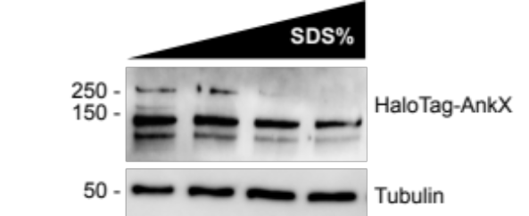

Additional file 1. Increasing SDS concentrations disrupt AnkX dimer formation. HEK293T cells ectopically producing HaloTag-AnkX were lysed and the post-nuclear supernatant (PNS) was collected. The PNS was incubated with increasing amounts of SDS (1.38, 1.72, 2.05, and 2.38%) in Laemmli buffer for 5 minutes at 80°C.
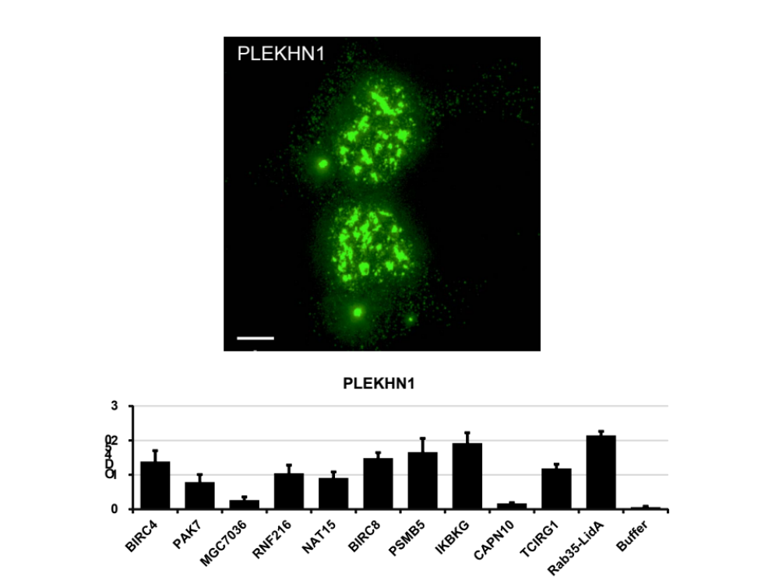
Additional file 1. Representative SR-SIM maximum-intensity projection image displaying immunofluorescence of endogenous PLEKHN1. The subcellular distribution of PLEKHN1 is predominantly nuclear. PLEKHN1 is also found as puncta dispersed throughout the cytosol and a larger vesicular structure. Scale bar: 10 µm

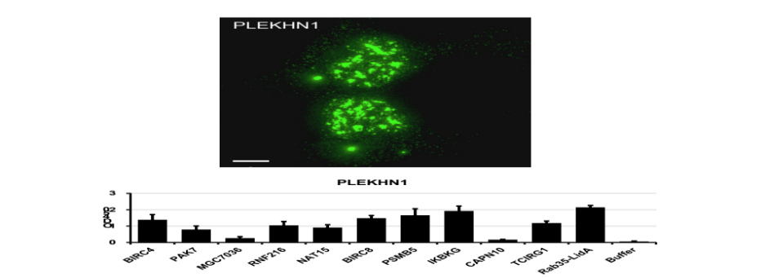

Additional file 1. PLEKHN1 interaction candidates revealed by wNAPPA. PLEKHN1 fused with a C-terminal HaloTag were co-produced with their interaction proteins using human cell-free expression system. The resulting protein complexes were captured by an anti-GST antibody-coated ELISA plate, and retention of AnkX-HaloTag was detected immunologically. These interaction proteins were selected based on the signal-to-noise ratio above 3. The HaloTag was used as a negative control. The Rab35 and LidA was employed as a positive control.

1. Allgood SC, Romero Dueñas BP, Noll RR, Pike C, Lein S, Neunuebel MR: Legionella effector AnkX disrupts host cell endocytic recycling in a phosphocholination-dependent manner Frontiers in Cellular and Infection Microbiology 2017, 8.
2. Yu X, Decker KB, Barker K, Neunuebel MR, Saul J, Graves M, Westcott N, Hang H, LaBaer J, Qiu J et al: Host-pathogen interaction profiling using self-assembling human protein arrays. J Proteome Res 2015, 14(4):1920-1936.

