Supplementary Data
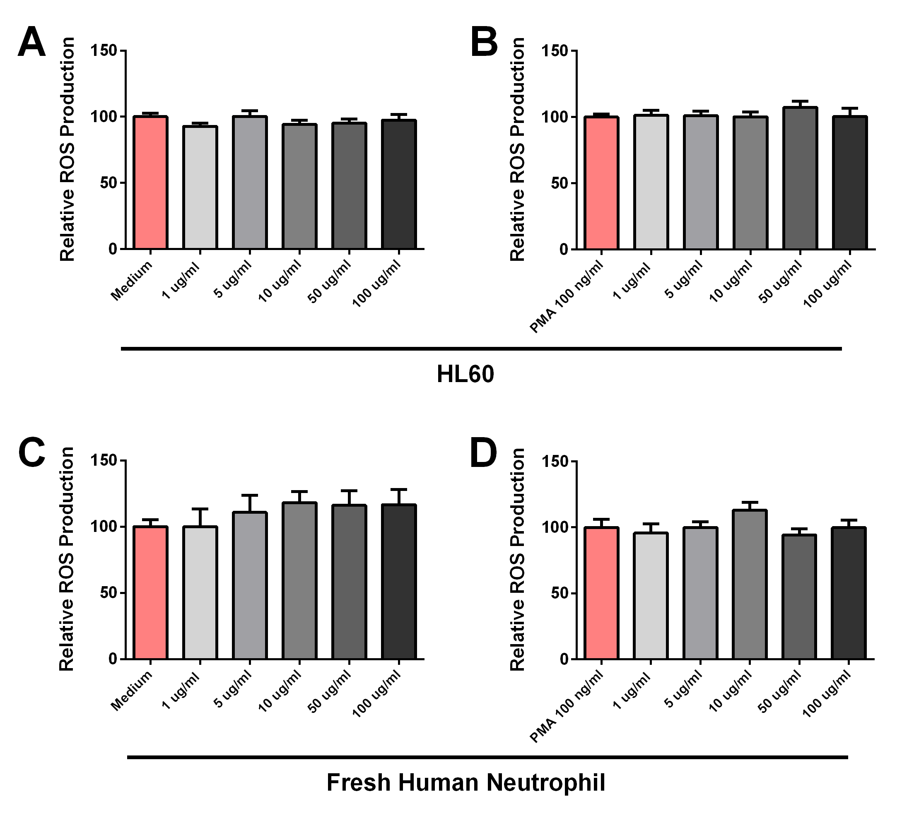
Additional file 1: Figure S1 – Relative Oxidative Burst Activity Of Differentiated HL-60 Human Neutrophils and Freshly Isolated Human Neutrophils. Neutrophils were stimulated for 90 minutes with or without additional PMA stimulation after which reactive oxygen species production was measured. Experiments were often repeated and are depicted as reactive oxygen production relative to medium control (A; HL-60 cells, C; freshly isolated neutrophils) or relative to PMA (1 ng.ml⁻¹) stimulated samples (B; HL-60 cells, D; freshly isolated neutrophils from two donors). Data is shown as average ± SD. Differences were considered statistically significant when p < 0.05 (*), p < 0.01 (**) or p < 0.001 (***).

Additional file 1: Table S1 – Origins of Strains.
Species | Strain | Origin
Lactobacillus reuteri | APC 2587 | Human
Lactobacillus mucosae | DPC 6418 | Bovine
 | DPC 6420 | Bovine
 | DPC 6425 | Bovine
 | DPC 6426 | Bovine

Additional file 1: Table S2 – Full Bile Deconjugation Experiment Profile. Full quantitative list of bile acids in MRS supplemented with murine or porcine bile untreated, or cultured with APC 2587 or DPC 6426. Data represent the mean ng/ml. Italics indicates significant different (p < 0.05) from the untreated bile concentration.
