Supplementary Material

Efficacy of bacteriophage treatment against carbapenem-resistant Acinetobacter baumannii in Galleria mellonella larvae and a mouse model of acute pneumonia

1. Supplementary Methods

Phage adsorption and one-step growth kinetic test

The adsorption rate and one-step growth kinetics of phage Bϕ-R2096 were performed as previously described with some modification [1, 2]. For the adsorption rate test, the host bacterial suspension (10⁵ CFU/ml) was mixed with the phage solution at MOI=0.01 and incubated at 37°C. Samples of the mixture (100 μl) were taken at 1, 2, 3, 4, 5, and 10 min and centrifuged immediately (12,000×g, 10 min). The supernatants were used determine the titer of unadsorbed phages using the double-layer agar plate method. For the one-step growth curve test, 40 μl of phage solution (10⁴ PFU/ml) was added to 4 ml of bacterial suspension (10⁵ CFU/ml) and incubated at 37°C for 5 min. The mixture was centrifuged (12,000×g, 10 min), and the supernatant, which included the unadsorbed phages, was removed. Then the pellets were resuspended in fresh LB medium of the same volume. Subsequently, culture samples were taken every 5 min for 120 min. The samples were immediately diluted and plated using the double-layer agar plate method. The agar plates were incubated for phage titration overnight at 37°C.

Thermal and pH stability testing

The thermal and pH stability of the phage were determined using the double-layer agar method [3]. To evaluate the thermal stability, a concentrated phage solution (1.7×10⁹ PFU/ml) was incubated at 25°C, 40°C, 50°C, 60°C, and 70°C for 3 h, 6 h, and 9 h. To evaluate the pH stability, buffers at pH 4, 5, 6, 7, 7.5, 8, 9, and 10 were used, and the phage titer was measured on days 1, 3, 6, 1 month, and 10 months. The initial control titer (4°C, pH 7.5) was used for comparison with each sample titer, and the data are represented as a percentage of the phage titer (PFU/ml).

Measurement of cytokines

The level of tumor necrosis factor alpha (TNF-α) interleukin 6 (IL-6), and interleukin 1β (IL-1β) in lung lysates was measured using the commercial DuoSet kit (R&D Systems, Inc., USA) as specified by the manufacturer.
2. Supplementary Figures and Table

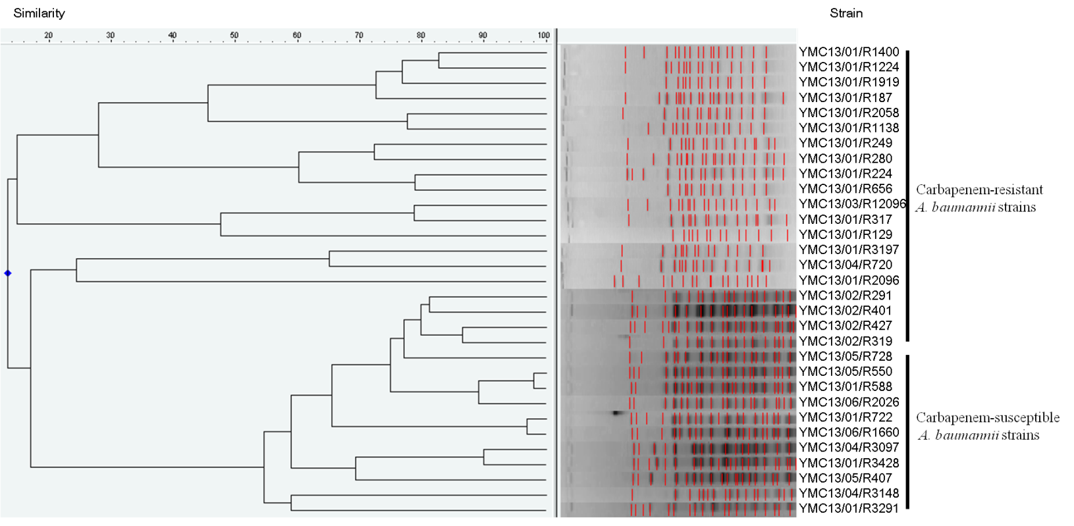
Figure S1. Pulsed-field gel electrophoresis (PFGE) analysis of 31 carbapenem-resistant and -susceptible A. baumannii isolates. XbaI-restricted DNA from A. baumannii isolates was separated by PFGE using a CHEF-DR II system (electrophoresis conditions: 1% agarose; 6 V/cm; high 10 s and low 3 s in a linear manner for 20 h; Bio-Rad, Hercules, CA). The similarity dendrogram of the PFGE patterns of A. baumannii isolates was analyzed using InfoQuest FP software (version 4.50, Bio-Rad Laboratories, Inc).

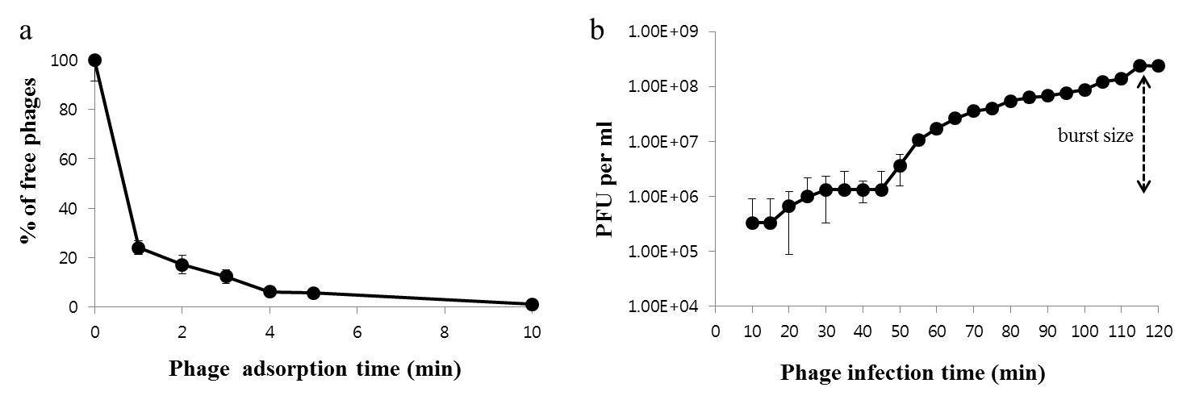
Figure S2. The adsorption rate (A) and one-step growth curve (B) of A. baumannii phage Bϕ-R2096 on A. baumannii strain YMC13/03/R2096. Data on phage adsorption showed that 83% of the phage was adsorbed on the host bacteria after 2 min. Mean ± standard deviation data are from triplicate experiments (A). The results show that the latent period was approximately 50 min, and the burst size was about 142 PFU/ml after 115 min (B).

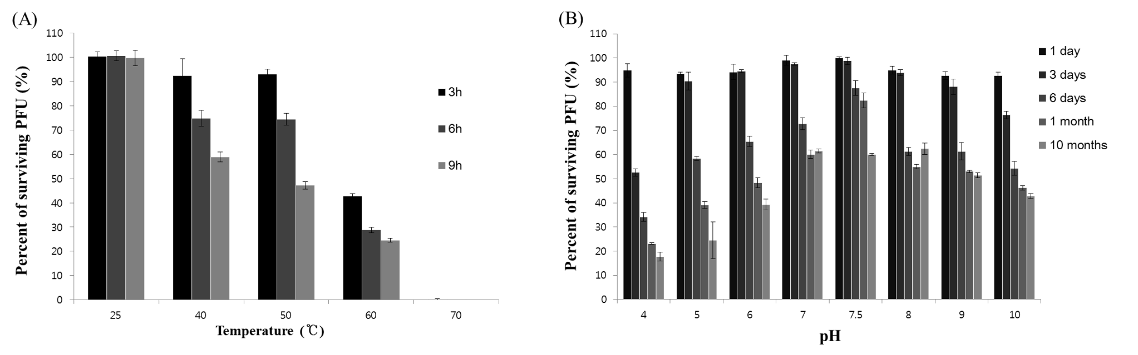
Figure S3. Temperature and pH stability of A. baumannii phage Βφ-R2096 on A. baumannii strain YMC13/03/R2096. Phages were incubated for 3, 6, and 9 h at 25°C, 40°C, 50°C, 60°C, and 70°C, and stability was calculated as the percentage of surviving phages (A). Phages were incubated at pH 4–10 for 1, 3, and 6 days, 1 month, and 10 months at 4°C, and stability was calculated as the percentage of surviving phages (B). The results shown are mean ± standard deviation.

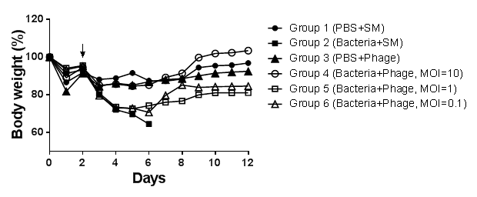

Figure S4. Body weight of C57BL/6 mice infected with A. baumannii phage Bϕ-R2096, A. baumannii YMC13/03/R2096, or both. Group 1 (control): PBS+SM buffer treatment; Group 2: bacteria-only-treatment; Group 3: phage-only-treatment; Groups 4–6: postinfection phage treatment (MOI 0.1, 1, 10) 30 min after bacterial infection. Body weights were measured daily. The black arrow indicates a second cyclophosphamide (CP) administration and the first bacterial infection. Values given are averages (n = 6 mice)

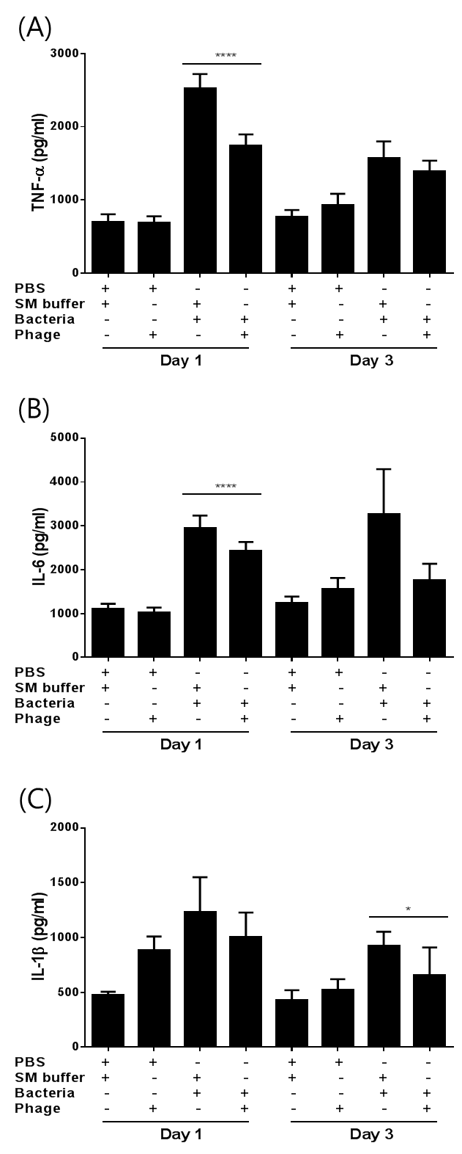
Figure S5. The concentration of cytokines (TNF-α, IL-6, and IL-1β) in the lungs of mice on days 1 and 3 after treatment with A. baumannii YMC13/03/R2096, phage Bϕ-R2096, or both. The one-way ANOVA with Tukey`s multiple comparisons test was used to compare the cytokine levels. Significant differences (****p<0.0001) were observed on each day.

Table S1. Antibiotic resistance profiles of carbapenem-resistant A. baumannii clinical strains used in this studyª
Host stain | MLST^{b} | OTC^{c} | MHT^{d} | Amikacin | Ampicillin/  Sulbactam | Ceftazidime | Colistin | Cefepime | Cefotaxime | Gentamicin | Imipenem | Levofloxacin | Meropenem | Minocycline | Piperacillin/  Tazobactam | Cotrimoxazole | Tigecycline
YMC13/03/R2096 | 357 | OXA-66-like | + | ≥64 (R) | ≤16 (I) | ≥64 (R) | ≤0.5 (S) | ≥64 (R) | ≥64 (R) | ≥16 (R) | ≥16 (R) | ≥8 (R) | ≥16 (R) | ≤8 (I) | ≥128 (R) | ≥320 (R) | ≤2 (S)
YMC13/01/R1400 | 357 | OXA-66-like | + | ≥64 (R) | ≥32 (R) | ≥64 (R) | ≤0.5 (S) | ≥64 (R) | ≥64 (R) | ≥16 (R) | ≥16 (R) | ≥8 (R) | ≥16 (R) | ≤8 (I) | ≥128 (R) | ≥320 (R) | ≤1 (S)
YMC13/01/R1224 | 357 | OXA-66-like | + | ≥64 (R) | ≥32 (R) | ≥64 (R) | ≤0.5 (S) | ≥64 (R) | ≥64 (R) | ≥16 (R) | ≥16 (R) | ≥8 (R) | ≥16 (R) | ≤4 (S) | ≥128 (R) | ≥320 (R) | ≤1 (S)
YMC13/01/R1919 | 357 | OXA-66-like | + | ≥64 (R) | ≥32 (R) | ≥64 (R) | ≤0.5 (S) | ≥64 (R) | ≥64 (R) | ≥16 (R) | ≥16 (R) | ≥8 (R) | ≥16 (R) | ≤4 (S) | ≥128 (R) | ≥320 (R) | ≤1 (S)
YMC13/01/R187 | 357 | OXA-66-like | + | ≤8 (S) | ≥32 (R) | ≥64 (R) | ≤0.5 (S) | ≥64 (R) | ≥64 (R) | ≤2 (S) | ≥16 (R) | ≥8 (R) | ≥16 (R) | ≤8 (I) | ≥128 (R) | ≥320 (R) | ≤2 (S)
YMC13/01/R2058 | 357 | OXA-66-like | + | ≥64 (R) | ≤8 (S) | ≥64 (R) | ≤0.5 (S) | ≥64 (R) | ≥64 (R) | ≥16 (R) | ≥16 (R) | ≤4 (I) | ≥16 (R) | ≤4 (S) | ≥128 (R) | ≥320 (R) | ≤1(S)
YMC13/02/R1138 | 357 | OXA-66-like | + | ≥64 (R) | ≤16 (I) | ≥64 (R) | ≤0.5 (S) | ≥64 (R) | ≥64 (R) | ≥16 (R) | ≥16 (R) | ≥8 (R) | ≥16 (R) | ≤8 (I) | ≥128 (R) | ≥320 (R) | ≤2 (S)
YMC13/01/R249 | 357 | OXA-66-like | + | ≤8 (S) | ≥32 (R) | ≥64 (R) | ≤0.5 (S) | ≥64 (R) | ≥64 (R) | ≤4 (S) | ≥16 (R) | ≥8 (R) | ≥16 (R) | ≤8 (I) | ≥128 (R) | ≥320 (R) | ≤1(S)
YMC13/01/R280 | 357 | OXA-66-like | + | ≤8 (S) | ≥32 (R) | ≥64 (R) | ≤0.5 (S) | ≥64 (R) | ≥64 (R) | ≤1 (S) | ≥16 (R) | ≥8 (R) | ≥16 (R) | ≤4 (S) | ≥128 (R) | ≥320 (R) | ≤2 (S)
YMC13/01/R224 | 357 | OXA-66-like | + | ≥64 (R) | ≤8 (S) | ≥64 (R) | ≤0.5 (S) | ≥64 (R) | ≥64 (R) | ≥16 (R) | ≥16 (R) | ≤4 (I) | ≥16 (R) | ≤8 (I) | ≥128 (R) | ≥320 (R) | ≤1(S)
YMC13/01/R656 | 357 | OXA-66-like | + | ≥64 (R) | ≥32 (R) | ≥64 (R) | ≤0.5 (S) | ≥64 (R) | ≥64 (R) | ≥16 (R) | ≥16 (R) | ≥8 (R) | ≥16 (R) | ≤4 (S) | ≥128 (R) | ≥320 (R) | ≤2 (S)
YMC13/03/R12096 | 357 | OXA-66-like | + | ≥64 (R) | ≥32 (R) | ≥64 (R) | ≤0.5 (S) | ≥64 (R) | ≥64 (R) | ≥16 (R) | ≥16 (R) | ≥8 (R) | ≥16 (R) | ≤8 (I) | ≥128 (R) | ≥320 (R) | ≤1 (S)
YMC13/01/R317 | 357 | OXA-66-like | + | ≥64 (R) | ≥32 (R) | ≥64 (R) | ≤0.5 (S) | ≥64 (R) | ≥64 (R) | ≥16 (R) | ≥16 (R) | ≥8 (R) | ≥16 (R) | ≤8 (I) | ≥128 (R) | ≥320 (R) | ≤2 (S)
YMC13/01/R129 | 357 | OXA-66-like | + | ≥64 (R) | ≤8 (S) | ≥64 (R) | ≤0.5 (S) | ≥64 (R) | ≥64 (R) | ≥16 (R) | ≥16 (R) | ≥8 (R) | ≥16 (R) | ≤8 (I) | ≥128 (R) | ≥320 (R) | ≤2 (S)
YMC13/01/R3197 | 357 | OXA-66-like | + | ≥64 (R) | ≥32 (R) | ≥64 (R) | ≤0.5 (S) | ≥64 (R) | ≥64 (R) | ≥16 (R) | ≥16 (R) | ≥8 (R) | ≥16 (R) | ≤4 (S) | ≥128 (R) | ≥320 (R) | ≤1(S)
YMC13/03/R720 | 357 | OXA-66-like | + | ≥64 (R) | ≤8 (S) | ≥64 (R) | ≤0.5 (S) | ≥64 (R) | ≥64 (R) | ≥16 (R) | ≥16 (R) | ≥8 (R) | ≥16 (R) | ≤8 (I) | ≥128 (R) | ≥320 (R) | ≤0.5 (S)
YMC13/02/R291 | 357 | OXA-66-like | + | ≥64 (R) | ≤8 (S) | ≥64 (R) | ≤0.5 (S) | ≥64 (R) | ≥64 (R) | ≥16 (R) | ≥16 (R) | ≥8 (R) | ≥16 (R) | ≤4 (S) | ≥128 (R) | ≥320 (R) | ≤2 (S)
YMC13/02/R319 | 357 | OXA-66-like | + | ≥64 (R) | ≤8 (S) | ≥64 (R) | ≤0.5 (S) | ≥64 (R) | ≥64 (R) | ≥16 (R) | ≥16 (R) | ≥8 (R) | ≥16 (R) | ≤8 (I) | ≥128 (R) | ≥320 (R) | ≤2 (S)
YMC13/02/R401 | 357 | OXA-66-like | + | ≥64 (R) | ≤8 (S) | ≥64 (R) | ≤0.5 (S) | ≥64 (R) | ≥64 (R) | ≥16 (R) | ≥16 (R) | ≥8 (R) | ≥16 (R) | ≤1 (I) | ≥128 (R) | ≥320 (R) | ≤1 (S)
YMC13/02/R427 | 357 | OXA-66-like | + | ≥64 (R) | ≤8 (S) | ≥64 (R) | ≤0.5 (S) | ≥64 (R) | ≥64 (R) | ≥16 (R) | ≥16 (R) | ≥8 (R) | ≥16 (R) | ≤8 (I) | ≥128 (R) | ≥320 (R) | ≤2 (S)
ª Antibiotic resistance was determined by the disk diffusion test method. ‘Susceptible’, ‘Intermediate’ and ‘Resistant’ are abbreviated as ‘S’, ‘I’ and ‘R’.
^{b}MLST: multilocus sequence typing, ^{c} OTC: OXA-type carbapenemase,^{d} MHT: modified Hodge test.
Table S2. A. baumannii phage Bϕ-R2096 ORFs summary
Gene no. | Range |  | Initiation  codon | Strand | Length  (bp) | Putative function | Annotation source | E-value | NCBI blastP  identity (%) | NCBI-Bank  accession number
Gene no. | start | stop
ORF 1 | 46 | 744 | ATG | - | 699
ORF 2 | 737 | 1180 | ATG | - | 444
ORF 3 | 1177 | 1389 | ATG | - | 213
ORF 4 | 1466 | 1882 | ATG | - | 417
ORF 5 | 1893 | 2060 | GTG | - | 168
ORF 6 | 2138 | 2374 | ATG | - | 237
ORF 7 | 2398 | 2607 | ATG | - | 210
ORF 8 | 2653 | 3030 | ATG | - | 378
ORF 9 | 3113 | 3229 | ATG | - | 117
ORF 10 | 3231 | 3461 | ATG | - | 231
ORF 11 | 3479 | 3775 | ATG | - | 297
ORF 12 | 3821 | 4168 | GTG | - | 348
ORF 13 | 4161 | 4451 | ATG | - | 291
ORF 14 | 4454 | 4726 | ATG | - | 273
ORF 15 | 4742 | 5176 | ATG | - | 435
ORF 16 | 5151 | 5342 | ATG | - | 192
ORF 17 | 5342 | 5554 | ATG | - | 213
ORF 18 | 5541 | 5693 | ATG | - | 153
ORF 19 | 5690 | 6178 | ATG | - | 489
ORF 20 | 6192 | 6554 | ATG | - | 363
ORF 21 | 6583 | 7809 | ATG | - | 1227
ORF 22 | 7810 | 8022 | ATG | - | 213
ORF 23 | 8022 | 8261 | ATG | - | 240
ORF 24 | 8254 | 8517 | ATG | - | 264
ORF 25 | 8734 | 9114 | ATG | - | 381
ORF 26 | 9196 | 9360 | ATG | - | 165
ORF 27 | 9364 | 9564 | ATG | - | 201
ORF 28 | 9557 | 9871 | ATG | - | 315
ORF 29 | 9852 | 10142 | ATG | - | 291
ORF 30 | 10139 | 10390 | ATG | - | 252
ORF 31 | 10401 | 10607 | ATG | - | 207
ORF 32 | 11077 | 11376 | ATG | + | 300
ORF 33 | 11396 | 12028 | ATG | + | 633
ORF 34 | 12032 | 14794 | ATG | + | 2763 | Putative tail fiber | [Acinetobacter phage AM24] | 3e-133 | 71 | APD20249.1
ORF 35 | 14921 | 15307 | TTG | + | 387 | Putative endolysin | [Acinetobacter phage vB_AbaM_B9] | 6e-16 | 31 | YP_007004738.1
ORF 36 | 15332 | 15847 | ATG | + | 516
ORF 37 | 18958 | 19239 | ATG | + | 282
ORF 38 | 19879 | 20193 | GTG | + | 315
ORF 39 | 20409 | 20903 | ATG | + | 495 | Putative HNH endonuclease | [Staphylococcus phage 6ec] | 4e-23 | 48 | YP_009042633.1
ORF 40 | 21742 | 22905 | ATG | + | 1164 | Putative terminase  large subunit | [Acinetobacter phage AM24] | 0 | 99 | YP_007002481.1
ORF 41 | 23056 | 24417 | ATG | + | 1362 | Putative portal protein | [Acinetobacter phage vB_AbaM_B9] | 2e-96 | 36 | AHY26734.1
ORF 42 | 24425 | 25999 | ATG | + | 1575 | Putative capsid protein | [Vibrio phage PWH3a-P1] | 3e-32 | 31 | YP_007676023.1
ORF 43 | 26018 | 26482 | ATG | + | 465 | Putative structural protein | [Acinetobacter phage vB_AbaM_Acibel004] | 1e-20 | 36 | AHY26736.1
ORF 44 | 26588 | 27658 | ATG | + | 1071 | Putative major capsid protein | [Acinetobacter phage vB_AbaM_Acibel004] | 2e-59 | 32 | AHY26737.1
ORF 45 | 27776 | 28324 | ATG | + | 549
ORF 46 | 28334 | 28939 | ATG | + | 606 | Putative tail protein | [Acinetobacter phage vB_AbaM_Acibel004] | 0.016 | 24 | AHY26742.1
ORF 47 | 28958 | 29368 | ATG | + | 411
ORF 48 | 29371 | 29937 | ATG | + | 567
ORF 49 | 29951 | 30979 | ATG | + | 1029 | Putative structural protein | [Pseudomonas phage PaP1] | 3e-28 | 32 | YP_007236467.1
ORF 50 | 31017 | 31544 | ATG | + | 528 | Putative structural protein | [Pseudomonas phage KPP10] | 2e-35 | 38 | YP_004306761.1
ORF 51 | 31601 | 32167 | ATG | + | 567 | Putative structural protein | [Acinetobacter phage vB_AbaM_Acibel004] | 5.00E-14 | 28 | AHY26747.1
ORF 52 | 32180 | 32785 | ATG | + | 606
ORF 53 | 32811 | 33236 | ATG | + | 426
ORF 54 | 33278 | 33445 | ATG | + | 168
ORF 55 | 33461 | 35584 | ATG | + | 2124 | Putative tape measure protein | [Acinetobacter phage vB_AbaM_Acibel004] | 1e-11 | 23 | AHY26751.1
ORF 56 | 35622 | 36515 | ATG | + | 894 | Putative structural protein | [Acinetobacter phage vB_AbaM_Acibel004] | 0.015 | 24 | AHY26752.1
ORF 57 | 36530 | 36877 | ATG | + | 348
ORF 58 | 36890 | 38086 | ATG | + | 1197
ORF 59 | 38097 | 38840 | ATG | + | 744 | Putative baseplate protein | [Pseudomonas phage KPP10] | 4e-35 | 38 | YP_004306770.1
ORF 60 | 38867 | 39277 | ATG | + | 411
ORF 61 | 39287 | 40750 | ATG | + | 1464
ORF 62 | 40759 | 41385 | ATG | + | 627 | Putative tail component | [Acinetobacter phage vB_AbaM_Acibel004] | 3e-20 | 40 | AHY26758.1
ORF 63 | 41387 | 42466 | ATG | + | 1080 | Putative tail fiber protein | [Pseudomonas phage PAK_P5] | 3e-12 | 44 | YP_008856902.1
ORF 64 | 42479 | 42865 | GTG | + | 387
ORF 65 | 42887 | 43213 | ATG | + | 327
ORF 66 | 43215 | 44459 | ATG | + | 1245 | Putative tail fiber protein | [Acinetobacter phage AM24] | 0.0 | 55 | YP_009005094.1
ORF 67 | 44461 | 45027 | ATG | + | 567
ORF 68 | 45054 | 45728 | ATG | + | 675 | Putative endolysin/autolysin | [Acinetobacter phage AM24] | 1e-160 | 56 | YP_006383807.1
ORF 69 | 45750 | 46031 | ATG | + | 282
ORF 70 | 46107 | 48878 | GTG | - | 2772 | Putative ribonucleoside-diphosphatereductase  alpha chain | [Acinetobacter phage AM24] | 0.0 | 63 | YP_007236524.1
ORF 71 | 48889 | 49317 | ATG | - | 429 | Putative ribonucleoside-diphosphatereductase  alpha chain | [Acinetobacter phage AM24] | 4e-99 | 40 | YP_007236523.1
ORF 72 | 49542 | 50090 | ATG | - | 549 | Putative HNH endonuclease | [Erwinia phage phiEa100] | 1e-07 | 33 | YP_007237524.1
ORF 73 | 50249 | 51016 | ATG | - | 768 | Putative ribonucleotide-diphosphatereductase  beta subunit | [Pseudomonas phage PAK_P1] | 1e-75 | 61 | YP_004327264.1
ORF 74 | 51096 | 51572 | ATG | - | 477
ORF 75 | 52177 | 52911 | ATG | + | 735
ORF 76 | 52944 | 53567 | ATG | + | 624
ORF 77 | 53659 | 54150 | ATG | + | 492
ORF 78 | 54158 | 54427 | ATG | + | 270
ORF 79 | 54510 | 54797 | ATG | + | 288
ORF 80 | 54811 | 56847 | GTG | + | 2037 | Putative DNA primase/helicase | [Pseudomonas phage vB_PaeM_C2-10_Ab1] | 3e-129 | 37 | YP_007236917.1
ORF 81 | 56888 | 59392 | TTG | + | 2505 | Putative DNA polymerase | [Acinetobacter phage AM24] | 0 | 93 | APD20293.1
ORF 82 | 59464 | 60723 | ATG | + | 1260 | Putative ATPase | [Salmonella phage 7-11] | 7e-46 | 43 | YP_004782500.1
ORF 83 | 60766 | 61002 | ATG | + | 237
ORF 84 | 60989 | 61228 | ATG | + | 240
ORF 85 | 61485 | 62144 | ATG | + | 660
ORF 86 | 62159 | 62704 | ATG | + | 546
ORF 87 | 62745 | 63980 | ATG | + | 1236 | Putative exodeoxyribonuclease | [Acinetobacter phage vB_AbaM_Acibel004] | 4e-36 | 28 | AHY26626.1
ORF 88 | 64062 | 64736 | ATG | + | 675 | Putative HNH endonuclease protein | [Acinetobacter phage vB_AbaM_Acibel004] | 5e-32 | 38 | AHY26628.1
ORF 89 | 64750 | 65727 | ATG | + | 978 | Putative DNA polymerase II | [Acinetobacter phage vB_AbaM_Acibel004] | 2e-86 | 44 | AHY26629.1
ORF 90 | 65742 | 66653 | ATG | + | 912
ORF 91 | 66619 | 66756 | ATG | + | 138
ORF 92 | 66743 | 67771 | TTG | + | 1029 | Putative thymidylate synthase | [Pseudomonas phage vB_PaeM_C2-10_Ab1] | 7e-94 | 48 | YP_004327262.1
ORF 93 | 67782 | 68171 | ATG | + | 390
ORF 94 | 68261 | 70030 | ATG | + | 1770 | Putative phosphate starvation-inducible protein | [Celeribacter phage P12053L] | 1e-32 | 41 | YP_006560919.1
ORF 95 | 70030 | 70419 | ATG | + | 390
ORF 96 | 70496 | 70681 | ATG | + | 186
ORF 97 | 70684 | 71109 | ATG | + | 426
ORF 98 | 71193 | 71765 | ATG | + | 573
ORF 99 | 71845 | 72237 | ATG | + | 393
ORF 100 | 72300 | 72602 | ATG | + | 303
ORF 101 | 72602 | 73117 | ATG | + | 516
ORF 102 | 73148 | 73354 | ATG | + | 207
ORF 103 | 73358 | 73621 | ATG | + | 264
ORF 104 | 73666 | 74493 | ATG | + | 828
ORF 105 | 74540 | 74707 | ATG | + | 168
ORF 106 | 74722 | 75072 | ATG | + | 351
ORF 107 | 75113 | 75319 | ATG | + | 207
ORF 108 | 75316 | 75528 | ATG | + | 213
ORF 109 | 75615 | 76046 | ATG | + | 432
ORF 110 | 76048 | 76182 | ATG | + | 135
ORF 111 | 76198 | 76764 | GTG | + | 567
ORF 112 | 76761 | 77147 | ATG | + | 387
ORF 113 | 77224 | 77595 | GTG | + | 372
ORF 114 | 77601 | 77924 | TTG | + | 324
ORF 115 | 78019 | 78459 | ATG | + | 441
ORF 116 | 78609 | 78743 | ATG | + | 135
ORF 117 | 78721 | 78864 | ATG | + | 144
ORF 118 | 78861 | 79085 | ATG | + | 225
ORF 119 | 79075 | 79248 | ATG | + | 174
ORF 120 | 79250 | 79456 | ATG | + | 207
ORF 121 | 79466 | 79852 | ATG | + | 387
ORF 122 | 79862 | 80077 | ATG | + | 216
ORF 123 | 80077 | 80289 | ATG | + | 213
ORF 124 | 80298 | 80519 | ATG | + | 222
ORF 125 | 80516 | 80743 | GTG | + | 228
ORF 126 | 80772 | 80960 | ATG | + | 189
ORF 127 | 80963 | 81157 | ATG | + | 195
ORF 128 | 81135 | 81284 | ATG | + | 150
ORF 129 | 81294 | 82487 | ATG | + | 1194 | Putative AAA family ATPase | [Staphylococcus phage JD007] | 1e-31 | 32 | YP_007112820.1
ORF 130 | 82617 | 83510 | ATG | + | 894
ORF 131 | 83513 | 83791 | ATG | + | 279
ORF 132 | 83791 | 84084 | ATG | + | 294
ORF 133 | 84115 | 84387 | ATG | + | 273
ORF 134 | 84391 | 84852 | GTG | + | 462
ORF 135 | 84937 | 85401 | ATG | + | 465
ORF 136 | 85394 | 85642 | ATG | + | 249
ORF 137 | 85642 | 85959 | ATG | + | 318
ORF 138 | 86145 | 86414 | ATG | + | 270
ORF 139 | 86411 | 86668 | ATG | + | 258
ORF 140 | 86671 | 87021 | ATG | + | 351
ORF 141 | 87120 | 87440 | ATG | + | 321
ORF 142 | 88195 | 88320 | GTG | + | 126
ORF 143 | 88482 | 89042 | ATG | + | 561
ORF 144 | 89166 | 89435 | ATG | + | 270
ORF 145 | 89974 | 90117 | ATG | + | 144
ORF 146 | 90199 | 90729 | ATG | + | 531
ORF 147 | 90776 | 90940 | ATG | + | 165
ORF 148 | 91045 | 91188 | ATG | + | 144
ORF 149 | 91740 | 91946 | ATG | + | 207
ORF 150 | 91961 | 92143 | ATG | + | 183
ORF 151 | 92430 | 92639 | ATG | + | 210
ORF 152 | 92776 | 93105 | ATG | + | 330
ORF 153 | 93342 | 93698 | ATG | + | 357
ORF 154 | 93743 | 93862 | TTG | + | 120
ORF 155 | 94455 | 94691 | ATG | - | 237
ORF 156 | 94681 | 94932 | ATG | - | 252
ORF 157 | 94925 | 95167 | ATG | - | 243
ORF 158 | 95161 | 95730 | GTG | - | 570
ORF 159 | 95752 | 96309 | ATG | - | 558
ORF 160 | 96325 | 96693 | ATG | - | 369
ORF 161 | 96745 | 97002 | ATG | - | 258
ORF 162 | 96999 | 98138 | GTG | - | 1140

Supplementary References

1. Karumidze N, Kusradze I, Rigvava S, Goderdzishvili M, Rajakumar K, Alavidze Z. Isolation and characterisation of lytic bacteriophages of Klebsiella pneumoniae and Klebsiella oxytoca. Curr Microbiol. 2013;66(3):251-8.
2. Lin NT, Chiou PY, Chang KC, Chen LK, Lai MJ. Isolation and characterization of phi AB2: a novel bacteriophage of Acinetobacter baumannii. Res Microbiol. 2010;161(4):308-14.
3. Yang H, Liang L, Lin S, Jia S. Isolation and characterization of a virulent bacteriophage AB1 of Acinetobacter baumannii. BMC Microbiol. 2010;10:131.

