Additional files
Bacterial microbiomes of Ixodes scapularis ticks collected from Massachusetts and
Texas, USA
Santosh Thapa^{1#}, Yan Zhang¹ and Michael S. Allen^{1*}
¹Tick Borne Disease Research Laboratory, Department of Microbiology, Immunology and
Genetics, University of North Texas Health Science Center, Fort Worth, Texas, USA
# Current address: Texas Children’s Microbiome Center, Department of Pathology, Texas Children's Hospital & Department of Pathology and Immunology, Baylor College of Medicine, Houston, Texas, USA
* Corresponding author: Michael S. Allen, michael.allen@unthsc.edu.
Additional file 1 legends:
Figure S1. Rarefaction curves of the number of OTUs observed in male and female I. scapularis. Figure S2. Relative abundance of bacterial phyla in I. scapularis ticks from Texas and
Massachusetts, USA.
Figure S3. Bacterial richness (ACE and Chao1 estimators) in I. scapularis ticks.
Figure S4. PCoA plot of weighted UniFrac distance metrics in male and female I. scapularis ticks collected from Texas and Massachusetts, USA.
Figure S5. Unweighted PCoA plot of Borrelia-positive and Borrelia-negative I. scapularis males and females collected from Massachusetts, USA.
Figure S6. Comparison of the bacterial microbiomes in colony-reared and field-collected I. scapularis ticks.

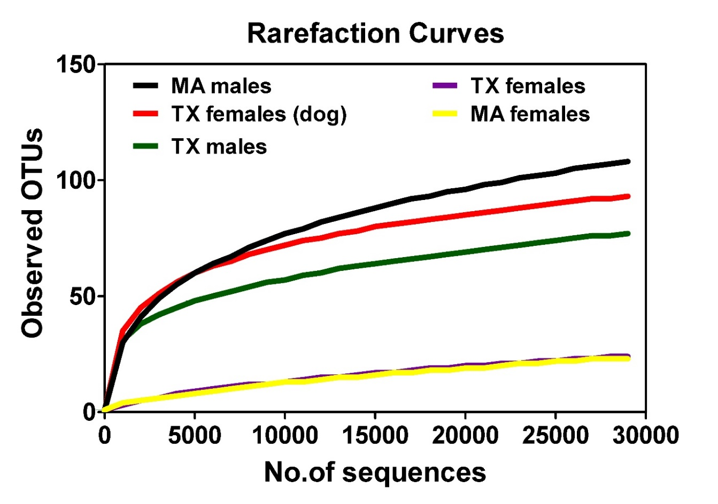
Figure S1. Rarefaction curves of the number of OTUs observed in male and female I. scapularis

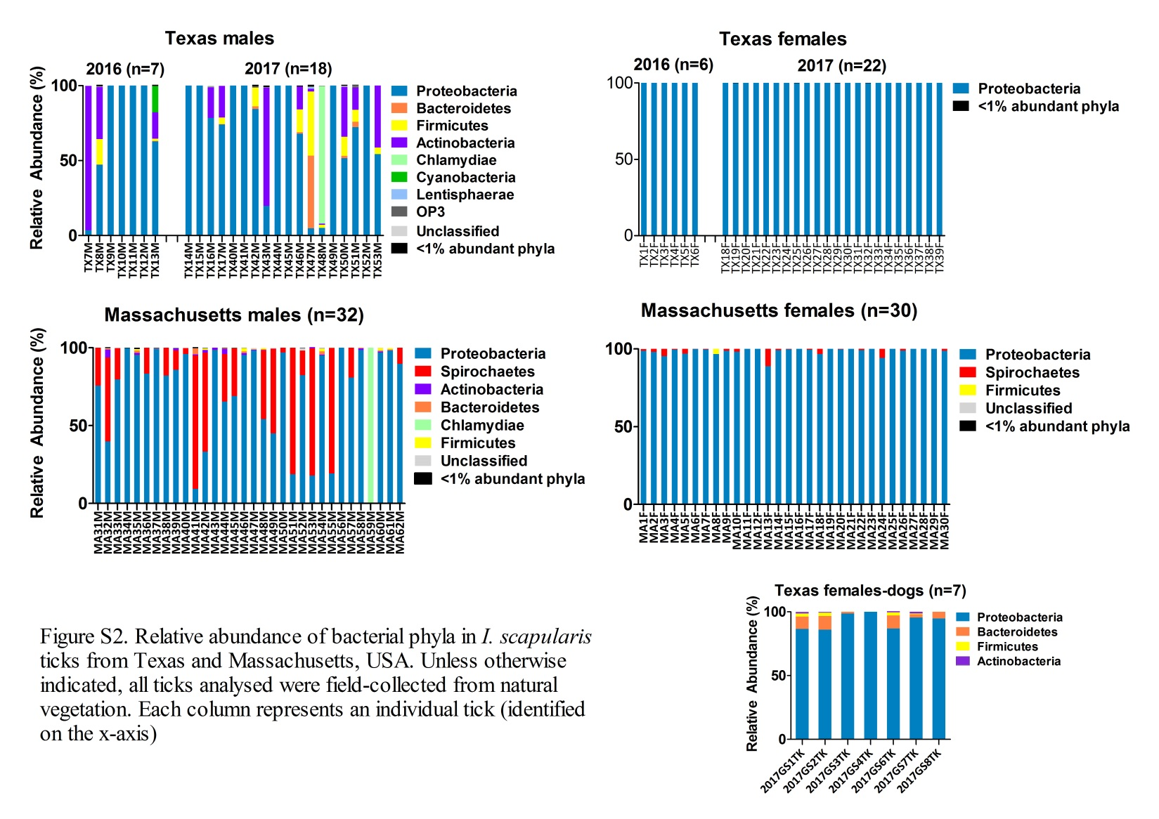

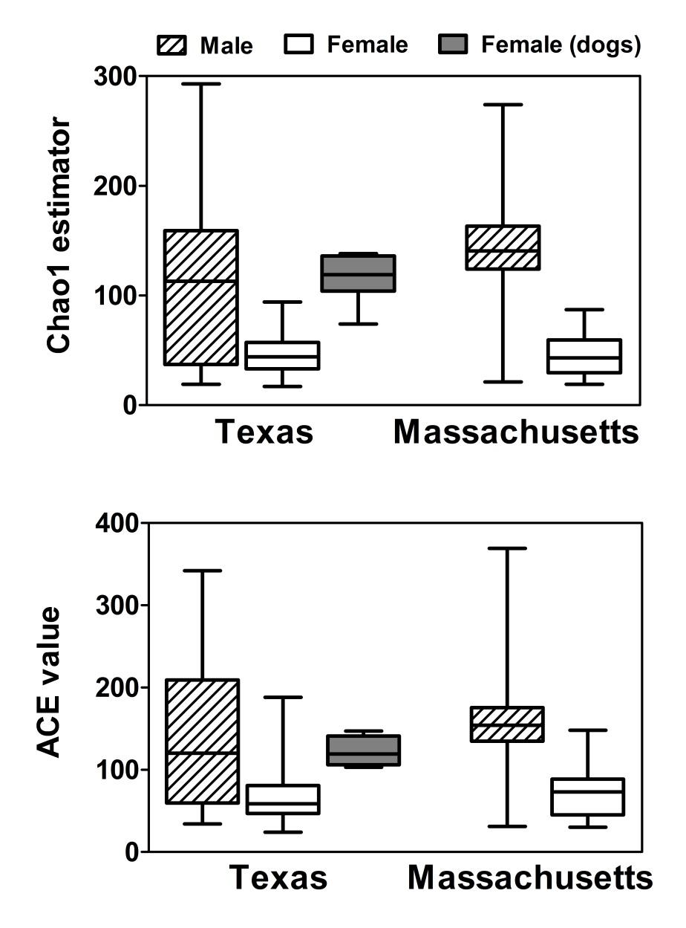

Figure S3. Bacterial richness (ACE and Chao1 estimator) in I. scapularis ticks. All ticks were collected from natural vegetation in Texas and Massachusetts, except female (dog) group where ticks were collected from dogs in North Texas. The ACE and Chao1 values for wild-caught male ticks (from both TX and MA) were significantly higher compared to that of the female ticks (Wilcoxon rank-sum test p < 0.05). Female ticks collected from Texas dogs had a significantly higher ACE and Chao1 indices in comparison to the female ticks collected from vegetation in both TX and MA (FDR corrected Wilcoxon rank-sum test p<0.0001 for all comparisons).

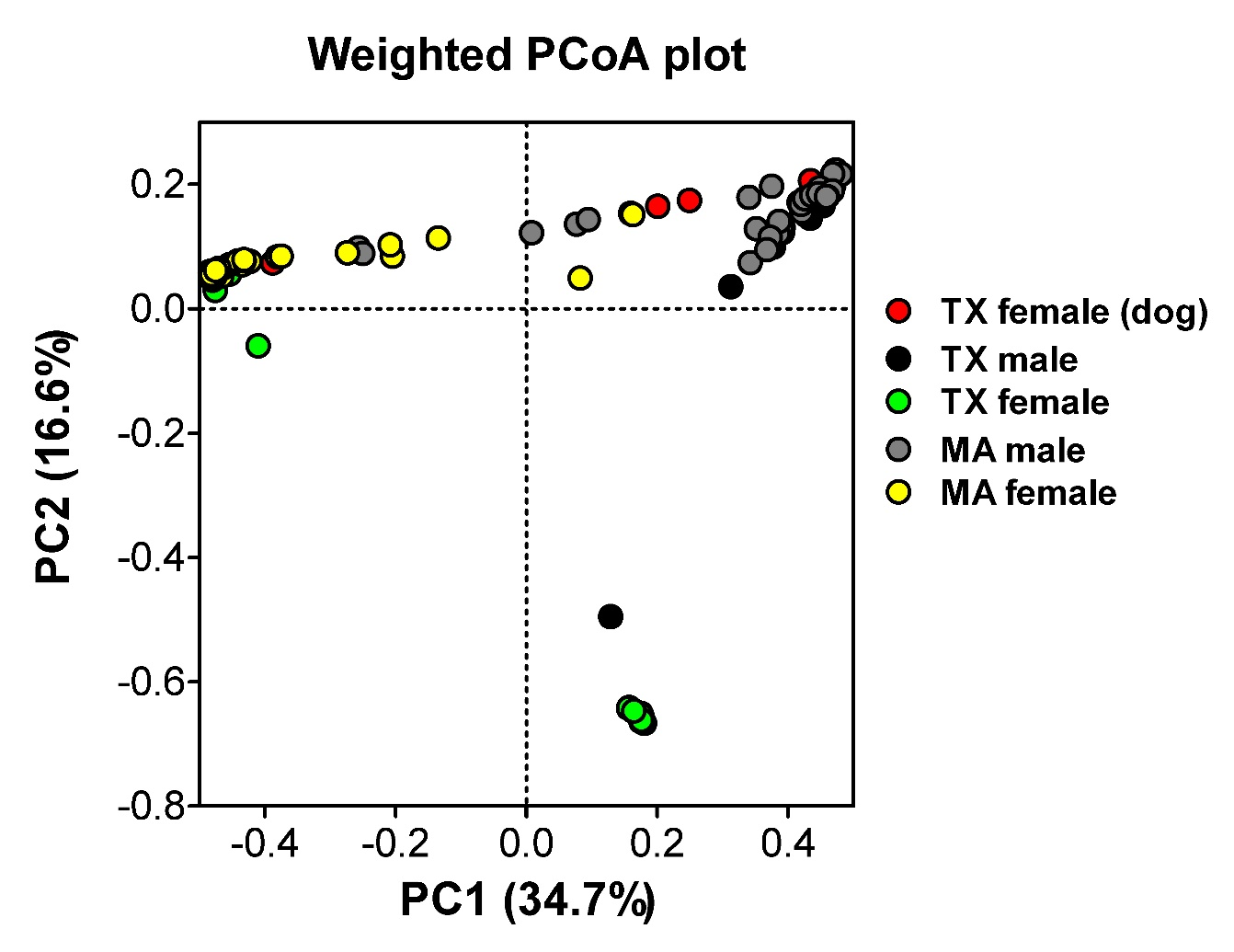

Figure S4. PCoA plot of weighted UniFrac distance metrics in male and female I. scapularis ticks collected from Texas and Massachusetts, USA.

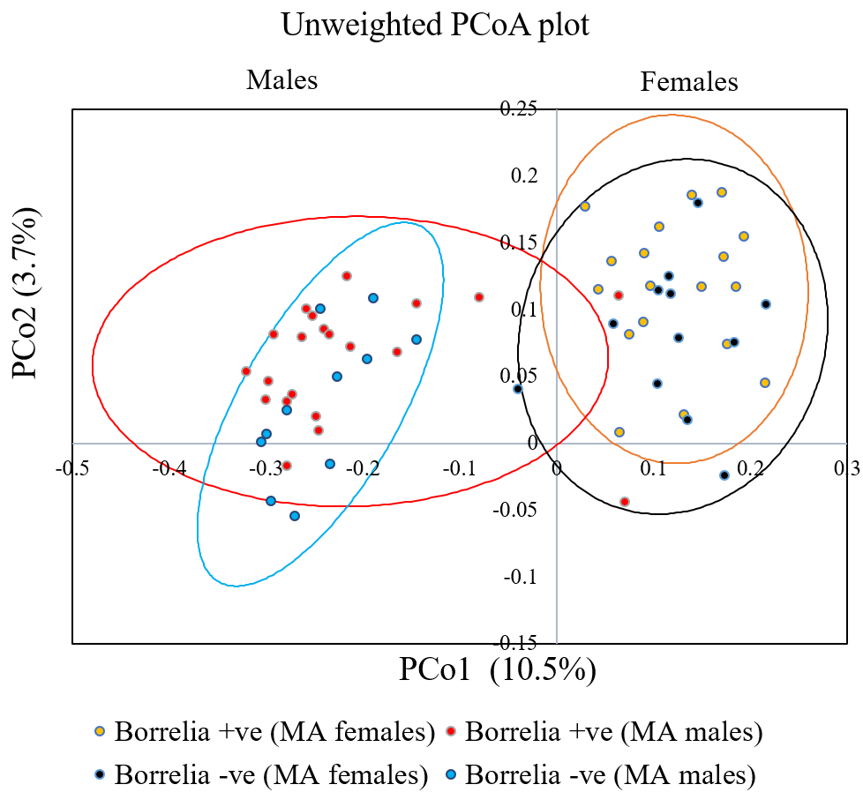

Figure S5. Unweighted PCoA plot of Borrelia-positive and Borrelia-negative I. scapularis males and females collected from Massachusetts, USA. The ellipses are drawn at 95% confidence intervals, where each dot represents the bacterial microbiome of an individual tick.

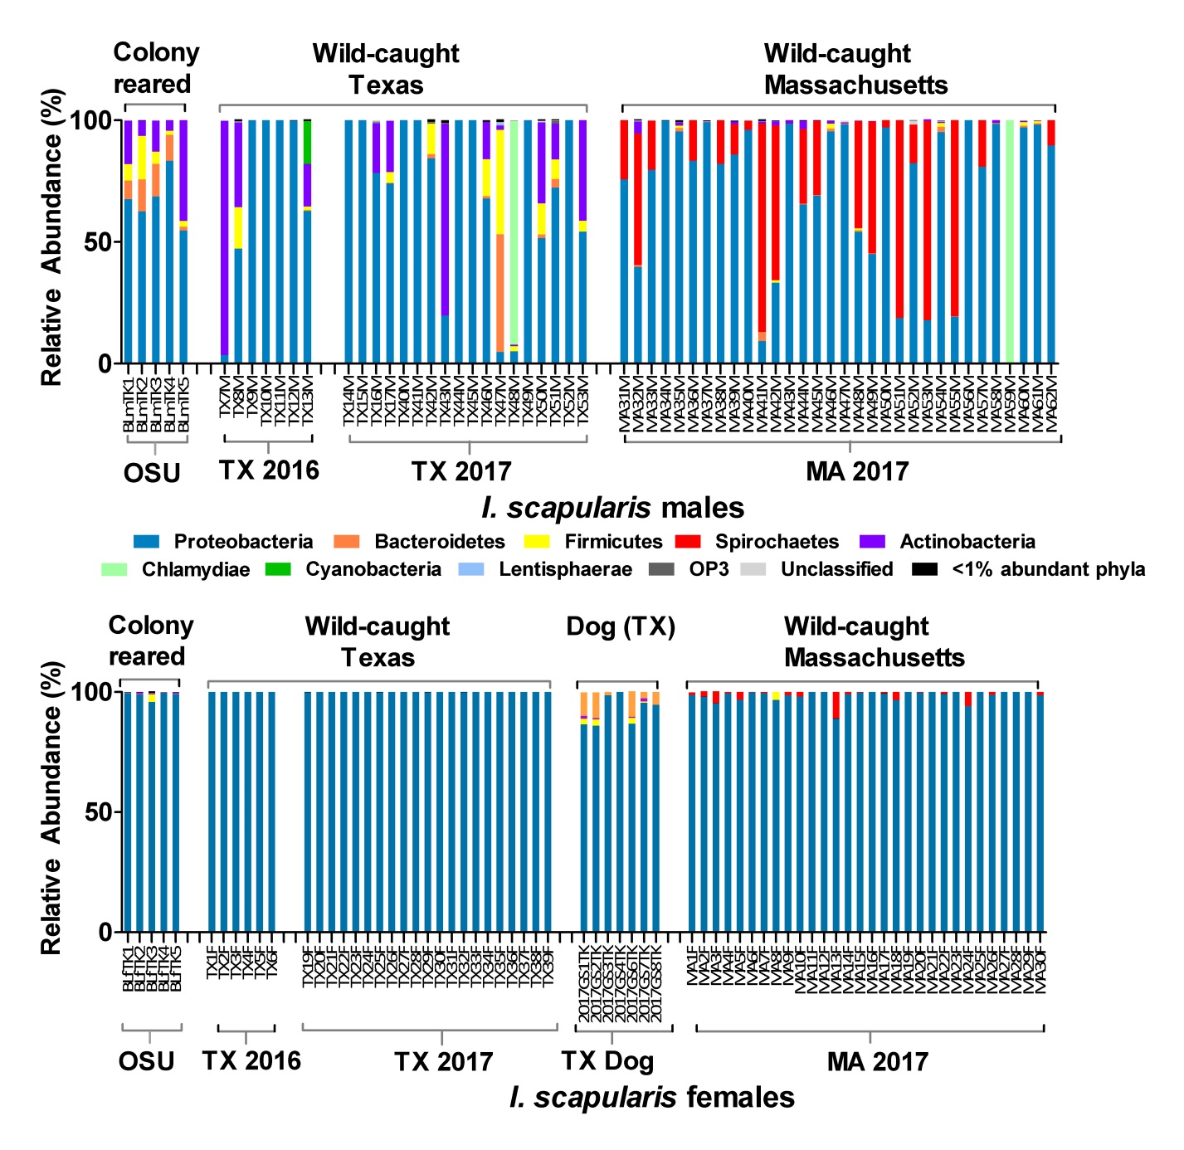

Figure S6. Comparison of the bacterial microbiomes in colony-reared and field-collected I. scapularis ticks. The ticks from natural vegetation in Texas were collected during 2016 and 2017 while the ticks from Massachusetts were collected in 2017. Five female ticks were collected from dogs in North Texas. OSU= colony-reared ticks purchased from the Oklahoma State University.

