Supplementary Data

Table S1 Statistics of sequencing data of each sample after ﬁltration
Sample | Raw_Tags | Clean_Tags | Final_tags | Effective (%)
BL1 | 23046 | 18670 | 14350 | 62.27
BL2 | 31153 | 25582 | 19327 | 62.04
BL3 | 24178 | 21635 | 15716 | 65.00
BL4 | 21189 | 19401 | 14491 | 68.39
BL5 | 39809 | 27683 | 21736 | 54.60
BH1 | 25182 | 24048 | 19253 | 76.45
BH2 | 23034 | 21840 | 17417 | 75.61
BH3 | 34341 | 28083 | 21665 | 63.09
BH4 | 39753 | 35536 | 27231 | 58.50
BH5 | 23929 | 22038 | 17568 | 73.42
SH1 | 34464 | 32848 | 28143 | 81.66
SH2 | 19168 | 18217 | 13740 | 71.68
SH3 | 24495 | 21769 | 16063 | 65.58
Sample, name of sequencing sample; Raw_Tags, number of original sequences obtained by splicing paired-endedreads; Clean_Tags, number of optimized sequences after ﬁltering the original sequence; Final_tags, number of tag corresponding to each sample in the final OTU table; Effective (%), proportion of effective tags among Raw_Tags =100 × (Final_tags / Raw_Tags).

Table S2 Statistics of OTU species of samples on various levels
Sample | Kimdom | Phylum | Class | Order | Family | Genus | Species
BL1 | 1 | 13 | 20 | 38 | 66 | 101 | 28
BL2 | 1 | 13 | 23 | 46 | 85 | 135 | 35
BL3 | 1 | 10 | 17 | 36 | 74 | 118 | 32
BL4 | 1 | 13 | 22 | 41 | 78 | 128 | 34
BL5 | 1 | 12 | 20 | 39 | 72 | 114 | 33
BH1 | 1 | 13 | 20 | 42 | 76 | 124 | 32
BH2 | 1 | 14 | 21 | 41 | 78 | 121 | 33
BH3 | 1 | 15 | 21 | 43 | 80 | 111 | 27
BH4 | 1 | 14 | 25 | 51 | 94 | 150 | 41
BH5 | 1 | 12 | 22 | 46 | 87 | 132 | 41
SH1 | 1 | 9 | 17 | 36 | 70 | 103 | 28
SH2 | 1 | 13 | 21 | 40 | 73 | 102 | 28
SH3 | 1 | 12 | 22 | 40 | 70 | 118 | 31

Table S3 Statistics of OTU clustering results of samples on various levels
Sample | Kimdom | Phylum | Class | Order | Family | Genus | Species
BL1 | 14306 | 9174 | 9024 | 8993 | 8983 | 6366 | 2967
BL2 | 19322 | 18543 | 18463 | 17722 | 17657 | 13773 | 7519
BL3 | 15714 | 15050 | 15009 | 14561 | 14503 | 10537 | 5021
BL4 | 14490 | 14064 | 14023 | 13602 | 13284 | 10734 | 5094
BL5 | 21710 | 9308 | 7928 | 7707 | 7677 | 5357 | 2339
BH1 | 19253 | 19219 | 19143 | 19038 | 18960 | 13519 | 8416
BH2 | 17412 | 17228 | 17153 | 17015 | 16851 | 13336 | 9684
BH3 | 21616 | 10528 | 10289 | 10198 | 10160 | 7790 | 3163
BH4 | 27231 | 27198 | 27124 | 27039 | 26671 | 22985 | 7373
BH5 | 17568 | 17549 | 17465 | 17435 | 17273 | 14729 | 11258
SH1 | 28134 | 27988 | 27948 | 27653 | 27423 | 21329 | 12465
SH2 | 13740 | 13734 | 13541 | 13399 | 13364 | 10453 | 4544
SH3 | 16063 | 16056 | 16037 | 16029 | 15686 | 13077 | 6035

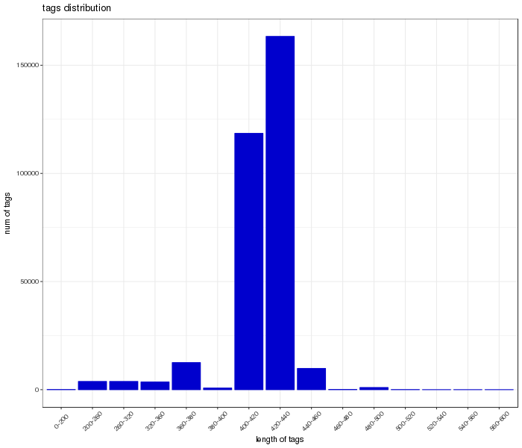
Fig. S1 Effective sequence length distribution. The x-coordinate is the sequence length range; the y-coordinate is the number of tags

