Supplementary data for:

In vitro conjugation kinetics of AmpC, broad spectrum and extended-spectrum beta-lactamase-producing Escherichia coli donors and various Enterobacteriaceae recipients
Eva-Maria Saliu, Jürgen Zentek and Wilfried Vahjen

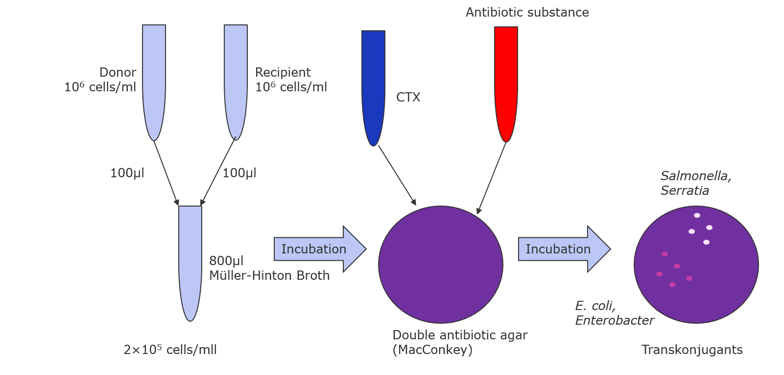
Figure S1: Setup screening trial

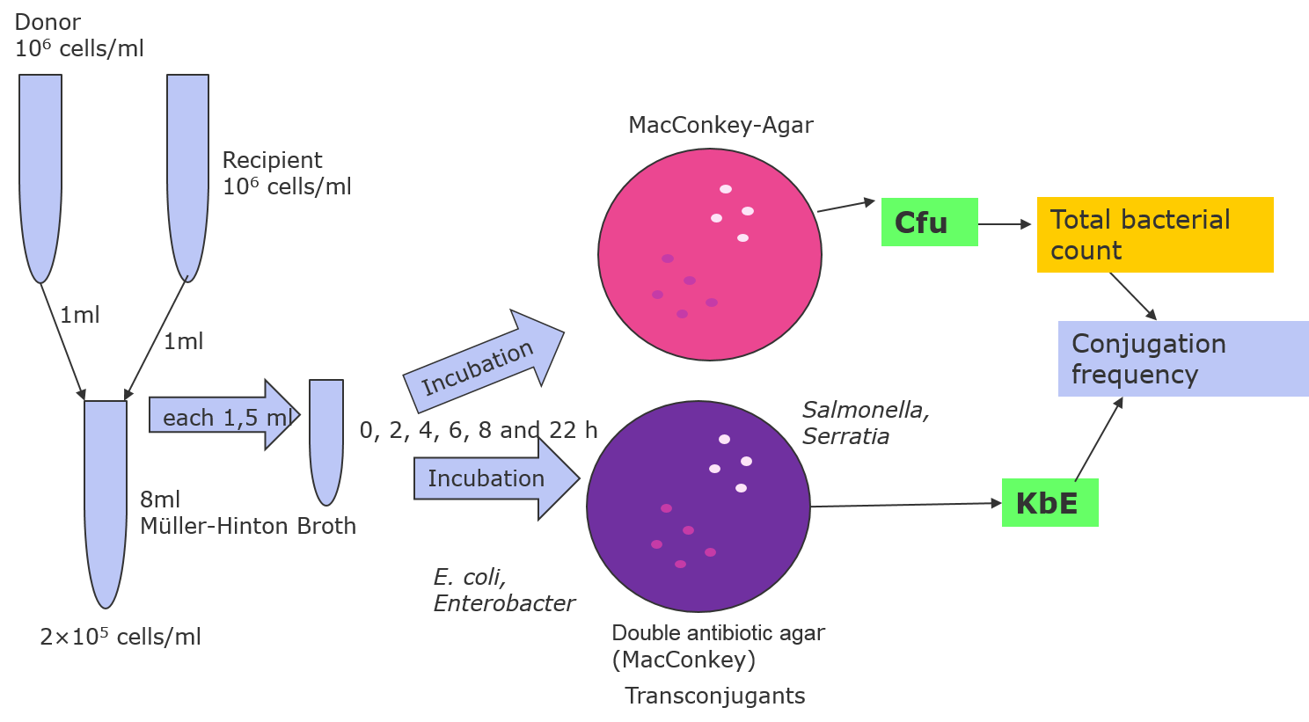
cfu

cfu
Figure S2: Setup 22-hours kinetic

