Supplemental Figure 1: Metabolites produced by growth if B. infantis on lactose or HMO in the differing concentrations of tryptophan.
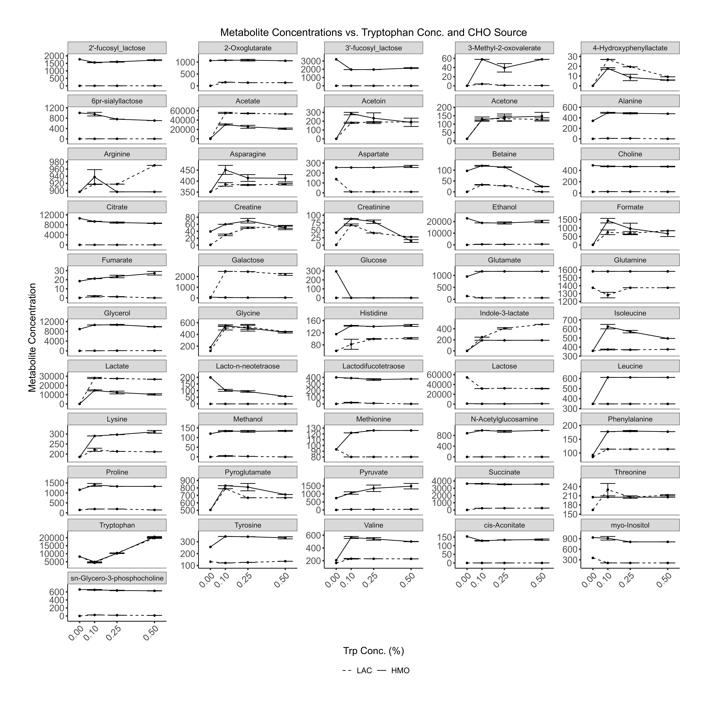
Supplemental Table 1: Composition of milk oligosaccharide

Supplemental Table 2: Primer sequences

Supplemental Table 3: Summary of statistics from TukeyHSD posthoc comparisons of ILA dose responses

