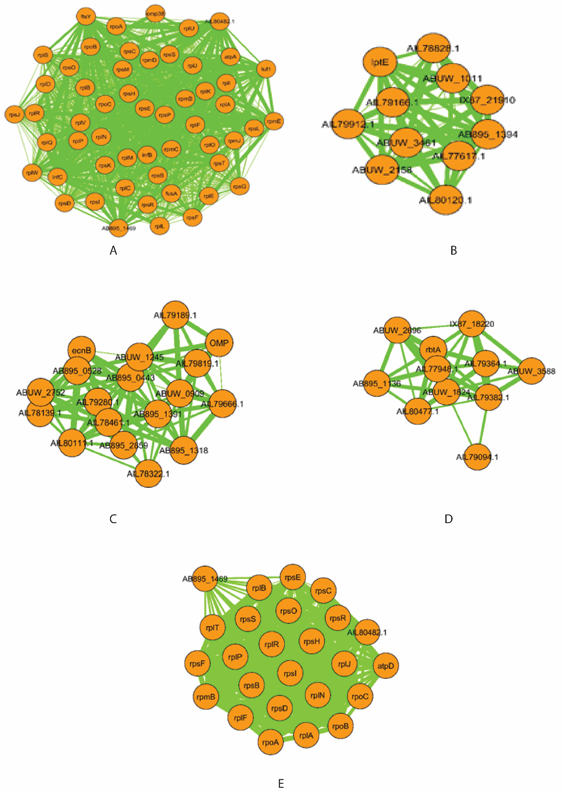

Additional file 8 : Schematic representation of MCODE clusters of A. baumannii ATCC 19606 (A-D) and JU0126 (E) strains. Nodes colors represent in orange color, and the size of edges was represented in combine score in PPI network.

