Supplementary material
Population structure and uropathogenic potential of extended-spectrum cephalosporin-resistant Escherichia coli from retail chicken meat
May Linn Buberg^{a#}, Solveig Sølverød Mo^{b#}, Camilla Sekse ^{b}, Marianne Sunde ^{b}, Yngvild Wastesonª, Ingun Lund Witsø ^{a*}
ªDepartment of Paraclinical Sciences, Faculty of Veterinary Medicine, Norwegian University of Life Sciences, Oslo, Norway
^{b}Section for Food safety and Animal Health Research, Department of Animal Health and Food Safety, Norwegian Veterinary Institute, Oslo, Norway
# Both authors contributed equally to this work

Running title: Uropathogenic potential of E. coli from poultry

*Corresponding author:
Ingun Lund Witsø, ingun.lund.witso@nmbu.no, Phone: +47 958 20 913

Supplementary
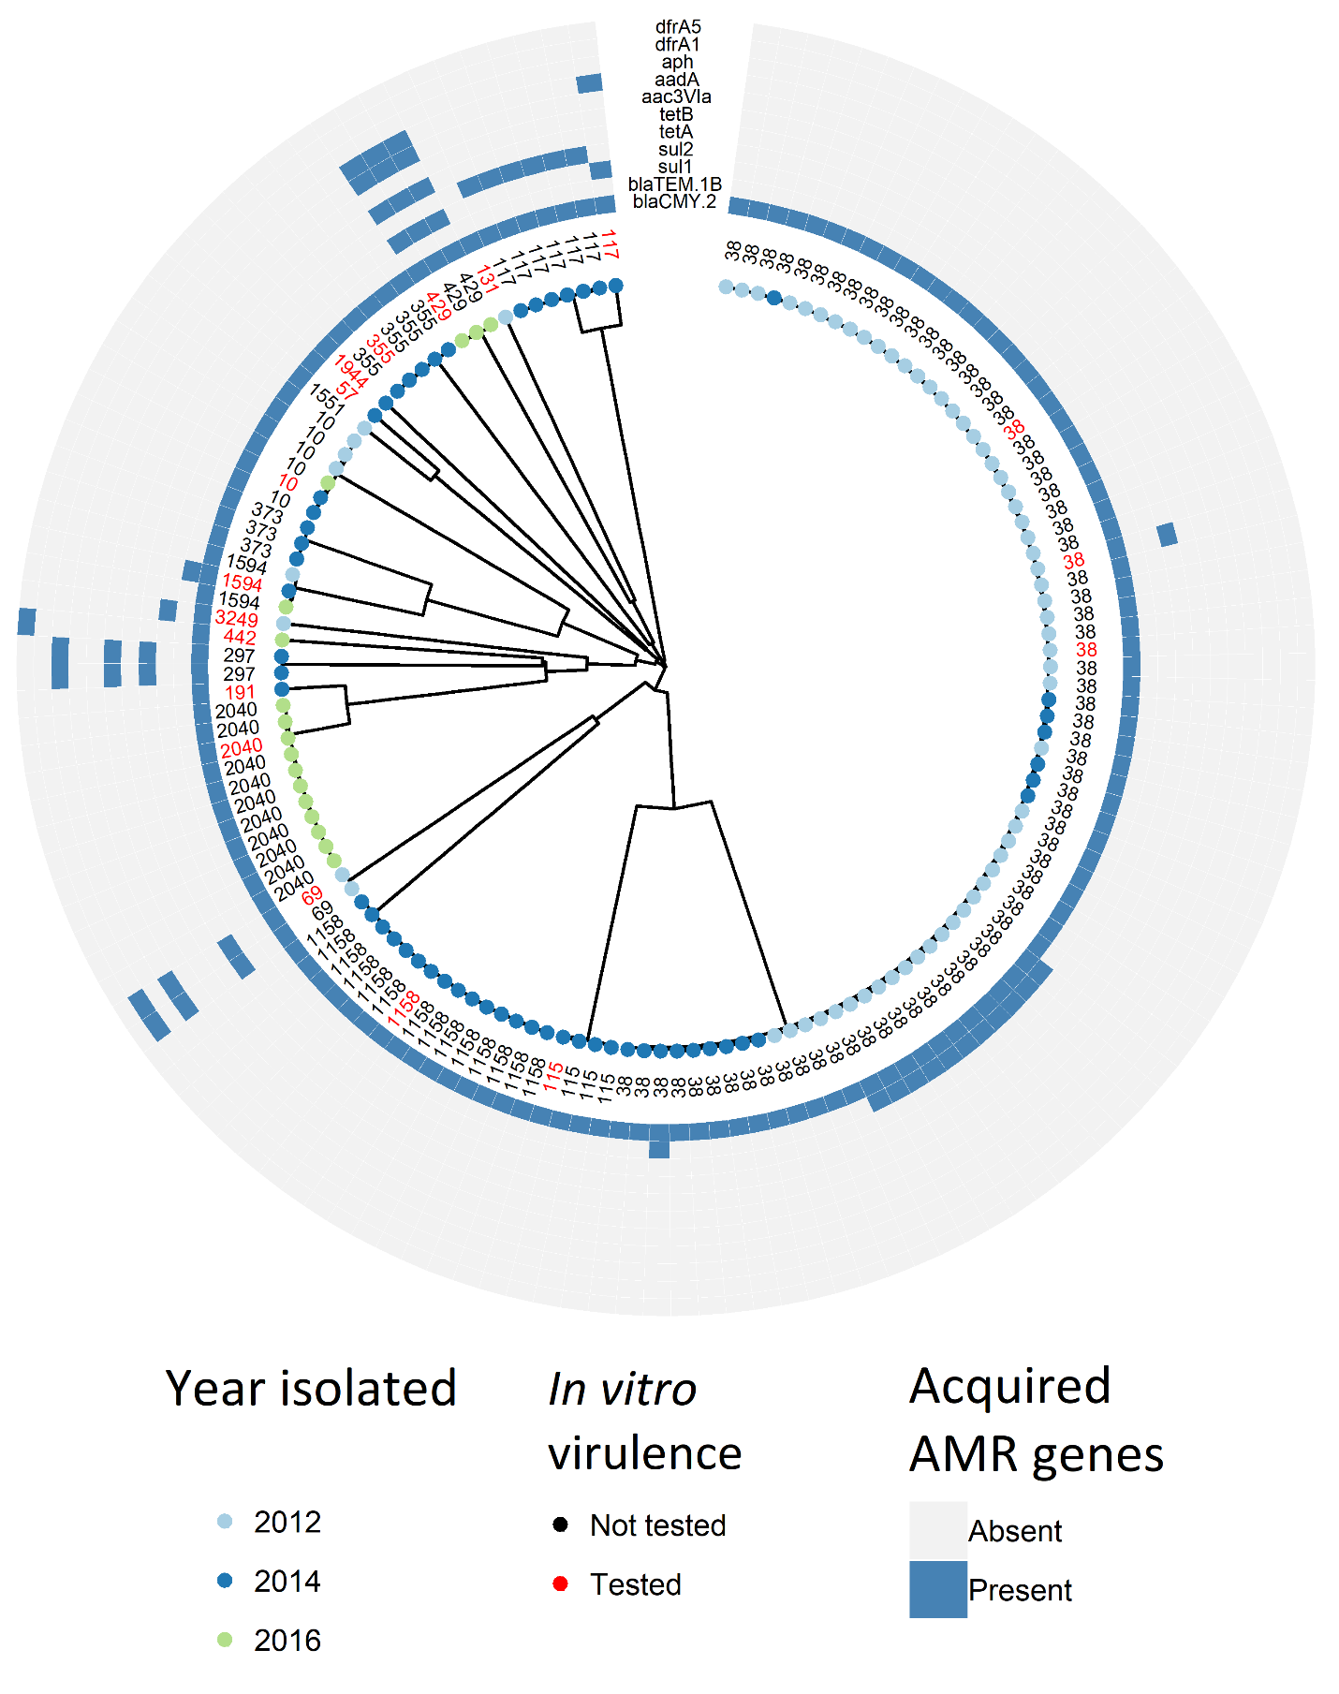
Figure S1 – Clustering of 141 extended-spectrum cephalosporin-resistant Escherichia coli isolated from Norwegian retail chicken meat.
The clustering is based on core genome multilocus sequence typing. Year isolated is indicated as light blue (2012), blue (2014), or light green (2016) dots. The 18 isolates marked in red were included in the in vitro virulence assays. Presence of acquired AMR genes is illustrated with blue boxes, while absence is illustrated with grey boxes.

Table S1 – Total dataset
All isolates and their respective genetic profile, in addition to sequence method performed for each of the respective isolates.

Table S2 – Growth curves supplementary
Growth rate, doubling time, and R² for each isolate for growth in LB-broth and sterile-filtered human urine. The optical density was measured at 600 nm in a Tecan plate reader every ten minutes for 23 hours. This was done in triplicate, and the average growth rate and doubling time were calculated in Excel.
Medium | Isolate | Growth rate | Doubling time | R²
LB | 2012-01-3586 | 0.216 | 3.20 | 0.667
LB | 2014-01-3678 | 0.101 | 6.81 | 0.296
LB | 2016-22-832 | 0.206 | 3.34 | 0.727
LB | 2014-01-5656 | 0.120 | 5.73 | 0.359
LB | 2014-01-7037 | 0.135 | 5.11 | 0.616
LB | 2016-22-220 | 0.212 | 3.26 | 0.657
LB | 2014-01-1336 | 0.208 | 3.31 | 0.638
LB | 2012-01-1295 | 0.212 | 3.25 | 0.064
LB | 2012-01-707 | 0.210 | 3.28 | 0.659
LB | 2014-01-3680 | 0.135 | 5.11 | 0.417
LB | 2014-01-4991 | 0.130 | 5.30 | 0.441
LB | 2014-01-5104 | 0.164 | 4.21 | 0.590
LB | 2012-01-771 | 0.181 | 3.82 | 0.59
LB | 2014-01-7011 | 0.169 | 4.08 | 0.560
LB | 2014-01-4267 | 0.160 | 4.31 | 0.521
LB | 2012-01-1292 | 0.210 | 3.29 | 0.663
LB | 2012-01-2798 | 0.157 | 4.38 | 0.546
LB | 2016-22-1061 | 0.281 | 2.46 | 0.427
LB | E. coli CFT073 | 0.268 | 2.58 | 0.404
Urine | 2012-01-3586 | 0.099 | 7.00 | 0.570
Urine | 2014-01-3678 | 0.112 | 6.14 | 0.648
Urine | 2016-22-832 | 0.916 | 0.75 | 0.644
Urine | 2014-01-5656 | 0.101 | 6.85 | 0.609
Urine | 2014-01-7037 | 0.107 | 6.47 | 0.649
Urine | 2016-22-220 | 0.104 | 6.64 | 0.613
Urine | 2014-01-1336 | 0.091 | 7.55 | 0.571
Urine | 2012-01-1295 | 0.106 | 6.52 | 0.591
Urine | 2012-01-0707 | 0.116 | 5.94 | 0.594
Urine | 2014-01-3680 | 0.092 | 7.52 | 0.587
Urine | 2014-01-4991 | 0.119 | 5.81 | 0.607
Urine | 2014-01-5104 | 0.112 | 6.13 | 0.618
Urine | 2012-01-771 | 0.110 | 6.25 | 0.600
Urine | 2014-01-7011 | 0.112 | 6.14 | 0.679
Urine | 2014-01-4267 | 0.101 | 6.81 | 0.599
Urine | 2012-01-1292 | 0.110 | 6.29 | 0.589
Urine | 2012-01-2798 | 0.105 | 6.55 | 0.553
Urine | 2016-22-1061 | 0.057 | 12.15 | 0.287
Urine | E. coli CFT073 | 0.062 | 11.03 | 0.398

