Supporting Information

Diversity and antibacterial activities of fungal endophytes from Eucalyptus exserta

Ziling Mao¹, Weihao Zhang¹, Chunyin Wu¹, Hao Feng¹, Yuanhang Peng¹, Hamza Shahid¹, Zining Cui², Ping Ding³*, Tijiang Shan¹*

¹ Guangdong Key Laboratory for Innovative Development and Utilization of Forest Plant Germplasm, College of Forestry and Landscape Architecture, South China Agricultural University, Guangzhou, 510642, China
² Guangdong Province Key Laboratory of Microbial Signals and Disease Control, South China Agricultural University, Guangzhou, 510642, China
³ School of Pharmaceutical Sciences, Guangzhou University of Chinese Medicine, Guangzhou 510006, China

Corresponding Author:
Ping Ding
No. 232, Waihuandong Road, Panyu District, Guangzhou, Guangdong, 510006, China
Email address: dingpinggz@126.com
Tijiang Shan
No. 483, Wushan Road, Tianhe District, Guangzhou, Guangdong, 510642, China
Email address: tjshan@scau.edu.cn

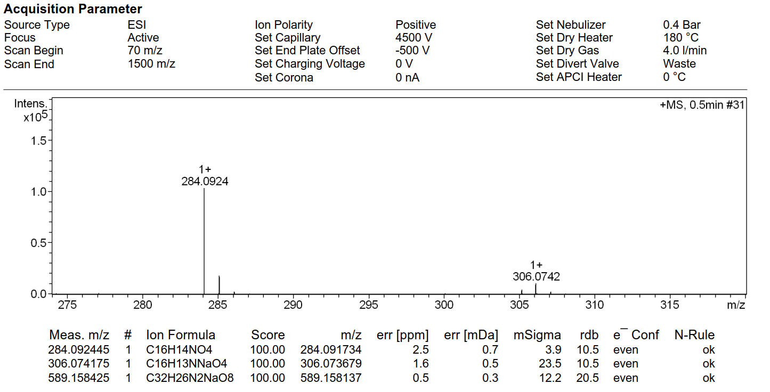

Fig. S1 HR-ESI-MS spectrum of scorpinone (1)
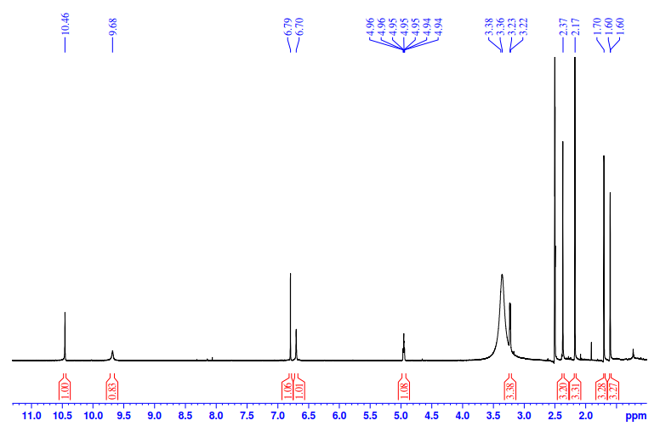

Fig. S2 ¹H NMR spectrum of scorpinone (1) (CDCl₃, 600 MHz)

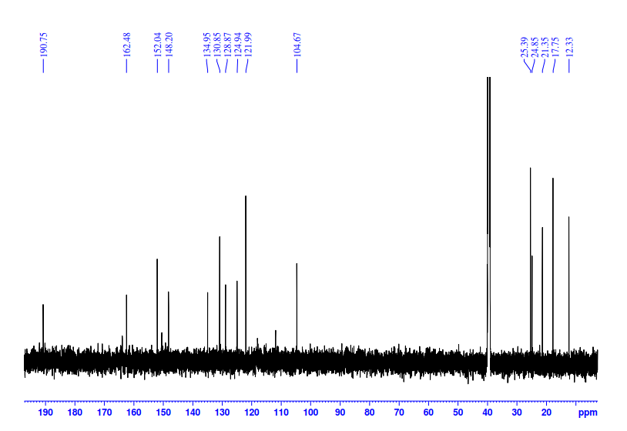

Fig. S3 ¹³C NMR spectrum of scorpinone (1) (CDCl₃, 151 MHz)

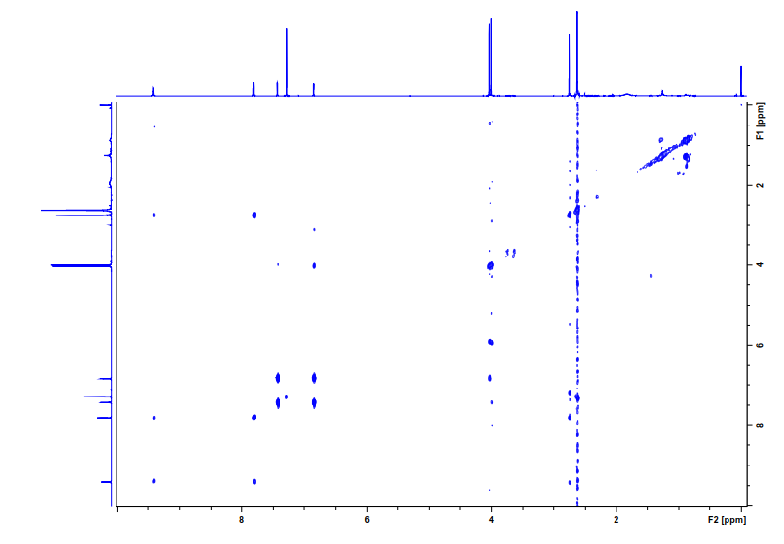Fig. S4 ¹H-¹H COSY spectrum of scorpinone (1) (CDCl₃, 151 MHz)

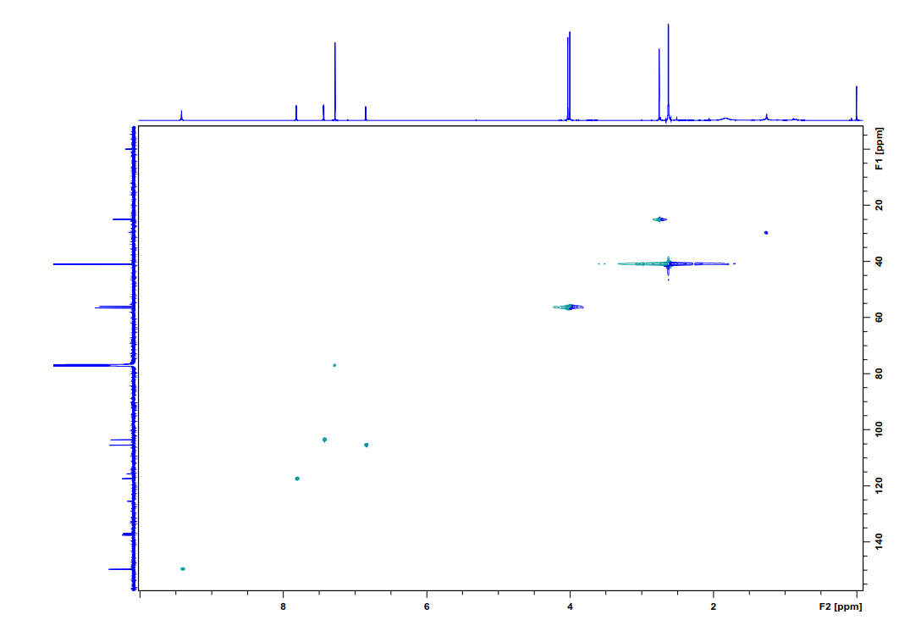

Fig. S5 HSQC spectrum of scorpinone (1) (CDCl₃, 151 MHz)
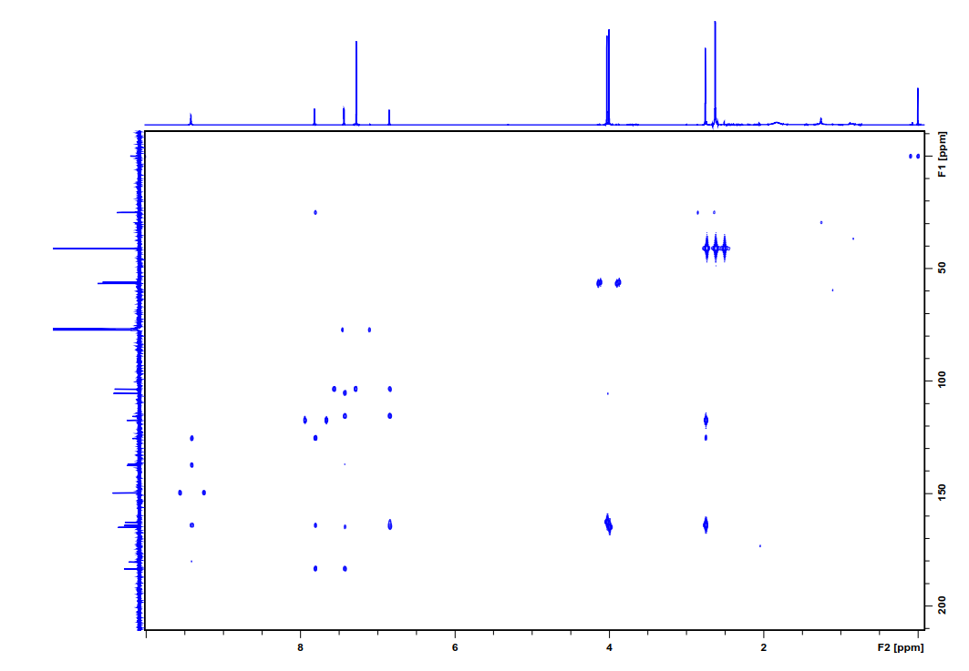

Fig. S6 HMBC spectrum of scorpinone (1) (CDCl₃, 151 MHz)

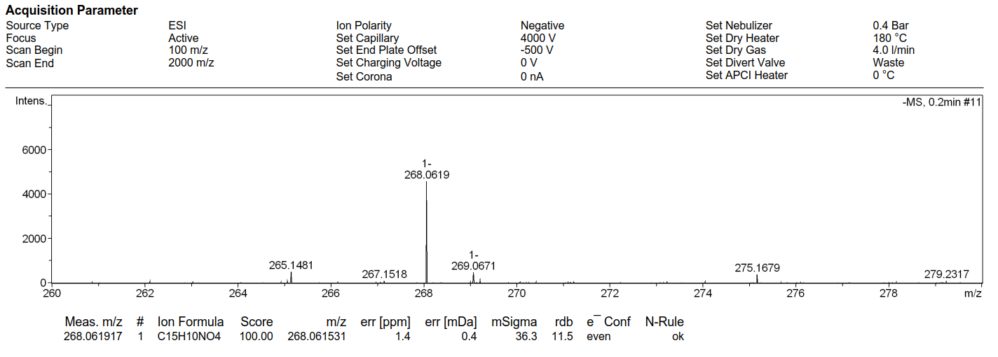

Fig. S7 HR-ESI-MS spectrum of 5-deoxybostrycoidin (2)

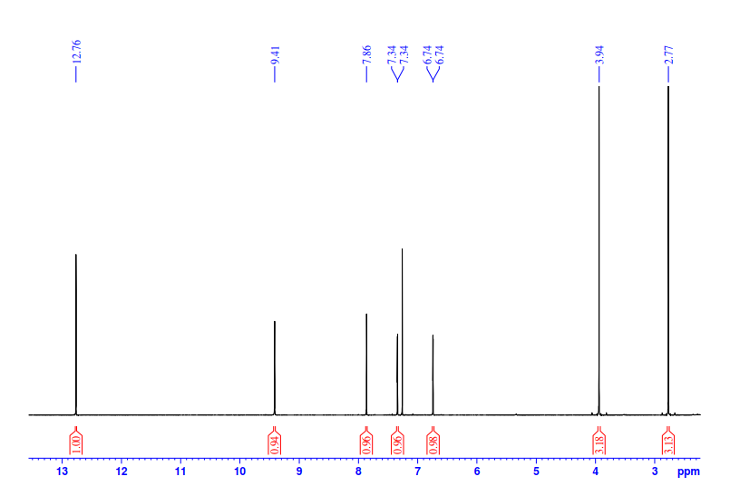

Fig. S8 ¹H NMR spectrum of 5-deoxybostrycoidin (2) (CDCl₃, 600 MHz)

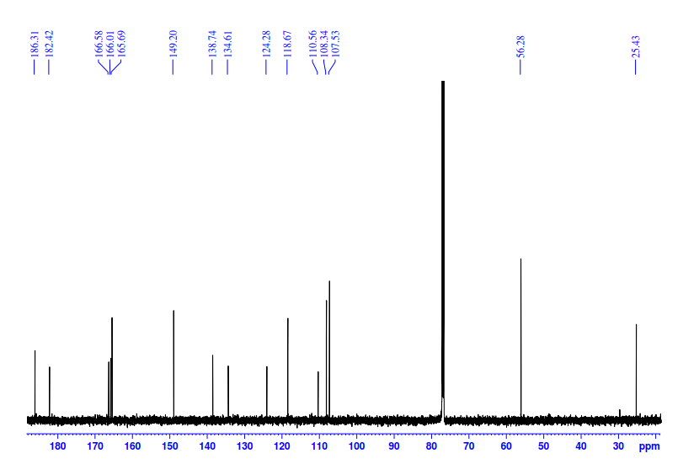

Fig. S9 ¹³C NMR spectrum of 5-deoxybostrycoidin (2) (CDCl₃, 151 MHz)
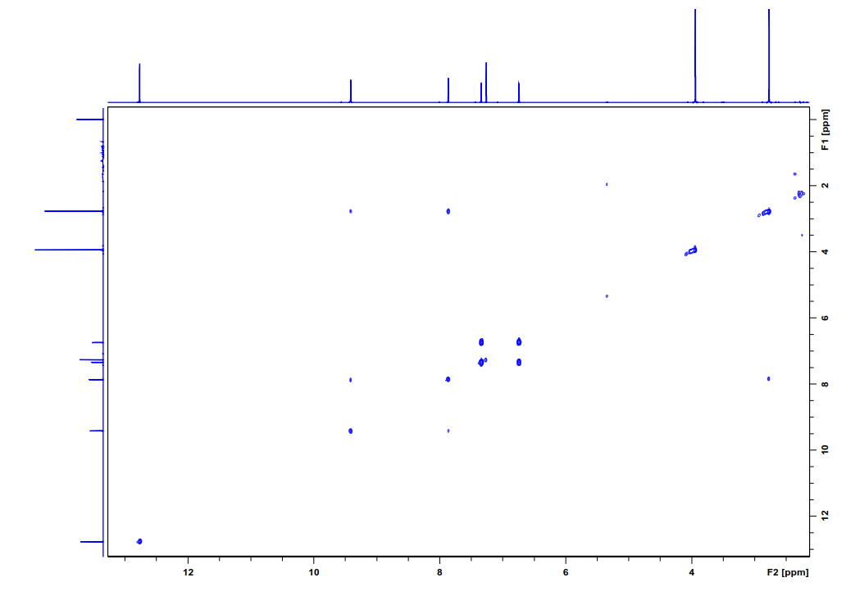

Fig. S10 ¹H-¹H COSY spectrum of 5-deoxybostrycoidin (2) (CDCl₃, 151 MHz)

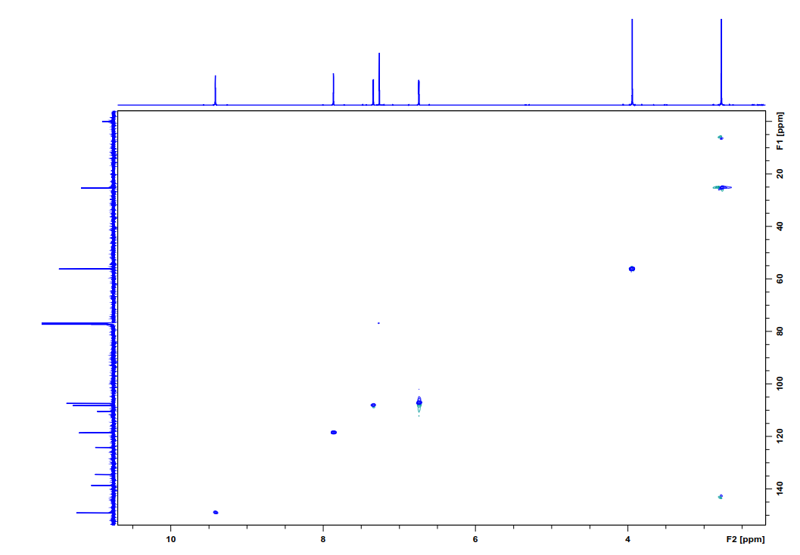

Fig. S11 HSQC spectrum of 5-deoxybostrycoidin (2) (CDCl₃, 151 MHz)
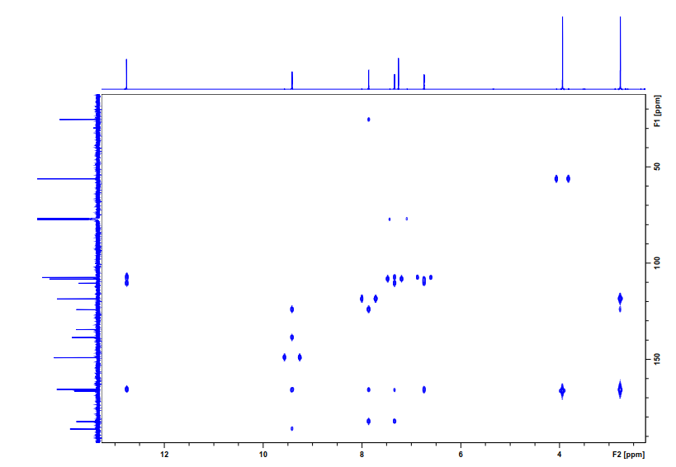

Fig. S12 HMBC spectrum of 5-deoxybostrycoidin (2) (CDCl₃, 151 MHz)

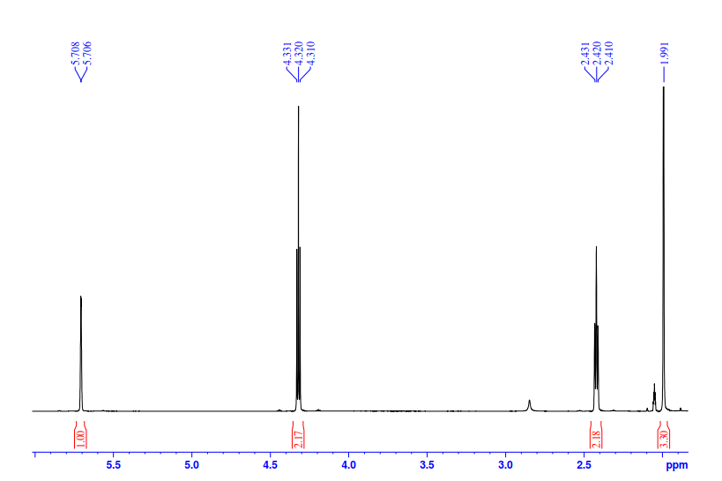

Fig. S13 ¹H NMR spectrum of 4-methyl-5, 6-dihydro-2-pyranone (3) (Acetone-d₆, 600 MHz)
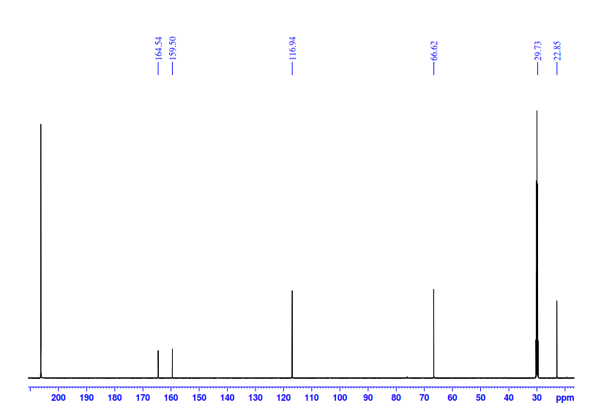

Fig. S14 ¹³C NMR spectrum of 4-methyl-5, 6-dihydro-2-pyranone (3) (Acetone-d₆, 151 MHz)

