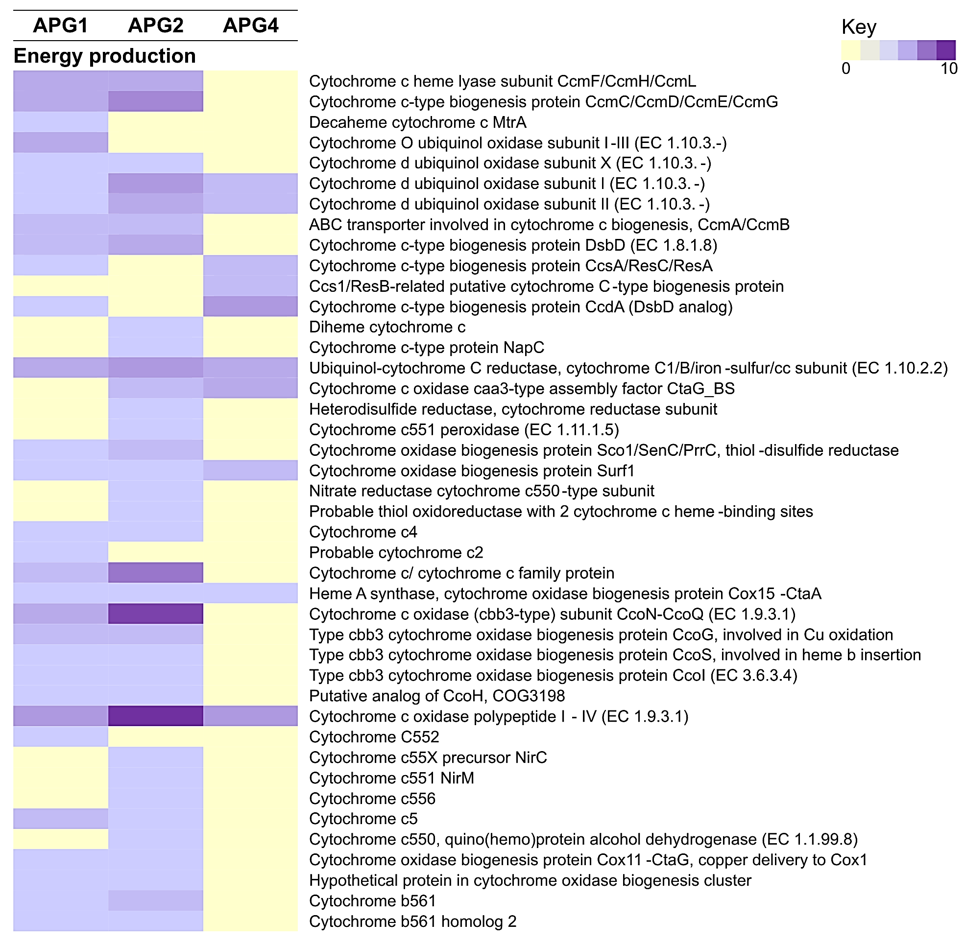
Additional file 11: Figure S6. Genes dedicated to energy production and conservation in APG genomes.

