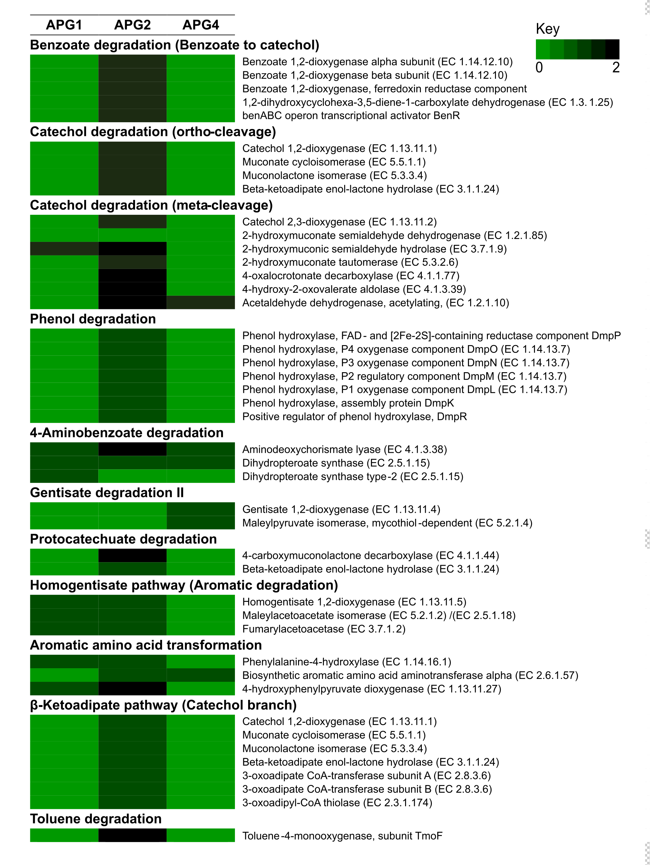
Additional file 14: Figure S9. Genes associated with degradation of aromatic compounds identified in APG genomes.

