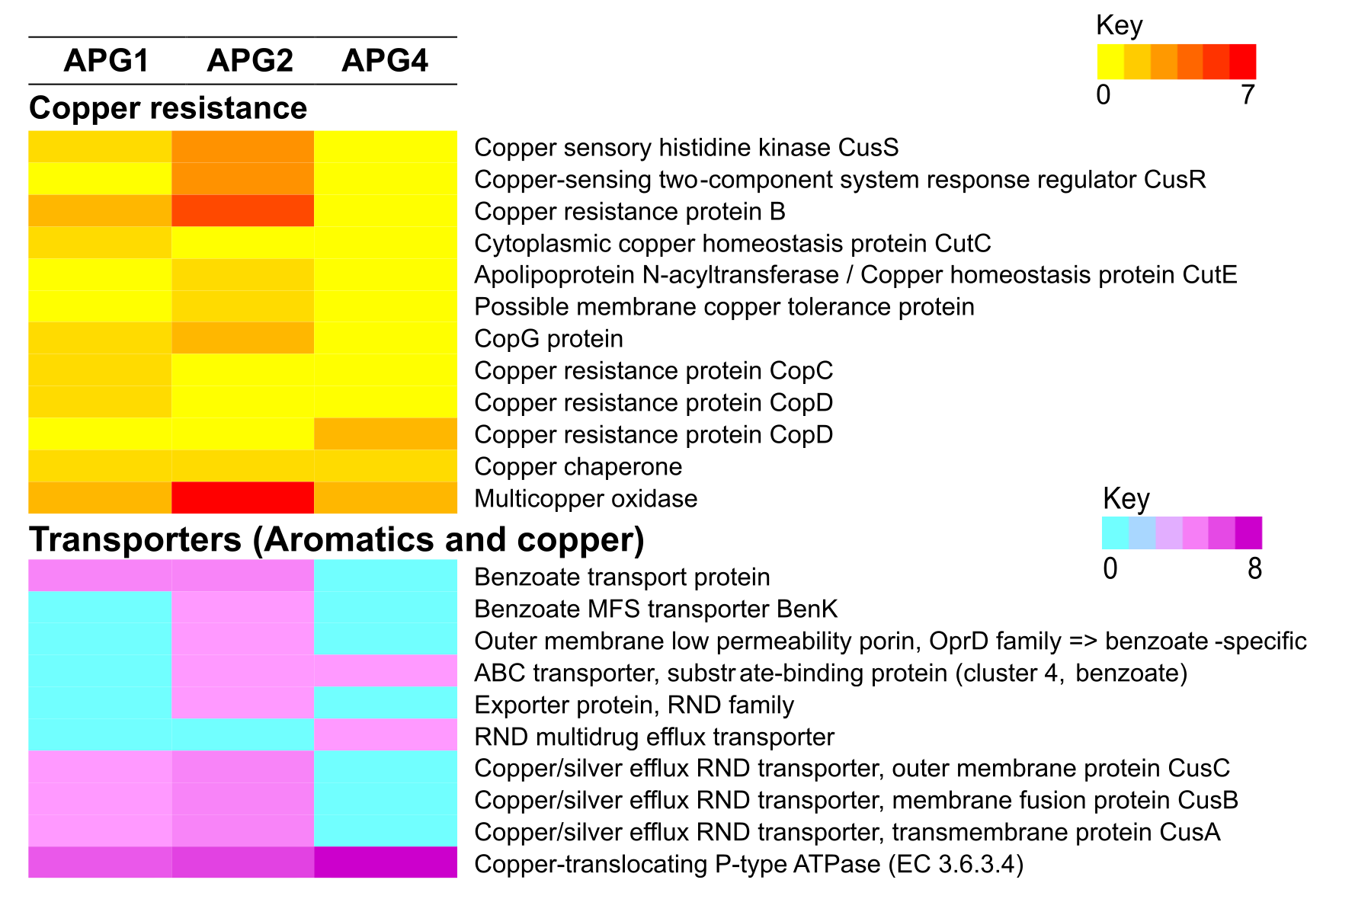
Additional file 15: Figure S10. Genes of APG genomes involved in copper resistance and transport.

