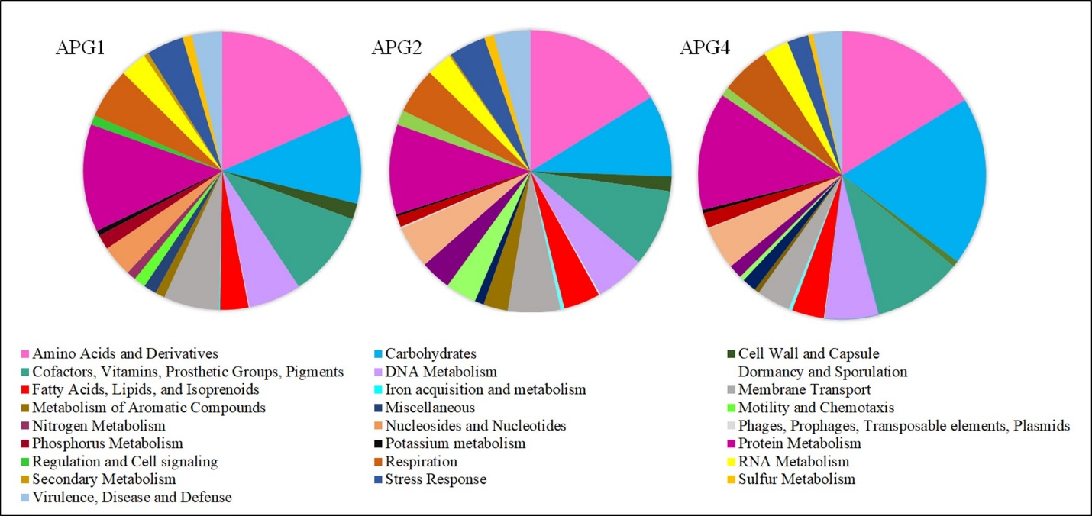
Additional file 2: Figure S2 An overview of subsystem categories distributions obtained from annotation of draft genome sequences of all APG isolates at the RAST (Rapid Annotation System Technology) server.

