Figure legends
Figure. S1 Rarefaction curves of the number of operational taxonomic units (OTUs) at 97% similarity boxplot for each of 88 samples.
Figure. S2 UPGMA result based on the unweighted Unifrac metric. The hierarchical clustering structure helps to determine the similarity of the bacterial communities between different samples.

Figure S1.
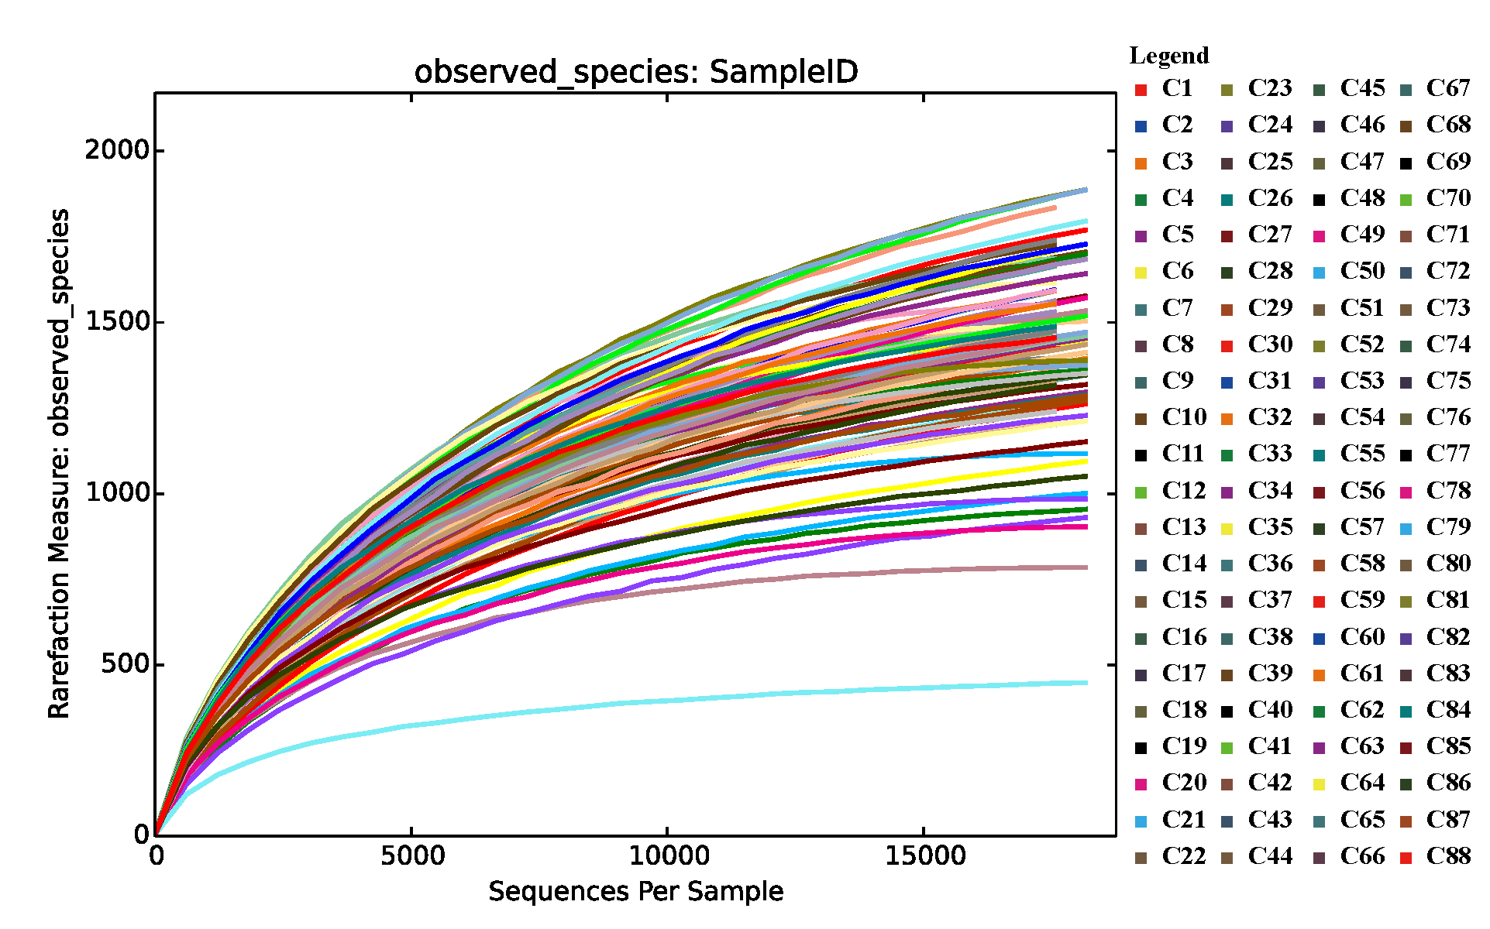

Figure S2.
