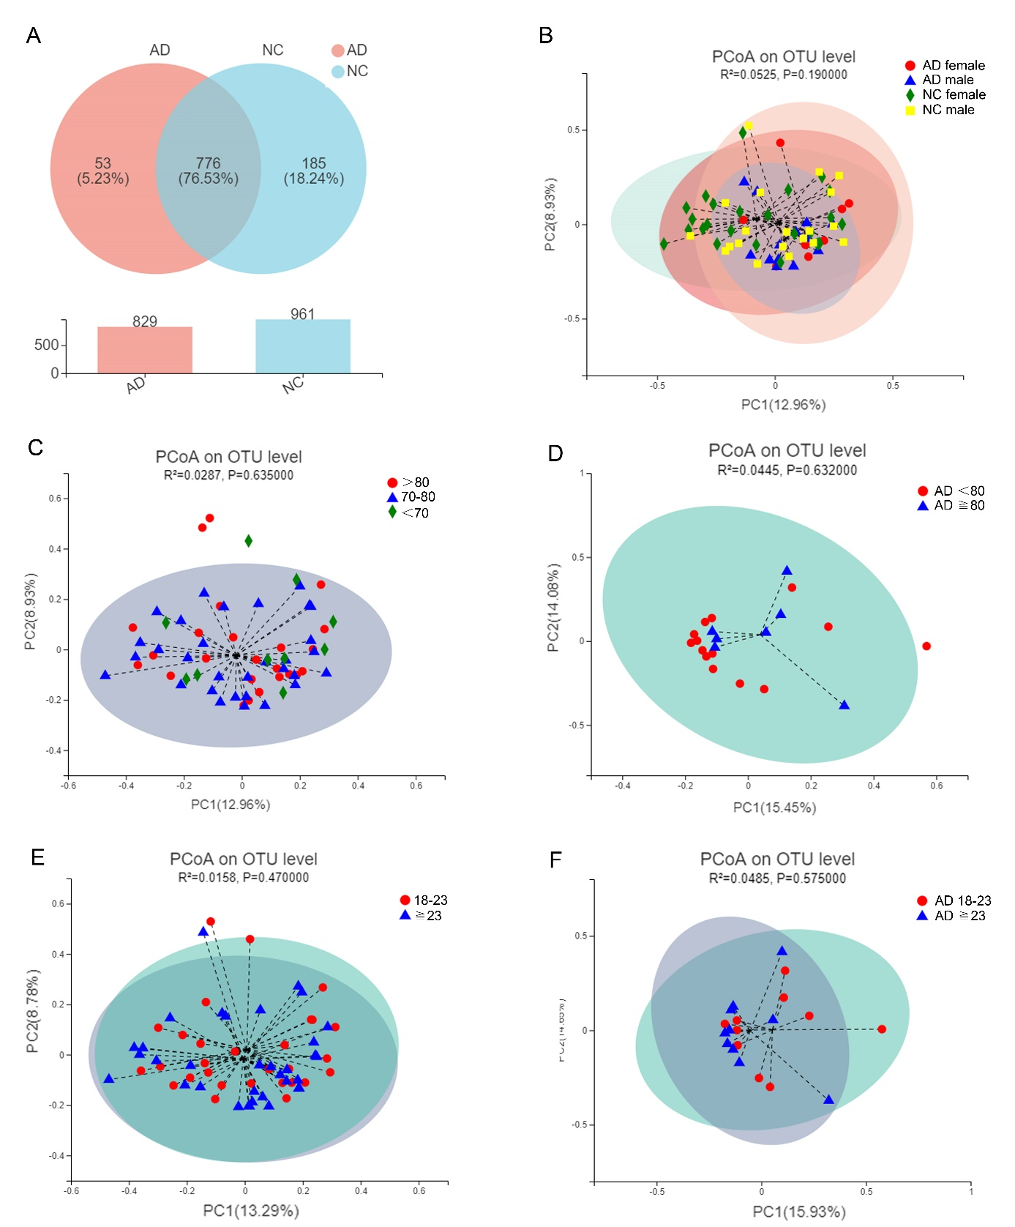
Fig. S1. The OUTs distribution and the control analyses of overall microbial phenotypes by PCoA with 95% confidence interval (CI) ellipses based on Bray-Curtis dissimilarity. (A) Venn diagram showing the unique and shared OTUs between AD participants and NC participants. (B) The overall microbial phenotypes based on sex (n=13, AD Male; n=8, AD Female; n=20, NC Male; n=24, NC Female). (C-D) The overall microbial phenotypes of all subjects (C) or AD group (D) based on age (All subjects: n=10, <70; n=31, 70-80; n=24, >80. AD group: n=14, <80; n=7,≧80). (E-F) The overall microbial phenotypes of all subjects (E) or AD group (F) based on Body Mass Index (BMI) (All subjects: n=29, BMI:18-23; n=34, BMI≧23; n=2, missing data. AD group: n=10, BMI:18-23; n=10, BMI≧23; n=1 missing data).

