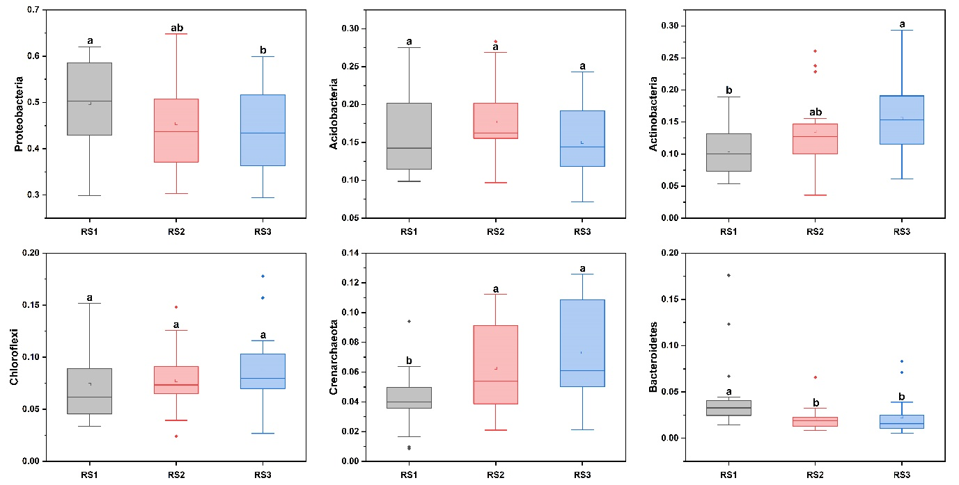
Supplementary Figure S1. The relative abundance of the bacterial communities at the phylum level in different soil profiles. The least significant test (LSD test, P<0.05) was applied to check the significance of bacterial relative abundance between the different groups.

Supplementary Figure S2. Functional analysis of bacterial communities on the basis of % OTUs. The symbol M represents the module, and contains a set of OTUs.

Supplementary Table S1. The intensive application of N. P. K in Pinghe County.
Nutrient type | Nutrient input (Kg·ha⁻¹)
N | 1206±508
P2O5 | 971±431
K2O | 955±368

