A DasA family sugar binding protein Ste2 links nutrient and oxidative stress to exopolysaccharides production in Streptomyces sp. 139
Mengxin Geng¹, Limei Ai¹, Ming Ma¹, Panpan Li², Lianhong Guo¹, Guangzhi Shan², Liping Bai^{1*}
¹ NHC Key Laboratory of Biotechnology of Antibiotics, CAMS Key Laboratory of Synthetic Biology for Drug Innovation, Institute of Medicinal Biotechnology, Chinese Academy of Medical Sciences & Peking Union Medical College, Beijing 100050, China
² Analytical & Testing Center, Institute of Medicinal Biotechnology, Chinese Academy of Medical Sciences & Peking Union Medical College, Beijing 100050, China
* Correspondence:
Corresponding Author
lipingbai1973@163.com
Tel./Fax: (010)63013336

Supplementary Figure 1. Analysis of ste234 gene. (A) Amino acid alignment of Ste2 (AAN04229) with sugar binding protein DasA. DasA from Streptomyces coelicolor A3 (2) (NP_629379), and Streptomyces griseus (BAB79297) are shown. (B) Amino acid alignment of Ste3 (AAN04230) with integral membrane protein DasB. DasB from from Streptomyces coelicolor A3 (2) (NP_629380), and Streptomyces griseus (BAG19109) are shown. (C) Amino acid alignment of Ste4 (AAN04231) with integral membrane protein DasC. DasC from Streptomyces coelicolor A3 (2) (NP_629381), and Streptomyces griseus (BAG19108) are shown. Note: B and C have been previously published by our group (Bai et al., 2015).
A.
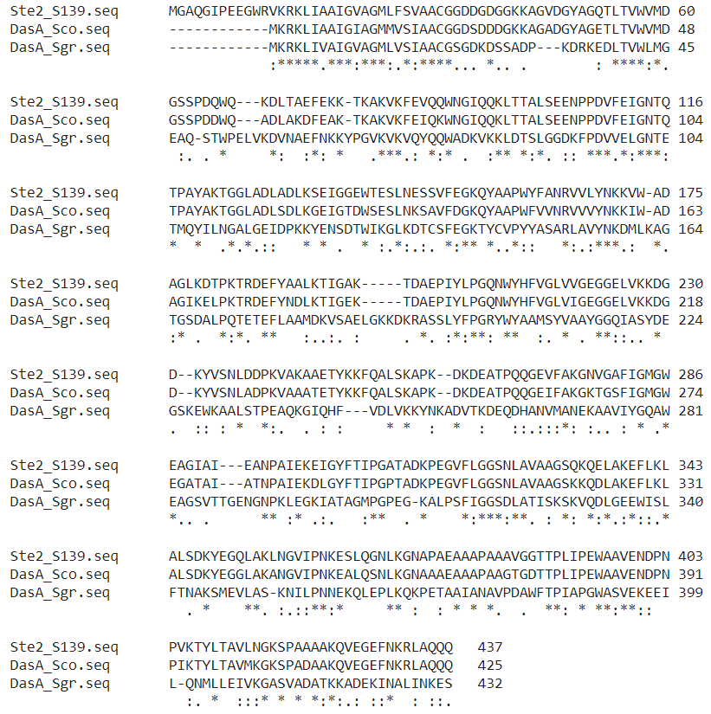

B.
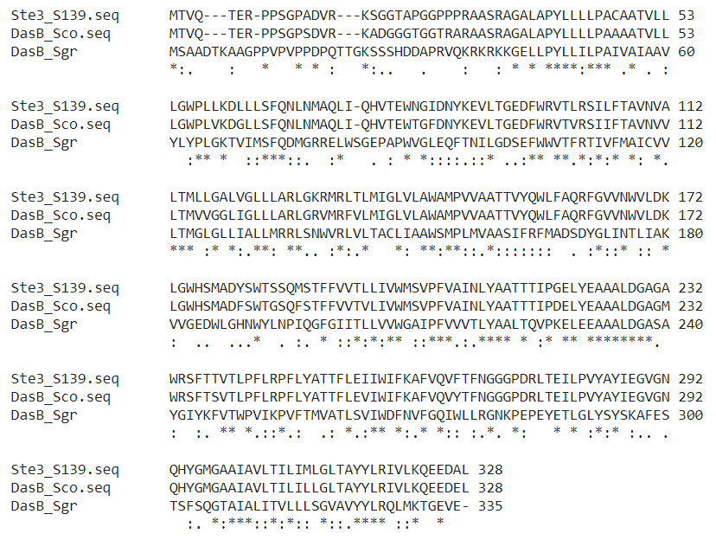

C.
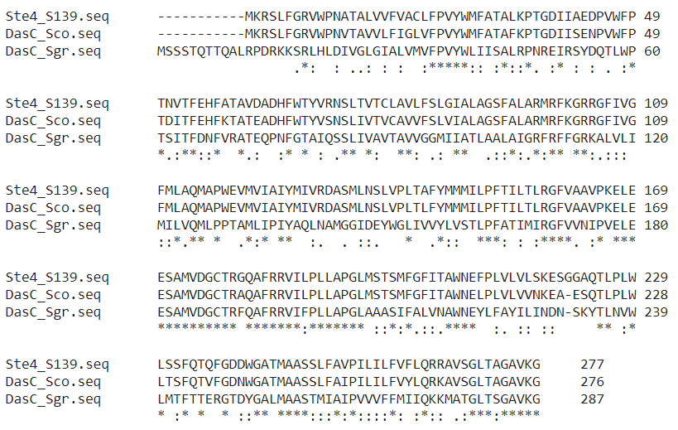

Supplementary Figure 2 Southern blotting analyses of the wild-type Streptomyces sp. 139 and Strain D2 (full length image of Figure 1B). (Line 2) Streptomyces sp. 139 chromosome DNA digested with BamHI and HindIII, (Line 3) Strain D2 chromosome DNA digested with BamHI. (M) DNA marker. A DIG-labeled F1 served as the hybridization probe. Note: Line 1, 4, and 5 were intended to demonstrate other questions and were not related to the current manuscript.

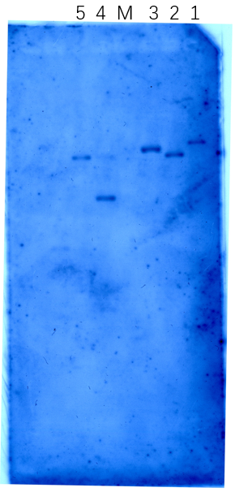

References
Bai L, Jiang R, Guo L, Zhang Y, Li Y. 2015. The Effects of ste3 and ste4 Genes Double Disruption in Ebosin Biosynthesis. China Biotechnol. 35: 23-28.

