Supplementary Materials for Li et al. Dietary lignans, plasma enterolactone levels, and metabolic risk: exploring the role of the gut microbiome

Supplementary Figure S1 Association between enterolactone and microbial community
(PERMANOVA with Bray-Curtis dissimilarities: R²=0.01044, P<0.001)
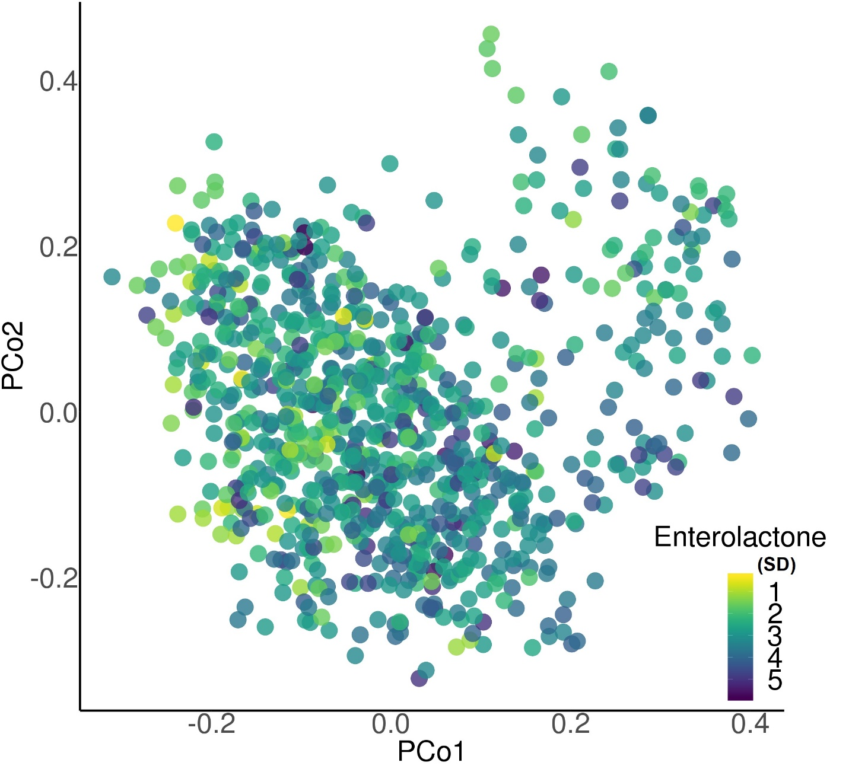

Supplemental Figure S2: Taxonomic tree with highlighted species that significantly associated with enterolactone concentrations
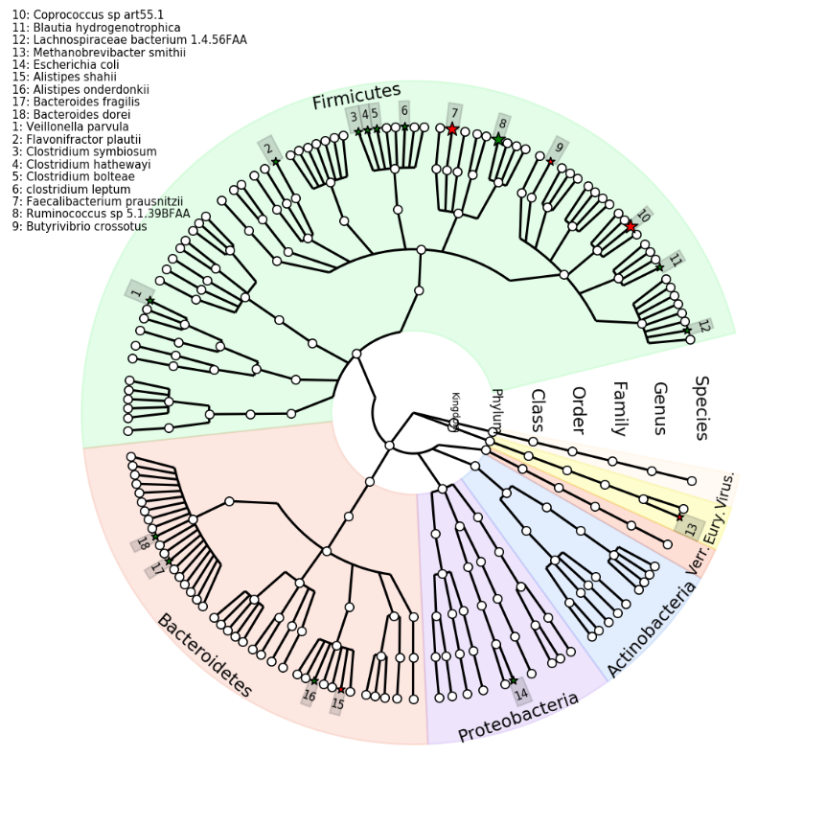
(Species were filled with red if increasing enterolactone was associated with a higher abundance; filled with green if increasing enterolactone was associated with a decreasing abundances of species; empty circles meant non-significant associations at FDR<0.05 level; stars mean the FDR<0.05. Generalized linear mixed-effects regressions implemented in MaAsLin2 were adjusted for repeated measurements (participants ID as random intercept), age, energy intake, alcohol, smoking, physical activity, using of antibiotics, consumed any probiotics and fecal sample characteristics.)

Supplemental Figure S3: Flowchart of participant enrollment.
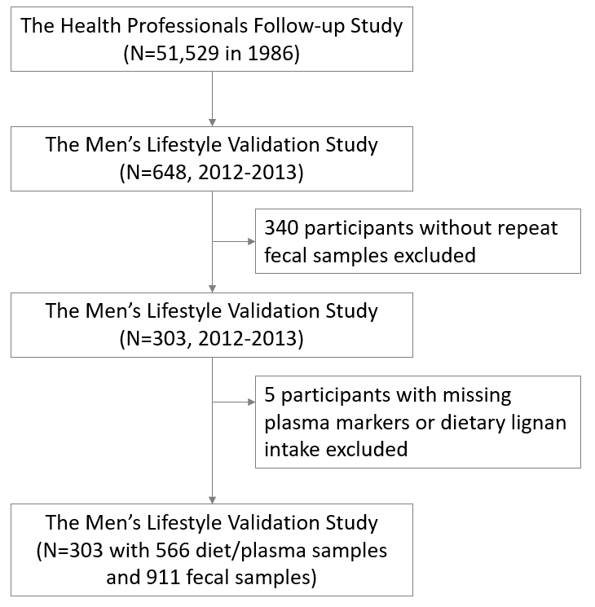

Supplementary Table S1 Multivariable-adjusted associations between plasma enterolactone and relative abundances of genetic predisposition of super pathways*
Super Pathways | N | beta coefficient² | SEM | P-value | P_{FDR}
Branched amino acid biosynthesis | 909 | 0.0068 | 0.0012 | <.0001 | <.0001
5-aminoimidazole ribonucleotide biosynthesis | 911 | 0.0050 | 0.0013 | 0.0001 | 0.002
L-isoleucine biosynthesis I | 910 | 0.0032 | 0.0008 | 0.0001 | 0.002
L-serine and glycine biosynthesis I | 907 | 0.0040 | 0.0012 | 0.0006 | 0.003
Purine nucleotides de novo biosynthesis I | 903 | 0.0030 | 0.0011 | 0.005 | 0.01
Aromatic amino acid biosynthesis | 910 | 0.0035 | 0.0013 | 0.008 | 0.02
L-lysine, l-threonine and l-methionine biosynthesis II | 911 | 0.0029 | 0.0011 | 0.008 | 0.02
Hexuronide and hexuronate degradation | 906 | 0.0025 | 0.0010 | 0.009 | 0.02
Thiamin diphosphate biosynthesis III (eukaryotes) | 908 | 0.0023 | 0.0009 | 0.010 | 0.02
Polyamine biosynthesis I | 893 | 0.0023 | 0.0009 | 0.01 | 0.03
Purine nucleotides de novo biosynthesis II | 900 | 0.0022 | 0.0009 | 0.02 | 0.04
ß-D-glucuronide and D-glucuronate degradation | 907 | 0.0022 | 0.0010 | 0.03 | 0.0478
Histidine, purine, and pyrimidine biosynthesis | 887 | 0.0024 | 0.0011 | 0.03 | 0.0496
Purine nucleotide salvage | 878 | -0.0064 | 0.0014 | <.0001 | 0.0003
Unsaturated fatty acids biosynthesis (e. coli) | 684 | -0.0049 | 0.0012 | <.0001 | 0.0009
Mycolate biosynthesis | 684 | -0.0051 | 0.0012 | <.0001 | 0.001
Purine deoxyribonucleosides degradation | 896 | -0.0040 | 0.0010 | 0.0001 | 0.002
L-phenylalanine biosynthesis | 501 | -0.0054 | 0.0014 | 0.0001 | 0.002
Heme biosynthesis from uroporphyrinogen-iii | 282 | -0.0020 | 0.0005 | 0.0003 | 0.002
Demethylmenaquinol-6 biosynthesis I | 190 | -0.0028 | 0.0008 | 0.0003 | 0.002
Demethylmenaquinol-9 biosynthesis | 190 | -0.0028 | 0.0008 | 0.0003 | 0.002
Menaquinol-9 biosynthesis | 190 | -0.0033 | 0.0009 | 0.0003 | 0.002
Menaquinol-6 biosynthesis I | 190 | -0.0033 | 0.0009 | 0.0003 | 0.002
Menaquinol-10 biosynthesis | 190 | -0.0033 | 0.0009 | 0.0003 | 0.002
Allantoin degradation In plants | 182 | -0.0010 | 0.0003 | 0.0006 | 0.003
(Kdo)2-lipid A biosynthesis | 203 | -0.0015 | 0.0004 | 0.0006 | 0.003
Methylglyoxal degradation | 207 | -0.0016 | 0.0005 | 0.0006 | 0.003
Cytosolic glycolysis (plants), pyruvate dehydrogenase and TCA cycle | 239 | -0.0022 | 0.0007 | 0.001 | 0.006
Glyoxylate cycle and fatty acid degradation | 276 | -0.0022 | 0.0007 | 0.002 | 0.009
Ubiquinol-8 biosynthesis (prokaryotic) | 211 | -0.0015 | 0.0005 | 0.003 | 0.009
N-acetylneuraminate degradation | 888 | -0.0023 | 0.0008 | 0.003 | 0.009
Fatty acid biosynthesis Initiation (e. coli) | 716 | -0.0031 | 0.0010 | 0.003 | 0.009
L-alanine biosynthesis | 686 | -0.0033 | 0.0011 | 0.002 | 0.009
Menaquinol-11 biosynthesis | 509 | -0.0039 | 0.0013 | 0.002 | 0.009
Menaquinol-12 biosynthesis | 509 | -0.0039 | 0.0013 | 0.002 | 0.009
Menaquinol-13 biosynthesis | 509 | -0.0039 | 0.0013 | 0.002 | 0.009
Phylloquinol biosynthesis | 502 | -0.0023 | 0.0008 | 0.004 | 0.01
Glycolysis, pyruvate dehydrogenase, TCA, and glyoxylate bypass | 343 | -0.0027 | 0.0009 | 0.003 | 0.01
Unstratified superpathway of heme biosynthesis from glutamate | 575 | -0.0023 | 0.0008 | 0.004 | 0.01
Glyoxylate bypass and TCA | 346 | -0.0022 | 0.0008 | 0.005 | 0.01
Heme biosynthesis from glycine | 201 | -0.0012 | 0.0005 | 0.007 | 0.02
Glycol metabolism and degradation | 245 | -0.0014 | 0.0005 | 0.007 | 0.02
Glucose and xylose degradation | 859 | -0.0030 | 0.0011 | 0.008 | 0.02
L-tryptophan biosynthesis | 181 | -0.0027 | 0.0010 | 0.008 | 0.02
Phospholipid biosynthesis I (bacteria) | 886 | -0.0038 | 0.0014 | 0.009 | 0.02
Acetyl-COA biosynthesis | 409 | -0.0015 | 0.0006 | 0.01 | 0.02
Hexitol degradation (bacteria) | 885 | -0.0025 | 0.0010 | 0.01 | 0.03
Guanosine nucleotides de novo biosynthesis I | 906 | -0.0034 | 0.0013 | 0.01 | 0.03
Menaquinol-8 biosynthesis I | 267 | -0.0024 | 0.0010 | 0.01 | 0.03
Demethylmenaquinol-8 biosynthesis | 267 | -0.0021 | 0.0008 | 0.01 | 0.03
L-tyrosine biosynthesis | 337 | -0.0029 | 0.0012 | 0.02 | 0.03
Fatty acids biosynthesis (e. coli) | 270 | -0.0026 | 0.0011 | 0.02 | 0.03
D-glucarate and d-galactarate degradation | 224 | -0.0010 | 0.0005 | 0.02 | 0.04
Fucose and rhamnose degradation | 450 | -0.0024 | 0.0010 | 0.02 | 0.04
Guanosine nucleotides de novo biosynthesis II | 906 | -0.0026 | 0.0012 | 0.03 | 0.049
Abbreviation: N means the number of samples (out of the 911 samples) with the species detected.
¹Analyzed using MaAsLin 2 adjusted for repeated measurements (participant ID as random intercept), age, energy intake, alcohol, smoking, physical activity, using of antibiotics, consumed any probiotics, body mass index at age 21 and fecal sample characteristics.
²beta coefficients: relative abundance of super pathways associated with per standard deviation of enterolactone levels, where enterolactone is batch-corrected log-transformed and in unit of per standard deviation; relative abundance of super pathways were standardized and normalized via arc-sin square root transformation. P_{FDR}: P values after false discovery rate (FDR) correction following the Benjamini–Hochberg method; Table S1 listed all species with a P_{FDR} below 0.05.

Supplementary Table S3 Plasma metabolites significantly associated with enterolactone-predicting species.
Species | Metabolites  (HMDBID#) | Correlation Coefficient | Raw  P value | P_{FDR}
Methanobrevibacter smithii | Cinnamoylglycine (HMDB0011621) | 0.35 | <0.001 | <0.001
Methanobrevibacter smithii | Hippurate (HMDB0000714) | 0.27 | <0.001 | <0.001
Methanobrevibacter smithii | Trigonelline (HMDB0000875) | 0.20 | <0.001 | 0.001
Lachnospiraceae bacterium 1 4 56FAA | Cinnamoylglycine (HMDB0011621) | -0.30 | <0.001 | <0.001
Lachnospiraceae bacterium 1 4 56FAA | Hippurate (HMDB0000714) | -0.23 | <0.001 | <0.001
Lachnospiraceae bacterium 1 4 56FAA | N-acetylleucine (HMDB0011756) | 0.23 | <0.001 | <0.001
Lachnospiraceae bacterium 1 4 56FAA | Glycodeoxycholate/glycoche (HMDB0000631) | 0.22 | <0.001 | <0.001
Flavonifractor plautii | Cinnamoylglycine (HMDB0011621) | -0.26 | <0.001 | <0.001
Flavonifractor plautii | Hippurate (HMDB0000714) | -0.24 | <0.001 | <0.001
Flavonifractor plautii | Hydroxycotinine (HMDB0001390) | -0.20 | <0.001 | 0.001
Coprococcus sp. ART55/1 | Cinnamoylglycine (HMDB0011621) | 0.21 | <0.001 | <0.001
Clostridium symbiosum | Cinnamoylglycine (HMDB0011621) | -0.28 | <0.001 | <0.001
Clostridium symbiosum | Hippurate (HMDB0000714) | -0.26 | <0.001 | <0.001
Clostridium symbiosum | N-acetylleucine (HMDB0011756) | 0.21 | <0.001 | <0.001
Clostridium bolteae | N-acetylleucine (HMDB0011756) | 0.24 | <0.001 | <0.001
Clostridium bolteae | Cinnamoylglycine (HMDB0011621) | -0.24 | <0.001 | <0.001
Clostridium bolteae | Hippurate (HMDB0000714) | -0.24 | <0.001 | <0.001
Butyrivibrio crossotus | C18:2 LPC (HMDB0010386) | 0.24 | <0.001 | <0.001
Butyrivibrio crossotus | Trigonelline (HMDB0000875) | 0.22 | <0.001 | <0.001
Butyrivibrio crossotus | Cinnamoylglycine (HMDB0011621) | 0.22 | <0.001 | <0.001
Butyrivibrio crossotus | C18:1 LPC (HMDB0002815) | 0.20 | <0.001 | 0.001
Butyrivibrio crossotus | C18:2 LPE (HMDB0011507) | 0.20 | <0.001 | 0.001
Blautia hydrogenotrophica | Pipecolic acid (HMDB0000070) | -0.28 | <0.001 | <0.001
Blautia hydrogenotrophica | Hydroxycotinine (HMDB0001390) | -0.21 | <0.001 | <0.001
Bacteroides dorei | 2-aminohippuric acid (HMDB0001867) | 0.22 | <0.001 | <0.001
Blautia hydrogenotrophica | 5-acetylamino-6-amino-3-methyluracil (HMDB0004400) | 0.20 | <0.001 | 0.001
R²: Spearman Partial Correlation adjusted for age, energy intake, alcohol, smoking, physical activity, using of antibiotics, consumed any probiotics, body mass index at age 21 and fecal sample characteristics.

