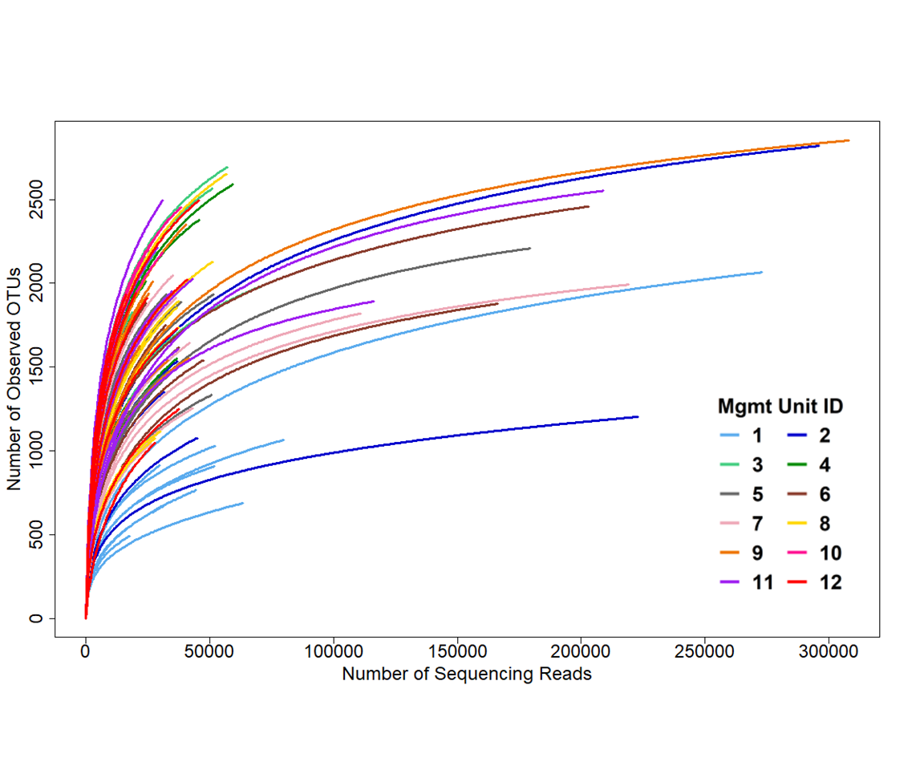
Figure S1. Rarefaction curves showing “Number of Observed OTUs” as a function of “Number of Sequencing Reads” for each sample. The curves were colored by management unit.

