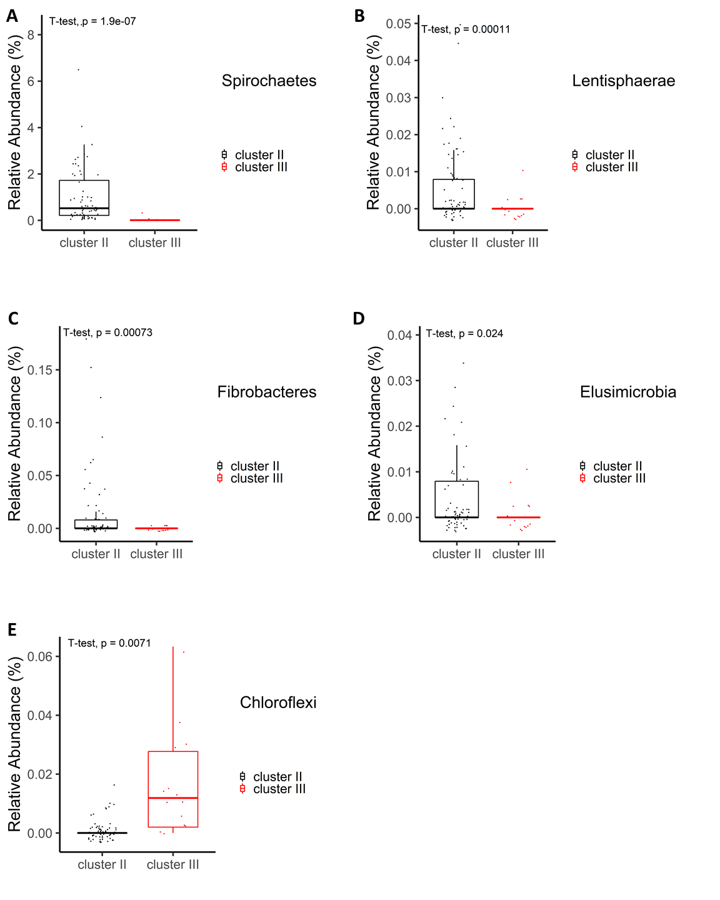
Figure S2. Boxplot of five additional phyla with low relative abundances showing significant difference between two clusters in Fig.4A. (A) Spirochaetes (B) Lentisphaerae (C) Fibrobacteres (D) Elusimicrobia (E) Chloroflexi.

