Virion enrichment, viral DNA extraction, and L. sakei phage TMW 1.1393 P1 DNA digestion (EcoRI)

Spectrophotometric protein quantification (after Bradford), and nucleic acid quantification of enriched phage solution.

Figure 1 Standard curve constructed using different bovine serum albumin (BSA) concentrations
Table 1 Spectrophotometric measurements of different bovine serum albumin (BSA) concentrations measured at 595 nm for the construction of the standard curve
 |  | OD₅₉₅
Vial | final conc. BSA [µg/ml] | value 1 | value 2 | MEAN | BLANK corrected (-I_{MEAN})
A | 2000 | 1.940 | 1.923 | 1.932 | 1.412
B | 1500 | 1.795 | 1.743 | 1.769 | 1.249
C | 1000 | 1.567 | 1.537 | 1.552 | 1.032
D | 750 | 1.346 | 1.322 | 1.334 | 0.814
E | 500 | 1.131 | 1.123 | 1.127 | 0.607
F | 250 | 0.860 | 0.887 | 0.874 | 0.354
G | 125 | 0.705 | 0.715 | 0.710 | 0.190
H | 25 | 0.550 | 0.552 | 0.551 | 0.031
I =BLANK | 0 | 0.517 | 0.523 | 0.520

Table 2 Protein concentrations of enriched phage solutions obtained after PEG8000/NaCl precipitation calculated by using the formula of Figure 1.
 | OD₅₉₅
Phage solutions (L. sakei strain) | value 1 | value 2 | OD₅₉₅  MEAN | BLANK corrected  OD₅₉₅ | final protein conc. calculated [µg/ml]
TMW 1.23 | 0.624 | 0.612 | 0.618 | 0.098 | 81.6
TMW 1.46 | 0.664 | 0.660 | 0.662 | 0.142 | 96.4
TMW 1.1290 | 1.162 | 1.179 | 1.171 | 0.651 | 504.9
TMW 1.1386 | 0.842 | 0.856 | 0.849 | 0.329 | 195.9
TMW 1.1393 | 0.795 | 0.797 | 0.796 | 0.276 | 161.7
TMW 1.1397 | 0.635 | 0.640 | 0.638 | 0.118 | 87.8
TMW 1.1398 | 0.936 | 0.961 | 0.949 | 0.429 | 272.9

Table 3 Amount and purity of extracted DNA measured with the NanoDrop® ND-1000 (Peqlab) spectrophotometer after phenol chloroform extraction of enriched phage solutions.
L. sakei strain | c(DNA) [ng/µl] | A₂₆₀/A₂₈₀ | A₂₆₀/A₂₃₀
TMW 1.23 | 42.6 | 1.82 | 1.66
TMW 1.46 | 10.2 | 1.64 | 1.40
TMW 1.1290 | 1385.5 | 1.99 | 2.44
TMW 1.1386 | 260.2 | 1.95 | 2.13
TMW 1.1393 | 150.7 | 1.89 | 2.11
TMW 1.1397 | 93.2 | 1.89 | 2.12
TMW 1.1398 | 396.0 | 1.97 | 2.41

EcoRI digestion of TMW 1.1393 P1 DNA after extraction from an enriched phage solution as proof of genome circularity.
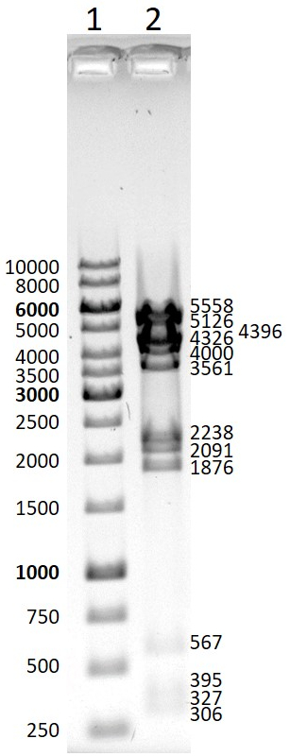
Figure 2 Digestion of viral TMW 1.1393 P1 DNA via EcoRI. 1: GeneRuler 1 kb DNA Ladder (Thermo Scientific). 2: 800 ng viral TMW 1.1393 P1 DNA + EcoRI (fast digest; Thermo Scientific). All expected fragments (fragment lengths including overhang: 306, 327, 395, 567, 1876, 2091, 2238, 3561, 4000, 4326, 4396, 5126, 5558) were present after digestion via EcoRI, indicating circularity of the phage genome inside the virions.

