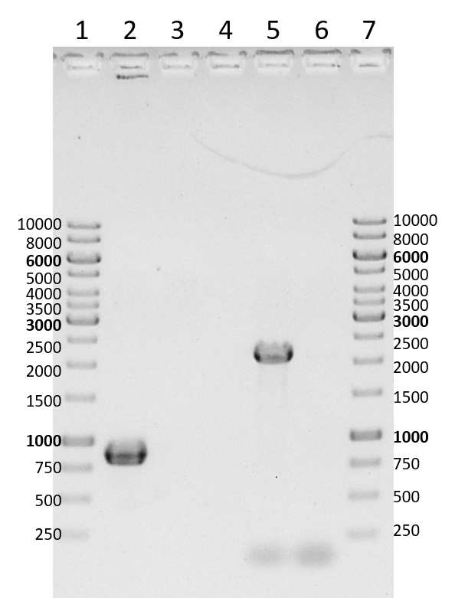
Figure S1 PCR-mediated DNA amplification, verifying circularization of both prophages (TMW 1.46 P1 and TMW 1.46 P2) within a non-induced cryo stock of L. sakei TMW 1.46, visualised by agarose gel electrophoresis. “1” + “7”: GeneRuler 1 kb DNA Ladder (Thermo Scientific). “2”: TMW 1.46 P1 circularization. “3”: Negative control for “2” (water instead of a washed cryo culture). “4”: Empty. “5”: TMW 1.46 P2 circularization. “6”: Negative control for “5” (water instead of a washed cryo culture).

