Supplementary Materials
Insight into Metabolic and Pharmacological Profiling of Aspergillus ficuum through Bioinformatics and Experimental Techniques
Zafar Ali Shah^{1,2}, Khalid Khan^{1*}, Haroon Ur Rashid³, Tanzeel Shah⁴, Mariusz Jaremko^{5*}, Zafar Iqbal²
^{1*}Department of Chemistry, Islamia College, Peshawar, KP, Pakistan
²Department of Agricultural Chemistry & Biochemistry, University of Agriculture, Peshawar, KP, Pakistan
³Department of Chemistry, Federal University of Santa Catarina, Florianopolis, SC, Brazil.
⁴Institute of Basic Medical Sciences, Khyber Medical University, Peshawar, KP, Pakistan
^{5*}Biological and Environmental Science and Engineering Division, King Abdullah University of Science and Technology, Thuwal, Makkah Province, 23955-6900, Saudi Arabia
*Corresponding authors E-mail addresses: drkhalidchem@yahoo.com, Mariusz.jaremko@kaust.edu.sa

Table of contents
- Fig. S1 Structures of docked ligands (L1-L9).
- Fig. S2 Percentage antioxidant activity of n-hexane and ethyl acetate fractions.
- Fig. S3 (A) Oral administration of AF extract, (B) Injection of carrageenan in paw, (C, D, E) measurement of Paw edema at regular intervals.
- Fig. S4 (A) 2D and (B) 3D interactions of L5 with DNA-polymerase enzymes of bacillus subtilis.
- Fig. S5 (A, C, E) 2D and (B, D, F) 3D interactions of L7, L8 and L9 with DNA-polymerase enzymes of bacillus subtilis, respectively.
- Fig. S6 (A, C, E, G) 2D and (B, D, F, H) 3D interactions of L1, L2, L3 and L4 with DNA-polymerase enzymes of bacillus subtilis, respectively.
- Fig. S7 (A, C, E) 2D and (B, D, F) 3D interactions of L7, L8, L9 and COX-2, respectively.
- Fig. S8 A, C, E, G) 2D and (B, D, F, H) 3D interactions of L1, L2, L3, L4 and L5 with COX-2, respectively.
- Table S1 Complete detail of LC-MS-QTOF analysis of Aspergillus ficuum
- Table S2 Complete detail of GC-MS analysis of Aspergillus ficuum
- Table S3 Nature, distance and energy of interactions of secondary metabolites (L1-L9) with receptor 4TR6.
- Table S4 Nature, distance and energy of interactions of secondary metabolites (L1-L9) with receptor 5JVZ.

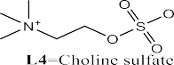
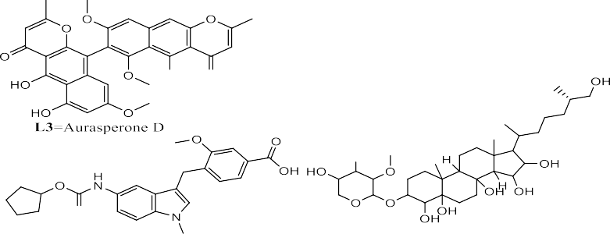

Fig. S1 Structures of docked ligands (L1-L9).

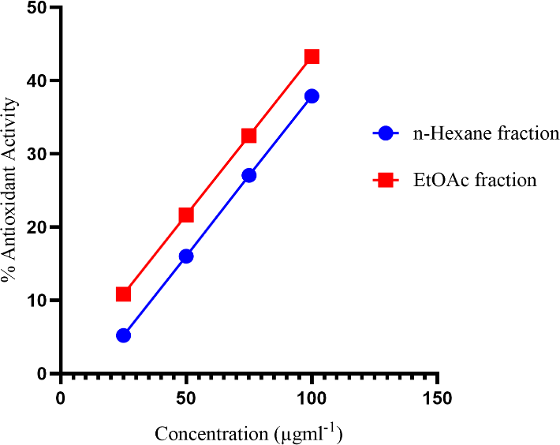

Fig. S2 Percentage antioxidant activity of n-hexane and ethyl acetate fractions.

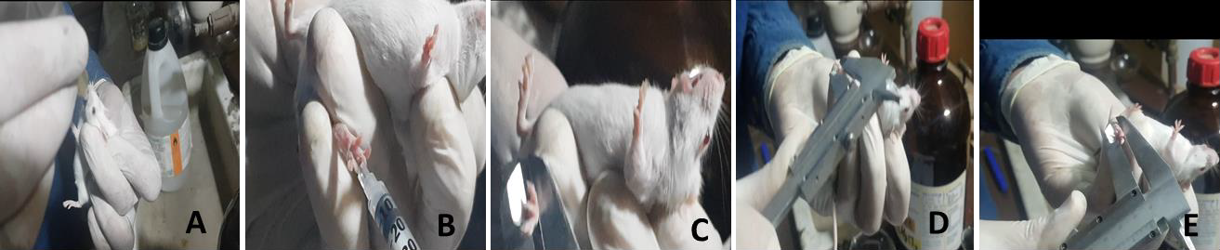

Fig. S3 (A) Oral administration of AF extract, (B) Injection of carrageenan in paw, (C, D, E) measurement of Paw edema at regular intervals.

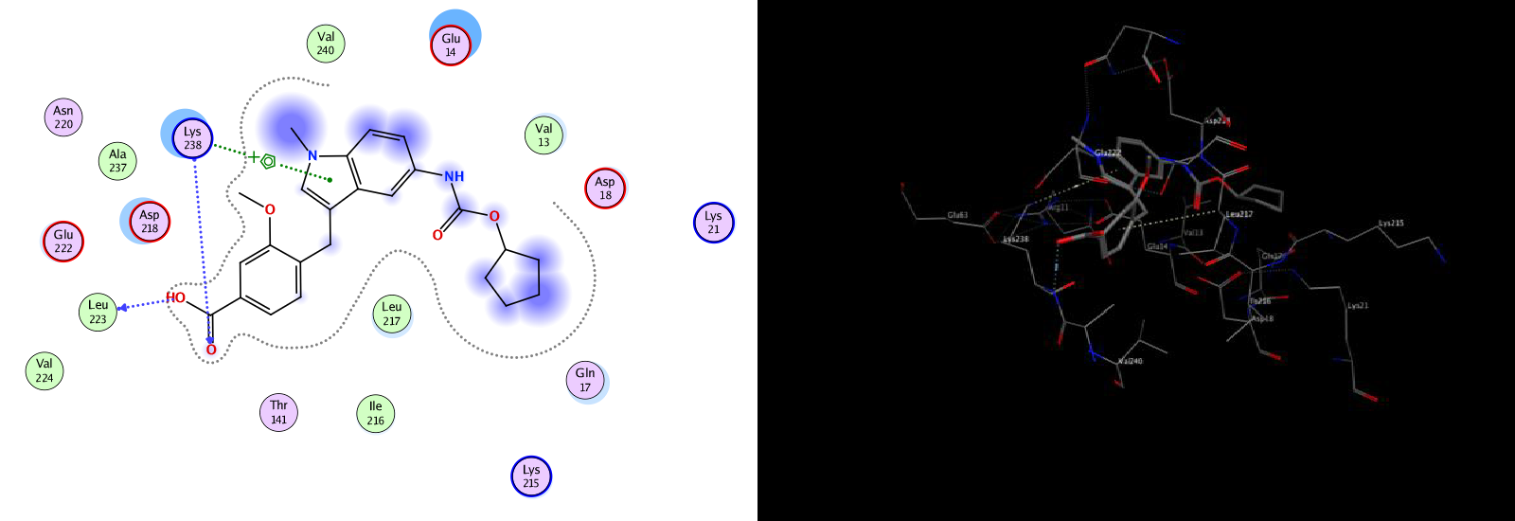
A
B

Fig. S4 (A) 2D and (B) 3D interactions of L5 with DNA-polymerase enzymes of bacillus subtilis.

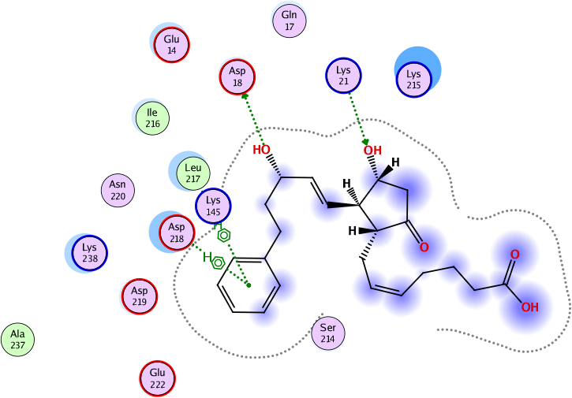
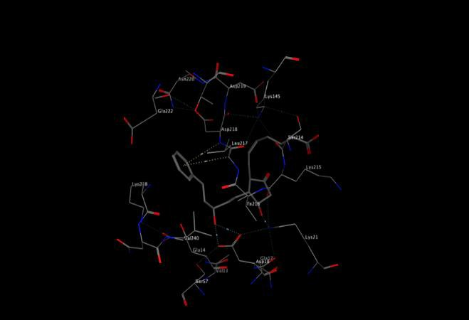
A
B

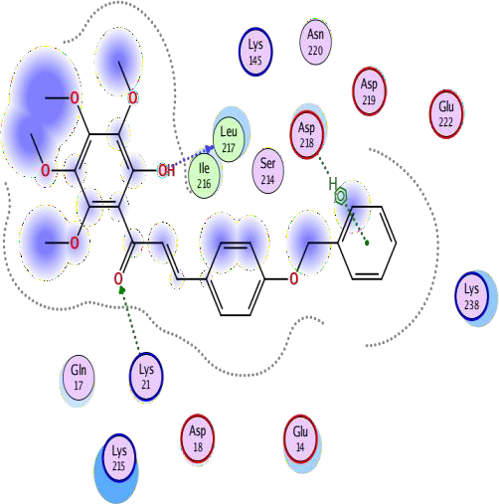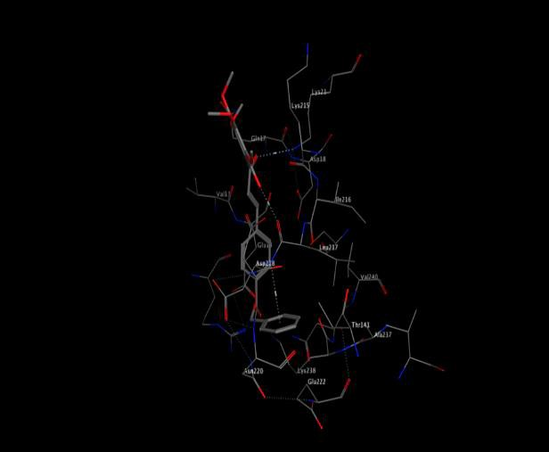
C
D

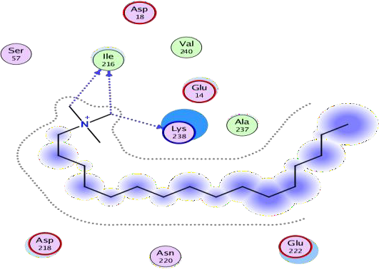
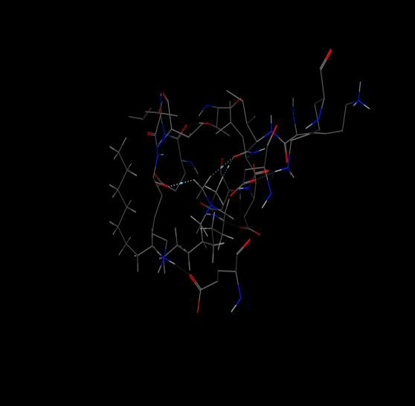
E
F

Fig. S5 (A, C, E) 2D and (B, D, F) 3D interactions of L7, L8 and L9 with DNA-polymerase enzymes of bacillus subtilis, respectively.
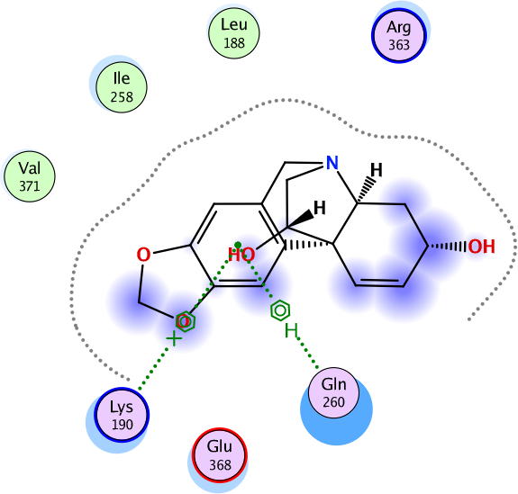
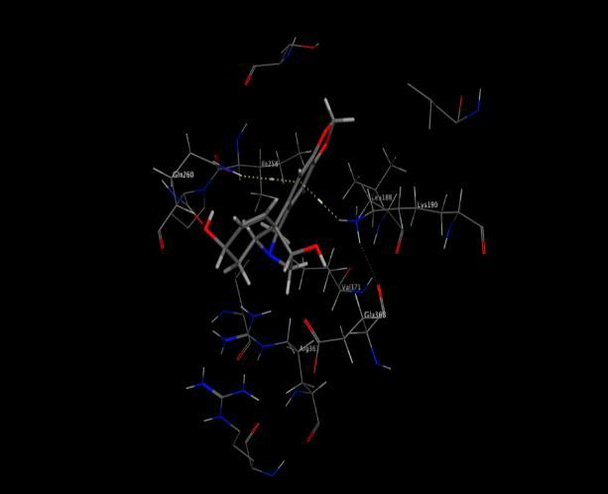
A
B

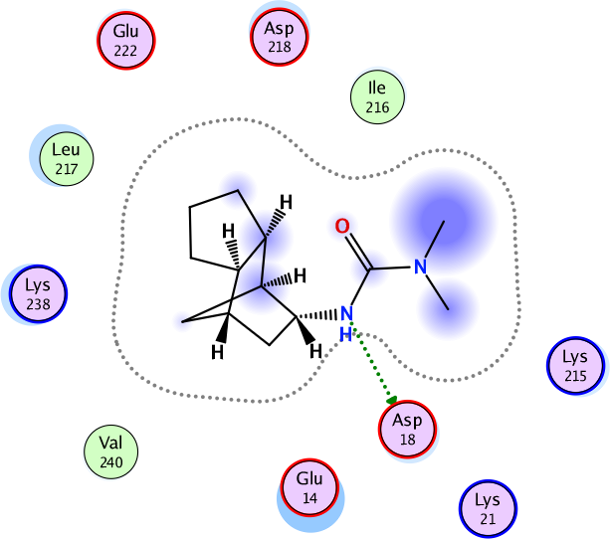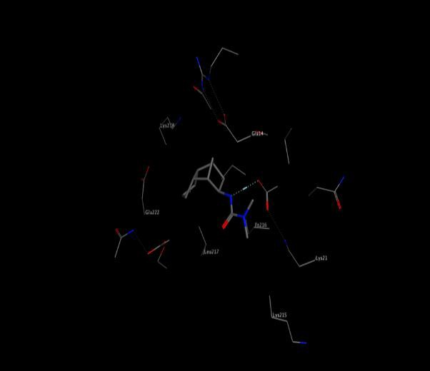
C
D

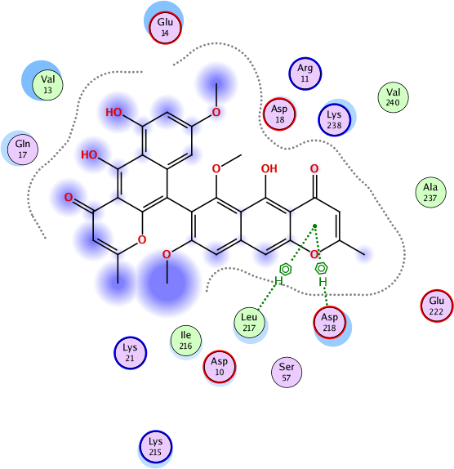
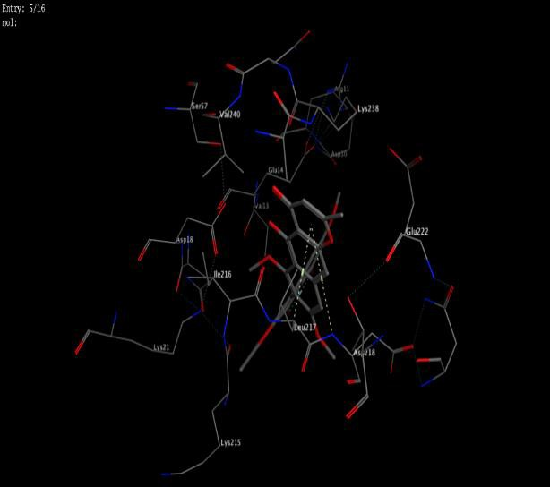
E
F

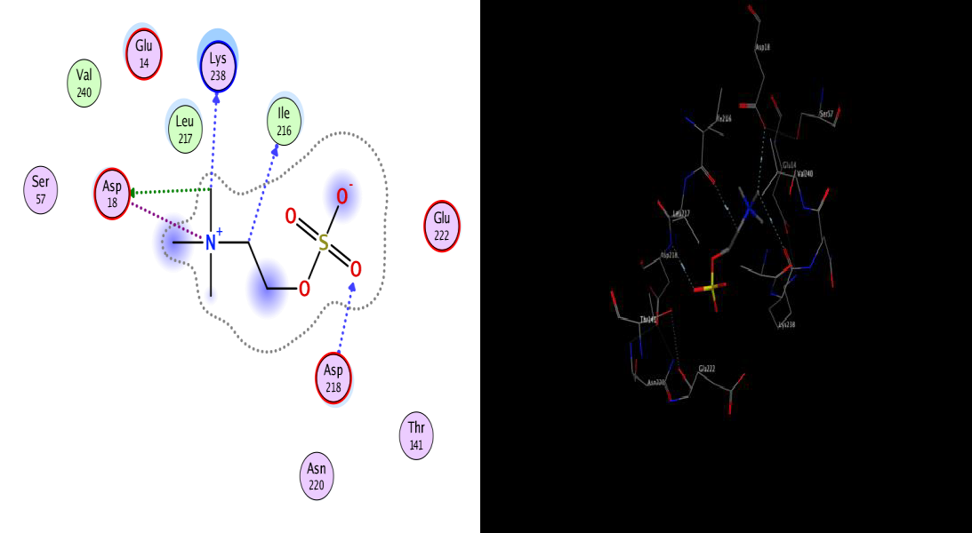
G
H

Fig. S6 (A, C, E, G) 2D and (B, D, F, H) 3D interactions of L1, L2, L3 and L4 with DNA-polymerase enzymes of bacillus subtilis, respectively.

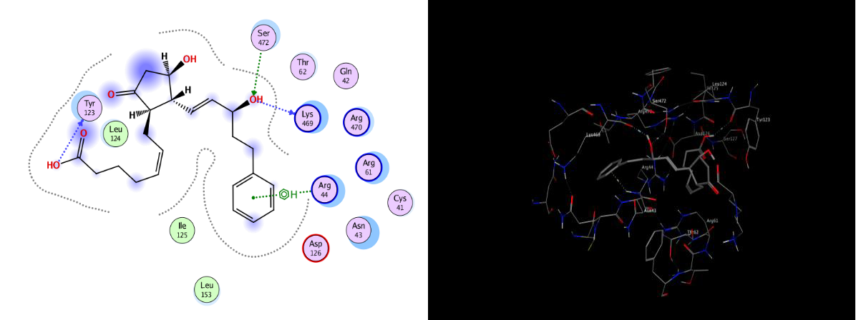
A
B
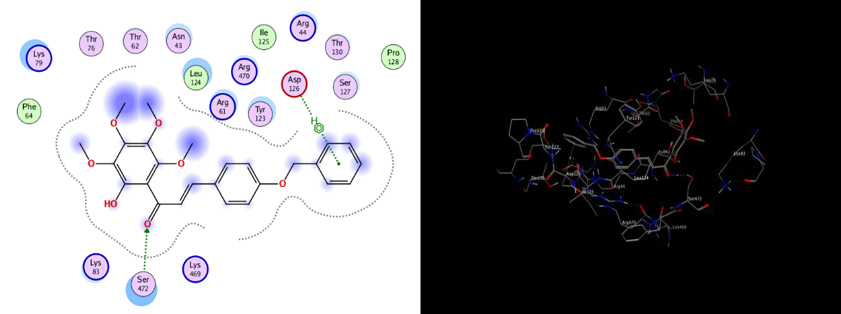
C
D

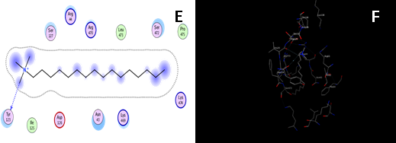

Fig. S7 (A, C, E) 2D and (B, D, F) 3D interactions of L7, L8, L9 and COX-2, respectively.

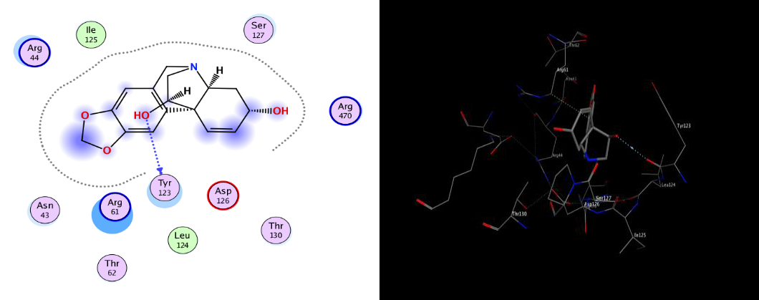
A
B

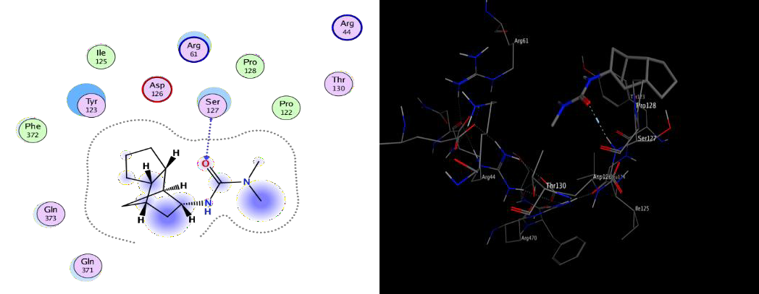
C
D

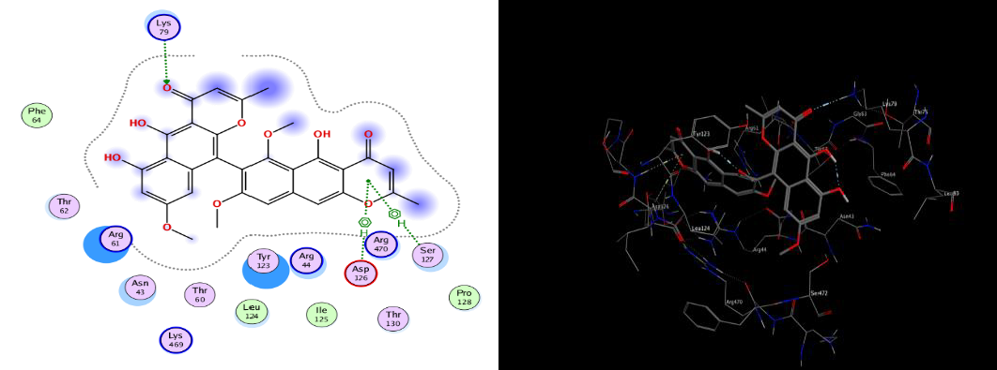
E
F

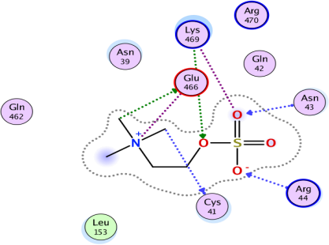
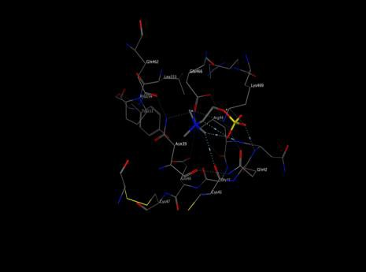
G
H

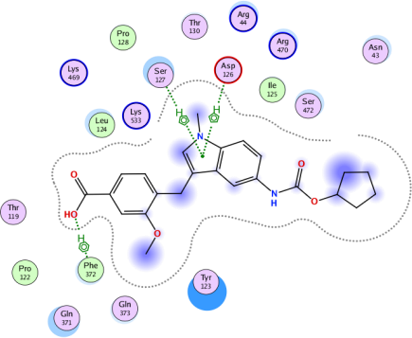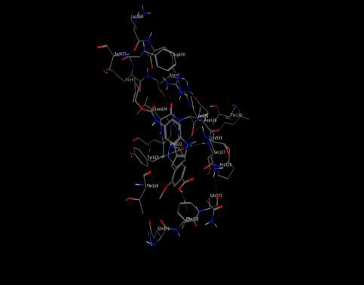
I
J

Fig. S8 A, C, E, G) 2D and (B, D, F, H) 3D interactions of L1, L2, L3, L4 and L5 with COX-2, respectively.

Table S1 Original file provided in MS Excel as a separate supplementary material

Table S2 Original file provided in MS Excel as a separate supplementary material

Table S3 Nature, distance and energy of interactions of secondary metabolites (L1-L9) with receptor 4TR6.

Ligand | Nature of interaction | Distance (A0) | E (Kcalmol-1)
L1 | pi-cation | 3.56 | -1.9
L1 | pi-H | 4.53 | -0.6
L2 | H-donor | 2.97 | -3.3
L3 | pi-H | 4.18 | -1.6
L3 | pi-H | 4.11 | -1.0
L4 | H-donor | 3.15 | -1.6
L4 | H-donor | 3.31 | -0.8
L4 | H-donor | 3.52 | -0.8
L4 | H-acceptor | 3.15 | -3.4
L4 | Ionic | 3.98 | -0.5
L5 | H-donor | 2.85 | -1.0
L5 | H-acceptor | 2.63 | -1.1
L5 | pi-cation | 4.33 | -1.0
L6 | H-donor | 2.74 | -1.9
L6 | H-donor | 2.55 | -1.2
L6 | H-donor | 2.90 | -1.7
L6 | H-acceptor | 2.95 | -1.1
L7 | H-donor | 3.28 | -0.6
L7 | H-donor | 2.97 | -1.1
L7 | H-acceptor | 3.01 | -1.0
L7 | pi-H | 4.30 | -1.1
L7 | pi-H | 4.15 | -0.7
L8 | H-donor | 2.89 | -1.0
L8 | H-acceptor | 2.94 | -1.5
L8 | pi-H | 4.41 | -1.8
L9 | H-donor | 3.30 | -0.9
L9 | H-donor | 3.15 | -0.9
L9 | H-donor | 3.21 | -1.1

Table S4 Nature, distance and energy of interactions of secondary metabolites (L1-L9) with receptor 5JVZ.

Ligand | Nature of interaction | Distance (A0) | E (Kcalmol-1)
L1 | H-donor | 3.11 | -1.4
L2 | H-acceptor | 3.14 | -1.9
L3 | H-acceptor | 3.38 | -3.3
L3 | pi-H | 4.42 | -1.6
L3 | pi-H | 4.04 | -3.0
L4 | H-donor | 3.12 | -1.4
L4 | H-donor | 3.21 | -0.9
L4 | H-acceptor | 2.99 | -0.9
L4 | H-acceptor | 3.06 | -1.0
L4 | H-acceptor | 2.73 | -5.1
L4 | ionic | 3.92 | -0.7
L4 | Ionic | 3.95 | -0.6
L5 | H-pi | 5.56 | -0.6
L5 | pi-H | 4.57 | -0.7
L5 | pi-H | 4.13 | -1.0
L6 | H-donor | 3.15 | -1.3
L6 | H-donor | 3.19 | -1.3
L6 | H-acceptor | 2.65 | -1.5
L7 | H-donor | 3.05 | -0.7
L7 | H-donor | 2.91 | -2.1
L7 | H-acceptor | 3.12 | -0.6
L7 | pi-H | 3.40 | -1.0
L8 | H-acceptor | 3.10 | -0.9
L8 | pi-H | 3.98 | -0.8
L9 | H-donor | 3.35 | -0.8

