Fig. S1 Krona diagram of all species classification. The circle of species classification represents the five classification levels of phylum, class, order, family and genus from inside to outside. The size of the fan reflects the relative abundance of different taxons.

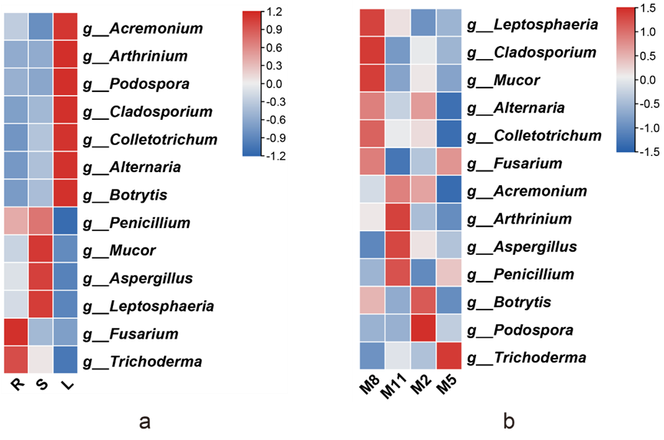
Fig. S2 Heat map of relative abundance of 13 genera of HupA-producing endophytic fungi (a) in three tissues (R, root; S, stem; L, leaf) and (b) four seasons (M8, August; M11, November; M2, February; M5, May).

Table S1 The negative correlation of HupA content with endophytic fungi within H. serrata (p<0.05).
Genus | Spearman’s correlation coefficient | Significance（p）
Cadophora | -0.648342 | 0.000019
Exophiala | -0.539611 | 0.000683
Gorgomyces | -0.496616 | 0.002064
Ilyonectria | -0.485125 | 0.002710
Sebacina | -0.482745 | 0.002864
Saitozyma | -0.445974 | 0.006408
Russula | -0.436634 | 0.007757
Trichocladium | -0.421975 | 0.010363
Lactifluus | -0.39944 | 0.015801
Metarhizium | -0.371738 | 0.025589
Stemphylium | -0.36578 | 0.028244
Leohumicola | -0.364161 | 0.029003
Tremella | -0.360394 | 0.030835
Pichia | -0.349479 | 0.036685
Papiliotrema | -0.344445 | 0.039671

