Table S1: Screening for cytosine deaminase producing fungi.

Isolate  Code | Fungal isolate | Deamination activity  (μmol/min) | Protein (mg/ml) | Specific activity  (μmol/mg/min)
S1 | A. carneus | 330.04 ± 60.29 | 10.77 ± 0.28 | 30.64
S2 | A. flavus 1 | 352.50 ± 41.10 | 7.39 ± 0.01 | 47.70
S3 | Penicillium sp 1 | 318.91 ± 48.95 | 9.09 ± 0.05 | 35.08
S4 | A. ochraceous 1 | 336.77 ± 24.01 | 10.00 ± 0.10 | 33.68
S5 | A. terreus | 309.08 ± 56.22 | 10.03 ± 0.06 | 30.82
S6 | A. flavipes | 318.80 ± 29.30 | 9.82 ± 0.05 | 32.46
S7 | A. nidulans | 344.54 ± 34.81 | 11.57 ± 0.24 | 29.78
Q1 | A. fumigatus 1 | 397.81 ± 26.01 | 8.33 ± 0.16 | 47.76
Q2 | A. ochraceous 2 | 367.12 ± 37.23 | 8.25 ± 0.08 | 44.50
Q3 | P. notatum | 172.55 ± 42.92 | 7.89 ± 0.01 | 21.87
Q4 | Fusarium oxysporum | 159.87 ± 16.05 | 4.98 ± 0.27 | 32.10
Q5 | P. expansum | 254.32 ± 23.07 | 6.62 ± 0.01 | 38.42
Q6 | Aspergillus sp 1 | 215.68 ± 22.33 | 8.01 ± 0.01 | 26.93
Q7 | Penicillium sp 2 | 197.07 ± 56.28 | 8.54 ± 0.07 | 23.08
Q8 | Fusarium sp | 186.94 ± 43.01 | 8.22 ± 0.05 | 22.74
Q9 | A. awamori | 257.73 ± 15.06 | 6.79 ± 0.05 | 37.96
Q10 | A. niger 1 | 334.86 ± 82.66 | 7.77 ± 0.02 | 43.10
M1 | A. carneus | 205.64 ± 30.70 | 6.40 ± 0.03 | 32.13
M2 | A. flavus 2 | 283.50 ± 23.04 | 6.45 ± 0.05 | 43.95
M3 | A. parasiticus | 334.86 ± 12.90 | 7.37 ± 0.02 | 45.43
M4 | Penicillium sp 3 | 220.26 ± 24.13 | 7.66 ± 0.01 | 28.75
M5 | A. fumigatus 2 | 195.95 ± 5.66 | 8.17 ± 0.03 | 23.98
M6 | A. flavus 3 | 189.19 ± 21.09 | 7.47 ± 0.14 | 25.33
M7 | Aspergillus sp 2 | 207.41 ± 36.80 | 7.12 ± 0.04 | 29.13
M8 | A. flavus 4 | 254.85 ± 38.70 | 8.53 ± 0.06 | 29.88
M9 | A. niger 2 | 375.68 ± 31.88 | 6.87 ± 0.08 | 54.68

Table S2: Substrate specificity of free and Dextran-CDA conjugates

Substrate | Substrate conc. (mM) | Free-CDA Relative activity% | Conjugated - CDA Relative activity %
Cytosine | 10 | 100.00 | 100.00
L-Arginine | 10 | 0.00 | 3.33
L-Asparagine | 10 | 0.00 | 0.00
L-Tyrosine | 10 | 0.00 | 3.33
L-Methionine | 10 | 5.83 | 0.00
L-Cysteine | 10 | 0.00 | 5.80
L-Glycine | 10 | 0.00 | 0.00
L-Phenylalanine | 10 | 9.17 | 4.35
L-Tryptophan | 10 | 4.17 | 9.28

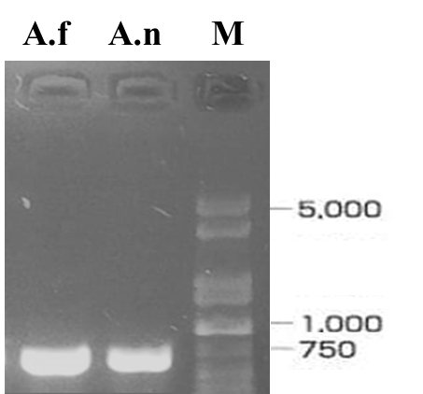

Fig. S1: PCR products of ITS region of A. niger (A.n.) and A. fumigatus (A.f) on 1.4 % agarose gel using genomic DNA as PCR template.

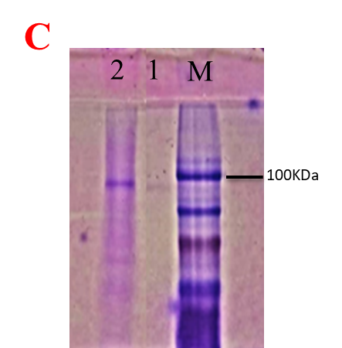
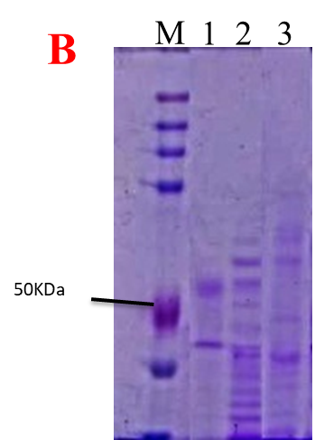
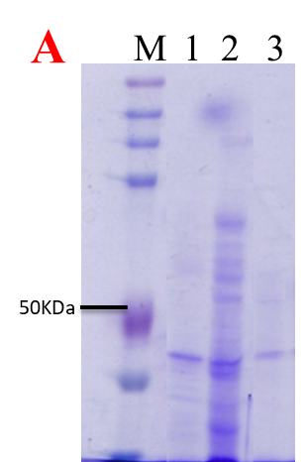

Fig. S2. SDS-PAGE profile of the purified and crude CDA from Aspergillus niger (A) and A. fumigatus (B). C, Is the native-PAGE profile of the purified CDA from A. fumigatus (Lane 1) and A. niger (Lane 2).

