Table S1. Features of genomes of eight PB-resistant K. pneumoniae isolates.
Genome | Genbank Accession | Genome Size (bp) | G+C (%) | Contigs (n) | CDS (n)
KP14 | SAMN27478462 | 5,616,838 | 57.16 | 133 | 5646
KP16 | SAMN27478463 | 5,538,404 | 57.49 | 107 | 5514
KP17 | SAMN27478464 | 5,865,303 | 57.01 | 131 | 5948
KP18 | SAMN27478465 | 5,685,521 | 57.18 | 127 | 5704
KP20 | SAMN27478466 | 5,684,219 | 57.16 | 134 | 5701
KP21 | SAMN27478467 | 5,866,112 | 57.01 | 133 | 5953
KP24 | SAMN27478468 | 5,693,187 | 57.09 | 140 | 5746
KP25 | SAMN27478469 | 5,863,695 | 57.01 | 129 | 5944

Table S2. Allelic profiles of eight PB-resistant K. pneumoniae isolates.
Strain | ST | gapA | infB | mdh | pgi | phoE | rpoB | tonB
KP14 | 11 | 3 | 3 | 1 | 1 | 1 | 1 | 4
KP16 | 5254 | 3 | 3 | 1 | 1 | 515 | 1 | 4
KP17 | 11 | 3 | 3 | 1 | 1 | 1 | 1 | 4
KP18 | 11 | 3 | 3 | 1 | 1 | 1 | 1 | 4
KP20 | 11 | 3 | 3 | 1 | 1 | 1 | 1 | 4
KP21 | 11 | 3 | 3 | 1 | 1 | 1 | 1 | 4
KP24 | 11 | 3 | 3 | 1 | 1 | 1 | 1 | 4
KP25 | 11 | 3 | 3 | 1 | 1 | 1 | 1 | 4

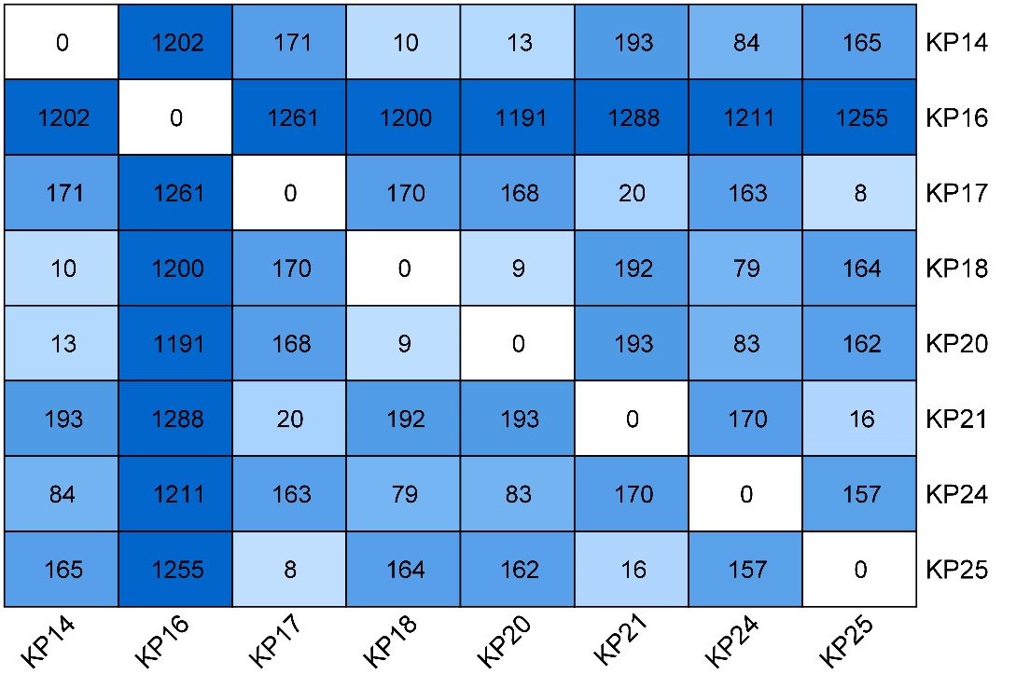
Figure S1. Paired SNP distance of eight PB-resistant K. pneumoniae isolates.
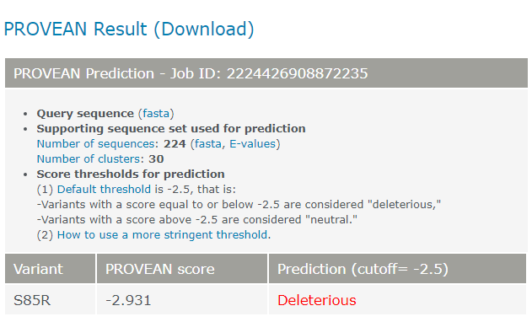
Figure S2. PROVEAN result shows the effect of S85R in PmrB.

