Additional Figure S 1 : Representation of molecular interaction, reaction, and relation networks in KEGG pathway map for the whole genome sequence of isolate BA04 through RAST annotation server.
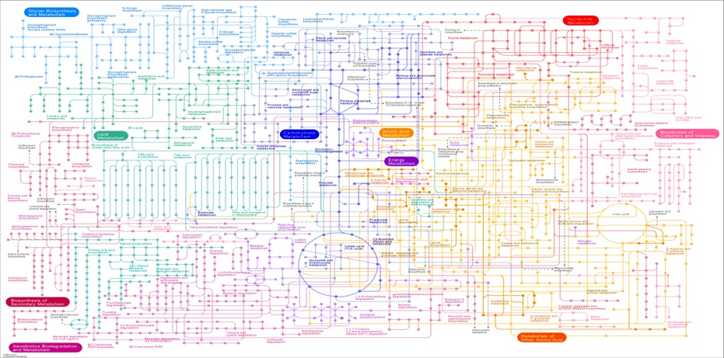

Additional Figure S2. Mortality of the Helicoverpa larvae on the artificial diet containing spores of B. thuringiensis strain BA04.

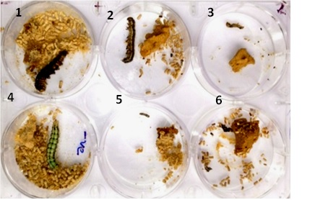

Insect on artificial diet having spores of BA04 1: 4th instar larvae , 2: 3rd instar larvae, 3: 2nd instar larvae, 5: 1st instar larvae, 6: Neonate after hatching.
4: 3rd instar larvae on diet with out spores of BA04
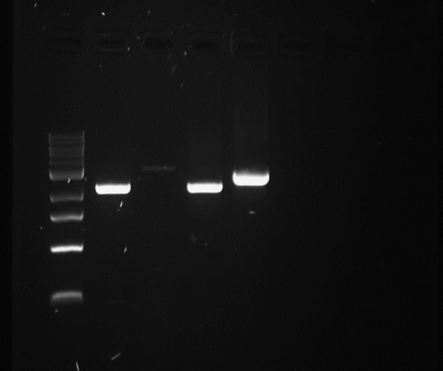
Original Figure 6: Amplification of full-length Cry gene of isolate BA04. Amplification was done using two different primer sets for the same gene. Lane M- 1kb DNA ladder, Lane 01- Amplified product of MH753362.1 using Primer 1A, Lane 02- Amplified product of MH753363.1 Primer 1B, Lane 01- Amplified product of MH753362.1 using Primer 1A.1, Lane 02- Amplified product of MH753363.1 using 1B.1

