Supplementary figure
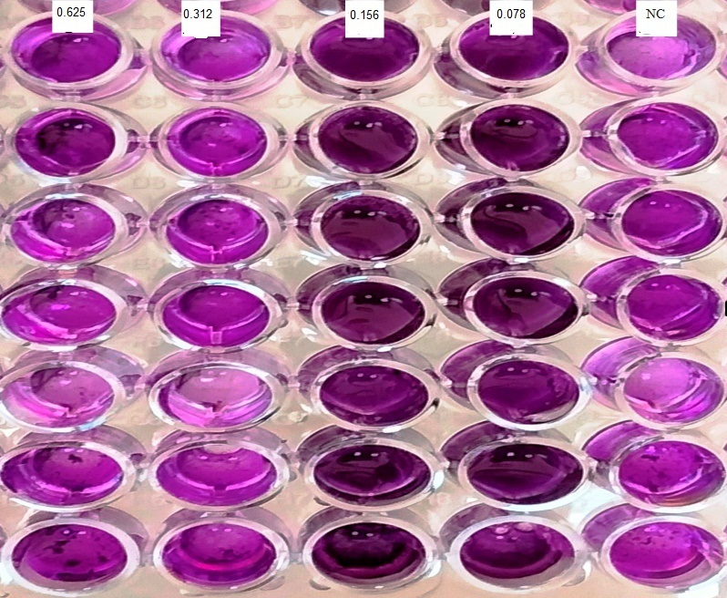
Supplementary figure S1: The effect of different vitamin C on biofilm formation. NC is the negative control. The lowest concentration that inhibits biofilm formation is 0.312mg/ml.

