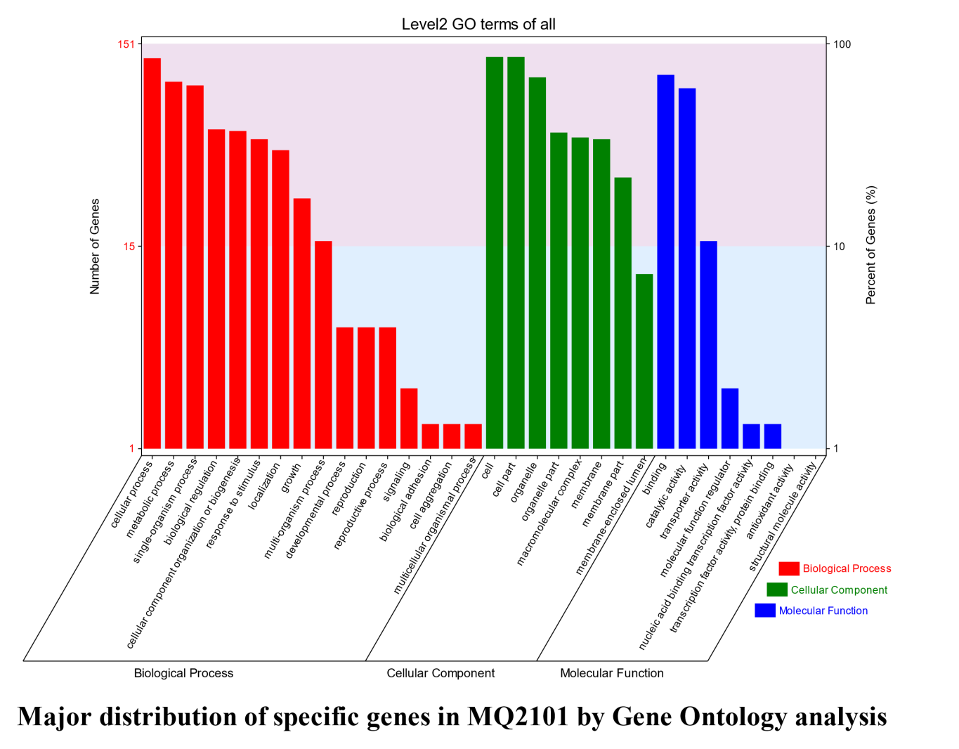
Figure S4. Major distribution of specific genes in MQ2101 by Gene Ontology analysis.

