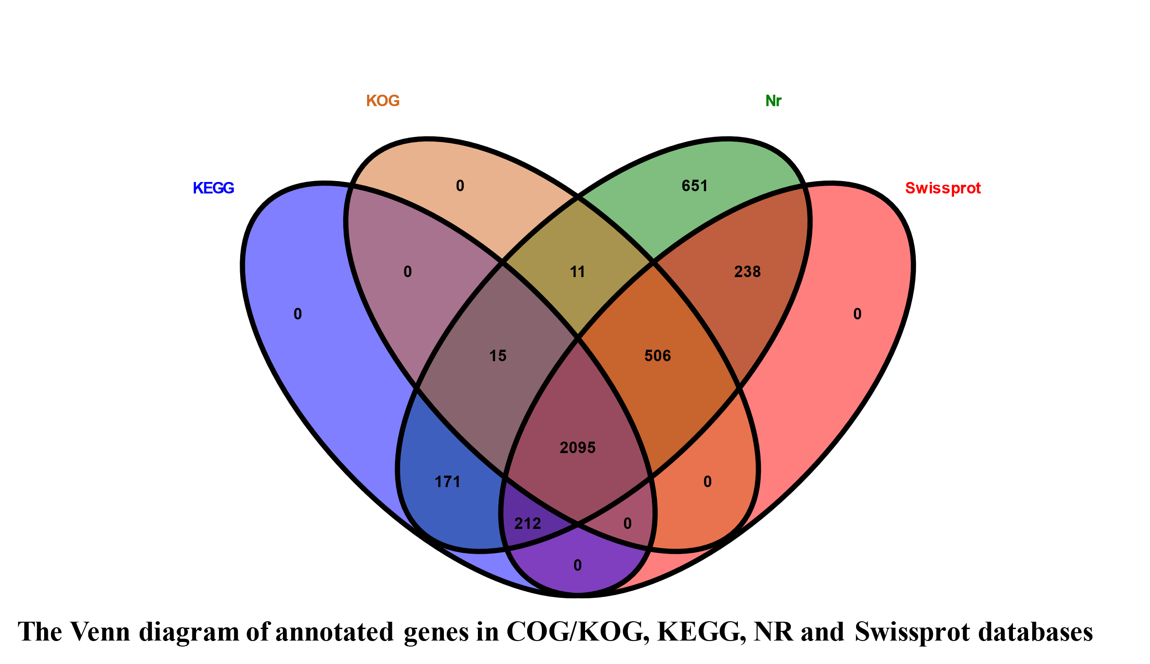
Figure S2. The Venn diagram of annotated genes in COG/KOG, KEGG, NR and Swissprot databases.

