Supplementary Table S1. The quality of H. pylori genomes
Assembly | # contigs | Largest contig | Total length | Reference length | GC (%) | Reference GC (%) | N50 | NG50 | N75 | NG75 | L50 | LG50 | L75 | LG75 | Average Length | Number of Reads | Coverage
BD0003 | 123 | 128077 | 1716262 | 1667867 | 38.8 | 38.87 | 52661 | 52661 | 27747 | 29326 | 11 | 11 | 23 | 21 | 170.5 | 800000 | 79.47504519
BD0010 | 109 | 244270 | 1682427 | 1667867 | 38.66 | 38.87 | 52682 | 52682 | 31935 | 32394 | 10 | 10 | 21 | 20 | 70 | 3400000 | 141.4623042
BD0013 | 48 | 280740 | 1577856 | 1667867 | 39.08 | 38.87 | 94596 | 94596 | 45339 | 40878 | 6 | 6 | 12 | 13 | 175 | 800000 | 88.72799546
BD0014 | 61 | 181374 | 1607002 | 1667867 | 39.04 | 38.87 | 66750 | 66750 | 43012 | 39266 | 8 | 8 | 15 | 16 | 171 | 600000 | 63.84559571
BD0015 | 36 | 210724 | 1562121 | 1667867 | 39.18 | 38.87 | 95807 | 95614 | 56683 | 46097 | 6 | 7 | 11 | 13 | 188 | 500000 | 60.17459595
BD0016 | 48 | 317789 | 1613713 | 1667867 | 39 | 38.87 | 82554 | 82554 | 52522 | 49217 | 6 | 6 | 12 | 13 | 151.5 | 700000 | 65.71800562
BD0024 | 34 | 293450 | 1618178 | 1667867 | 38.83 | 38.87 | 108598 | 99671 | 68064 | 56466 | 4 | 5 | 9 | 10 | 171.5 | 600000 | 63.59003768
BD0027 | 60 | 195858 | 1607626 | 1667867 | 38.94 | 38.87 | 88095 | 88095 | 37498 | 31714 | 7 | 7 | 14 | 16 | 169.5 | 600000 | 63.26098234
BD0034 | 34 | 268157 | 1605489 | 1667867 | 38.97 | 38.87 | 124246 | 102922 | 78533 | 78533 | 4 | 5 | 9 | 9 | 146.5 | 1300000 | 118.6242945
BD0036 | 56 | 149136 | 1646969 | 1667867 | 38.86 | 38.87 | 64678 | 58511 | 35718 | 35718 | 9 | 10 | 19 | 19 | 140 | 1600000 | 136.0074173
BD0038 | 40 | 195847 | 1576976 | 1667867 | 39.14 | 38.87 | 83429 | 83429 | 52793 | 49092 | 7 | 7 | 12 | 13 | 168.5 | 700000 | 74.79505078
BD0042 | 98 | 185295 | 1694043 | 1667867 | 38.84 | 38.87 | 81846 | 81846 | 47258 | 47258 | 8 | 8 | 15 | 15 | 147 | 1600000 | 138.8394509
BD0043 | 58 | 199360 | 1654489 | 1667867 | 38.78 | 38.87 | 82394 | 82394 | 43541 | 43541 | 7 | 7 | 15 | 15 | 139 | 700000 | 58.80969895
BD0045 | 50 | 232130 | 1589933 | 1667867 | 38.99 | 38.87 | 70616 | 63153 | 39672 | 38491 | 7 | 8 | 15 | 16 | 132 | 1100000 | 91.32460299
BD0046 | 41 | 217476 | 1608852 | 1667867 | 39.09 | 38.87 | 130946 | 94199 | 64635 | 58730 | 5 | 6 | 10 | 11 | 148.5 | 1000000 | 92.30184007
BD0047 | 55 | 135207 | 1669133 | 1667867 | 38.73 | 38.87 | 60814 | 60814 | 47572 | 47572 | 9 | 9 | 17 | 17 | 164 | 700000 | 68.77822199
BD0049 | 121 | 124410 | 1759006 | 1667867 | 38.68 | 38.87 | 62199 | 68597 | 26556 | 33256 | 10 | 9 | 21 | 18 | 163 | 800000 | 74.13277726
BD0052 | 42 | 246164 | 1591320 | 1667867 | 39.07 | 38.87 | 66714 | 66714 | 41418 | 39413 | 6 | 6 | 13 | 15 | 144 | 2300000 | 208.1291004
BD0053 | 432 | 62565 | 2030725 | 1667867 | 38.73 | 38.87 | 13567 | 16694 | 4249 | 8503 | 41 | 29 | 106 | 62 | 146 | 1100000 | 79.08505583
BD0054 | 61 | 172458 | 1662617 | 1667867 | 38.79 | 38.87 | 59497 | 59497 | 38131 | 38131 | 9 | 9 | 18 | 18 | 165.5 | 1000000 | 99.54186683
BD0063 | 56 | 179427 | 1575872 | 1667867 | 39.12 | 38.87 | 102417 | 102417 | 40627 | 39151 | 6 | 6 | 12 | 14 | 135 | 3100000 | 265.5672542
BD0065 | 63 | 270362 | 1592158 | 1667867 | 39.14 | 38.87 | 64837 | 59572 | 37797 | 35104 | 7 | 8 | 15 | 17 | 134.5 | 700000 | 59.13357845
BD0068 | 50 | 318469 | 1600238 | 1667867 | 38.9 | 38.87 | 65071 | 65071 | 43233 | 38907 | 7 | 7 | 14 | 15 | 146.5 | 1300000 | 119.0135467
BD0069 | 29 | 233614 | 1611178 | 1667867 | 39.07 | 38.87 | 132757 | 130739 | 84716 | 55682 | 5 | 6 | 9 | 10 | 142 | 2400000 | 211.5222527
BD0070 | 37 | 265525 | 1587934 | 1667867 | 38.93 | 38.87 | 108594 | 99791 | 55240 | 50174 | 4 | 5 | 10 | 11 | 163 | 1400000 | 143.7087436
BD0072 | 83 | 265799 | 1609297 | 1667867 | 39.16 | 38.87 | 74030 | 66147 | 33667 | 28927 | 6 | 7 | 14 | 16 | 156.5 | 800000 | 77.79794531
BD0073 | 45 | 284948 | 1644350 | 1667867 | 38.87 | 38.87 | 82315 | 80552 | 39428 | 37900 | 7 | 8 | 15 | 16 | 155 | 900000 | 84.83595342
BD0076 | 37 | 173440 | 1556137 | 1667867 | 39.13 | 38.87 | 101535 | 101110 | 59033 | 51837 | 6 | 7 | 11 | 12 | 170.5 | 500000 | 54.78309429
BD0077 | 1207 | 38084 | 2550386 | 1667867 | 38.91 | 38.87 | 3192 | 5073 | 1650 | 3302 | 204 | 95 | 486 | 197 | 150.5 | 2100000 | 123.922418
BD0078 | 44 | 159562 | 1656774 | 1667867 | 38.73 | 38.87 | 101714 | 101714 | 68500 | 68500 | 7 | 7 | 12 | 12 | 159.5 | 1000000 | 96.27142869
BD0080 | 36 | 226868 | 1584240 | 1667867 | 38.89 | 38.87 | 83498 | 80083 | 52801 | 51527 | 6 | 7 | 12 | 13 | 152.5 | 1000000 | 96.26066758
BD0081 | 25 | 397278 | 1549815 | 1667867 | 39.21 | 38.87 | 151784 | 151784 | 95341 | 59392 | 4 | 4 | 7 | 8 | 177.5 | 400000 | 45.81191949
BD0082 | 45 | 396258 | 1625016 | 1667867 | 38.84 | 38.87 | 78113 | 78113 | 37509 | 35328 | 6 | 6 | 13 | 14 | 169.5 | 700000 | 73.0146657
BD0084 | 248 | 94631 | 1812299 | 1667867 | 38.9 | 38.87 | 44333 | 46110 | 18758 | 28445 | 17 | 15 | 31 | 26 | 158 | 400000 | 34.87283279
BD0086 | 95 | 125954 | 1602447 | 1667867 | 39.13 | 38.87 | 54137 | 54137 | 32375 | 29711 | 11 | 11 | 20 | 22 | 171 | 800000 | 85.36943812
BD0090 | 37 | 268919 | 1558874 | 1667867 | 39.08 | 38.87 | 62495 | 59764 | 45685 | 38822 | 6 | 7 | 14 | 16 | 154.5 | 600000 | 59.46599918
BD0091 | 44 | 289033 | 1553891 | 1667867 | 39.2 | 38.87 | 89548 | 84519 | 60352 | 53316 | 5 | 6 | 11 | 12 | 134.5 | 800000 | 69.24552623
BD0094 | 44 | 251058 | 1568553 | 1667867 | 39.11 | 38.87 | 80485 | 60511 | 40524 | 36697 | 5 | 6 | 13 | 15 | 132.5 | 900000 | 76.02548336
BD0095 | 54 | 162333 | 1615143 | 1667867 | 38.92 | 38.87 | 67728 | 67728 | 34088 | 33767 | 9 | 9 | 17 | 19 | 132 | 800000 | 65.38120773
BD0096 | 44 | 205460 | 1617192 | 1667867 | 38.86 | 38.87 | 61657 | 59936 | 41213 | 40367 | 6 | 7 | 14 | 15 | 132.5 | 2000000 | 163.8642783
BD0097 | 39 | 228537 | 1607872 | 1667867 | 38.93 | 38.87 | 91671 | 91671 | 60780 | 59352 | 6 | 6 | 11 | 12 | 156 | 1100000 | 106.7249134
BD0101 | 62 | 118065 | 1653177 | 1667867 | 38.75 | 38.87 | 71724 | 71724 | 32945 | 32061 | 9 | 9 | 18 | 19 | 146.5 | 900000 | 79.75552527
BD0103 | 58 | 215984 | 1562157 | 1667867 | 39.01 | 38.87 | 57755 | 55406 | 33474 | 32732 | 7 | 8 | 17 | 19 | 128.5 | 600000 | 49.35483437
BD0104 | 50 | 174307 | 1661402 | 1667867 | 38.84 | 38.87 | 67039 | 67039 | 38558 | 38558 | 8 | 8 | 16 | 16 | 163 | 500000 | 49.05495479
BD0107 | 48 | 232055 | 1611901 | 1667867 | 39.02 | 38.87 | 143382 | 143382 | 37920 | 36651 | 5 | 5 | 11 | 12 | 156.5 | 800000 | 77.67226399
BD0109 | 32 | 195706 | 1567439 | 1667867 | 39.09 | 38.87 | 90655 | 90655 | 52735 | 42206 | 7 | 7 | 12 | 14 | 175.5 | 700000 | 78.37625579
BD0110 | 41 | 229297 | 1534575 | 1667867 | 39.11 | 38.87 | 100247 | 85957 | 46498 | 41193 | 6 | 7 | 12 | 14 | 172.5 | 800000 | 89.92717853
BD0111 | 36 | 243971 | 1640136 | 1667867 | 38.79 | 38.87 | 97688 | 97688 | 46083 | 46083 | 6 | 6 | 13 | 13 | 162 | 1500000 | 148.1584454
BD0112 | 33 | 230721 | 1620336 | 1667867 | 38.94 | 38.87 | 95201 | 88686 | 72044 | 71435 | 6 | 7 | 11 | 12 | 173 | 400000 | 42.70719159
BD0114 | 59 | 176197 | 1593684 | 1667867 | 39.04 | 38.87 | 56612 | 56612 | 37731 | 37042 | 8 | 8 | 16 | 17 | 173.5 | 500000 | 54.43362674
BD0115 | 51 | 237184 | 1634451 | 1667867 | 38.94 | 38.87 | 51283 | 50032 | 34909 | 34150 | 7 | 8 | 17 | 18 | 188.5 | 200000 | 23.06584902
BD0119 | 84 | 176678 | 1631015 | 1667867 | 38.94 | 38.87 | 53399 | 53399 | 29145 | 28780 | 9 | 9 | 19 | 20 | 70.5 | 4000000 | 172.8984712
BD0120 | 68 | 230571 | 1642419 | 1667867 | 39.02 | 38.87 | 69162 | 69162 | 34395 | 33019 | 8 | 8 | 16 | 17 | 154 | 500000 | 46.88206846
BD0127 | 65 | 171585 | 1610787 | 1667867 | 38.91 | 38.87 | 59456 | 59456 | 32452 | 30234 | 10 | 10 | 19 | 20 | 170.5 | 600000 | 63.50932805
BD0130 | 43 | 305084 | 1661114 | 1667867 | 38.82 | 38.87 | 126734 | 126734 | 68204 | 68204 | 5 | 5 | 10 | 10 | 154.5 | 600000 | 55.80592301
BD0133 | 86 | 247775 | 1722293 | 1667867 | 38.64 | 38.87 | 52523 | 52523 | 34004 | 34733 | 9 | 9 | 20 | 19 | 157 | 900000 | 82.04178964

Supplementary Table 2. List of genes evaluated and the present-absent status
Cluster Names | Genes | Present | Absent | Percentage of presence | Non-Synonimous SNP
cluster | Ars | 56 | 0 | 100% | 203
cluster_1 | Toxin-Antitoxin_HP0968 | 54 | 2 | 96% | 69
cluster_2 | aibA | 56 | 0 | 100% | 101
cluster_3 | alpB | 56 | 0 | 100% | 207
cluster_4 | alpA | 56 | 0 | 100% | 165
cluster_5 | flaA | 56 | 0 | 100% | 12
cluster_6 | cheP | 54 | 2 | 96% | 270
cluster_7 | murF | 56 | 0 | 100% | 148
cluster_8 | futB | 54 | 2 | 96% | 197
cluster_9 | amiA | 56 | 0 | 100% | 167
cluster_10 | csd4 | 56 | 0 | 100% | 111
cluster_11 | tolB | 56 | 0 | 100% | 59
cluster_12 | cagE | 41 | 15 | 73% | 92
cluster_13 | rpoN | 56 | 0 | 100% | 100
cluster_14 | gluP | 56 | 0 | 100% | 78
cluster_15 | csd3 | 56 | 0 | 100% | 88
cluster_16 | cgt | 56 | 0 | 100% | 66
cluster_17 | flgR | 56 | 0 | 100% | 65
cluster_18 | csd6 | 56 | 0 | 100% | 49
cluster_19 | pseB | 56 | 0 | 100% | 70
cluster_20 | csd1 | 56 | 0 | 100% | 75
cluster_21 | csd2 | 56 | 0 | 100% | 62
cluster_22 | cheY | 56 | 0 | 100% | 57
cluster_23 | cheA | 56 | 0 | 100% | 272
cluster_24 | motA | 56 | 0 | 100% | 61
cluster_25 | motB | 56 | 0 | 100% | 47
cluster_26 | fliA | 56 | 0 | 100% | 36
cluster_27 | aibB | 55 | 1 | 98% | 92
cluster_28 | arsR | 56 | 0 | 100% | 46
cluster_29 | cagD | 41 | 15 | 73% | 51
cluster_30 | csd5 | 50 | 6 | 89% | 136
cluster_31 | duf386 | 56 | 0 | 100% | 82
cluster_32 | cheW | 56 | 0 | 100% | 22
cluster_33 | luxS | 55 | 1 | 98% | 33
cluster_34 | spOT | 56 | 0 | 100% | 126
cluster_35 | fur | 56 | 0 | 100% | 12
cluster_36 | nikR | 56 | 0 | 100% | 20
cluster_38 | napA | 51 | 5 | 91% | 68
cluster_39 | ccmA | 55 | 1 | 98% | 17
cluster_40 | cheY | 56 | 0 | 100% | 1
cluster_41 | vapD | 31 | 25 | 55% | 25
cluster_42 | homD | 56 | 0 | 100% | 173
cluster_43 | flhA | 56 | 0 | 100% | 46
cluster_44 | homB | 54 | 2 | 96% | 279
cluster_45 | flgE | 56 | 0 | 100% | 60
cluster_46 | tlpB | 53 | 3 | 95% | 142

Supplementary Table S3. Genes mutation of the Validation dataset (n=20)

Strain.ID | group | Biofilm.OD | alpB G160S | alpB A223V | alpB N156K | gluP T85S | cgt V34A | csd5 P43S | csd5 V110A | csd5 M125I | murF V250I
JAY21 | 0 | 0.185 | S | A | N | S | V | S | A | I | V
KPG33 | 1 | 0.564 | G | V | K | T | A | P | V | M | I
MKS56 | 0 | 0.324 | K | A | N | S | V | S | T | I | V
SBY137 | 0 | 0.381 | S | A | N | T | V | P | V | M | V
MN3 | 0 | 0.302 | S | A | N | S | V | S | A | I | V
JAY1 | 1 | 0.511 | R | A | N | S | V | S | T | I | V
MER20 | 1 | 0.401 | S | V | N | S | V | Q | A | I | V
MN11 | 0 | 0.324 | S | A | N | S | V | S | T | I | V
KPG28 | 1 | 0.953 | S | A | N | T | A | S | V | M | V
NIAS56 | 1 | 0.624 | S | A | N | S | V | S | T | I | V
Manado29 | 0 | 0.380 | S | A | N | - | V | S | V | I | V
IND7 | 0 | 0.244 | S | A | N | T | V | S | V | M | V
MER21 | 0 | 0.309 | S | D | N | S | V | Q | V | I | V
SBY283 | 0 | 0.241 | G | A | N | S | V | S | V | I | V
JAY6 | 0 | 0.149 | S | V | N | S | V | Q | A | I | V
SMS30 | 1 | 0.414 | G | I | N | S | V | S | T | I | V
KPG64 | 1 | 0.440 | S | A | N | S | V | S | I | I | V
PTN63 | 0 | 0.377 | S | A | N | S | V | S | T | I | I
SMS22 | 0 | 0.339 | G | A | N | S | V | S | A | I | V
NIAS37 | 0 | 0.297 | S | A | N | S | V | S | T | I | V
High+mutant |  |  | 71.4 | 42.9 | 14.3 | 71.4 | 28.6 | 85.7 | 71.4 | 71.4 | 14.3
Low+mutant |  |  | 84.6 | 15.4 | 0.0 | 84.6 | 0.0 | 92.3 | 61.5 | 84.6 | 14.3

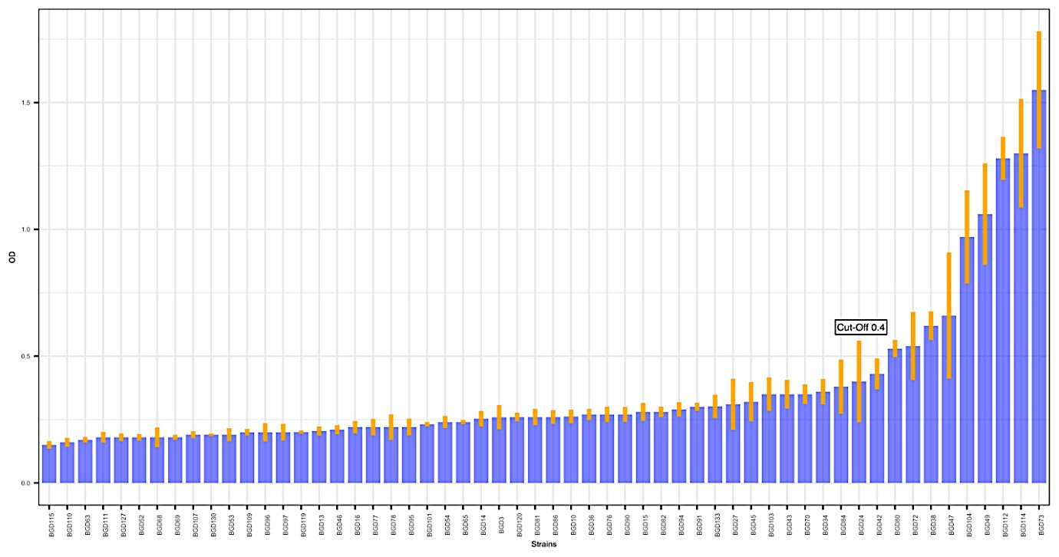
Supplementary Figure S1. Distribution of biofilm formation in strains from 56 patients from Bangladesh. The x-axis represented the strains and y-axis was the optical density of biofilm formation after crystal violet staining (reduced with the OD of the blank plates without samples). The cutoff (0.4) divided the strains into High and Low biofilm former. Lower: The biofilm formation relative to the growth OD at Day 4.

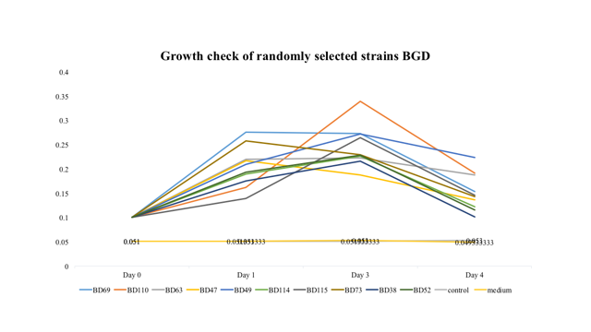
Supplementary Figure S2a. Bacterial growth curve of Bangladesh strain from Day 0 until the Day 4 as indicated by Optical Density (OD) measurement. The y- axis is the Optical Density, x-axis is the days of measurement and each strains represented by different strains. This showed that the bacterial growth does not significantly different between the strains.

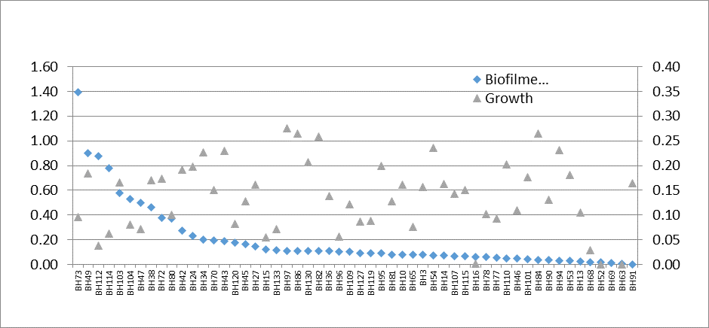

Supplementary Figure S2b. The graph of Day 4 bacterial growth (gray triangle) and biofilm formation (blue square) indicated by optical density. The left y-axis represented the biofilm optical density (0- 1.60 OD) and right y- axis. represented the bacterial growth OD (0-0.40 OD).

Supplementary Figure S3. The expression of alpB gene that are normalized with the ppa housekeeping gene. The y-axis is the absolute quantity of the 120ng total RNA and x-axis represented isolates` name. The green bar represented the high biofilm former isolates (BGD114, BGD112, BGD104) while the orange bar are the low biofilm former isolates (BGD96 and BGD109).
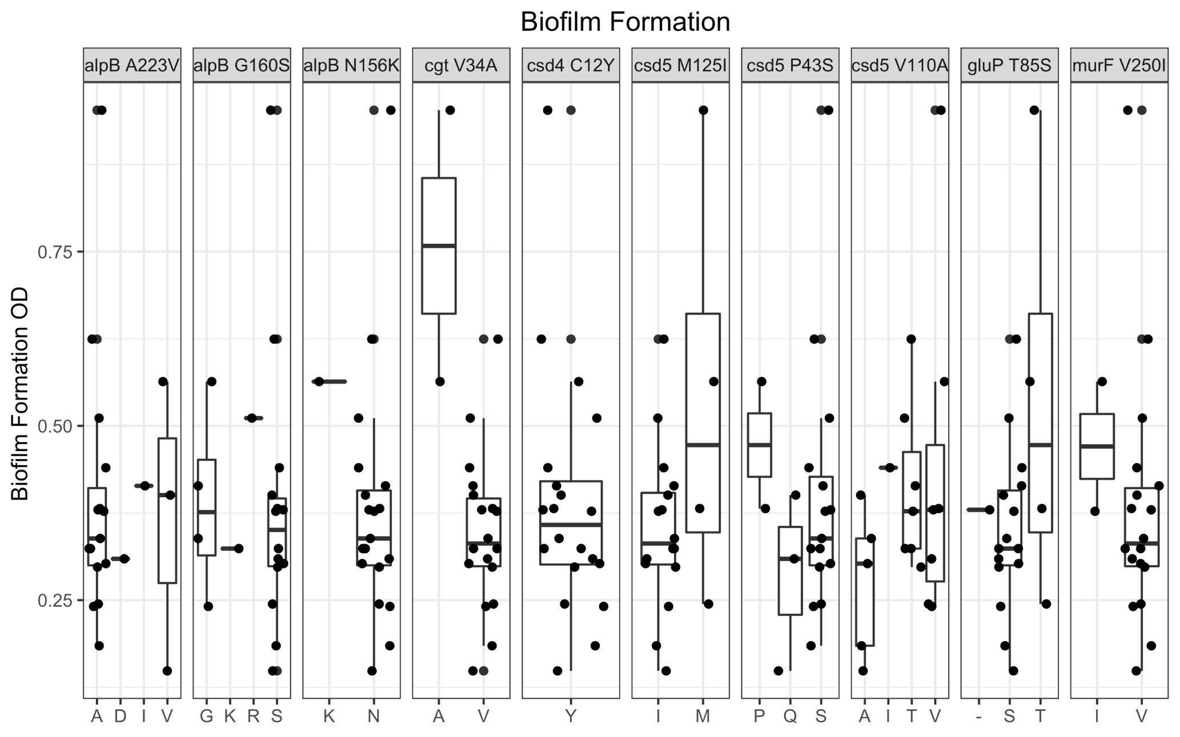

Supplementary Figure S4. The presence of mutation of alpB, cgt, csd4, csd5, gluP and murF in the new dataset genome (n=20). The Y- axis represent the biofilm formation. Among those genes, the allele present in each locus were shown.

