Supplementary Figure
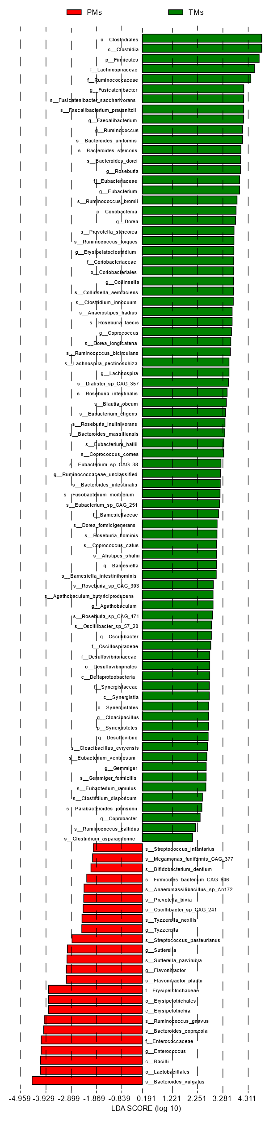
Figure S1 Taxa identified by LEfSe as differentiating between PMs and TMs, the influencing degree of taxa was expressed by the length of bar in histogram, the criteria for feature selection is log LDA score >2

