Appendix
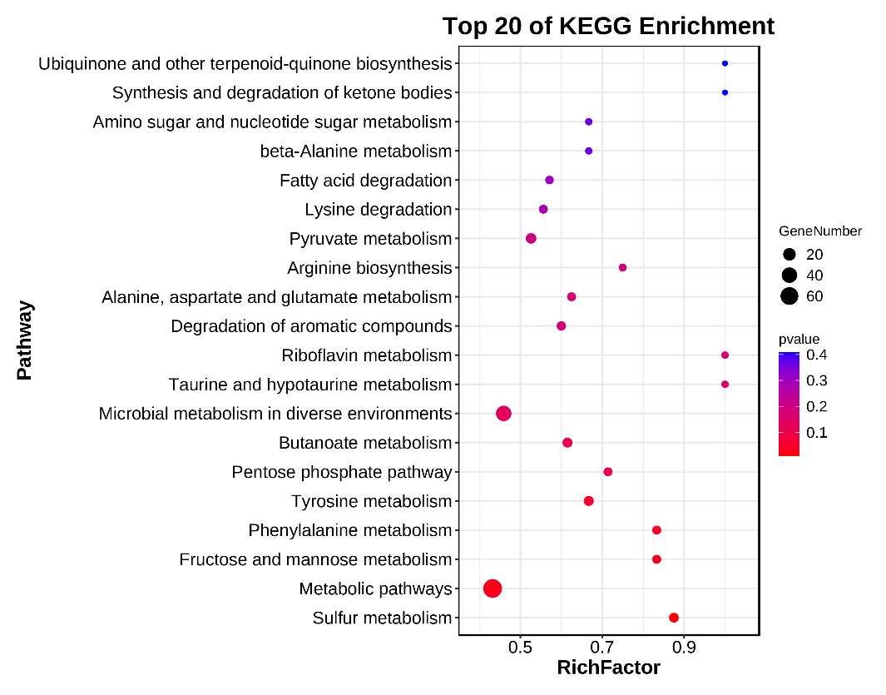
Figure S1 Metabolic pathways from KEGG database of differential functional genes.

Figure S2. Six genera and 20 genes biomarkers in PPI group across CTRL group.
The bars in red and grey show the relative abundance of the 6 genera and 20 genes in the CTRL and PPI group respectively.
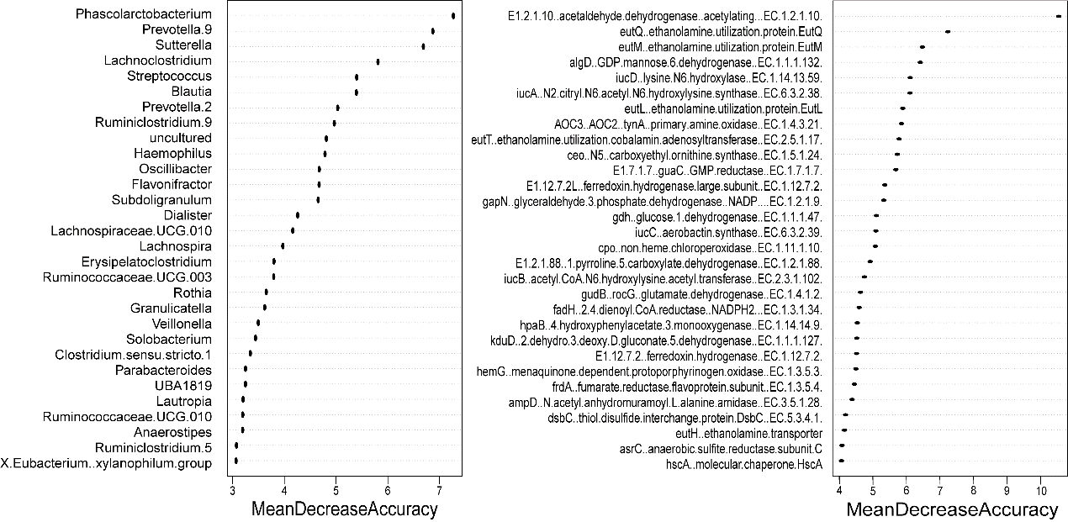
Figure S3 The importance score of the 30 discriminatory genera and genes.

Figure S4 Classification of gut microbiota and functional genes associated with proton pump inhibitor (PPI) use based on the random forest model in every included study.

Table S1 PubMed results of the meta-analysis search and reasons for exclusion of studies.
Authors | Title | Year | doi | Exclusion Reason
MA Jackson et al. | Proton pump inhibitors alter the composition of the gut microbiota | 2016 | http://orcid.org/0000-0002-7891-6217 | No raw reads
T Takagi et al. | The influence of long-term use of proton pump inhibitors on the gut microbiota: an age-sex-matched case-control study | 2018 | https://doi.org/10.3164/jcbn.17-78 | Data not accessible
F Imhann et al. | The influence of proton pump inhibitors and other commonly used medication on the gut microbiota | 2017 | https://doi.org/10.1080/19490976.2017.1284732 | No raw reads
LMM Gommers et al. | Low gut microbiota diversity and dietary magnesium intake are associated with the development of PPI-induced hypomagnesemia | 2019 | https://doi.org/10.1096/fj.201900839R | Data not accessible
EK Ward et al. | The effect of PPI use on human gut microbiota and weight loss in patients undergoing laparoscopic Roux-en-Y gastric bypass | 2014 | https://doi.org/10.1007/s11695-014-1275-1 | Data not accessible
M Hojo et al | Gut Microbiota Composition Before and After Use of Proton Pump Inhibitors | 2018 | https://doi.org/10.1007/s10620-018-5122-4 | Data not accessible
KR Reveles et al. | Proton pump inhibitor use associated with changes in gut microbiota composition | 2018 | http://dx.doi.org/10.1136/gutjnl-2017-315306 | Letter
JS Bajaj et al. | Proton Pump Inhibitor Initiation and Withdrawal affects Gut Microbiota and Readmission Risk in Cirrhosis | 2018 | 10.1038/s41395-018-0085-9 | No raw reads
Y Wang et al. | Advances in gut microbiota of viral hepatitis cirrhosis | 2019 | https://doi.org/10.1155/2019/9726786 | Unrelated
JW Kim et al. | Influence of proton pump inhibitor or rebamipide use on gut microbiota of rheumatoid arthritis patients | 2021 | https: //doi.org/10.1093/rheumatology/keaa316 | No raw reads
D.G. Burke et al. | The altered gut microbiota in adults with cystic fibrosis | 2017 | https://doi.org/10.1186/s12866-017-0968-8 | 454-pyrosequencing
AC Erber et al. | The role of gut microbiota, butyrate and proton pump inhibitors in amyotrophic lateral sclerosis: a systematic review | 2019 | https://doi.org/10.1080/00207454.2019.1702549 | Review
L Simakachorn et al. | Gut Microbiota Characteristics in Children After the Use of Proton Pump Inhibitors | 2021 | 10.5152/tjg.2020.20245 | No raw reads
A G Clooney et al. | A comparison of the gut microbiome between long-term users and non-users of proton pump inhibitors | 2016 | 10.1111/apt.13568 | No raw reads
Singh et al. | Proton Pump Inhibitors: Risks and Rewards and Emerging Consequences to the Gut Microbiome | 2018 | https://doi.org/10.1002/ncp.10181 | Review
R K Weersma et al. | Interaction between drugs and the gut microbiome | 2020 | 10.1136/gutjnl-2019-320204 | No PPI samples
Shi et al. | Effects of Proton Pump Inhibitors on the Gastrointestinal Microbiota in Gastroesophageal Reflux Disease | 2019 | https://doi.org/10.1016/j.gpb.2018.12.004 | The author did not respond for incomplete raw reads
Mishiro et al. | Oral microbiome alterations of healthy volunteers with proton pump inhibitor | 2017 | https://doi.org/10.1111/jgh.14040 | No raw reads
Yuji Naito et al. | Intestinal Dysbiosis Secondary to  Proton-Pump Inhibitor Use | 2018 | 10.1159/000481813 | Review
Lin et al. | Proton Pump Inhibitor-Induced Gut Dysbiosis Increases Mortality Rates for Patients with Clostridioides difficile Infection | 2022 | https://doi.org/10.1128/spectrum.00486-22 | Not published when searching
A Tsuda et al. | Influence of Proton-Pump Inhibitors on the Luminal Microbiota in the Gastrointestinal Tract | 2015 | 10.1038/ctg.2015.20 | Data not accessible

Table S2 Baseline characteristics of study subjects.
Reference | Country | Age(years) |  | Gender |  | BMI
Reference | Country | PPI | CTRL | male | female | BMI
Horvath et al. | Austria | 58(56-62) | 55(53-60) | 23 | 77 | NA
Castellani et al. | Austria | 0.43(0.042-0.85) | / | 8 | 4 | NA
Lin et al. | China | 68.3(53.5-76.5) | 64.1(53.1-75.1) | NA | NA | NA
Freedberg et al. | USA | 39.5(29.0-51.5) | / | 3 | 9 | 28.4(21.3-34.5)
NA means relevant information was not reported in the included studies. Data is given as median and range.

Table S3 Differential Metabolic Potential from PICRUSt2 of 16S rDNA based bacterial profile.
 |  | p value |  |  |  | p. adjusted |  |  |  | log2FC
K_ID | Description | Meta | CN | AT1 | AT2 | Meta | CN | AT1 | AT2 | Meta | CN | AT1 | AT2
K00276 | AOC3, AOC2, tynA; primary-amine oxidase [EC:1.4.3.21] | 4.42E-12 | 3.01E-06 | 5.91E-09 | 0.4701 | 4.29E-10 | 4.23E-06 | 9.93E-08 | 0.599156 | -9.38741 | -3.75832 | -7.71678 | 0.311795
K00533 | E1.12.7.2L; ferredoxin hydrogenase large subunit [EC:1.12.7.2] | 1.43E-09 | 3.97E-14 | 7.88E-08 | 0.513723 | 4.67E-08 | 7.2E-13 | 9.55E-07 | 0.599156 | -6.87751 | -11.638 | -6.59174 | 0.350333
K00007 | dalD; D-arabinitol 4-dehydrogenase [EC:1.1.1.11] | 1.77E-09 | 0.007151 | 6.14E-09 | 0.540279 | 4.67E-08 | 0.007973 | 9.93E-08 | 0.616554 | -6.78446 | -0.38208 | -7.69992 | 0.372223
K00244 | frdA; fumarate reductase flavoprotein subunit [EC:1.3.5.4] | 1.93E-09 | 6.85E-15 | 0.061625 | 0.40951 | 4.67E-08 | 3.32E-13 | 0.184765 | 0.544144 | -6.7484 | -12.4007 | -0.69833 | 0.251869
K00127 | fdoI, fdsG; formate dehydrogenase subunit gamma | 5.36E-09 | 1.84E-15 | 0.203551 | 0.377685 | 1.04E-07 | 1.78E-13 | 0.411342 | 0.508826 | -6.3034 | -12.9725 | -0.17942 | 0.216735
K03895 | iucC; aerobactin synthase [EC:6.3.2.39] | 9.31E-09 | 0.00219 | 2.84E-09 | 0.088734 | 1.3E-07 | 0.00247 | 6.88E-08 | 0.195618 | -6.06381 | -0.89606 | -8.03547 | -0.41231
K03894 | iucA; N2-citryl-N6-acetyl-N6-hydroxylysine synthase [EC:6.3.2.38] | 9.41E-09 | 0.00219 | 2.84E-09 | 0.10053 | 1.3E-07 | 0.00247 | 6.88E-08 | 0.203155 | -6.05906 | -0.89606 | -8.03547 | -0.3581
K00034 | gdh; glucose 1-dehydrogenase [EC:1.1.1.47] | 2.61E-08 | 1.19E-10 | 9.54E-07 | 0.932301 | 3.16E-07 | 7.18E-10 | 8.42E-06 | 0.951928 | -5.61701 | -8.16268 | -5.50841 | 0.60916
K03791 | K03791; putative chitinase | 4.88E-08 | 1.63E-06 | 0.00288 | 1 | 4.63E-07 | 2.6E-06 | 0.014705 | 1 | -5.34456 | -4.0232 | -2.02864 | 0.639604
K03806 | ampD; N-acetyl-anhydromuramoyl-L-alanine amidase [EC:3.5.1.28] | 5.27E-08 | 3.88E-13 | 0.506599 | 0.10053 | 4.63E-07 | 4.18E-12 | 0.692114 | 0.203155 | -5.31115 | -10.6477 | 0.216575 | -0.3581
K00483 | hpaB; 4-hydroxyphenylacetate 3-monooxygenase [EC:1.14.14.9] | 5.66E-08 | 8.92E-10 | 1.1E-05 | 0.452822 | 4.63E-07 | 4.12E-09 | 8.86E-05 | 0.58565 | -5.27987 | -7.28602 | -4.44805 | 0.295532
K03897 | iucD; lysine N6-hydroxylase [EC:1.14.13.59] | 5.73E-08 | 0.00219 | 4.88E-08 | 0.26567 | 4.63E-07 | 0.00247 | 6.77E-07 | 0.390454 | -5.27473 | -0.89606 | -6.79942 | 0.063946
K04044 | hscA; molecular chaperone HscA | 7.05E-08 | 4.09E-14 | 0.545253 | 0.113502 | 5E-07 | 7.2E-13 | 0.724514 | 0.220195 | -5.1848 | -11.6246 | 0.248509 | -0.30539
K00066 | algD; GDP-mannose 6-dehydrogenase [EC:1.1.1.132] | 7.22E-08 | 0.174104 | 2.97E-14 | 0.904603 | 5E-07 | 0.177769 | 2.88E-12 | 0.933473 | -5.17416 | 1.00438 | -13.0158 | 0.596062
K03896 | iucB; acetyl CoA:N6-hydroxylysine acetyl transferase [EC:2.3.1.102] | 8.91E-08 | 0.008924 | 2.84E-09 | 0.10053 | 5.65E-07 | 0.009836 | 6.88E-08 | 0.203155 | -5.08314 | -0.28589 | -8.03547 | -0.3581
K03893 | arsB; arsenical pump membrane protein | 9.32E-08 | 1.6E-06 | 0.011025 | 0.019347 | 5.65E-07 | 2.59E-06 | 0.046495 | 0.069885 | -5.06337 | -4.03179 | -1.44573 | -1.07378
K03981 | dsbC; thiol:disulfide interchange protein DsbC [EC:5.3.4.1] | 2.01E-07 | 4.45E-14 | 0.880287 | 0.218921 | 1.15E-06 | 7.2E-13 | 0.948754 | 0.331802 | -4.72997 | -11.5876 | 0.456535 | -0.02011
K00364 | E1.7.1.7, guaC; GMP reductase [EC:1.7.1.7] | 2.37E-07 | 7.75E-14 | 0.460386 | 3.33E-05 | 1.27E-06 | 1.07E-12 | 0.655676 | 0.003228 | -4.65889 | -11.3472 | 0.175033 | -3.83818
K00065 | kduD; 2-dehydro-3-deoxy-D-gluconate 5-dehydrogenase [EC:1.1.1.127] | 3.63E-07 | 4.04E-10 | 0.000241 | 0.842836 | 1.85E-06 | 2.06E-09 | 0.001672 | 0.879087 | -4.47294 | -7.62979 | -3.1055 | 0.565348
K00455 | hpaD, hpcB; 3,4-dihydroxyphenylacetate 2,3-dioxygenase [EC:1.13.11.15] | 4.09E-07 | 0.000833 | 5.27E-05 | 0.214095 | 1.98E-06 | 0.00101 | 0.000393 | 0.331802 | -4.42154 | -1.31561 | -3.76664 | -0.02979
K00529 | hcaD; 3-phenylpropionate/trans-cinnamate dioxygenase ferredoxin reductase component [EC:1.18.1.3] | 5.5E-07 | 2.55E-06 | 0.026916 | 0.193834 | 2.54E-06 | 3.64E-06 | 0.100418 | 0.308228 | -4.29221 | -3.83007 | -1.05808 | -0.07297
K00219 | fadH; 2,4-dienoyl-CoA reductase (NADPH2) [EC:1.3.1.34] | 1.59E-06 | 2.47E-09 | 0.248914 | 0.10053 | 6.99E-06 | 9.21E-09 | 0.446183 | 0.203155 | -3.83244 | -6.84395 | -0.09204 | -0.3581
K00380 | cysJ; sulfite reductase (NADPH) flavoprotein alpha-component [EC:1.8.1.2] | 1.77E-06 | 6.05E-08 | 0.096482 | 0.002316 | 7.47E-06 | 1.68E-07 | 0.239968 | 0.023517 | -3.78456 | -5.45468 | -0.50364 | -1.99558
K00246 | frdC; fumarate reductase subunit C | 3.61E-06 | 1.18E-11 | 0.753859 | 0.113502 | 1.43E-05 | 9.52E-11 | 0.84051 | 0.220195 | -3.47555 | -9.16549 | 0.389201 | -0.30539
K00015 | gyaR, GOR1; glyoxylate reductase [EC:1.1.1.26] | 3.68E-06 | 2.3E-09 | 0.005394 | 0.218921 | 1.43E-05 | 8.92E-09 | 0.024917 | 0.331802 | -3.46732 | -6.87489 | -1.75615 | -0.02011
K00245 | frdB; fumarate reductase iron-sulfur subunit [EC:1.3.5.4] | 4.39E-06 | 1.18E-11 | 0.753859 | 0.159973 | 1.64E-05 | 9.52E-11 | 0.84051 | 0.277096 | -3.39049 | -9.16549 | 0.389201 | -0.15635
K00184 | K00184; prokaryotic molybdopterin-containing oxidoreductase family, iron-sulfur binding subunit | 5.55E-06 | 4.23E-14 | 0.700123 | 0.37074 | 1.96E-05 | 7.2E-13 | 0.837536 | 0.506504 | -3.28855 | -11.6098 | 0.357085 | 0.208674
K03841 | FBP, fbp; fructose-1,6-bisphosphatase I [EC:3.1.3.11] | 5.82E-06 | 8.98E-13 | 0.818394 | 0.143168 | 1.96E-05 | 8.71E-12 | 0.902094 | 0.262024 | -3.26762 | -10.2831 | 0.424873 | -0.20455
K00484 | hpaC; flavin reductase (NADH) [EC:1.5.1.36] | 5.86E-06 | 0.000746 | 0.001889 | 0.193543 | 1.96E-05 | 0.000928 | 0.011454 | 0.308228 | -3.26513 | -1.36363 | -2.21179 | -0.07362
K00260 | gudB, rocG; glutamate dehydrogenase [EC:1.4.1.2] | 1.02E-05 | 1.87E-13 | 0.619714 | 0.000496 | 3.3E-05 | 2.27E-12 | 0.791473 | 0.023517 | -3.02355 | -10.9635 | 0.304102 | -2.66532
K00532 | E1.12.7.2; ferredoxin hydrogenase [EC:1.12.7.2] | 1.21E-05 | 2.74E-11 | 0.172153 | 0.178182 | 3.79E-05 | 1.9E-10 | 0.355294 | 0.297994 | -2.95 | -8.79879 | -0.25218 | -0.10953
K00064 | E1.1.1.122; D-threo-aldose 1-dehydrogenase [EC:1.1.1.122] | 1.56E-05 | 2.54E-05 | 0.636442 | 0.150381 | 4.73E-05 | 3.28E-05 | 0.791473 | 0.270128 | -2.83945 | -2.83239 | 0.315669 | -0.1832
K00151 | hpaE, hpcC; 5-carboxymethyl-2-hydroxymuconic-semialdehyde dehydrogenase [EC:1.2.1.60] | 1.68E-05 | 0.000833 | 0.006139 | 0.157123 | 4.94E-05 | 0.00101 | 0.027066 | 0.277096 | -2.80756 | -1.31561 | -1.70002 | -0.16416
K00124 | fdoH, fdsB; formate dehydrogenase iron-sulfur subunit | 3.81E-05 | 3.1E-11 | 0.990151 | 0.178182 | 0.000107 | 2E-10 | 0.99803 | 0.297994 | -2.45154 | -8.74529 | 0.507612 | -0.10953
K00146 | feaB; phenylacetaldehyde dehydrogenase [EC:1.2.1.39] | 3.86E-05 | 3.64E-06 | 0.833642 | 0.18846 | 0.000107 | 5.05E-06 | 0.908576 | 0.308228 | -2.44654 | -3.67522 | 0.43289 | -0.08518
K00412 | CYTB, petB; ubiquinol-cytochrome c reductase cytochrome b subunit | 0.00021 | 9.8E-08 | 0.404833 | 0.485063 | 0.000567 | 2.5E-07 | 0.604029 | 0.599156 | -1.71011 | -5.24532 | 0.119187 | 0.325402
K00523 | ascD, ddhD, rfbI; CDP-4-dehydro-6-deoxyglucose reductase, E3 [EC:1.17.1.1] | 0.00028 | 1.64E-09 | 0.260949 | 0.572605 | 0.000733 | 6.91E-09 | 0.452001 | 0.638422 | -1.58624 | -7.02201 | -0.07153 | 0.39746
K00254 | DHODH, pyrD; dihydroorotate dehydrogenase [EC:1.3.5.2] | 0.000796 | 0.001721 | 0.015226 | 0.513723 | 0.002033 | 0.002012 | 0.061538 | 0.599156 | -1.13179 | -1.00055 | -1.30551 | 0.350333
K00385 | asrC; anaerobic sulfite reductase subunit C | 0.001341 | 8.06E-10 | 0.357096 | 0.67066 | 0.003305 | 3.91E-09 | 0.541224 | 0.730944 | -0.90555 | -7.33015 | 0.064696 | 0.466107
K04020 | eutD; phosphotransacetylase | 0.001431 | 2.11E-07 | 0.635405 | 0.033241 | 0.003305 | 4.35E-07 | 0.791473 | 0.089567 | -0.87718 | -4.91259 | 0.314962 | -0.83872
K04021 | eutE; aldehyde dehydrogenase | 0.001431 | 2.11E-07 | 0.635405 | 0.033241 | 0.003305 | 4.35E-07 | 0.791473 | 0.089567 | -0.87718 | -4.91259 | 0.314962 | -0.83872
K04025 | eutK; ethanolamine utilization protein EutK | 0.001431 | 2.11E-07 | 0.635405 | 0.033241 | 0.003305 | 4.35E-07 | 0.791473 | 0.089567 | -0.87718 | -4.91259 | 0.314962 | -0.83872
K00101 | lldD; L-lactate dehydrogenase (cytochrome) [EC:1.1.2.3] | 0.001732 | 2.91E-07 | 0.287157 | 0.002914 | 0.003908 | 5.65E-07 | 0.48867 | 0.023517 | -0.79422 | -4.77204 | -0.02997 | -1.8959
K00395 | aprB; adenylylsulfate reductase, subunit B [EC:1.8.99.2] | 0.002074 | 5.05E-05 | 2.64E-07 | 0.052891 | 0.004573 | 6.45E-05 | 2.84E-06 | 0.13155 | -0.71597 | -2.53294 | -6.06704 | -0.63701
K00394 | aprA; adenylylsulfate reductase, subunit A [EC:1.8.99.2] | 0.004025 | 1.05E-05 | 7.6E-07 | 0.068723 | 0.008677 | 1.39E-05 | 7.38E-06 | 0.162588 | -0.42807 | -3.21535 | -5.60706 | -0.52329
K00534 | E1.12.7.2S; ferredoxin hydrogenase small subunit [EC:1.12.7.2] | 0.004263 | 1.27E-07 | 0.751493 | 0.829031 | 0.008983 | 2.99E-07 | 0.84051 | 0.874087 | -0.40317 | -5.13189 | 0.387836 | 0.558175
K00163 | aceE; pyruvate dehydrogenase E1 component [EC:1.2.4.1] | 0.004352 | 7.13E-08 | 0.251906 | 0.008293 | 0.008983 | 1.92E-07 | 0.446183 | 0.042339 | -0.39414 | -5.38321 | -0.08685 | -1.44168
K00210 | E1.3.1.12; prephenate dehydrogenase [EC:1.3.1.12] | 0.004746 | 2.34E-08 | 0.716655 | 0.291343 | 0.00959 | 7.56E-08 | 0.837536 | 0.415592 | -0.35658 | -5.86772 | 0.367221 | 0.104009
K00104 | glcD; glycolate oxidase [EC:1.1.3.15] | 0.0053 | 1.63E-11 | 0.709291 | 0.551167 | 0.010491 | 1.22E-10 | 0.837536 | 0.621665 | -0.30861 | -9.02437 | 0.362735 | 0.380888
K03788 | aphA; acid phosphatase (class B) [EC:3.1.3.2] | 0.005687 | 4.22E-08 | 0.074852 | 0.00183 | 0.010926 | 1.24E-07 | 0.207447 | 0.023517 | -0.27795 | -5.6113 | -0.61388 | -2.098
K00390 | cysH; phosphoadenosine phosphosulfate reductase [EC:1.8.4.8 1.8.4.10] | 0.005745 | 0.001313 | 0.532207 | 0.477575 | 0.010926 | 0.001573 | 0.717002 | 0.599156 | -0.2736 | -1.11809 | 0.237992 | 0.318646
K00121 | frmA, ADH5, adhC; S-(hydroxymethyl)glutathione dehydrogenase / alcohol dehydrogenase [EC:1.1.1.284 1.1.1.1] | 0.007046 | 1.41E-06 | 0.903696 | 0.017271 | 0.012967 | 2.41E-06 | 0.951276 | 0.069804 | -0.18491 | -4.08599 | 0.467933 | -1.12307
K00261 | GLUD1_2, gdhA; glutamate dehydrogenase (NAD(P)+) [EC:1.4.1.3] | 0.007085 | 4.32E-07 | 0.354524 | 0.003637 | 0.012967 | 8.07E-07 | 0.541224 | 0.023517 | -0.18254 | -4.60055 | 0.061556 | -1.7997
K00045 | E1.1.1.67, mtlK; mannitol 2-dehydrogenase [EC:1.1.1.67] | 0.007428 | 0.015088 | 0.687361 | 0.310208 | 0.013342 | 0.016444 | 0.837536 | 0.43609 | -0.16202 | -0.0578 | 0.349096 | 0.131258
K00383 | GSR, gor; glutathione reductase (NADPH) [EC:1.8.1.7] | 0.008789 | 2.44E-07 | 0.731462 | 0.024184 | 0.015297 | 4.82E-07 | 0.84051 | 0.073309 | -0.08891 | -4.84982 | 0.376102 | -0.97686
K03933 | cpbD; chitin-binding protein | 0.008846 | 0.563684 | 0.000575 | 0.028421 | 0.015297 | 0.569556 | 0.003719 | 0.08354 | -0.08612 | 1.514608 | -2.7283 | -0.90676
K03796 | bax; Bax protein | 0.008989 | 2.01E-08 | 0.0813 | 0.010045 | 0.015297 | 6.71E-08 | 0.219058 | 0.046396 | -0.07915 | -5.93411 | -0.578 | -1.35847
K00019 | E1.1.1.30, bdh; 3-hydroxybutyrate dehydrogenase [EC:1.1.1.30] | 0.009161 | 2.07E-06 | 0.946517 | 0.728978 | 0.01532 | 3.25E-06 | 0.966785 | 0.777042 | -0.07094 | -3.91951 | 0.488039 | 0.502319
K00457 | HPD, hppD; 4-hydroxyphenylpyruvate dioxygenase [EC:1.13.11.27] | 0.010609 | 0.00057 | 0.898654 | 0.224097 | 0.017209 | 0.000718 | 0.951276 | 0.334421 | -0.00719 | -1.48032 | 0.465503 | -0.00996
K00381 | cysI; sulfite reductase (NADPH) hemoprotein beta-component [EC:1.8.1.2] | 0.010644 | 9.42E-08 | 0.300869 | 0.008293 | 0.017209 | 2.47E-07 | 0.503177 | 0.042339 | -0.00574 | -5.26217 | -0.00971 | -1.44168
K00123 | fdoG, fdhF, fdwA; formate dehydrogenase major subunit [EC:1.17.1.9] | 0.011937 | 1.42E-08 | 0.466408 | 0.020489 | 0.018745 | 4.91E-08 | 0.655676 | 0.069885 | 0.044014 | -6.085 | 0.180677 | -1.04887
K04047 | dps; starvation-inducible DNA-binding protein | 0.012135 | 1.59E-06 | 0.125225 | 0.143168 | 0.018745 | 2.59E-06 | 0.28921 | 0.262024 | 0.051166 | -4.03589 | -0.3904 | -0.20455
K00179 | iorA; indolepyruvate ferredoxin oxidoreductase, alpha subunit [EC:1.2.7.8] | 0.012411 | 2.73E-08 | 0.104784 | 0.020489 | 0.018745 | 8.55E-08 | 0.254102 | 0.069885 | 0.06095 | -5.79976 | -0.46779 | -1.04887
K00180 | iorB; indolepyruvate ferredoxin oxidoreductase, beta subunit [EC:1.2.7.8] | 0.012411 | 3.73E-08 | 0.092696 | 0.024184 | 0.018745 | 1.13E-07 | 0.239561 | 0.073309 | 0.06095 | -5.66479 | -0.52103 | -0.97686
K00108 | betA, CHDH; choline dehydrogenase [EC:1.1.99.1] | 0.012689 | 7.71E-07 | 0.226246 | 0.024184 | 0.018745 | 1.38E-06 | 0.429453 | 0.073309 | 0.070557 | -4.3494 | -0.13351 | -0.97686
K04040 | chlG, bchG; chlorophyll/bacteriochlorophyll a synthase [EC:2.5.1.62 2.5.1.133] | 0.012947 | 0.015576 | 0.314626 | 0.518856 | 0.018745 | 0.016603 | 0.508645 | 0.599156 | 0.07932 | -0.04397 | 0.009705 | 0.354652
K04038 | chlN; light-independent protochlorophyllide reductase subunit N [EC:1.3.7.7] | 0.012947 | 0.015576 | 0.314626 | 0.518856 | 0.018745 | 0.016603 | 0.508645 | 0.599156 | 0.07932 | -0.04397 | 0.009705 | 0.354652
K00285 | dadA; D-amino-acid dehydrogenase [EC:1.4.5.1] | 0.013214 | 2.19E-07 | 0.354402 | 0.020489 | 0.01885 | 4.43E-07 | 0.541224 | 0.069885 | 0.088179 | -4.89541 | 0.061407 | -1.04887
K00036 | G6PD, zwf; glucose-6-phosphate 1-dehydrogenase [EC:1.1.1.49 1.1.1.363] | 0.013941 | 4.77E-08 | 0.500299 | 0.078024 | 0.01936 | 1.36E-07 | 0.692114 | 0.176008 | 0.111421 | -5.55771 | 0.211141 | -0.46817
K00228 | CPOX, hemF; coproporphyrinogen III oxidase [EC:1.3.3.3] | 0.013971 | 4.18E-07 | 0.223275 | 0.010045 | 0.01936 | 7.95E-07 | 0.429453 | 0.046396 | 0.112358 | -4.615 | -0.13925 | -1.35847
K00259 | ald; alanine dehydrogenase [EC:1.4.1.1] | 0.014897 | 8.66E-07 | 0.136549 | 0.513723 | 0.020352 | 1.53E-06 | 0.308029 | 0.599156 | 0.14023 | -4.29898 | -0.3528 | 0.350333
K00247 | frdD; fumarate reductase subunit D | 0.017095 | 1.97E-07 | 0.019154 | 0.002316 | 0.02303 | 4.34E-07 | 0.074318 | 0.023517 | 0.199993 | -4.94259 | -1.20582 | -1.99558
K00086 | dhaT; 1,3-propanediol dehydrogenase [EC:1.1.1.202] | 0.017435 | 0.017257 | 0.0047 | 0.078024 | 0.023116 | 0.018195 | 0.022794 | 0.176008 | 0.208566 | 0.000539 | -1.81602 | -0.46817
K00427 | lldP, lctP; L-lactate permease | 0.017635 | 2.41E-06 | 0.230222 | 0.003637 | 0.023116 | 3.54E-06 | 0.429453 | 0.023517 | 0.213513 | -3.85409 | -0.12594 | -1.7997
K03805 | dsbG; thiol:disulfide interchange protein DsbG | 0.018429 | 2.41E-06 | 0.218589 | 0.004513 | 0.023647 | 3.54E-06 | 0.429453 | 0.025751 | 0.232647 | -3.85409 | -0.14846 | -1.70593
K00135 | gabD; succinate-semialdehyde dehydrogenase / glutarate-semialdehyde dehydrogenase [EC:1.2.1.16 1.2.1.79 1.2.1.20] | 0.018527 | 1.57E-05 | 0.694644 | 0.017271 | 0.023647 | 2.06E-05 | 0.837536 | 0.069804 | 0.234947 | -3.03958 | 0.353673 | -1.12307
K00005 | gldA; glycerol dehydrogenase [EC:1.1.1.6] | 0.020679 | 2.03E-09 | 0.334368 | 0.291343 | 0.02605 | 8.2E-09 | 0.5317 | 0.415592 | 0.282663 | -6.92915 | 0.036136 | 0.104009
K00138 | aldB; aldehyde dehydrogenase [EC:1.2.1.-] | 0.022844 | 6.42E-07 | 0.066707 | 0.002914 | 0.028274 | 1.18E-06 | 0.19031 | 0.023517 | 0.325902 | -4.42878 | -0.66392 | -1.8959
K03855 | fixX; ferredoxin like protein | 0.023027 | 5.17E-09 | 0.157624 | 0.000858 | 0.028274 | 1.86E-08 | 0.332381 | 0.023517 | 0.329374 | -6.5227 | -0.29047 | -2.42694
K00249 | ACADM, acd; acyl-CoA dehydrogenase [EC:1.3.8.7] | 0.02375 | 0.140547 | 0.050626 | 1 | 0.028797 | 0.145033 | 0.163692 | 1 | 0.342804 | 0.911395 | -0.78371 | 0.639604
K00117 | gcd; quinoprotein glucose dehydrogenase [EC:1.1.5.2] | 0.026196 | 2.55E-06 | 0.155135 | 0.002914 | 0.03137 | 3.64E-06 | 0.332381 | 0.023517 | 0.385363 | -3.83007 | -0.29738 | -1.8959
K00313 | fixC; electron transfer flavoprotein-quinone oxidoreductase [EC:1.5.5.-] | 0.026781 | 1.03E-09 | 0.107994 | 0.00183 | 0.031496 | 4.55E-09 | 0.255498 | 0.023517 | 0.394966 | -7.2232 | -0.45469 | -2.098
K00230 | hemG; menaquinone-dependent protoporphyrinogen oxidase [EC:1.3.5.3] | 0.02695 | 1.81E-10 | 0.002295 | 0.059657 | 0.031496 | 1.03E-09 | 0.013095 | 0.144668 | 0.397701 | -7.97817 | -2.1273 | -0.58473
K00248 | ACADS, bcd; butyryl-CoA dehydrogenase [EC:1.3.8.1] | 0.028327 | 2.44E-10 | 0.430937 | 0.442833 | 0.032711 | 1.31E-09 | 0.623894 | 0.580471 | 0.419338 | -7.84967 | 0.146324 | 0.285845
K03801 | lipB; lipoyl(octanoyl) transferase [EC:2.3.1.181] | 0.02927 | 1.69E-07 | 0.946851 | 0.513723 | 0.033275 | 3.81E-07 | 0.966785 | 0.599156 | 0.433556 | -5.00873 | 0.488193 | 0.350333
K00098 | idnD; L-idonate 5-dehydrogenase [EC:1.1.1.264] | 0.029502 | 1.29E-07 | 0.044532 | 0.020894 | 0.033275 | 2.99E-07 | 0.150972 | 0.069885 | 0.43698 | -5.12482 | -0.83942 | -1.04038
K00004 | BDH, butB; (R,R)-butanediol dehydrogenase / meso-butanediol dehydrogenase / diacetyl reductase [EC:1.1.1.4 1.1.1.- 1.1.1.303] | 0.030112 | 0.01961 | 0.03651 | 0.051865 | 0.033574 | 0.020454 | 0.131166 | 0.13155 | 0.44588 | 0.056059 | -0.92567 | -0.64552
K03820 | lnt; apolipoprotein N-acyltransferase [EC:2.3.1.-] | 0.031136 | 4.19E-06 | 0.99803 | 0.347358 | 0.03432 | 5.64E-06 | 0.99803 | 0.481339 | 0.460393 | -3.61426 | 0.511054 | 0.180382
K00262 | E1.4.1.4, gdhA; glutamate dehydrogenase (NADP+) [EC:1.4.1.4] | 0.031844 | 1.02E-07 | 0.252991 | 0.017271 | 0.034707 | 2.53E-07 | 0.446183 | 0.069804 | 0.470169 | -5.22827 | -0.08499 | -1.12307
K00216 | entA; 2,3-dihydro-2,3-dihydroxybenzoate dehydrogenase [EC:1.3.1.28] | 0.033845 | 2.41E-06 | 0.093849 | 0.004513 | 0.036478 | 3.54E-06 | 0.239561 | 0.025751 | 0.496631 | -3.85409 | -0.51566 | -1.70593
K00281 | GLDC, gcvP; glycine dehydrogenase [EC:1.4.4.2] | 0.036424 | 1.18E-07 | 0.410989 | 0.712535 | 0.038826 | 2.87E-07 | 0.604029 | 0.767954 | 0.528524 | -5.16333 | 0.125741 | 0.492411
K00090 | ghrB; glyoxylate/hydroxypyruvate/2-ketogluconate reductase [EC:1.1.1.79 1.1.1.81 1.1.1.215] | 0.038905 | 1.47E-06 | 0.062858 | 0.003637 | 0.04102 | 2.46E-06 | 0.184765 | 0.023517 | 0.557145 | -4.06843 | -0.68973 | -1.7997
K03840 | fldB; flavodoxin II | 0.040739 | 9.34E-07 | 0.045136 | 0.003637 | 0.042491 | 1.62E-06 | 0.150972 | 0.023517 | 0.577144 | -4.26586 | -0.83357 | -1.7997
K00508 | E1.14.19.3; linoleoyl-CoA desaturase [EC:1.14.19.3] | 0.045051 | 0.680172 | 0.002675 | 0.605821 | 0.046489 | 0.680172 | 0.014415 | 0.667779 | 0.620837 | 1.596191 | -2.06078 | 0.421948
K00130 | betB, gbsA; betaine-aldehyde dehydrogenase [EC:1.2.1.8] | 0.047454 | 4.06E-06 | 0.139799 | 0.038721 | 0.048453 | 5.55E-06 | 0.308193 | 0.101512 | 0.643408 | -3.62802 | -0.34259 | -0.77245
K00311 | ETFDH; electron-transferring-flavoprotein dehydrogenase [EC:1.5.5.1] | 0.047974 | 0.001435 | 0.912048 | 0.121659 | 0.048474 | 0.001698 | 0.951276 | 0.23139 | 0.648142 | -1.07952 | 0.471928 | -0.27525
K03807 | ampE; AmpE protein | 0.049212 | 2.41E-06 | 0.057049 | 0.003637 | 0.049212 | 3.54E-06 | 0.178508 | 0.023517 | 0.659206 | -3.85409 | -0.73184 | -1.7997

