Sample collection (n=770)
Identification of P. aeruginosa by cultural and biochemical tests
Detection of MDR P. aeruginosa by antibiotic susceptibility test
Detection of MBL-producer by combined disc test (CDT)
Detection of colistin resistant isolates by determining MIC value by broth macro dilution method
Direct extraction of DNA by using phenol and chloroform in 1;1 ratio
Plasmid extraction by alkaline hydrolysis method
Plasmid extraction by alkaline hydrolysis method

Detection of MexB gene via PCR
Detection of bla_{NDM-} gene via PCR
Detection of mcr-1 gene via PCR

Figure 1: Flowchart of the procedure

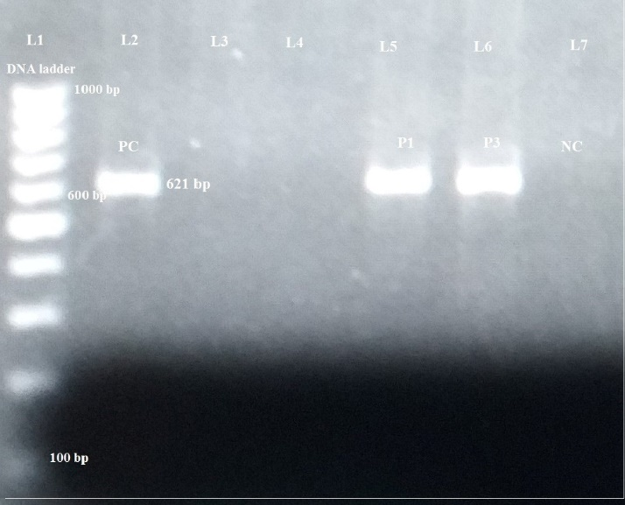
Figure 2: PCR amplification of bla_{NDM-1} gene in MDR P.aeruginosa isolates
Lane L1: DNA size marker (100-1000 bp); Lane 2: positive control; Lane 3&4: bla_{NDM-1} negative isolates; Lane 5&6: bla_{NDM-1} positive isolates; Lane 7: negative control

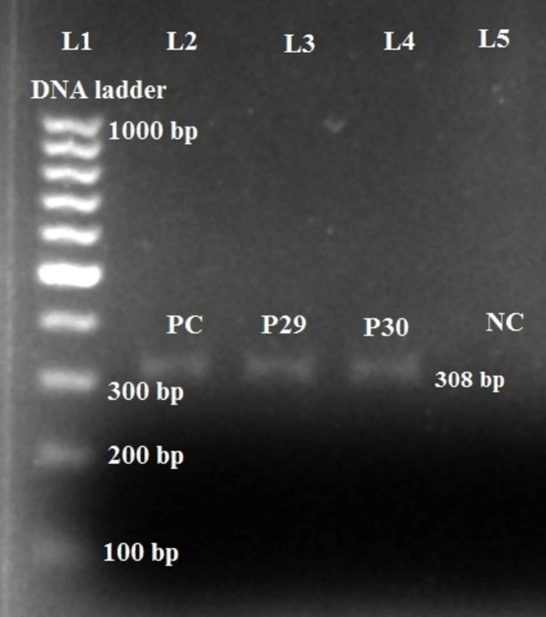
Figure 3: PCR amplification of mcr-1 gene in MDR P. aeruginosa isolates
Lane L1: DNA size marker (100-1000 bp); Lane 2: positive control (mcr-1 positive plasmid DNA); Lane 3&4: mcr-1 positive isolates; Lane 5: negative control
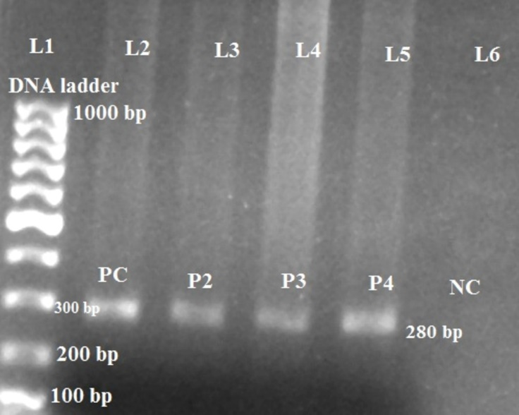
Figure 4: PCR amplification of MexB gene in MDR P. aeruginosa
Lane L1: DNA size marker (100-1000 bp); Lane 2: positive control; Lane 3/4/5: MexB positive isolates; Lane 6: negative control.
100 bp

