Supplementary Information

Diversity and characteristics of plant immunity–activating bacteria from Brassicaceae plants

Hiroki Kaneko, Fuma Miyata, Mari Kurokawa, Kenji Hashimoto, Kazuyuki Kuchitsu, Toshiki Furuya*

----------------------------------------------------------------------------------------------------------
Department of Applied Biological Science, Faculty of Science and Technology, Tokyo University of Science, 2641, Yamazaki, Noda, Chiba 278-8510, Japan
*Correspondence: tfuruya@rs.tus.ac.jp

Table S1. Bacterial strains recovered from the interior of R. sativus var. hortensis.
Strain | Host  tissue | Phylum | Accession no. | Closest type strain  (accession no.) | Sequence  length (bp) | Similarity (%)
RS1P-1 | Petiole | Proteobacteria | LC646120 | Pseudomonas fulva NBRC 16637T  (NR_113857.1) | 708 | 99
RS1P-2 | Petiole | Proteobacteria | LC646121 | Agrobacterium tumefaciens NBRC 12607  (AB680300.1) | 559 | 99
RS1P-4 | Petiole | Proteobacteria | LC646122 | Agrobacterium tumefaciens NBRC 12607  (AB680300.1) | 799 | 100
RS1P-5 | Petiole | Proteobacteria | LC646123 | Pseudomonas fulva NBRC 16637T  (NR_113857.1) | 646 | 99
RS1P-6 | Petiole | Proteobacteria | LC646124 | Pseudomonas fulva NBRC 16637T  (NR_113857.1) | 421 | 99
RS1R-1 | Root | Proteobacteria | LC646131 | Pseudomonas viridiflava DSM 6694T  (NR_114482.1) | 427 | 99
RS1R-2 | Root | Proteobacteria | LC646132 | Pseudomonas fulva NBRC 16637T  (NR_042351.1) | 479 | 99
RS1R-3 | Root | Proteobacteria | LC646133 | Pantoea brenneri LMG 5343T  (NR_116748.1) | 515 | 99
RS1R-4 | Root | Proteobacteria | LC646134 | Pantoea brenneri LMG 5343T  (NR_116748.1) | 258 | 98
RS1R-5 | Root | Proteobacteria | LC646135 | Rhizobium indigoferae NBRC 100398T  (NR_113895.1) | 409 | 100
RS1R-6 | Root | Actinobacteria | LC646136 | Rhodococcus qingshengii JCM 15477T  (NR_043535.1) | 854 | 99
RS2P-1 | Petiole | Proteobacteria | LC646125 | Xanthomonas campestris ATCC 33913T  (NR_074936.1) | 411 | 97
RS2P-2 | Petiole | Proteobacteria | LC646126 | Pseudomonas fulva NBRC 16637T  (NR_042351.1) | 567 | 99
RS2P-3 | Petiole | Actinobacteria | LC646127 | Microbacterium maritypicum DSM 12512T  (NR_114986.1) | 665 | 99
RS2P-4 | Petiole | Proteobacteria | LC646128 | Xanthomonas campestris ATCC 33913T  (NR_074936.1) | 455 | 97
RS2P-6 | Petiole | Proteobacteria | LC646129 | Pseudomonas tolaasii ATCC 33618T  (NR_114481.1) | 543 | 97
RS2P-7 | Petiole | Proteobacteria | LC646130 | Agrobacterium tumefaciens NBRC 12607  (AB680300.1) | 467 | 99
RS2R-1 | Root | Proteobacteria | LC646137 | Enterobacter mori LMG 25706T  (MG846019.1) | 614 | 99
RS2R-3 | Root | Proteobacteria | LC646138 | Enterobacter soli ATCC BAA-2102T  (NR_117547.1) | 571 | 99
RS3R-1 | Root | Proteobacteria | LC646139 | Pseudomonas fulva NBRC 16637T  (NR_042351.1) | 515 | 99
RS3R-2 | Root | Proteobacteria | LC646140 | Pseudomonas tolaasii ATCC 33618T  (NR_114481.1) | 845 | 98
RS3R-3 | Root | Proteobacteria | LC646141 | Pseudomonas fulva NBRC 16637T  (NR_042351.1) | 606 | 99
RS3R-4 | Root | Proteobacteria | LC646142 | Leclercia adecarboxylata NBRC 102595T  (NR_114154.1) | 833 | 100
RS3R-6 | Root | Actinobacteria | LC646143 | Pseudomonas fulva NBRC 16637T  (NR_042351.1) | 620 | 99
RS3R-7 | Root | Actinobacteria | LC646144 | Plantibacter flavus DSM 14012T  (AJ310417.1) | 408 | 99

Table S2. List of clusters of orthologous genes present in all ROS-enhancing strains that were absent in all non–ROS-enhancing strains.
group_id | COG  category | Description
COG1529 | C | Cytochrome c
COG2080 | C | 2Fe-2S -binding domain protein
COG0604 | C | PFAM Alcohol dehydrogenase zinc-binding domain protein
COG0247 | C | FAD linked oxidase domain protein
COG0604 | C | Zinc-binding dehydrogenase
COG1301 | C | Responsible for the transport of dicarboxylates such as succinate, fumarate, and malate
COG0446 | C | PFAM FAD-dependent pyridine nucleotide-disulphide oxidoreductase
COG2864 | C | formate dehydrogenase
COG0243 | C | Belongs to the prokaryotic molybdopterin-containing oxidoreductase family
COG4657 | C | Part of a membrane complex involved in electron transport
COG0403 | E | The glycine cleavage system catalyzes the degradation of glycine. The P protein binds the alpha-amino group of glycine through its pyridoxal phosphate cofactor
COG0436 | E | Cys/Met metabolism PLP-dependent enzyme
COG1280 | E | Lysine transporter LysE
COG0346 | E | PFAM Glyoxalase bleomycin resistance protein dioxygenase
COG1231 | E | amine oxidase
COG0477 | E, G, P | PFAM major facilitator superfamily MFS_1
COG0477 | E, G, P | Permeases of the major facilitator superfamily
COG0477 | E, G, P | PFAM General substrate transporter
COG0477 | E, G, P | PFAM major facilitator superfamily MFS_1
COG2233 | F | xanthine
COG0590 | F, J | CMP dCMP deaminase, zinc-binding
COG2271 | G | Major facilitator superfamily
COG2271 | G | Major facilitator superfamily
COG2271 | G | COG0477 Permeases of the major facilitator superfamily
COG3232 | G | 5-carboxymethyl-2-hydroxymuconate isomerase
COG3958 | G | Transketolase
COG3959 | G | Transketolase
COG0451 | G, M | NAD(P)H-binding
COG0642 | H | His Kinase A (phosphoacceptor) domain
COG1903 | H | Catalyzes the methylation of C-1 in cobalt-precorrin-5B to form cobalt-precorrin-6A
COG0657 | I | Alpha beta hydrolase
COG3255 | I | transcription factor jumonji
COG4925 | I | sulfurtransferase activity
COG1028 | I, Q | Dehydrogenases with different specificities (Related to short-chain alcohol dehydrogenases)
COG1234 | J | Zinc phosphodiesterase, which displays some tRNA 3'- processing endonuclease activity. Probably involved in tRNA maturation, by removing a 3'-trailer from precursor tRNA
COG1514 | J | Hydrolyzes RNA 2',3'-cyclic phosphodiester to an RNA 2'- phosphomonoester
COG1670 | J | Siderophore biosynthesis protein
COG1921 | J | Converts seryl-tRNA(Sec) to selenocysteinyl-tRNA(Sec) required for selenoprotein biosynthesis
COG1208 | J, M | Glucose-1-phosphate cytidylyltransferase
COG0583 | K | Transcriptional regulator
COG1396 | K | Transcriptional regulator
COG0583 | K | Transcriptional regulator
COG1167 | K | Aminotransferase, class I
COG0454 | K | Acetyltransferase (GNAT) domain
COG1595 | K | Sigma-70, region 4
COG0583 | K | Transcriptional regulator
COG0317 | K, T | HD domain
COG3568 | L | PFAM Endonuclease exonuclease phosphatase
COG0708 | L | Exodeoxyribonuclease III
COG0122 | L | DNA-3-methyladenine glycosylase
COG0789 | L | Interacts with CbpA and inhibits both the DnaJ-like co- chaperone activity and the DNA binding activity of CbpA. Together with CbpA, modulates the activity of the DnaK chaperone system. Does not inhibit the co-chaperone activity of DnaJ
COG1201 | L | DEAD/H associated
COG0412 | M | dienelactone hydrolase
COG0472 | M | Catalyzes the transfer of the GlcNAc-1-phosphate moiety from UDP-GlcNAc onto the carrier lipid undecaprenyl phosphate (C55-P), yielding GlcNAc-pyrophosphoryl-undecaprenyl (GlcNAc-PP- C55)
COG3773 | M | Cell wall hydrolase
COG1368 | M | Sulfatase
COG1216 | M | PFAM glycosyl transferase family 2
COG1898 | M | Catalyzes the epimerization of the C3' and C5'positions of dTDP-6-deoxy-D-xylo-4-hexulose, forming dTDP-6-deoxy-L-lyxo-4- hexulose
COG0451 | M | CDP-glucose 4,6-dehydratase
COG4948 | M | Belongs to the mandelate racemase muconate lactonizing enzyme family
COG3264 | M | mechanosensitive ion channel
COG3659 | M | PFAM Carbohydrate-selective porin OprB
COG2373 | M, N, U | Bacterial Ig-like domain (group 3)
COG3170 | N, U | Tfp pilus assembly protein FimV
COG0265 | O | Trypsin-like serine proteases, typically periplasmic, contain C-terminal PDZ domain
COG3058 | O | Necessary for formate dehydrogenase activity
COG0600 | P | binding-protein-dependent transport systems inner membrane component
COG1116 | P | ABC transporter
COG0715 | P | NMT1-like family
COG0428 | P | Zinc iron permease
COG3119 | P | Arylsulfatase A and related enzymes
COG1914 | P | Natural resistance-associated macrophage protein
COG1457 | P | Belongs to the purine-cytosine permease (2.A.39) family
COG1020 | Q | Non-ribosomal peptide synthetase modules and related proteins
COG5301 | S | Phage tail-collar fibre protein
COG4104 | S | Uncharacterized alpha/beta hydrolase domain (DUF2235)
COG0599 | S | Carboxymuconolactone decarboxylase family
COG2194 | S | membrane-associated metal-dependent hydrolase
COG3741 | S | CS1 type fimbrial major subunit
COG4125 | S | PFAM transmembrane pair domain protein
COG2259 | S | DoxX family
COG0393 | S | Belongs to the UPF0145 family
COG1881 | S | PFAM PEBP family protein
COG3011 | S | Protein conserved in bacteria
COG1917 | S | conserved protein, contains double-stranded beta-helix domain
COG3767 | S | EF hand
COG2604 | S | Motility accesory factor maf-2
COG2910 | S | NAD(P)H-binding
COG4319 | S | ketosteroid isomerase
COG1289 | S | Fusaric acid resistance protein
COG2199 | T | (GGDEF) domain
COG2199 | T | Diguanylate cyclase
COG0664 | T | cyclic nucleotide-binding
COG0467 | T | Circadian clock protein KaiC
COG0745 | T | response regulator
COG4943 | T | PFAM EAL domain protein
COG5001 | T | Diguanylate cyclase
COG2199 | T | Diguanylate cyclase
COG0457 | T | Response regulator receiver
COG1132 | V | Involved in lipid A export and possibly also in glycerophospholipid export and for biogenesis of the outer membrane. Transmembrane domains (TMD) form a pore in the inner membrane and the ATP-binding domain (NBD) is responsible for energy generation
COG3510 | V | Cephalosporin hydroxylase
COG2274 | V | ABC-type bacteriocin lantibiotic exporters, contain an N-terminal double-glycine peptidase domain

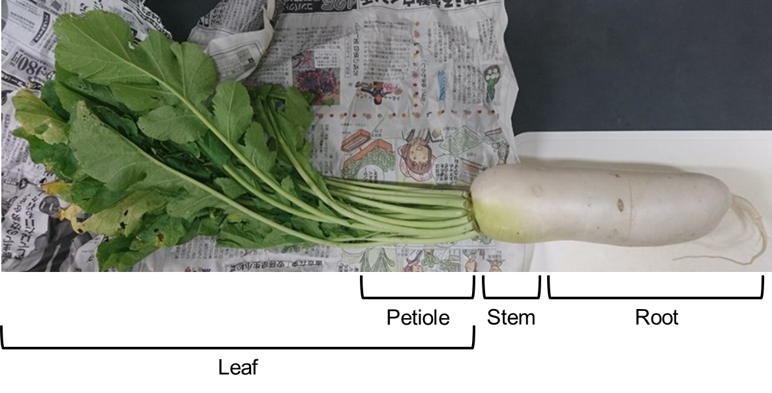

Fig. S1 Photograph of R. sativus var. hortensis.

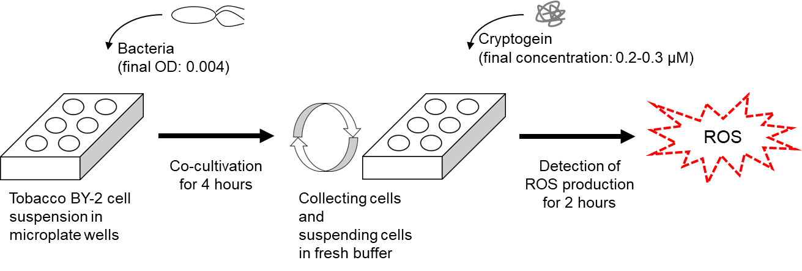

Fig. S2 Schematic illustration of assays for cryptogein-induced ROS production in BY-2 cells co-incubated with bacteria.

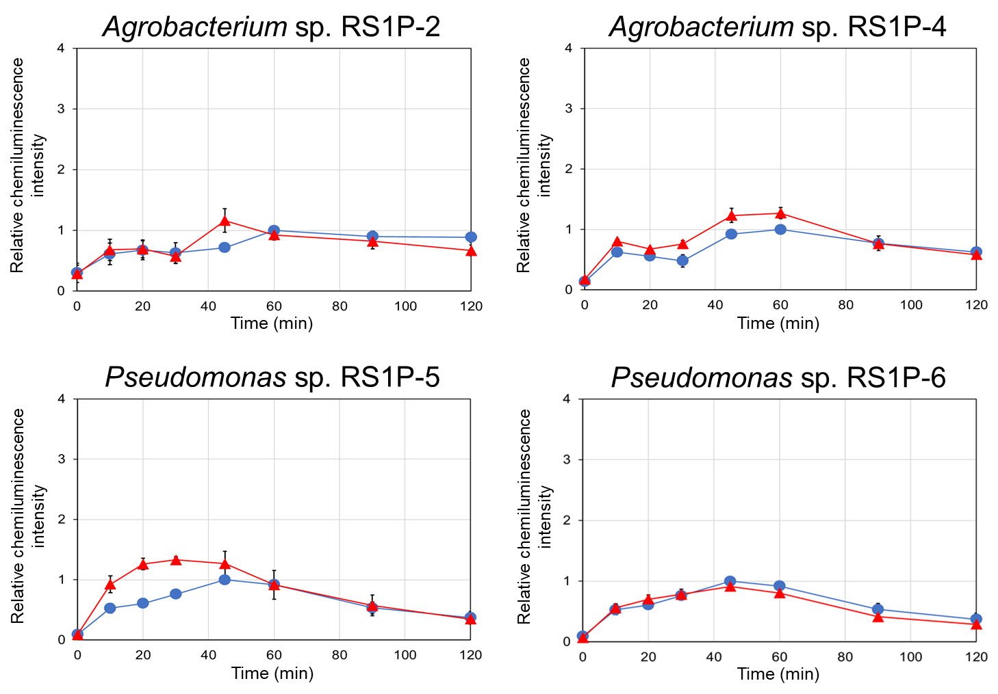

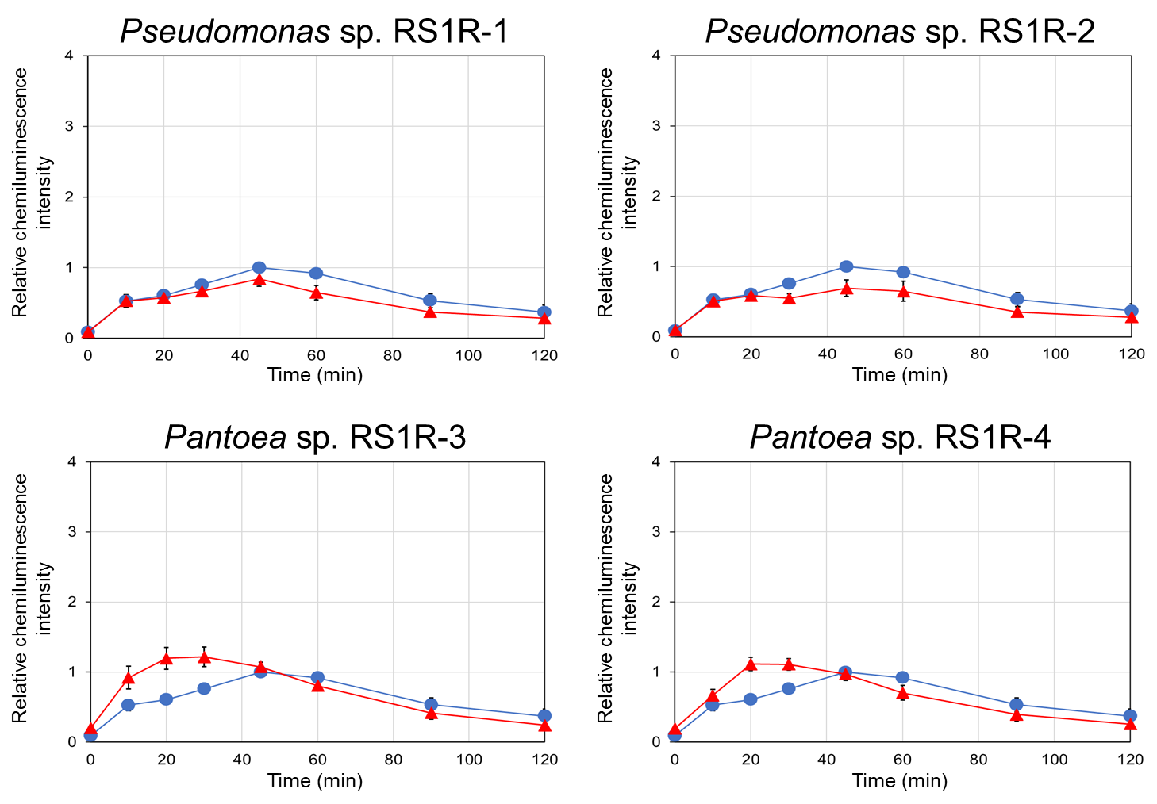

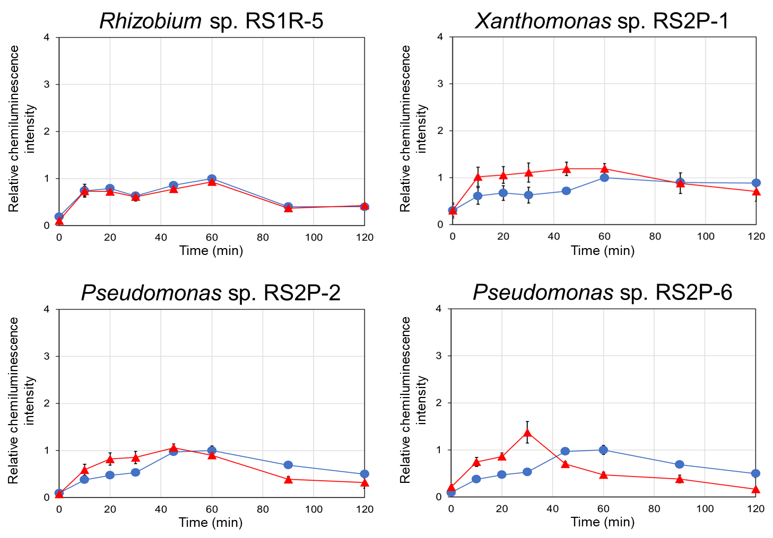

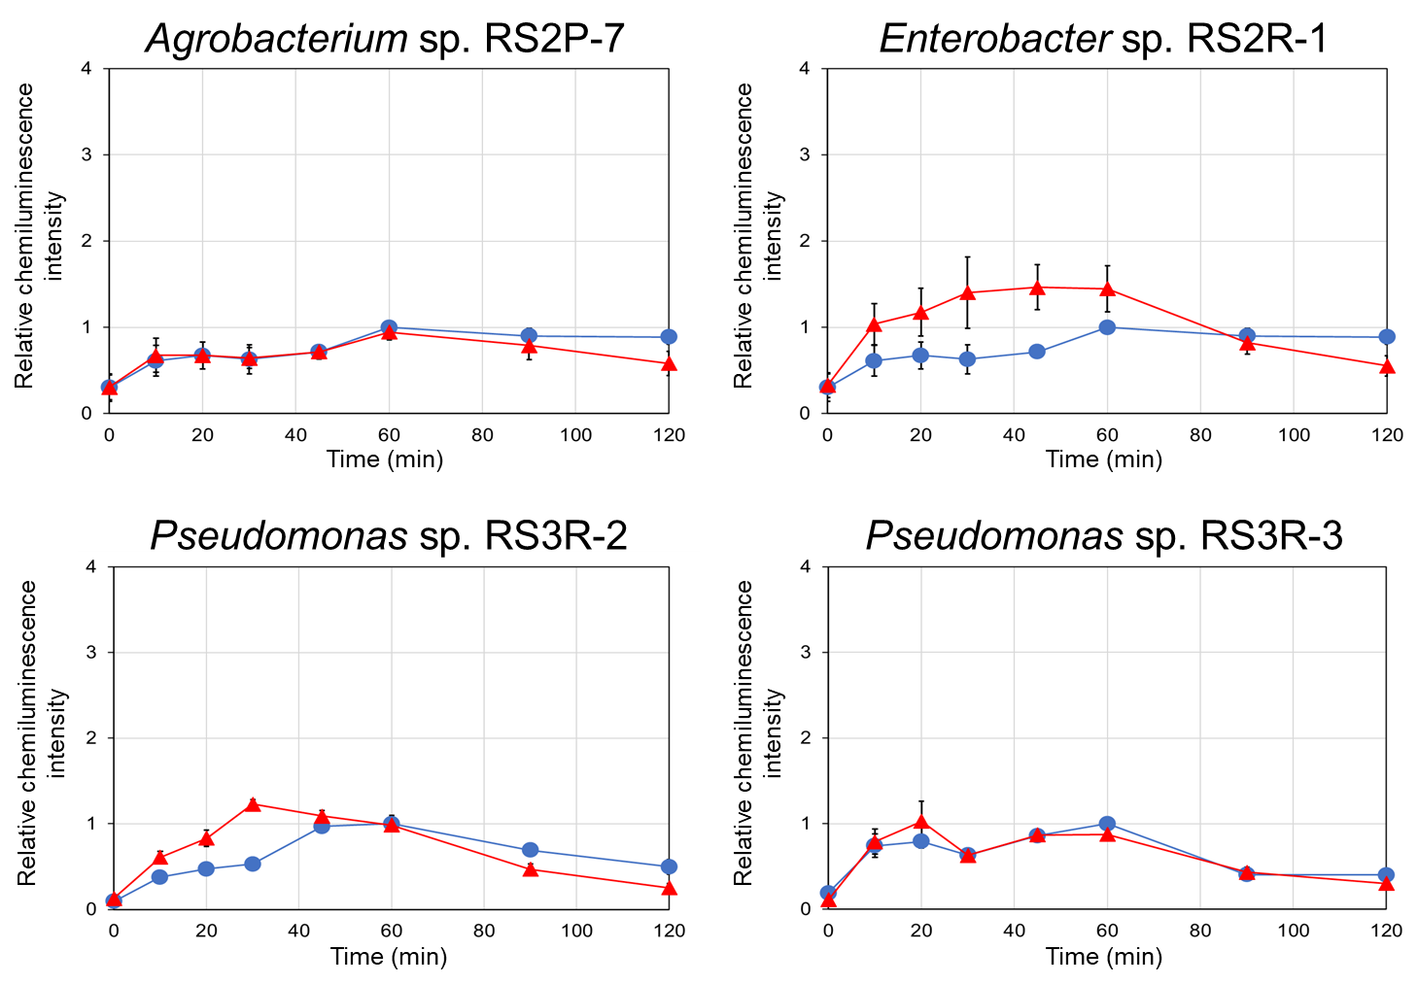

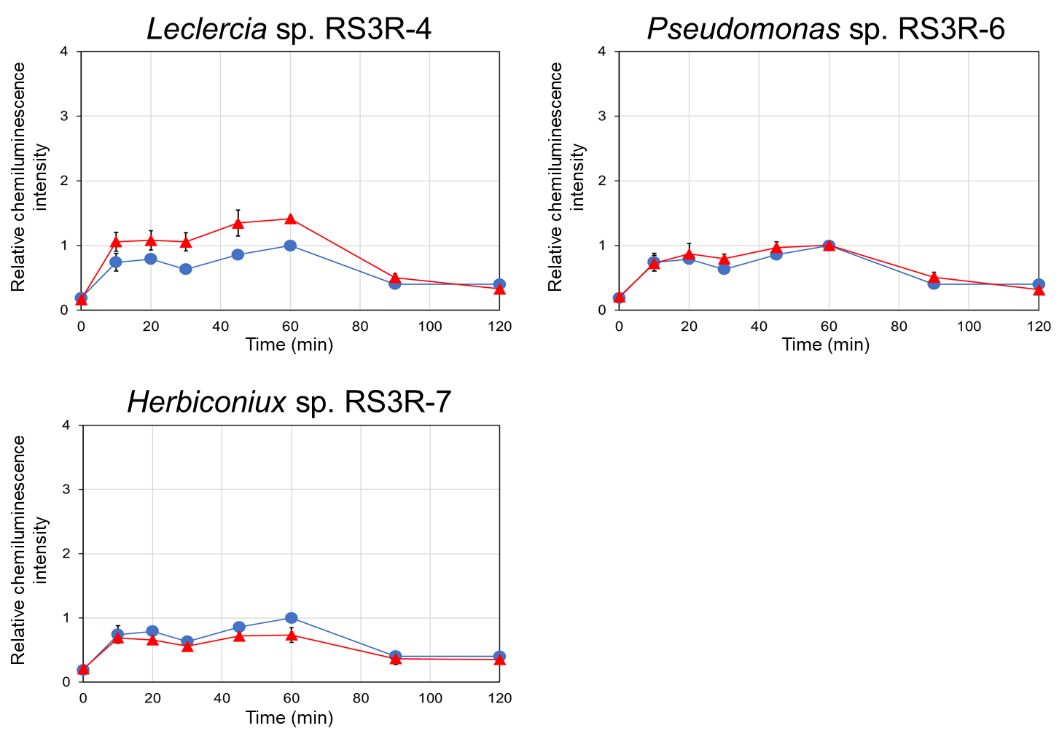

Fig. S3 Cryptogein-induced ROS production in BY-2 cells co-incubated with bacteria. Bacteria that did not enhanced cryptogein-induced ROS production are shown. BY-2 cells were co-incubated with bacteria of each strain (∆) or subjected to mock treatment (only a mixture of medium and buffer, ○), and then cryptogein was added. ROS production was monitored based chemiluminescence. The maximum value of the mock control was expressed as 1.0, and relative chemiluminescence intensity is shown. Average values ± SE from three independent experiments are presented.

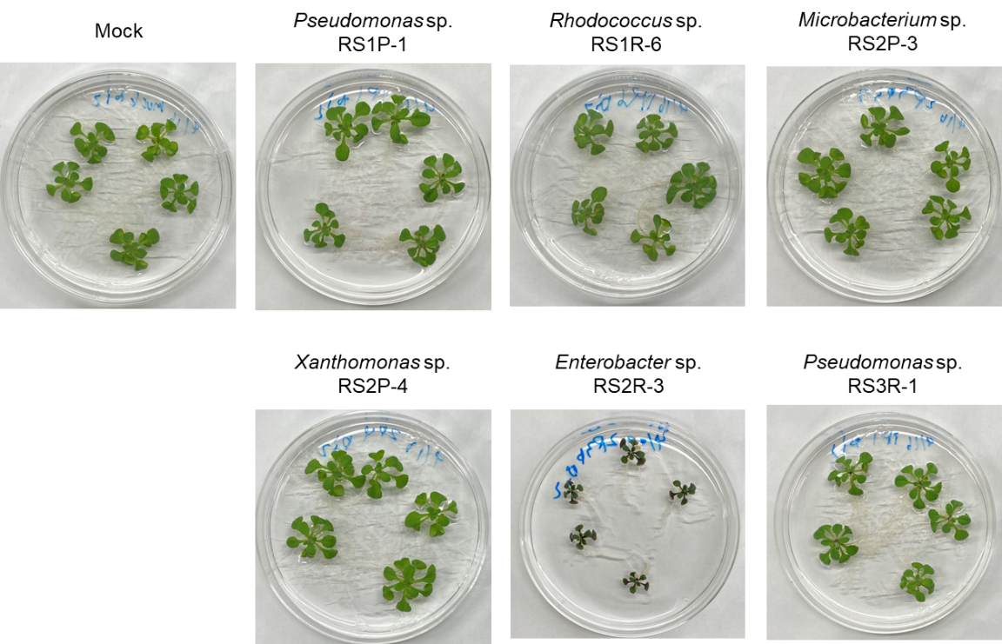
(a)

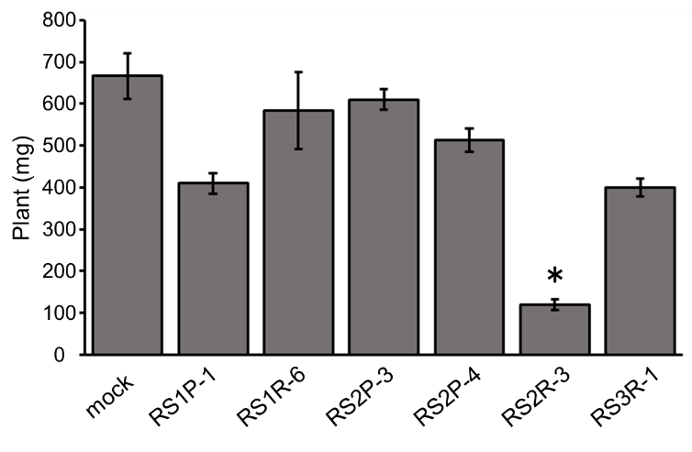
(b)

Fig. S4 Arabidopsis plants inoculated with the selected bacteria. Plants were inoculated with each strain of selected bacteria or mock treatment (only the medium) by immersing the root tip of 7-day-old seedlings in bacterial cell culture solution, followed by cultivation for 7 days. (a), representative photographs. (b), fresh weight of a plant. Average values ± SE from three independent experiments are presented. Asterisks indicate a significant difference from the mock control based on Student’s t-test (*, P<0.05).
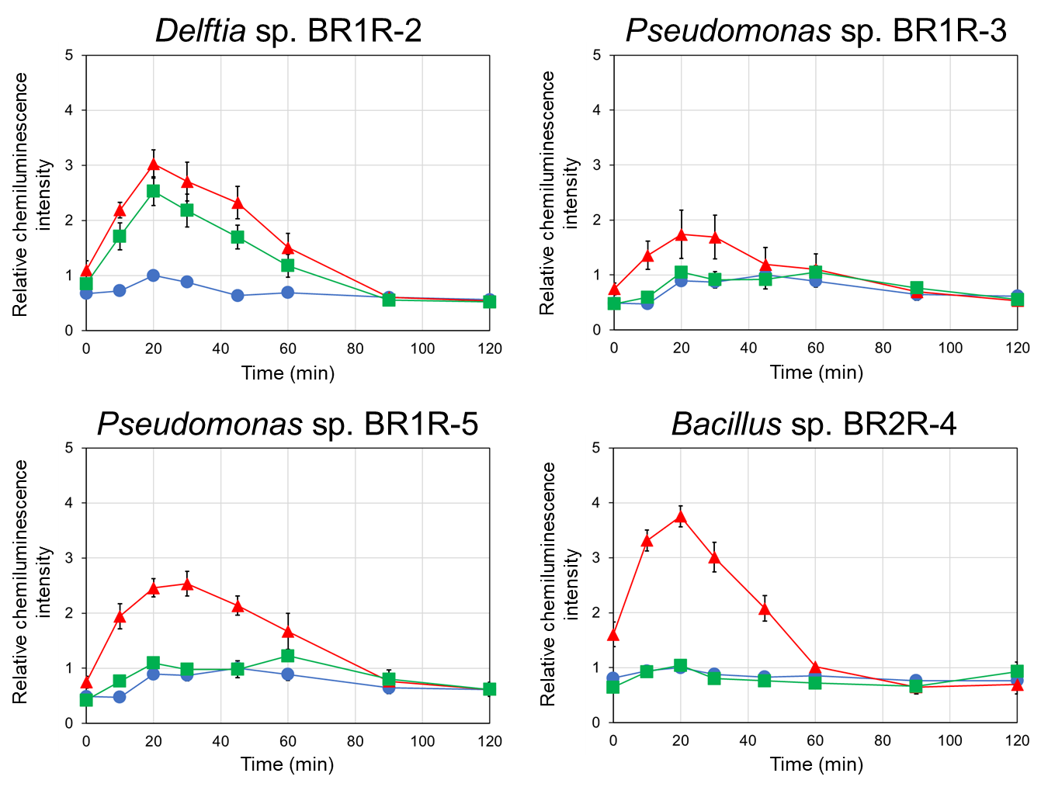

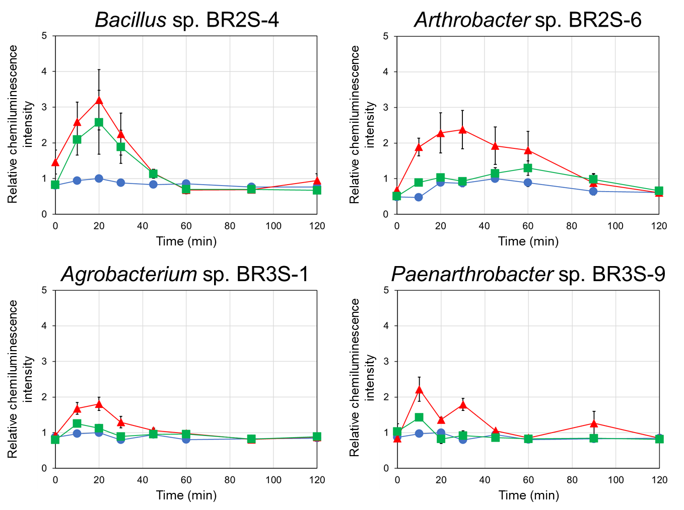

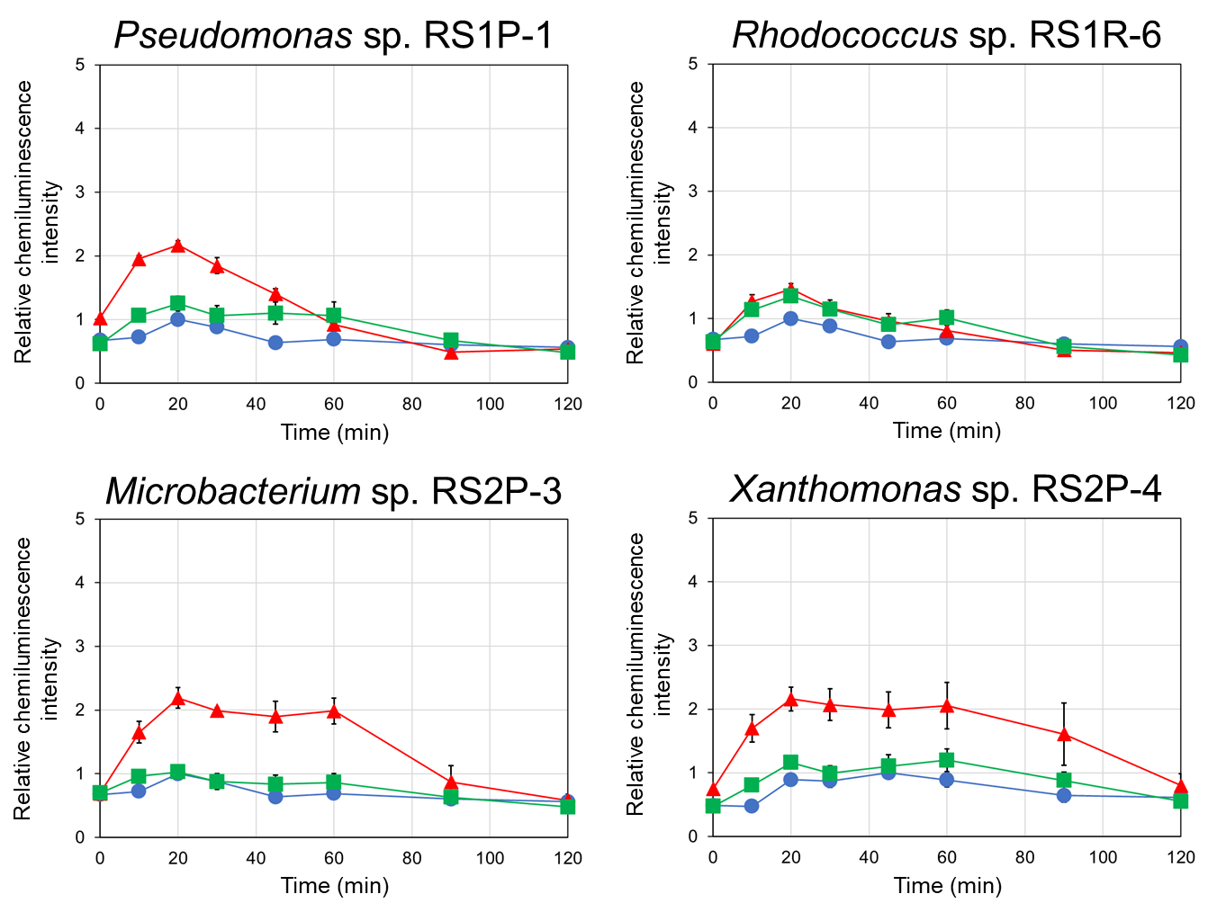

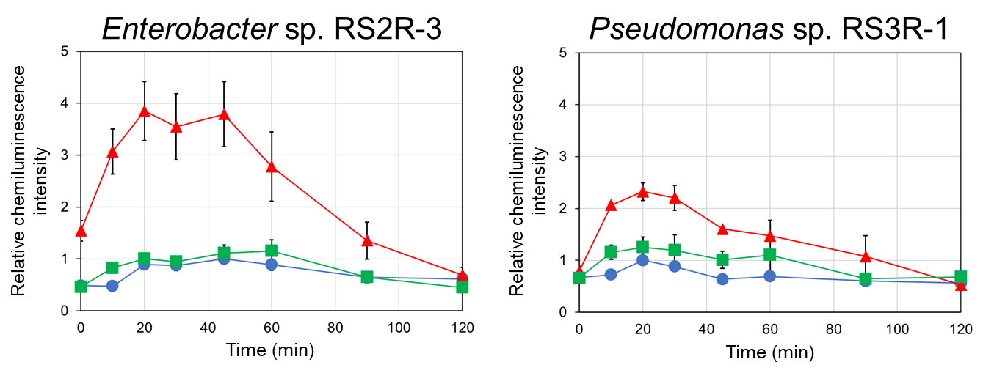

Fig. S5 Thermal stability of components that enhanced cryptogein-induced ROS production. BY-2 cells were co-incubated with bacterial cell culture solution (∆) or the solution after autoclaving (□), or subjected to mock treatment (only a mixture of medium and buffer, ○), and then cryptogein was added. ROS production was monitored based on chemiluminescence. The maximum value of the mock control was expressed as 1.0, and relative chemiluminescence intensity is shown. Average values ± SE from three independent experiments are presented.

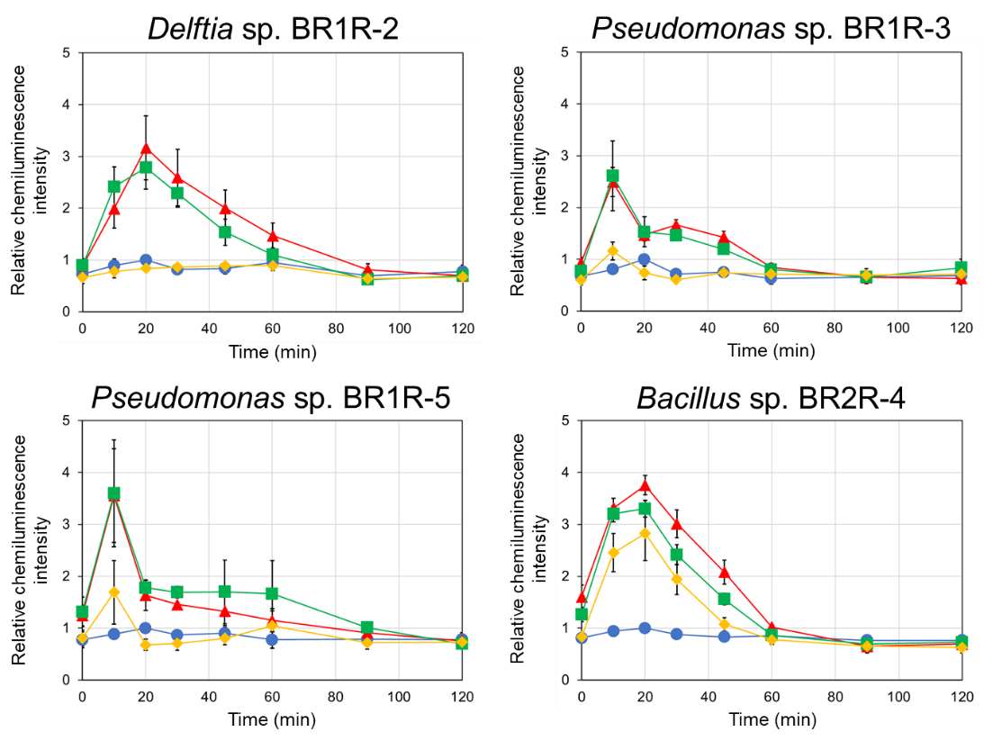

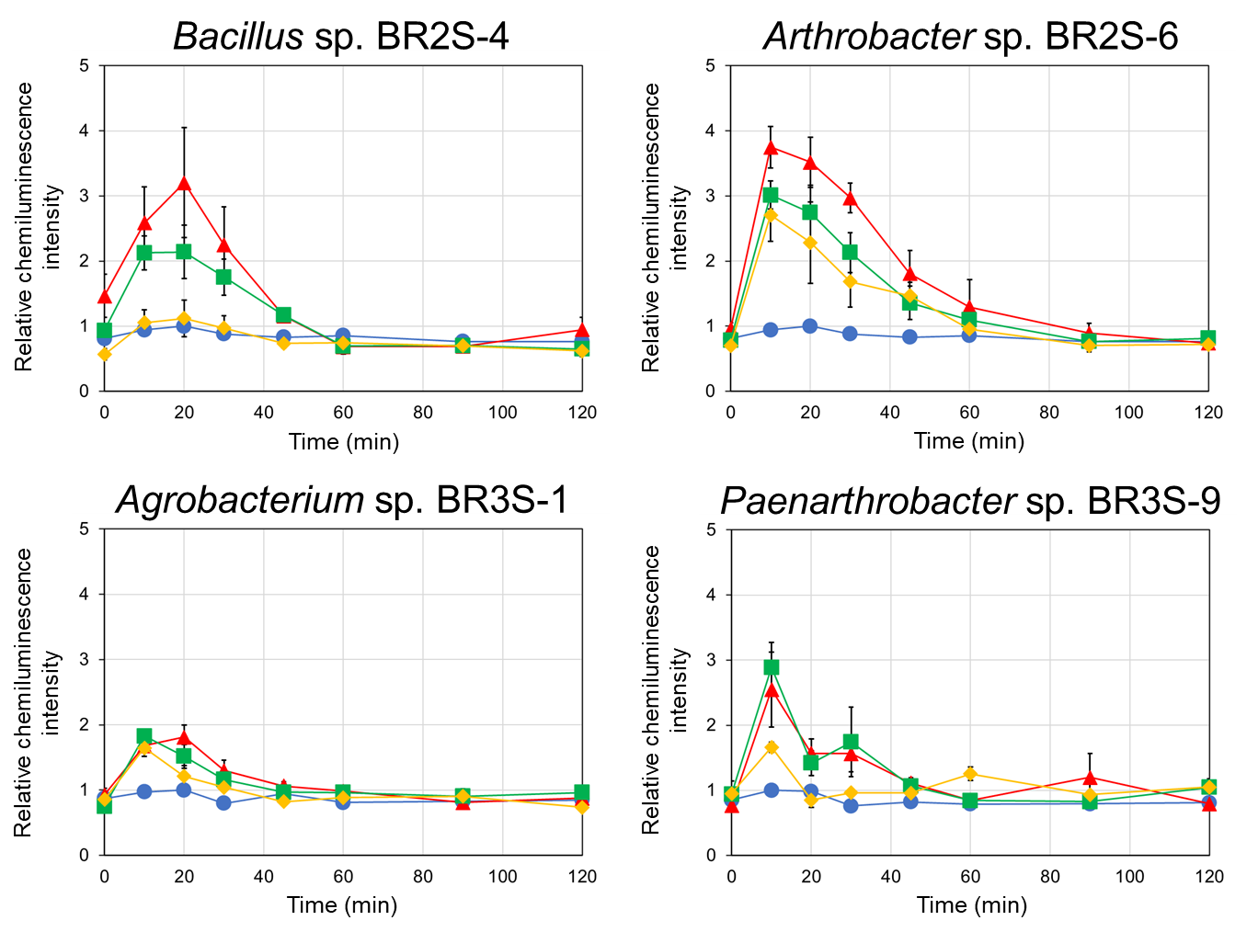

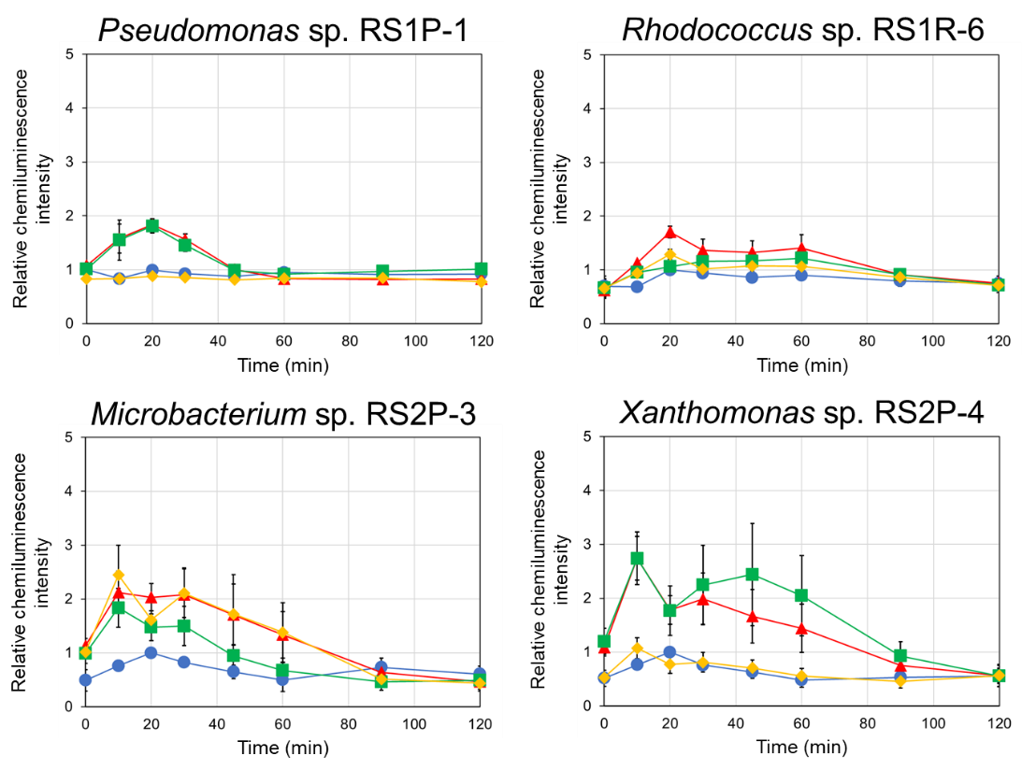

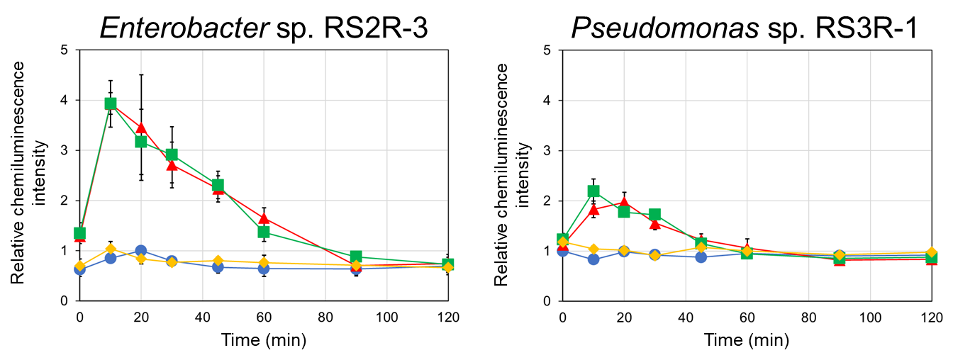

Fig. S6 Localization of components that enhanced cryptogein-induced ROS production. BY-2 cells were co-incubated with bacterial cell culture solution (∆) or the cells (precipitate, □) or extracellular components (supernatant, ◊) after centrifugation of the solution, or subjected to mock treatment (only a mixture of medium and buffer, ○), and then cryptogein was added. ROS production was monitored based on chemiluminescence. The maximum value of the mock control was expressed as 1.0, and relative chemiluminescence intensity is shown. Average values ± SE from three independent experiments are presented.
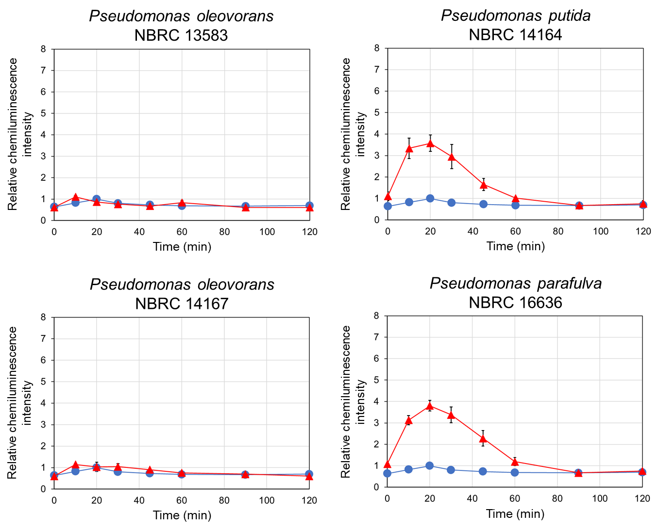

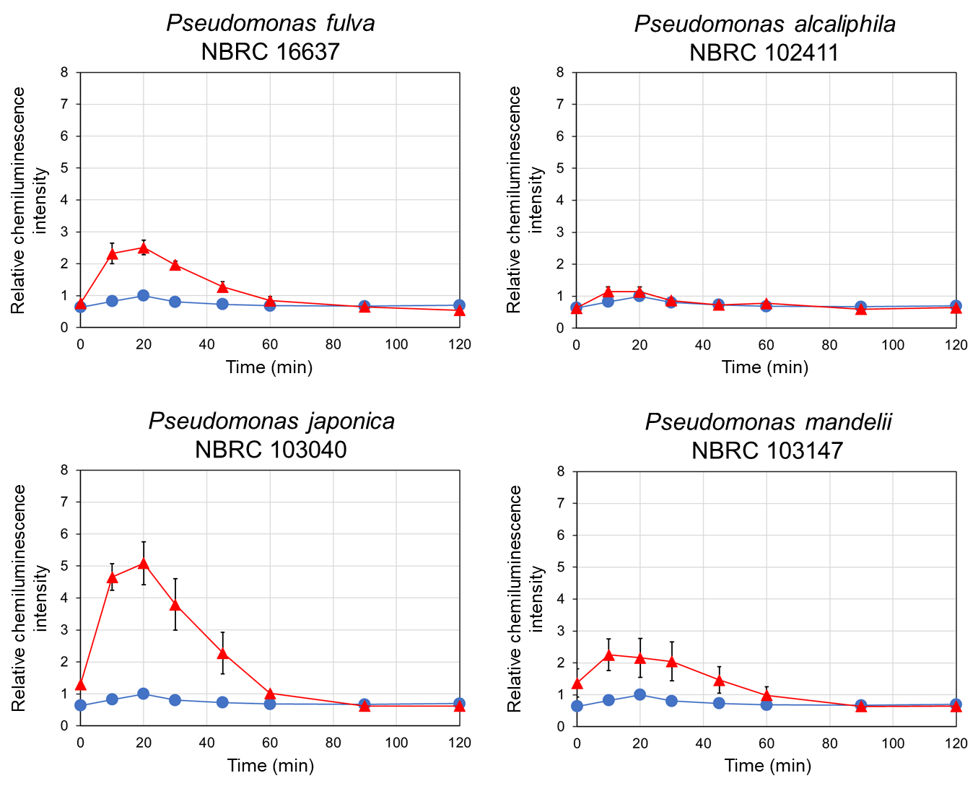

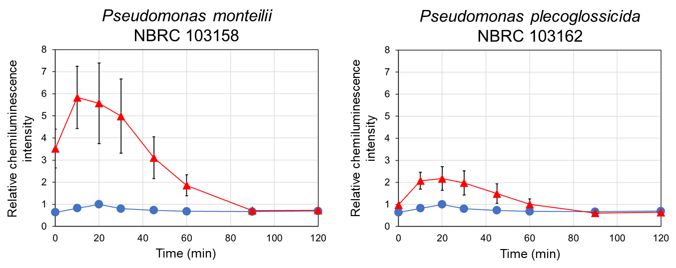

Fig. S7. Cryptogein-induced ROS production in BY-2 cells co-incubated with Pseudomonas strains obtained from NBRC. BY-2 cells were co-incubated with bacteria of each strain (∆) or subjected to mock treatment (only a mixture of medium and buffer, ○), and then cryptogein was added. ROS production was monitored based on chemiluminescence. The maximum value of the mock control was expressed as 1.0, and relative chemiluminescence intensity is shown. Average values ± SE from three independent experiments are presented.

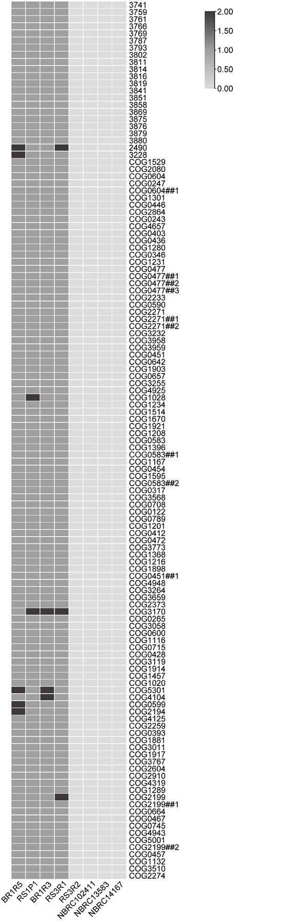

Fig. S8. Heatmap of Clusters of orthologous genes present in all ROS-enhancing strains that were absent in all non–ROS-enhancing strains.

