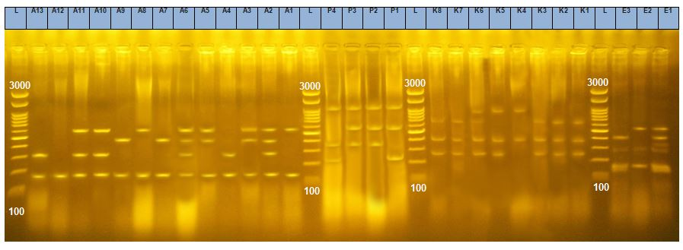
Figure S1. Agarose gel electrophoresis of ERIC-PCR analysis of some selected carbapenem-resistant Gram-negative bacterial isolates; lanes A1-A13 were ERIC PCR analysis of 13 Acinetobacter baumannii clinical isolates (coded AB1-AB13); lanes P1-P4 were ERIC PCR analysis of 4 Pseudomonas aeruginosa clinical isolates (coded PA1-PA-4); lanes K1-K8 were ERIC PCR analysis of 8 Klebsiella pneumoniae clinical isolates (coded KP1-KP8); lanes E1-E3 were ERIC PCR analysis of 3 E. coli clinical isolates (coded EC1-EC3). lane L, a gene Ruler 1 kb ladder (Thermo Scientific™ Oxoid™, Loughborough, UK);

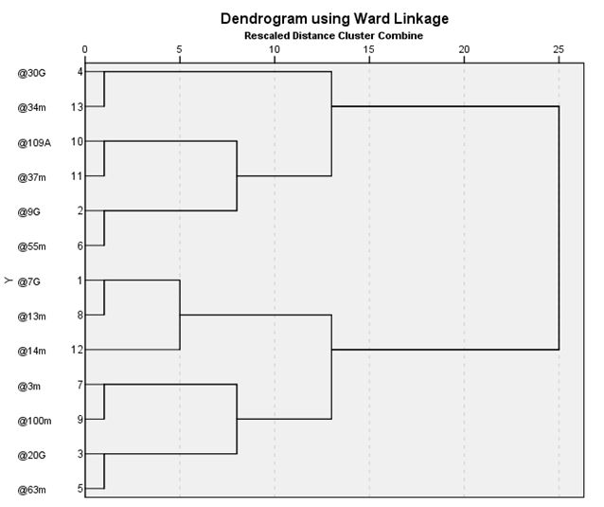

Figure S2. Dendrogram generated from ERIC-PCR genomic DNA products of 13 carbapenem-resistant A. baumnnii bacterial isolates (AB1-AB13).

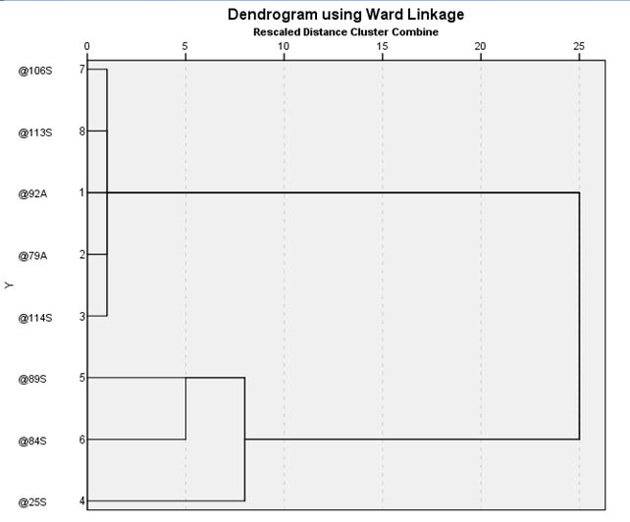

Figure S3. Dendrogram generated from ERIC-PCR genomic DNA products of 8 carbapenem-resistant K. pneumoniae bacterial isolates (KP1-KP8)
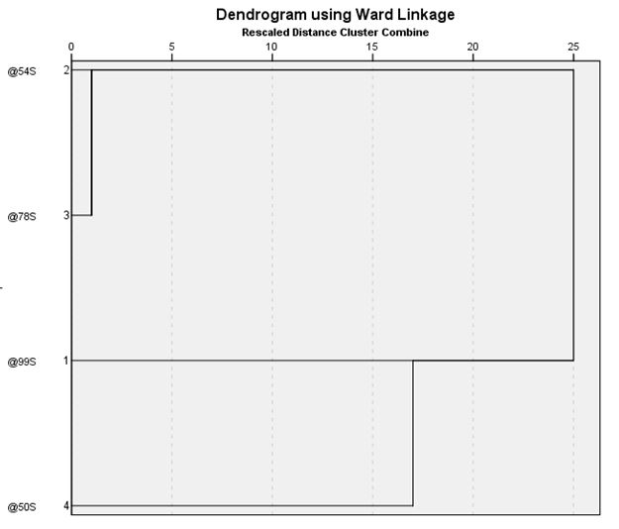

Figure S4. Dendrogram generated from ERIC-PCR genomic DNA products of 8 carbapenem-resistant P. aeruginosa bacterial isolates (PA1-PA4)
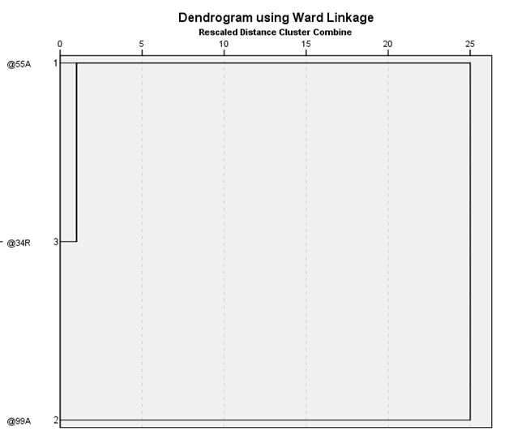

Figure S5. Dendrogram generated from ERIC-PCR genomic DNA products of 8 carbapenem-resistant E. coli bacterial isolates (EC1-EC3)

