Additional File 1. OTUs clustering and annotation statistics.
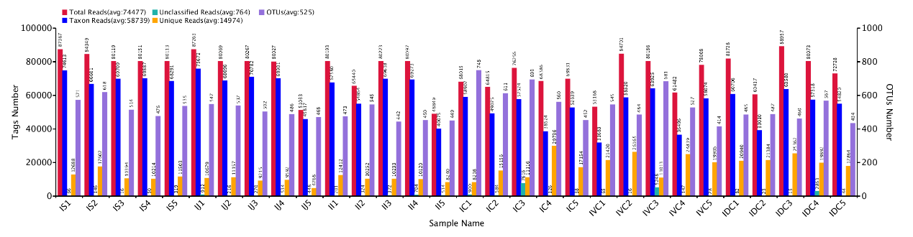
Abscissa: sample name; First ordinate (reads number): reads Number; Total reads (red): the Total number of reads per sample (valid data for subsequent analysis such as OTUs clustering per sample); Taxon reads (blue): Number of reads used to build OTUs and obtain annotated information; Unique reads (orange): refers to the number of reads with frequency 1 that cannot be clustered into OTUs (sequences that cannot be clustered into OTUs will not be used for subsequent analysis). The second ordinate (OTUs Number): refers to the number of OTUs; OTUs (purple): indicate the number of OTUs obtained for each sample; Unclassified reads (tea green): refer to the number of reads without any classified information.

Additional File 2. Breed comparisons for the relative abundance of LG and UG fungal composition at the phylum level.
Phylum | The upper GIT | The lower GIT
Neocallimastigomycota | 0.1966±0.5488^{B} | 0.5384±0.3786^{A}
Basidiomycota | 0.6002±0.1726^{A} | 0.22914±0.2471^{B}
Ascomycota | 0.3619±0.1628ª | 0.2047±0.1802^{b}
Glomeromycota | 0.0047±0.0059 | 0.0054±0.0138
Zygomycota | 0.0051±0.0064 | 0.0028±0.0030
Chytridiomycota | 0.0030±0.0042 | 0.0008±0.0011
Note: Different uppercase letters mean the significance at P < 0.01, Different lowercase letters mean the significance at P < 0.05 and blank indicate no significant difference P > 0.05.

Additional File 3. Comparison of relative abundance of gastrointestinal fungi at the phylum level.
Phylum | Stomach（S） | Jejunum（J） | Ileum（I） | Cecum（C） | Ventral colon（VC） | Dorsal colon（DC）
Neocallimastigomycota | 0.0466±0.0956^{C} | 0.0041±0.0013C | 0.0083±0.0058^{C} | 0.2491±0.2817^{Bb} | 0.5731±0.4080^{ABa} | 0.7931±0.2620^{A}
Basidiomycota | 0.7140±0.1908^{A} | 0.6140±0.1406^{A} | 0.4727±0.1064^{A} | 0.3757±0.2619^{Ba} | 0.2474±0.2850^{Bb} | 0.0644±0.0.0520^{C}
Ascomycota | 0.2347±0.1341^{Ab} | 0.3560±0.1398^{Aa} | 0.4949±0.1137^{Aa} | 0.3376±0.1727^{Aa} | 0.1589±0.1500^{B} | 0.1175±0.1647^{B}
Glomeromycota | 0.0007±0.0004 | 0.0064±0.0080 | 0.0070±0.0051 | 0.0024±0.0013 | 0.0015±0.0010 | 0.0124±0.0241
Zygomycota | 0.0019±0.0025 | 0.0057±0.0043 | 0.0077±0.0010 | 0.004±0.0043 | 0.0016±0.0013 | 0.0022±0.0020
Chytridiomycota | 0.0005±0.0007^{B} | 0.0067±0.0056^{A} | 0.0019±0.0013^{B} | 0.0011±0.0084^{B} | 0.0011±0.0017^{B} | 0.0004±0.0006^{B}
Note: Different uppercase letters mean the significance at P < 0.01, Different lowercase letters mean the significance at P < 0.05 and blank indicate no significant difference P > 0.05.

Additional File 4. OTUs Venn diagram of intestinal flora in Mongolian horses. In each figure, C represents the cecum segment, VC represents the ventral colon segment, and DC represents the dorsal colon segment.

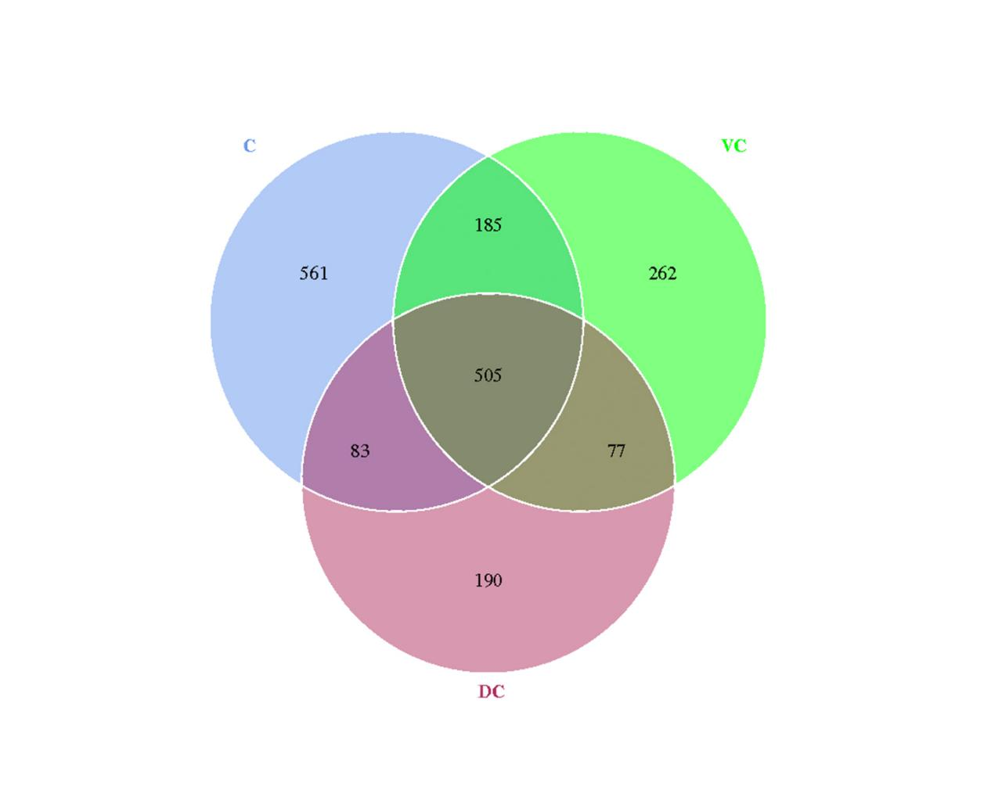

Additional File 5. Comparisons for the relative abundance of UG and LG microbiota at the genus level.
Genus | The upper GIT | The lower GIT
Cryptococcus | 0.1154±0.1520ª | 0.0234±0.0361^{b}
Cladosporium | 0.0966±0.077^{A} | 0.0236±0.0340^{B}
Lysurus | 0.0215±0.0483 | 0.0010±0.0014
Alternaria | 0.0465±0.0350^{A} | 0.0139±0.0183^{B}
Gibberella | 0.0184±0.0158 | 0.0095±0.0299
Bipolaris | 0.0137±0.0298 | 0.0011±0.0011
Candida | 0.0012±0.0017 | 0.0083±0.0223
Bullera | 0.0206±0.0255 | 0.0064±0.0085
Sarocladium | 0.0212±0.0224^{A} | 0.0030±0.0040^{B}
Hannaella | 0.0215±0.0212 | 0.0094±0.0114
others | 0.5398±0.1770^{B} | 0.8554±0.1372^{A}
Note: Different uppercase letters mean the significance at P < 0.01, Different lowercase letters mean the significance at P < 0.05 and blank indicate no significant difference P > 0.05.

Additional File 6. Comparison of relative abundance of GIT fungi at the genus level.
Genus | Stomach（S） | Jejunum（J） | Ileum（I） | Cecum（C） | Ventral colon（VC） | Dorsal colon（DC）
Cryptococcus | 0.1251±0.1701 | 0.1459±0.1756 | 0.0751±0.1332 | 0.0448±0.0591 | 0.0181±0.0114 | 0.0072±0.0024
Cladosporium | 0.0575±0.0293^{Ab} | 0.0810±0.0526^{Aa} | 0.1511±0.1045^{Aa} | 0.0242±0.0191^{B} | 0.0419±0.0530^{B} | 0.0047±0.0023^{B}
Lysurus | 0.0389±0.0843 | 0.0061±0.0056 | 0.0196±0.01833 | 0.0018±0.0023 | 0.0008±0.0003 | 0.0005±0.0001
Alternaria | 0.0385±0.0158^{Aa} | 0.0324±0.0205^{Aa} | 0.0686±0.5180^{Aa} | 0.0143±0.0091^{B} | 0.0236±0.0290^{Ab} | 0.0037±0.0012^{B}
Gibberella | 0.0115±0.0123 | 0.0194±0.0147 | 0.0244±0.0201 | 0.0262±0.0511 | 0.0018±0.0018 | 0.0006±0.0003
Bipolaris | 0.0012±0.0010 | 0.0153±0.0297 | 0.0247±0.0433 | 0.0014±0.0010 | 0.0014±0.0015 | 0.0004±0.0001
Candida | 0.0005±0.0003 | 0.0020±0.0028 | 0.0012±0.0007 | 0.0045±0.0055 | 0.0016±0.0015 | 0.0188±0.0387
Bullera | 0.0224±0.0339 | 0.0245±0.0286 | 0.0148±0.0157 | 0.0080±0.0069 | 0.0100±0.0124 | 0.0011±0.0004
Sarocladium | 0.0154±0.0140ª | 0.0230±0.0309ª | 0.0251±0.0226ª | 0.0055±0.0051ª | 0.0029±0.0039^{b} | 0.0008±0.0006^{b}
Hannaella | 0.0324±0.0293^{Aa} | 0.0224±0.0167^{Ab} | 0.0097±0.0106^{Aa} | 0.0120±0.0076^{Aa} | 0.0149±0.0166^{Aa} | 0.0015±0.0008^{B}
others | 0.5858±0.1894^{Bb} | 0.5335±0.2331^{B} | 0.5004±0.1218^{B} | 0.7859±0.1520^{Aa} | 0.8504±0.1473^{A} | 0.9298±0.0897^{A}
Note: Different uppercase letters mean the significance at P < 0.01, Different lowercase letters mean the significance at P < 0.05 and blank indicate no significant difference P > 0.05.

Additional File 7. LDA value distribution histogram (only the genera LDA scores above 4 are shown).
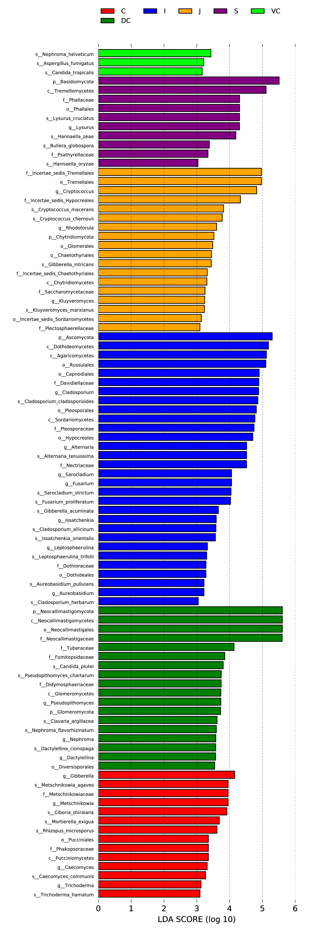

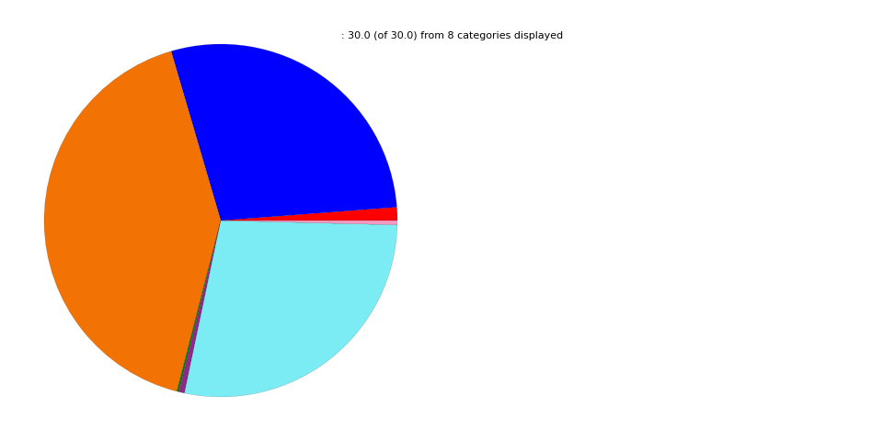
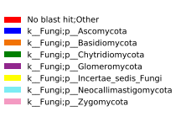
Additional File 8. Distribution of the Mongolian horses GIT fungal community composition.

