Antifungal Activity of Lysinibacillus macroides against toxigenic Aspergillus flavus and Fusarium proliferatum and Analysis of its mycotoxin minimization potential
Ahmed L. Mahmoud¹, Ayat H. Kileny^{1*}, Elhagag A. Hassan¹
¹Botany and Microbiology Department, Faculty of Science, Assiut University, 71516 Assiut, Egypt

*Corresponding to: Ayat Hassan Kileny, Teaching assistant of Microbiology*
Botany and Microbiology Department, Faculty of Science, Assiut University, 71516 Assiut, Egypt
Tel: 002 01013721523 E-mail: Ayat93@aun.edu.eg

Supplementary Figure S1
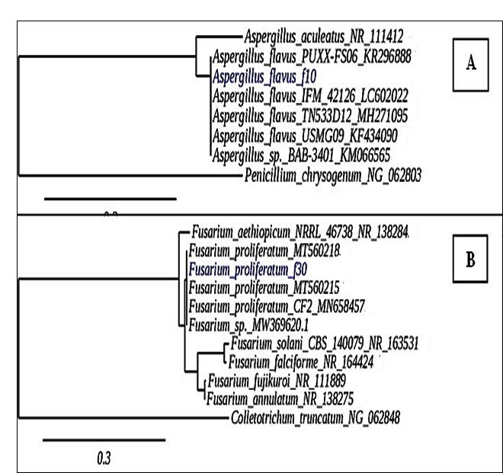
S1: The phylogenetic trees representing (A) Aspergillus flavus f10, (B) Fusarium proliferatum f30. Trees were constructed from aligned sequences (ITS) using neighbor-joining methods. Penicillium chrysogenum and Colletotrichum truncatum were used as the out of the group.

Supplementary Figure S2
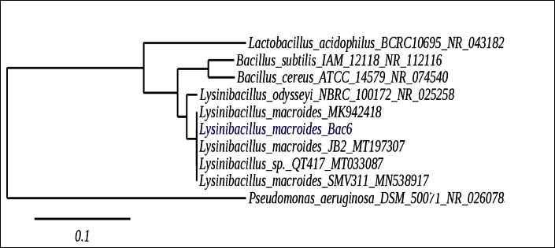
S 2: phylogenetic tree of Lysinibacillus macroides. Tree was constructed from aligned sequences (16s rRNA) using neighbor-joining method. Pseudomonas aeruginosa was used as the out of group.

